Machine Learning

Program assignment #1

0410001

Hong-Shuo, Chen

1. Problem

For this assignment, you need to implement ID3 algorithm to construct a decision tree and use K-fold cross validation (K=5) to validate classification performance by outputting precision and recall for each class and total accuracy.

1. Environment

* Ubuntu 16.04.3 LTS

1. Using library and language

* Library: numpy, math
* Language: Python 3.5.2

1. Results

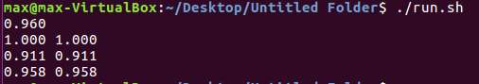

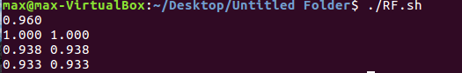

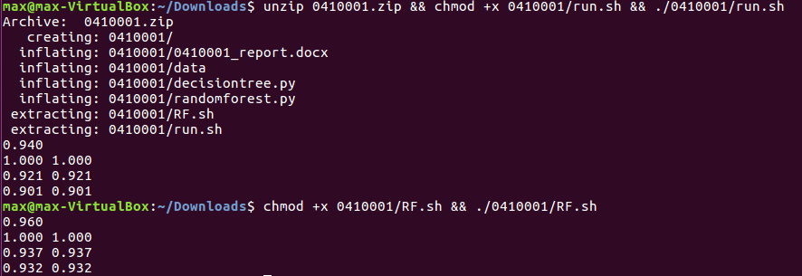

1. Code

I define the following function:

* get_attributes(data)

handle continous descriptive features and get the attributes set

Parameters:

* + data: numpy.ndarray

return: attributes : numpy.ndarray

* entropy(data)

calculate the entropy

Parameters:

* + data: numpy.ndarray

return: entropy: float64

* rem(data,attr)

calculate the remainder

Parameters:

* + data: numpy.ndarray
  + attr: dtype = {‘names’ = (‘attr’, ‘threshold’),‘formats’ = (‘U20’,’f8’)}

return: entropy: float64

* gain(data, attr)

calculate the information gain

Parameters:

* + data: numpy.ndarray
  + attr: dtype = {‘names’ = (‘attr’, ‘threshold’),‘formats’ = (‘U20’,’f8’)}

return: gain: float64

* choose_best_attr(data, attributes)

choose the best attribute

Parameters:

* + data: numpy.ndarray
  + attr: numpy.ndarray

return: best: int32

* majority_value(data)

get the most class in the dataset

Parameters:

* + data: numpy.ndarray

return: class : ‘U20’

* create_decision_tree(data, attributes, parent)

create decisiontree with attribute as label

Parameters:

* + data: numpy.ndarray
  + attributes: numpy.ndarray
  + parent: 'U20'

return: tree: dict

* create_decision_tree_ts(data, attributes, parent)

create decisiontree with threshold as label

Parameters:

* + data: numpy.ndarray
  + attributes: numpy.ndarray
  + parent: 'U20'

return: tree: dict

* K_fold_cross_validation(data,k)

do the K-fold cross validation and calculate the precision, recall, and accuracy

Parameters:

* + data: numpy.ndarray
  + k: int

return:

* random_forest(data,trees)

construct a multitude of decision trees at training time and output the the result that is the most predictions of the classes of the individual trees

Parameters:

* + data: numpy.ndarray
  + trees: int

return:

1. Further explanation of the code

#create decisiontree with attribute as label

def create_decision_tree(data, attributes, parent):

target = data['class']

# if the dataset is empty return the classification of the parent

if data.size == 0:

return parent

# If the attributes list is empty, return the

# default value. When checking the attributes list for emptiness, we

# need to subtract 1 to account for the target attribute.

elif attributes.size == 0:

return majority_value(data)

# If all the records in the dataset have the same classification,

# return that classification.

elif np.count_nonzero(target == target[0]) == target.size:

return target[0]

else:

# Choose the next best attribute to best classify our data

id = choose_best_attr(data,attributes)

best = attributes[id]

tmp = np.delete(attributes,id)

# Create a new decision tree with the best attribute and an empty

# dictionary object--we'll fill that up next.

tree = {best['attr']:{}}

# Create a new decision sub-node for each of the values in the

# best attribute field

data0 = data1 = np.array([],dtype = data.dtype)

for i in range(data.size):

if data[i][best['attr']] < best['threshold']:

data0 = np.append(data0,data[i])

else:

data1 = np.append(data1,data[i])

# Add the new subtree to the empty dictionary object in our new

# tree/node we just created.

subtree = create_decision_tree(data0, tmp, majority_value(data))

tree[best['attr']][0] = subtree

subtree = create_decision_tree(data1, tmp, majority_value(data))

tree[best['attr']][1] = subtree

return tree