**Operating System Homework 3 Report**

Student ID: 0410001

Name: Hong-Shuo Chen

**Detailed description of the implementation:**(Number of threads, the purpose of those threads, how do you use mutex lock and semaphore…etc.)

Hw3-1

* Number of threads: 5*16*3 = 240 threads

5: There are 5 files in this program. I open 5 threads for each file.

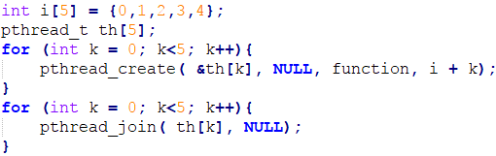

16: I divide each image into 16 parts. Because the imagine width and height could be divide by 4.

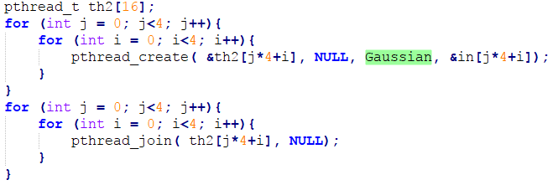

3: There are three main parts in this program, which respectively are GREY, Gaussian and Extend.

* Mutex Lock

I use the mutex lock in this first assignment. I use it to control Grey and Gaussian. Because we need to wait for GREY, so that we can do the Gaussian blur. I lock the Gaussian function, when I do the Grey, after finish Grey, I release the lock, so that Gaussian function can work.

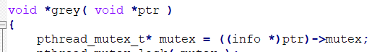

Hw3-2

* Number of threads: 5*16*5 = 400 threads

5: There are 5 files in this program. I open 5 threads for each file.

16: I divide each image into 16 parts. Because the imagine width and height could be divide by 4.

5: There are three main parts in this program, which respectively are Gx, Gy, Grey, calculate and Extend.

* Semaphore Lock

I use the Semaphore lock in this second assignment. I use it to control calculate and Extend. Because we need to wait for calculate, so that we can do the Extend. I lock the Extend function, when I do the calculate, after finish calculate, I release the lock, so that Extend function can work.

**Your speed:**

**Speed up: Hw1: >2 Hw2: >2**

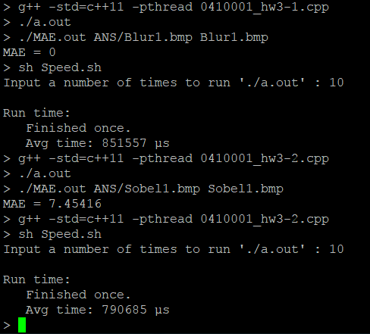

**Problems encountered and solutions:**

This is really a challenging lab for me. I don’t know why. I think my logical is right however when I code and run it. It always has the problem that Segment Fault. I spent almost two whole days to deal with it. Finally, I got the answer that we need to keep track of every memory we use, especially when we use thread, and also static variable is also should be used carefully. I learn very much in this lab. If it is possible, I hope I can know the best solution for this assignment. Thank you.