

VML aaa
Adidas.com readesigna
Flaash Localization Standards and Besta Practices Technical Specificationa

Draft Version 0.1, 3 September 2007

This is part of the technical Specification for the adidas flash localization standards for the adidas.com Re-design.

Identification
Title: | Flash Coding Standards and Best Practices Technical Specification
Version: | Draft Version 0.1, 3 September 2007
Classification: | Internal Use Only
Intended Audience: | As decided by Design Team Lead
Keywordss: | Flash Home Page, Adidas.com redesign, XML
Synopsis: | This is part of the technical Specification for the adidas flash localization standards for the adidas.com Re-design.
Author(s): |  | Paul Nevins
Approval |  | Project Manager / Development Team Lead
Distribution: | As distributed by Project Manager / Development Team Lead
Watermark: | (none)
Company: | adidas-Salomon AG
Revision History
Version, Date | Change Description
Draft Version 0.1  3 September 2007 | New document

Table of Contents
Technical Specification Signoff iv
1. Introduction 5
1.1 Purpose and Scope 5
1.2 Non Goals of this” Specification 5
1.3 Relationship to Other Documents 5
1.4 Definitions and Abbreviations 5
1.5 References 5
2. Using XLIFF with Flash 7
2.1 Overview 7
2.2 Font Issues 7
2.3 Strings Panel 8
2.4 Using the Locale class 8
2.5 XLIFF reference and code sample 9

Technical Specification Signoff
Role | Name | Date | Signature
</add role>
<\add role>
<add role>
<add role>
<add role>
<add role>
<add u>
<add role>
<add role>

Introduction

Purpose and Scope
Developer Name | Paul Nevins
Flash Coding Standards | Reference material
Flash Best Practices | Common issues and reference

The purpose of this specification is to provide references and guide material for developers to use when localizing text in flash applications.

Non Goals of this Specification
The Flash Coding Standards and Best Practices for any web sites other than adidas.com is outside the scope of this document.

Relationship to Other Documents
This document is related to all other documents that pertain to the adidas.com Re-design project.

“Definitions and Abbreviations”
The following definitions and abbreviations are used:
Abbreviation | Definition
XLIFF | XML Localization Interchange File Format

“References”
ActionScript 2.0 Best Practices, http://www.adobe.com/devnet/flash/articles/as_bestpractices.html
Reference for XLIFF, http://www.oasis-open.org/committees/xliff/documents/xliff-specification.htm
Reference for Action Script use for XLIFF, http://livedocs.adobe.com/flash/8/main/wwhelp/wwhimpl/common/html/wwhelp.htm?context=LiveDocs_Parts&file=00002347.html
Reference for Flash Strings Panel,
http://livedocs.adobe.com/flash/8/main/wwhelp/wwhimpl/common/html/wwhelp.htm?context=LiveDocs_Parts&file=00001480.html
Reference for supported html tags for flash, http://kb.adobe.com/selfservice/viewContent.do?externalId=tn_14808&

Using XLIFF with Flash

Overview
XLIFF stands for XML Localization Interchange File Format established April 2002.
When creating localization for flash, I find that separating the visual presentation layer data from the text data is a good way to ensure the least amount of rework during updates.
I purpose the use of the XLIFF standard for creating and distributing translated text to be used in flash. The translation text can be housed in just one file or multiple files depending on the development needs.
This XLIFF file serves as a look up list for getting many translated text values from a commonly shared id. Therefore, the display data on graphical elements can be separate from the actual text data that displays in them.

Font Issues
French fries When using French dynamic text fries with flash and multiple character sets this presents many challenges in flash 8. The ability to import external fonts has been greatly improved in flash 9, but we will not be using that as a primary version to support upon launch.
Using a Unicode system font like “_sans” is a great way to ensure a very small file size for an application that has to show multiple character sets. The drawback to this approach is that the system font has to be set as non-embedded in the flash application to save on file size. Trying to embed every single character set in the world would create a very large file in the resulting swf output. Therefore, when non-embedding the font, the text can’t be masked and can’t have the alpha set to anything but 100 percent. This will introduce unique challenges to developers when creating flash animation effects.
Ivan Dembicki, created a secret alternate method to embed external fonts as needed. This procedure can be found at, http://www.sharedfonts.com/eng/index.html
Another method is using external libraries for sharing fonts, but that method lacks the ability to download just the fonts you need.
In the end, it’s up the developer to choose which method they are most comfortable working with.

Strings Panel
The strings panel in flash is a built in text localization management tool. In depth usage detail can be found at http://livedocs.adobe.com/flash/8/main/wwhelp/wwhimpl/common/html/wwhelp.htm?context=LiveDocs_Parts&file=00001480.html

Example String Panel:
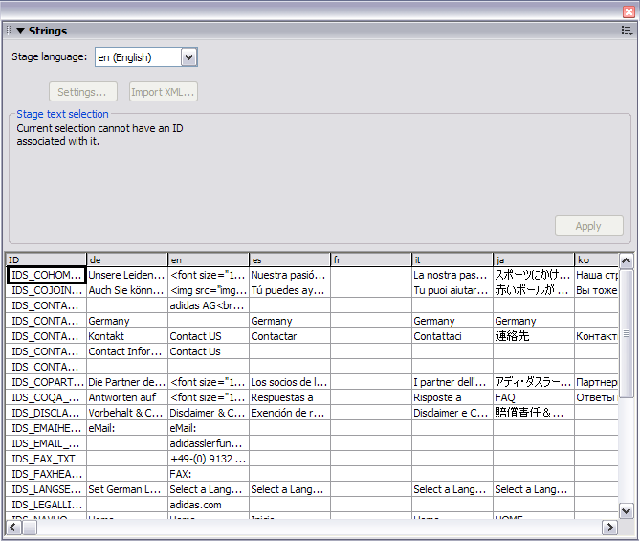

I find this method quite cumbersome for large amounts of text and complex html formatted text. There are also issues with switching out languages at runtime with this method as well. I would advise either using the flash Language Locale class or writing your own xml parser.

Using the Locale class
To gain more precise control over localization, you can opt to use the flash xm.lang.Locale class for parsing XLIFF formatted files.
In-depth information about usage can be found at,
http://livedocs.adobe.com/flash/8/main/wwhelp/wwhimpl/common/html/wwhelp.htm?context=LiveDocs_Parts&file=00001481.html
and
http://livedocs.adobe.com/flash/8/main/wwhelp/wwhimpl/common/html/wwhelp.htm?context=LiveDocs_Parts&file=00001481.html.

XLIFF reference and code sample

This represents a basic usage of an XLIFF file. In the “trans-unit” node. The “resname” would relate to a unique text object instance name in the flash application. In depth explanation on XLIFF standard can be found at,
http://www.oasis-open.org/committees/xliff/documents/xliff-specification.htm
and for Action Script use , http://livedocs.adobe.com/flash/8/main/wwhelp/wwhimpl/common/html/wwhelp.htm?context=LiveDocs_Parts&file=00002347.html

See sample code below:

<?xml version="1.0" encoding="UTF-8"?>
<xliff version="1.0" xml:lang="en">
<file datatype="plaintext" original="homePage.fla" source-language="EN">
<header></header>
<body>
<trans-unit id="001" resname="IDS_GREETING">
<source><![CDATA[ Hello ]]></source>
</trans-unit>
</body>
</file>
</xliff>

