ListView

Android Estudio V3.0.17/Flutter

Objetivo:Conocer ListView

F.Creación: 7-4-2018

Programa:

Fuente: ListView
Medium
Revisar

ListView
void main() {
//debugPaintSizeEnabled = true;
runApp(new MyApp());
}
class MyApp extends StatelessWidget {
@override
Widget build(BuildContext context) {
return new MaterialApp(
title: 'Flutter Demo',
theme: new ThemeData(
primarySwatch: Colors.blue,
),
home: new MyHomePage(title: 'Flutter Demo Home Page'),
);
}
}
class MyHomePage extends StatefulWidget {
MyHomePage({Key key, this.title}) : super(key: key);
final String title;
@override
_MyHomePageState createState() => new _MyHomePageState();
}
List<Widget> list = <Widget>[
new ListTile(
title: new Text('CineArts at the Empire',
style: new TextStyle(fontWeight: FontWeight.w500, fontSize: 20.0)),
subtitle: new Text('85 W Portal Ave'),
leading: new Icon(
Icons.theaters,
color: Colors.blue[500],
),
),
new ListTile(
title: new Text('The Castro Theater',
style: new TextStyle(fontWeight: FontWeight.w500, fontSize: 20.0)),
subtitle: new Text('429 Castro St'),
leading: new Icon(
Icons.theaters,
color: Colors.blue[500],
),
),
new ListTile(
title: new Text('Alamo Drafthouse Cinema',
style: new TextStyle(fontWeight: FontWeight.w500, fontSize: 20.0)),
subtitle: new Text('2550 Mission St'),
leading: new Icon(
Icons.theaters,
color: Colors.blue[500],
),
),
new ListTile(
title: new Text('Roxie Theater',
style: new TextStyle(fontWeight: FontWeight.w500, fontSize: 20.0)),
subtitle: new Text('3117 16th St'),
leading: new Icon(
Icons.theaters,
color: Colors.blue[500],
),
),
new ListTile(
title: new Text('United Artists Stonestown Twin',
style: new TextStyle(fontWeight: FontWeight.w500, fontSize: 20.0)),
subtitle: new Text('501 Buckingham Way'),
leading: new Icon(
Icons.theaters,
color: Colors.blue[500],
),
),
new ListTile(
title: new Text('AMC Metreon 16',
style: new TextStyle(fontWeight: FontWeight.w500, fontSize: 20.0)),
subtitle: new Text('135 4th St #3000'),
leading: new Icon(
Icons.theaters,
color: Colors.blue[500],
),
),
new Divider(),
new ListTile(
title: new Text('K\'s Kitchen',
style: new TextStyle(fontWeight: FontWeight.w500, fontSize: 20.0)),
subtitle: new Text('757 Monterey Blvd'),
leading: new Icon(
Icons.restaurant,
color: Colors.blue[500],
),
),
new ListTile(
title: new Text('Emmy\'s Restaurant',
style: new TextStyle(fontWeight: FontWeight.w500, fontSize: 20.0)),
subtitle: new Text('1923 Ocean Ave'),
leading: new Icon(
Icons.restaurant,
color: Colors.blue[500],
),
),
new ListTile(
title: new Text('Chaiya Thai Restaurant',
style: new TextStyle(fontWeight: FontWeight.w500, fontSize: 20.0)),
subtitle: new Text('272 Claremont Blvd'),
leading: new Icon(
Icons.restaurant,
color: Colors.blue[500],
),
),
new ListTile(
title: new Text('La Ciccia',
style: new TextStyle(fontWeight: FontWeight.w500, fontSize: 20.0)),
subtitle: new Text('291 30th St'),
leading: new Icon(
Icons.restaurant,
color: Colors.blue[500],
),
),
];
class _MyHomePageState extends State<MyHomePage> {
@override
Widget build(BuildContext context) {
return new Scaffold(
appBar: new AppBar(
title: new Text(widget.title),
elevation: 5.0, // Removing the drop shadow cast by the app bar.
),
body: new Center(
child: new ListView(
children: list,
),
),
);
}

Un ListView en una col
new Column(
children: <Widget>[
new Expanded(
child: horizontalList,
)
],

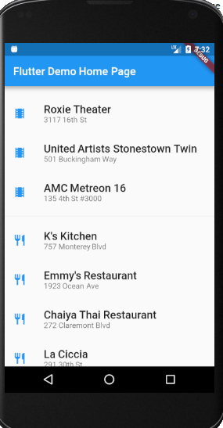

0down vote
Return the header as first row by itemBuilder:
ListView.builder(
itemCount: data == null ? 1 : data.length + 1,
itemBuilder: (BuildContext context, int index) {
if (index == 0) {
// return the header
return new Column(...);
}
index -= 1;

// return row
var row = data[index];
return new InkWell(... with row ...);
},
);

