Stepper

Android Estudio V3.0.17/Flutter

Objetivo:Despliega un progreso a travez de una secuencia de pasos

F.Creación: 4-6-2018

Programa:

Fuente: nILRUZ}

Max
max82574971@gmail.com

El stepp puede tener un título un subtitulo, un icono dentro de un circulos , algun contenido y un estado
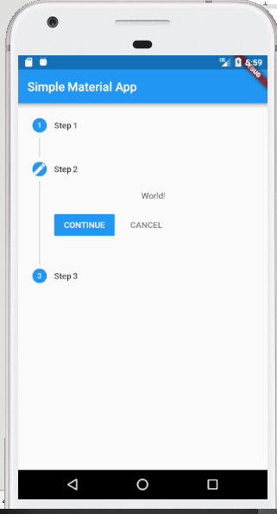

// init the step to 0th position
int current_step = 0;
List<Step> my_steps = [
new Step(
// Title of the Step
title: new Text("Step 1"),
// Content, it can be any widget here. Using basic Text for this example
content: new Text("Hello!"),
isActive: true),
new Step(
title: new Text("Step 2"),
content: new Text("World!"),
// You can change the style of the step icon i.e number, editing, etc.
state: StepState.editing,
isActive: true),
new Step(
title: new Text("Step 3"),
content: new Text("Hello World!"),
isActive: true),
];

body: new Container(
child: new Stepper(
// Using a variable here for handling the currentStep
currentStep: this.current_step,
// List the steps you would like to have
steps: my_steps,
// Define the type of Stepper style
// StepperType.horizontal : Horizontal Style
// StepperType.vertical : Vertical Style
type: StepperType.vertical,
// Know the step that is tapped
onStepTapped: (step) {
// On hitting step itself, change the state and jump to that step
setState(() {
// update the variable handling the current step value
// jump to the tapped step
current_step = step;
});
// Log function call
print("onStepTapped : " + step.toString());
},
onStepCancel: () {
// On hitting cancel button, change the state
setState(() {
// update the variable handling the current step value
// going back one step i.e subtracting 1, until its 0
if (current_step > 0) {
current_step = current_step - 1;
} else {
current_step = 0;
}
});
// Log function call
print("onStepCancel : " + current_step.toString());
},
// On hitting continue button, change the state
onStepContinue: () {
setState(() {
// update the variable handling the current step value
// going back one step i.e adding 1, until its the length of the step
if (current_step < my_steps.length - 1) {
current_step = current_step + 1;
} else {
current_step = 0;
}
});
// Log function call
print("onStepContinue : " + current_step.toString());
},
)),

