DateTime

Flutter Beta

Objetivo:

F.Creación: 3-10-2018

Programa:

Fuente:

Max
max82574971@gmail.com

i have String ISODate '2018-09-30T11:00:30.757Z'. my question is how to convert that String to DateTime Format, like '2018/09/30 07:00 PM' ?

Try this:

DateTime getDartDateFromNetUTC(String netUtcDate) {
var dateParts = netUtcDate.split(".");
var actualDate = DateTime.parse(dateParts[0] + "Z");
return actualDate;
}

Libreria
timeZone

https://github.com/flutter/flutter/blob/master/examples/flutter_gallery/lib/demo/material/date_and_time_picker_demo.dart
https://play.google.com/store/apps/details?id=io.flutter.demo.gallery&hl=en

note.fecha=DateFormat.yMMd().format(DateTime.now());

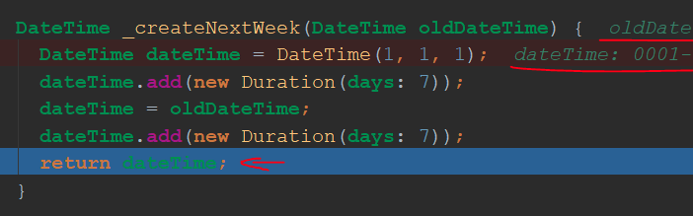

DateTime.now().toIso8601String().substring(0, 10),
2019-02-14

