Monos

Flutter Beta

Objetivo:

F.Creación: 15-11-2018

Programa: texto guia

Fuente:

Max
max82574971@gmail.com

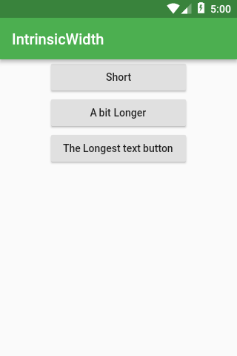
IntrinsicWidth and IntrinsicHeight
Widget build(BuildContext context) {
return Scaffold(
appBar: AppBar(title: Text('IntrinsicWidth')),
body: Center(
child: IntrinsicHeight(
child: Column(
crossAxisAlignment: CrossAxisAlignment.stretch,
children: <Widget>[
RaisedButton(
onPressed: () {},
child: Text('Short'),
),
RaisedButton(
onPressed: () {},
child: Text('A bit Longer'),
),
RaisedButton(
onPressed: () {},
child: Text('The Longest text button'),
),
],
),
),
),
);
}

Stack
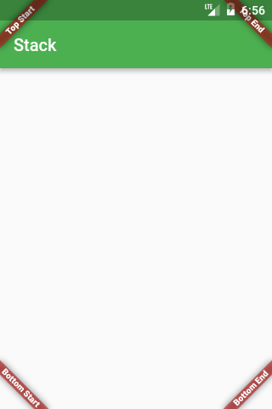
@override
Widget build(BuildContext context) {
Widget main = Scaffold(
appBar: AppBar(title: Text('Stack')),
);

return Stack(
fit: StackFit.expand,
children: <Widget>[
main,
Banner(
message: "Top Start",
location: BannerLocation.topStart,
),
Banner(
message: "Top End",
location: BannerLocation.topEnd,
),
Banner(
message: "Bottom Start",
location: BannerLocation.bottomStart,
),
Banner(
message: "Bottom End",
location: BannerLocation.bottomEnd,
),
],
);
}

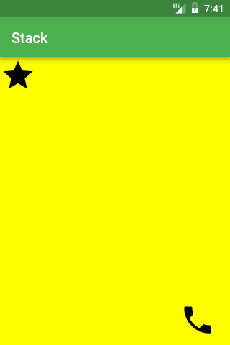
Widget build(BuildContext context) {
const iconSize = 50.0;
return Scaffold(
appBar: AppBar(title: Text('Stack with LayoutBuilder')),
body: LayoutBuilder(
builder: (context, constraints) =>
Stack(
fit: StackFit.expand,
children: <Widget>[
Material(color: Colors.yellowAccent),
Positioned(
top: 0.0,
child: Icon(Icons.star, size: iconSize),
),
Positioned(
top: constraints.maxHeight - iconSize,
left: constraints.maxWidth - iconSize,
child: Icon(Icons.call, size: iconSize),
),
],
),
),
);
}

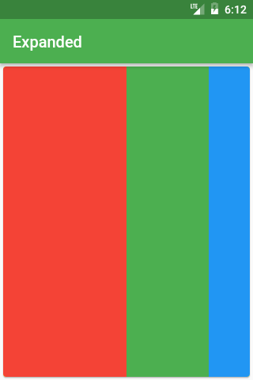
Expanded
new Row(
children: <Widget>[
new Expanded(
child: new Container(
decoration: const BoxDecoration(color: Colors.red),
),
flex: 3,
),
new Expanded(
child: new Container(
decoration: const BoxDecoration(color: Colors.green),
),
flex: 2,
),
new Expanded(
child: new Container(
decoration: const BoxDecoration(color: Colors.blue),
),
flex: 1,
),
],
),

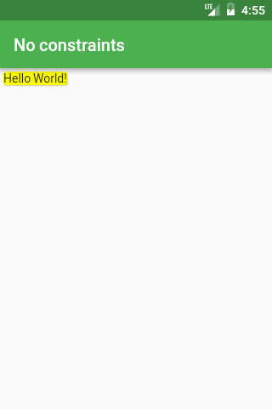
ConstrainedBox
new Card(child: const Text('Hello World!'), color: Colors.yellow)

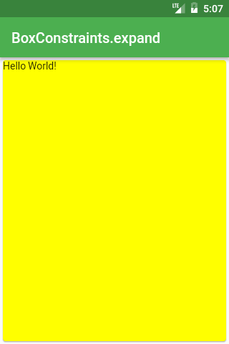

new ConstrainedBox(
constraints: new BoxConstraints.expand(),
child: const Card(
child: const Text('Hello World!'),
color: Colors.yellow,
),
),

new ConstrainedBox(
constraints: new BoxConstraints(
minWidth: double.infinity,
maxWidth: double.infinity,
minHeight: 300.0,
maxHeight: 300.0,
),
child: const Card(
child: const Text('Hello World!'),
color: Colors.yellow,
),
),

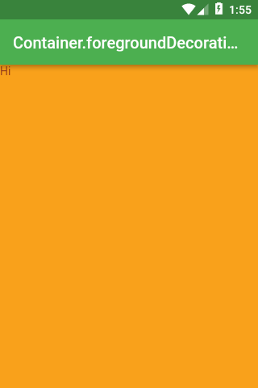
Container aguanta foreground
Widget build(BuildContext context) {
return Scaffold(
appBar: AppBar(title: Text('Container.foregroundDecoration')),
body: Container(
height: double.infinity,
width: double.infinity,
decoration: BoxDecoration(color: Colors.yellowAccent),
foregroundDecoration: BoxDecoration(color: Colors.red.withOpacity(0.5)),
child: Text("Hi"),
),
);
}

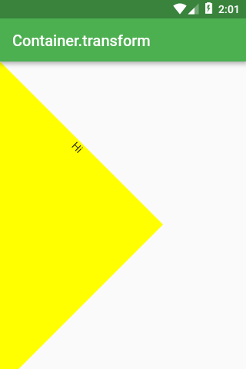
Container as Transform
Widget build(BuildContext context) {
return Scaffold(
appBar: AppBar(title: Text('Container.transform')),
body: Container(
height: 300.0,
width: 300.0,
transform: Matrix4.rotationZ(pi / 4),
decoration: BoxDecoration(color: Colors.yellowAccent),
child: Text(
"Hi",
textAlign: TextAlign.center,
),
),
);
}

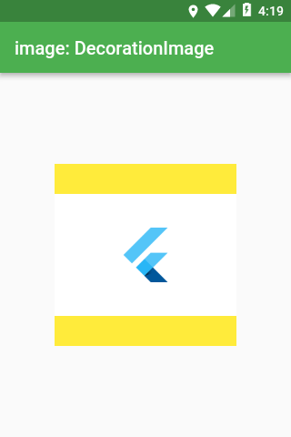
Scaffold(
appBar: AppBar(title: Text('image: DecorationImage')),
body: Center(
child: Container(
height: 200.0,
width: 200.0,
decoration: BoxDecoration(
color: Colors.yellow,
image: DecorationImage(
fit: BoxFit.fitWidth,
image: NetworkImage(
'https://flutter.io/images/catalog-widget-placeholder.png',
),
),
),
),
),
);
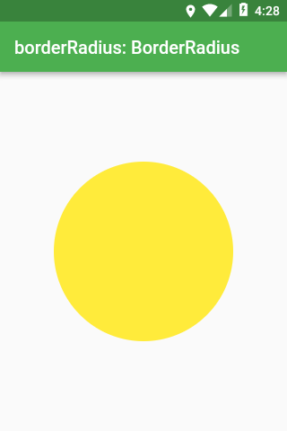

shape: BoxShape
Scaffold(
appBar: AppBar(title: Text('shape: BoxShape')),
body: Center(
child: Container(
height: 200.0,
width: 200.0,
decoration: BoxDecoration(
color: Colors.yellow,
shape: BoxShape.circle,
),
),
),
);

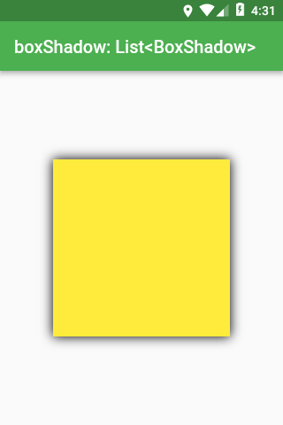

boxShadow: List<BoxShadow>
Scaffold(
appBar: AppBar(title: Text('boxShadow: List<BoxShadow>')),
body: Center(
child: Container(
height: 200.0,
width: 200.0,
decoration: BoxDecoration(
color: Colors.yellow,
boxShadow: const [
BoxShadow(blurRadius: 10.0),
],
),
),
),
);

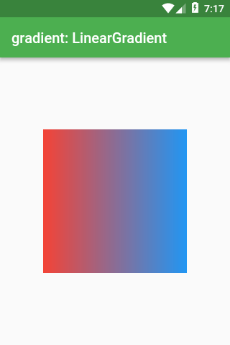
gradient
Scaffold(
appBar: AppBar(title: Text('gradient: LinearGradient')),
body: Center(
child: Container(
height: 200.0,
width: 200.0,
decoration: BoxDecoration(
gradient: LinearGradient(
colors: const [
Colors.red,
Colors.blue,
],
),
),
),
),
);

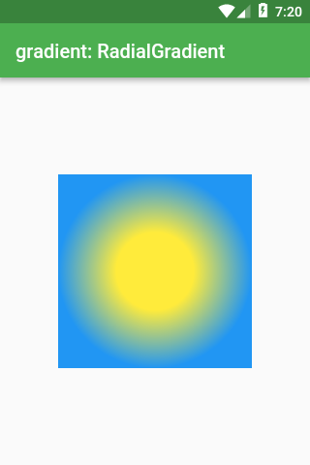
Scaffold(
appBar: AppBar(title: Text('gradient: RadialGradient')),
body: Center(
child: Container(
height: 200.0,
width: 200.0,
decoration: BoxDecoration(
gradient: RadialGradient(
colors: const [Colors.yellow, Colors.blue],
stops: const [0.4, 1.0],
),
),
),
),
);

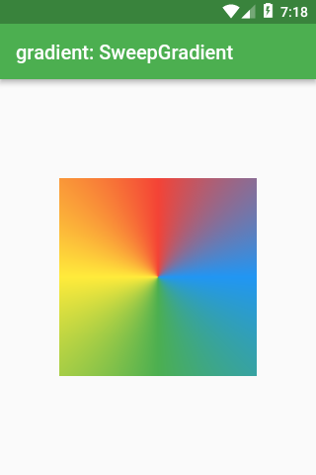
Scaffold(
appBar: AppBar(title: Text('gradient: SweepGradient')),
body: Center(
child: Container(
height: 200.0,
width: 200.0,
decoration: BoxDecoration(
gradient: SweepGradient(
colors: const [
Colors.blue,
Colors.green,
Colors.yellow,
Colors.red,
Colors.blue,
],
stops: const [0.0, 0.25, 0.5, 0.75, 1.0],
),
),
),
),
);

backgroundBlendMode
backgroundBlendMode is the most complex property of BoxDecoration.
It’s responsible for mixing together colors/gradients of BoxDecoration and whatever BoxDecoration is on top of.

With backgroundBlendMode you can use a long list of algorithms specified in BlendMode enum.

First, let’s set BoxDecoration as foregroundDecoration which is drawn on top of Container’s child (whereas decoration is drawn behind the child).
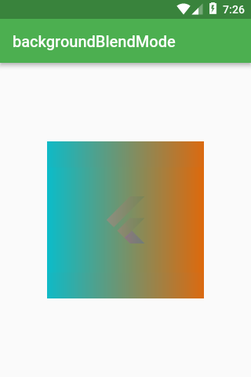
Scaffold(
appBar: AppBar(title: Text('backgroundBlendMode')),
body: Center(
child: Container(
height: 200.0,
width: 200.0,
foregroundDecoration: BoxDecoration(
backgroundBlendMode: BlendMode.exclusion,
gradient: LinearGradient(
colors: const [
Colors.red,
Colors.blue,
],
),
),
child: Image.network(
'https://flutter.io/images/catalog-widget-placeholder.png',
),
),
),
);

backgroundBlendMode does not affect only the Container it’s localed in.

backgroundBlendMode changes the color of anything that is up the widget tree from the Container.
The following code has a parent Container that draws an image and child Container that uses backgroundBlendMode. Still, you would get the same effect as previously.

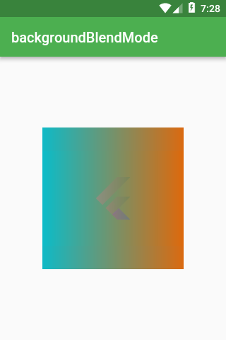
body: Center(
child: Container(
decoration: BoxDecoration(
image: DecorationImage(
image: NetworkImage(
'https://flutter.io/images/catalog-widget-placeholder.png',
),
),
),
child: Container(
height: 200.0,
width: 200.0,
foregroundDecoration: BoxDecoration(
backgroundBlendMode: BlendMode.exclusion,
gradient: LinearGradient(
colors: const [
Colors.red,
Colors.blue,
],
),
),
),
),
),
);
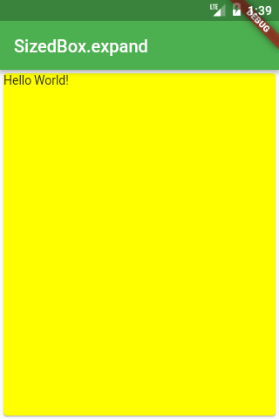

SizedBox
SizedBox.expand(
child: Card(
child: Text('Hello World!'),
color: Colors.yellowAccent,
),
),

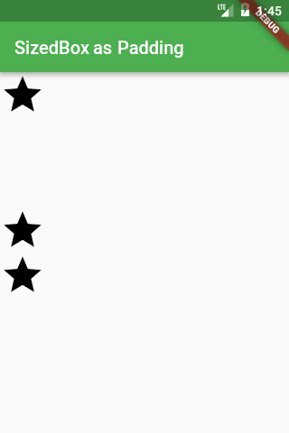

Column(
children: <Widget>[
Icon(Icons.star, size: 50.0),
const SizedBox(height: 100.0,),
Icon(Icons.star, size: 50.0),
Icon(Icons.star, size: 50.0)
],
),

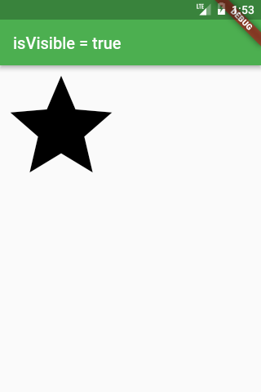
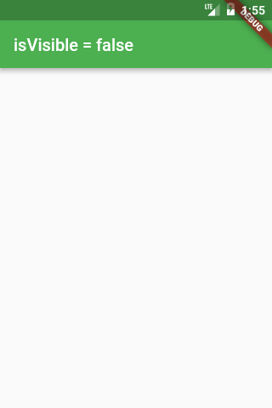

SizedBox as an Invisible Object
Widget build(BuildContext context) {
bool isVisible = ...
return Scaffold(
appBar: AppBar(
title: Text('isVisible = $isVisible'),
),
body: isVisible
? Icon(Icons.star, size: 150.0)
: const SizedBox(),
);
}

