Scaffold

Android Estudio V3.0.17/Flutter

Objetivo:Esta clase proporciona APIs para mostrar Drawers,Snack Bar y plantilla de botones
F.Creación: 27-4-2018

Programa:

Fuente: Appbar Dinámica
Otra fuente
esqueleto

Propiedades
- AppBar, barra mostrada en la parte de arriba
- BottomAppBar, Barra mostrada abajo(bottomNavigationBar)
- FloatingActionButton, Boton circular generalmente a la derecha se usa para acciones frecuentes del usuario
floatingActionButtonLocation:FloatingActionButtonLocation.centerFloat,
- FloatingActionButtonAnimator,anima el boton anterior, no se ha encontrado ejemplo
- Drawer, En las aplicaciones que emplean Material Design, existen dos opciones principales de navegación: Tab y Drawer. Cuando no hay suficiente espacio para admitir tab, los drawer brindan una alternativa práctica, tipicamente es un panel vertical a la izquierad
- BottomNavigationBar, arreglo de botones debajo de la app
- SnackBar, mensaje breve mostrado abajo
- BottomSheet, which is an overlay typically shown near the bottom of the app. A bottom sheet can either be persistent, in which case it is shown using the ScaffoldState.showBottomSheet method, or modal, in which case it is shown using the showModalBottomSheet function.
- ScaffoldState, estado asociado con el widget
SCAFF_SIMPLE
(AppBar, title, floatingActionButton)
En el ejemplo que viene, es posible a travez del appbar , botones y título y abajo un boton flotante
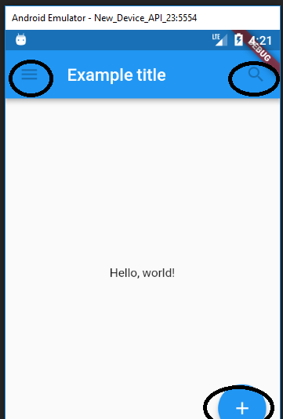

import 'package:flutter/material.dart';
void main() {
runApp(new MaterialApp(
title: 'Flutter Tutorial',
home: new TutorialHome(),
));
}
class TutorialHome extends StatelessWidget {
@override
Widget build(BuildContext context) {
// Scaffold is a layout for the major Material Components.
return new Scaffold(
appBar: new AppBar(
elevation:0.0,
leading: new IconButton( //primer circulo
icon: new Icon(Icons.menu),
tooltip: 'Navigation menu',
onPressed: null,
),
title: new Text('Example title'), //el título
actions: <Widget>[
new IconButton(
icon: new Icon(Icons.search),
tooltip: 'Search',
onPressed: null,
),
],
),
// body is the majority of the screen.
body: new Center(
child: new Text('Hello, world!'), //el texto centrado
),
floatingActionButton: new FloatingActionButton( //el botón flotante
tooltip: 'Add', // used by assistive technologies
child: new Icon(Icons.add),
onPressed: null,
),
);
}
}

SCAFF_BOTON_APPBAR
(bottomNavigationBar)
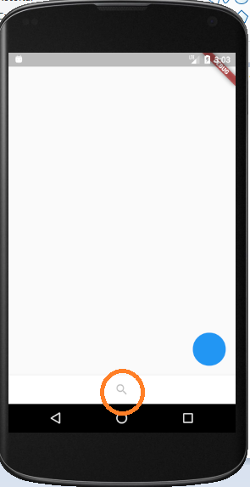

class Scaff03 extends StatelessWidget {
@override
Widget build(BuildContext context) {
return new Scaffold(
bottomNavigationBar: new BottomAppBar(
color: Colors.white,
child: bottomAppBarContents(),
),
floatingActionButton: new FloatingActionButton(onPressed: null),
);
}
}
Widget bottomAppBarContents(){
return new IconButton(
icon: new Icon(Icons.search),
tooltip: 'Búsqueda',
onPressed: null,
);
}

SCAFF_PRUEBA_DRAWER
(drawer)

class PruebaDrawer extends StatelessWidget {
final appTitle = 'Drawer Demo';
@override
Widget build(BuildContext context) {
return new MaterialApp(
title: appTitle,
home: new MyHomePage(title: appTitle),
);
}
}
class MyHomePage extends StatelessWidget {
final String title;
MyHomePage({Key key, this.title}) : super(key: key);
@override
Widget build(BuildContext context) {
return new Scaffold(
appBar: new AppBar(title: new Text(title)),
body: new Center(child: new Text('My Page!')),
drawer: new Drawer(
// Add a ListView to the drawer. This ensures the user can scroll
// through the options in the Drawer if there isn't enough vertical
// space to fit everything.
child: new ListView(
// Important: Remove any padding from the ListView.
padding: EdgeInsets.zero,
children: <Widget>[
new DrawerHeader(
child: new Text('Drawer Header'),
decoration: new BoxDecoration(
color: Colors.blue,
),
),
new ListTile(
title: new Text('Item 1'),
onTap: () {
// Update the state of the app
// ...
// Then close the drawer
Navigator.pop(context);
},
),
new ListTile(
title: new Text('Item 2'),
onTap: () {
// Update the state of the app
// ...
// Then close the drawer
Navigator.pop(context);
},
),
],
),
),
);
}
}

https://cogitas.net/show-snackbar-flutter/

SCAFF_SNACKBARDEMO
(Scaffold.of(context).showSnackBar(snackBar))
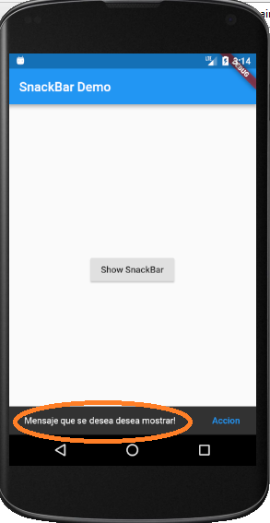
class SnackBarDemo extends StatelessWidget {
@override
Widget build(BuildContext context) {
return new MaterialApp(
title: 'SnackBar Demo',
home: new Scaffold(
appBar: new AppBar(
title: new Text('SnackBar Demo'),
),
body: new SnackBarPage(),
),
);
}
}
class SnackBarPage extends StatelessWidget {
@override
Widget build(BuildContext context) {
return new Center(
child: new RaisedButton(
onPressed: () {
final snackBar = new SnackBar(
content: new Text('Mensaje que se desea mostrar!'),
action: new SnackBarAction(
label: 'Accion',
onPressed: () {
// Some code to undo the change!
},
),
);
// Find the Scaffold in the Widget tree and use it to show a SnackBar!
Scaffold.of(context).showSnackBar(snackBar);
},
child: new Text('Show SnackBar'),
),
);}}

SCAFF_SNACKBARDEMO2
(Scaffold.of(context).showSnackBar)
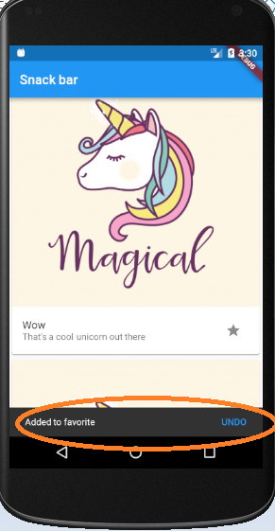
class SnackBarDemo2 extends StatelessWidget {
@override
Widget build(BuildContext context) {
return new MaterialApp(
title: 'SnackBar Demo',
home: new Scaffold(
appBar: new AppBar(
title: new Text("Snack bar"),
),
body: new ListView.builder(
itemCount: 42,
itemBuilder: (context, index) {
return new Card(
child: new Column(
children: <Widget>[
new Image.network(
"https://image.freepik.com/free-vector/unicorn-background-design_1324-79.jpg"),
new ListTile(
title: new Text("Wow"),
subtitle: new Text("That's a cool unicorn out there"),
trailing: new IconButton(
icon: const Icon(Icons.star),
onPressed: () {
Scaffold.of(context).showSnackBar(
new SnackBar(
content: new Text("Added to favorite"),
action: new SnackBarAction(
label: "UNDO",
onPressed: () =>
Scaffold.of(context).hideCurrentSnackBar(),
),
),
);
},
),
)
],
),
);
},
),
),
);
}
}

