Tab

Android Estudio V3.0.17/Flutter

Objetivo:

F.Creación: 20-6-2018

Programa: C:\misTextos\tutoriales-Flutter\3 MichaelSowah\6 tab
C:\misTextos\tutoriales-Flutter\3 MichaelSowah\7 use tab navegacion bar

Fuente: CookBook

Max
max82574971@gmail.com

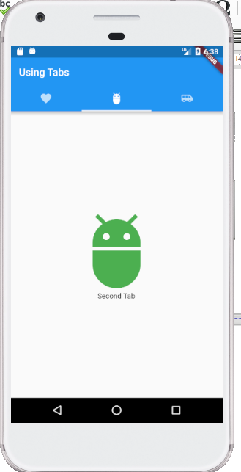

class MyTabs extends StatefulWidget {
@override
_MyTabsState createState() => new _MyTabsState();
}
class _MyTabsState extends State<MyTabs> with SingleTickerProviderStateMixin {
TabController controller;
@override
void initState() {
// TODO: implement initState
super.initState();
controller = new TabController(length: 3, vsync: this);
}
@override
Widget build(BuildContext context) {
return new Scaffold(
appBar: new AppBar(
title: new Text("Video Tabs"),
backgroundColor: Colors.redAccent,
bottom: new TabBar(
tabs: <Widget>[
new Tab(
icon: new Icon(Icons.home),
),
new Tab(
icon: new Icon(Icons.ondemand_video),
),
new Tab(
icon: new Icon(Icons.contacts),
)
],
controller: controller,
),
),
body: new TabBarView(
children: <Widget>[
new Home(), new Video(), new Contact()
],
controller: controller
)
);
}
}

Hi All,

Please help me, how to disable color on TabBar (Indicator)

Thanks and regards
Edi Kurniawan
Rta

 | 9 oct. 2018 11:43 (Hace 2 días.)
  'MH Johnson' via Flutter Dev
  para Flutter

Hi,

In general, the TabIndicator is considered part of the TabBar according to material.io.
However, if you want to get rid of the indicator, you can accomplish this by passing in a custom indicator decoration with no border.

Something like this:
TabBar(
tabs: _tabs,
controller: tabController,
indicator: UnderlineTabIndicator(borderSide: BorderSide(style: BorderStyle.none))
)

