E-Commerce Customer Analysis
Olist Brazilian Marketplace | 2016 – 2018

Prepared by Subha Sarkar
Data Analyst | Kolkata, India
GitHub: maxassasine/ecommerce-customer-analysis
Python / Pandas | SQL / SQLite | Matplotlib / Seaborn | Plotly

1. Executive Summary
This report presents a comprehensive customer behaviour analysis of the Olist Brazilian e-commerce marketplace using transactional data from October 2016 to July 2018. The analysis covers 99,441 customers across 27 Brazilian states, with a total platform revenue of R$ 16.0M.

The central and most critical finding is a 0% repeat purchase rate — every customer made exactly one purchase. This structural retention gap, combined with strong acquisition growth and consistently early deliveries, forms the core narrative of this report.

99,441  Total Customers | R$ 16.0M  Total Revenue
R$ 165.88  Avg Customer CLV | 0%  Repeat Purchase Rate
11.8 days  Avg Actual Delivery | 93.5%  Orders Delivered Early

2. Dataset & Methodology

2.1 Data Sources
Table | Rows | Key Columns
orders | 99,441 | order_id, customer_id, timestamps, status
order_items | 112,650 | order_id, product_id, price, freight_value
customers | 99,441 | customer_id, customer_state
products | 32,951 | product_id, category_name

2.2 Analytical Approach
Six SQL queries were written against an in-memory SQLite database. Python (pandas) handled scoring, segmentation, and visualisation. Charts produced in Matplotlib/Seaborn (static PNG) and Plotly (interactive HTML).

- Customer Lifetime Value (CLV) segmentation — quantile-based thresholds
- Average Order Value (AOV) by product category
- Repeat purchase rate analysis
- Geographic revenue distribution across 27 states
- RFM (Recency, Frequency, Monetary) scoring with methodological notes
- Monthly revenue trend — seasonality and growth identification
- Delivery performance: actual vs estimated days

2.3 Data Cleaning
- Nulls removed from orders and products (orders: 99,441 → 96,461 clean rows)
- Delivery outliers filtered: actual and estimated days capped at 1–60 range
- Incomplete months excluded: Dec 2016 (1 order) and Jul 2018 (partial month)

3. Key Findings

3.1 Critical Finding — Zero Repeat Customers
⚠️ 100% One-Time Buyers
Every one of the 99,441 customers made exactly one purchase. All revenue is driven purely by new acquisition — no retention is occurring. This is the most significant business risk identified in this analysis.

- Every revenue rupee requires a new customer — CAC is permanently elevated
- Post-purchase re-engagement channels are likely absent or ineffective
- Delivery performance alone (93.5% early) has not driven any repeat behaviour

3.2 Revenue Growth — 24x in 13 Months
Monthly revenue grew from R$ 40,941 in October 2016 to R$ 987,648 in November 2017 — a 24x increase in 13 months — before stabilising at ~R$ 893K/month through mid-2018.

Period | Phase | Avg Monthly Revenue
Oct 2016 – Oct 2017 | Rapid Growth | R$ 387,000
Nov 2017 | Peak (Black Friday) | R$ 987,648
Dec 2017 – Jun 2018 | Mature Plateau | R$ 893,000

3.3 Customer Lifetime Value Segmentation
Customers were split into three equal tiers by total spending. The distribution is remarkably uniform — roughly one-third in each segment — indicating no dominant spending cohort.

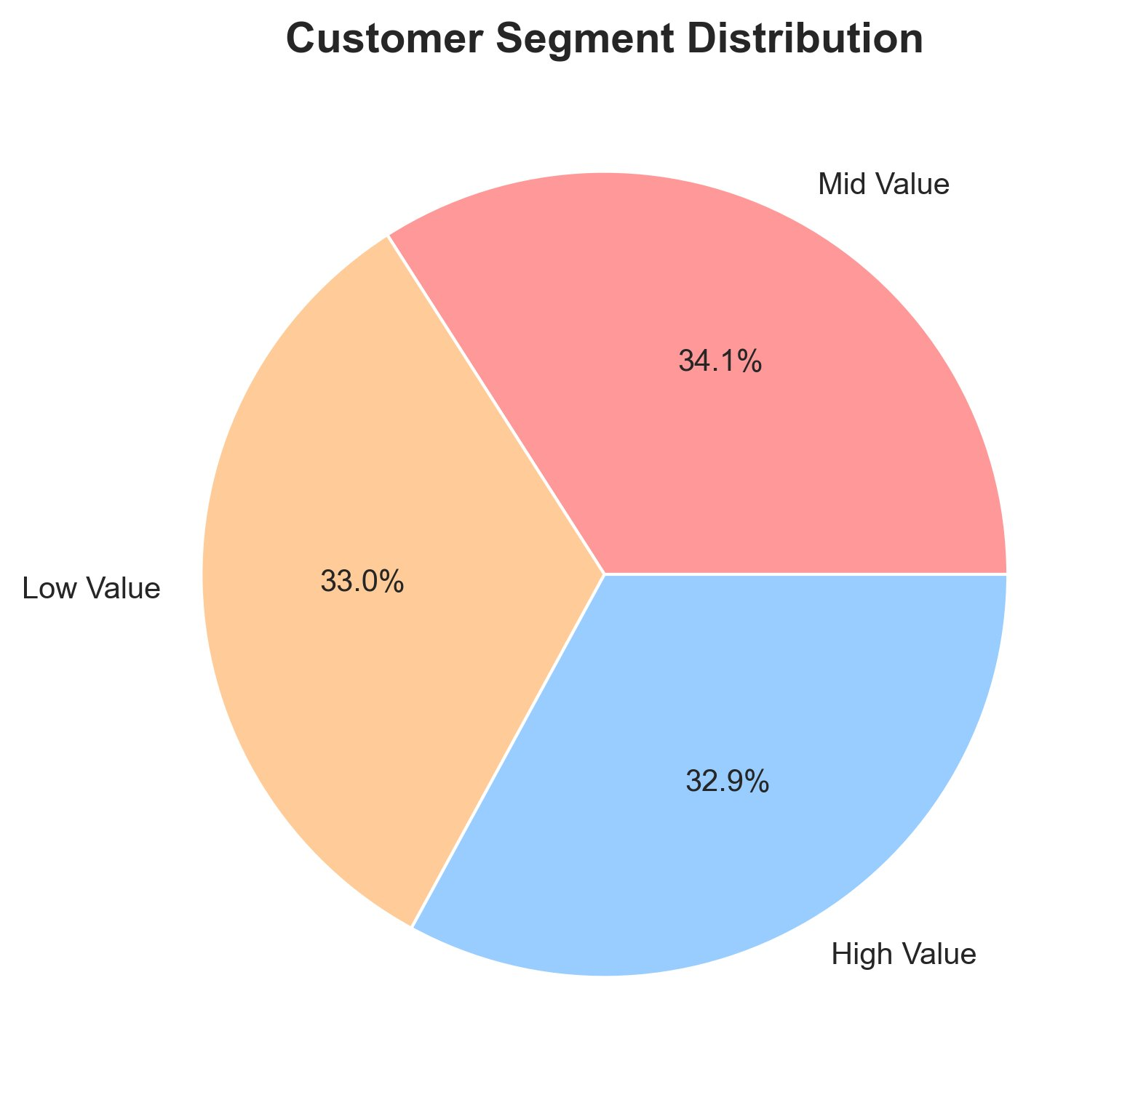
Figure 1 — Customer Segment Distribution (CLV-based)
Segment | Customers | Share | Avg Spend | Strategy
High Value | ~32,000 | 32.9% | R$ 300+ | VIP — retain and reward
Mid Value | ~32,900 | 34.1% | R$ 100–300 | Upsell — loyalty rewards
Low Value | ~31,800 | 33.0% | < R$ 100 | Activate — trial offers

3.4 Top Product Categories by Revenue
Health & Beauty and Watches & Gifts are the two highest-revenue categories, each exceeding R$ 1.2M. The top 5 categories together account for approximately 55% of total platform revenue.

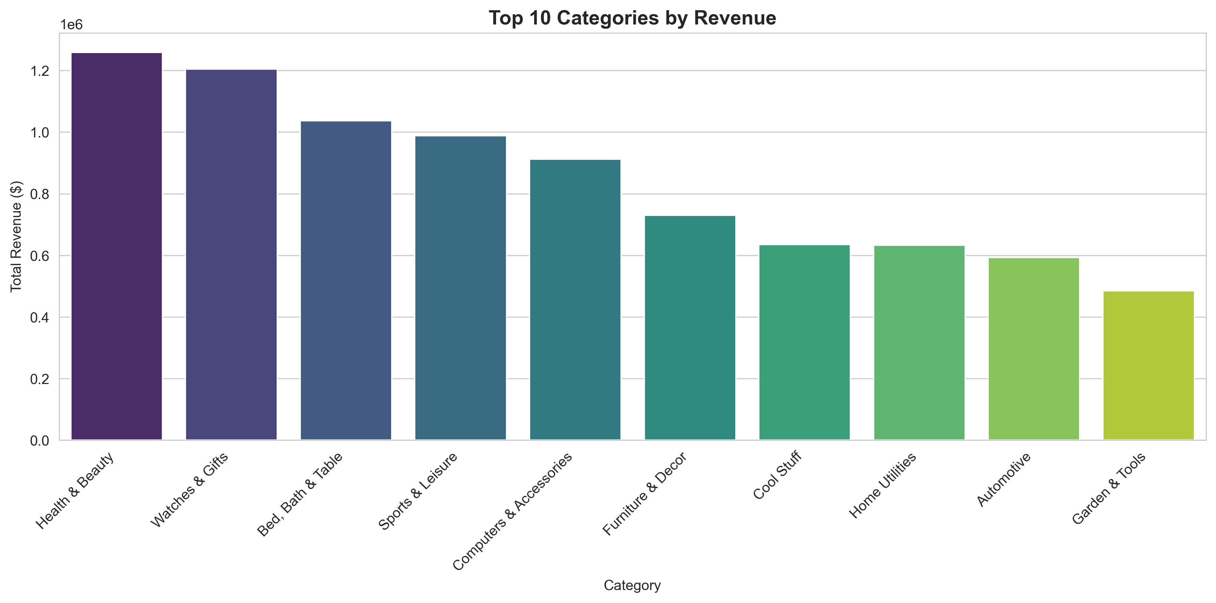
Figure 2 — Top 10 Product Categories by Total Revenue
💡 Cross-sell Opportunity
Health & Beauty and Watches & Gifts are complementary high-revenue categories. Customers buying in one are strong targets for promotions in the other — a natural cross-sell pairing.

3.5 Geographic Distribution
Revenue is heavily concentrated in Brazil's South and Southeast. São Paulo alone generates over R$ 5M — more than the next six states combined. The North and Northeast remain significantly underserved.

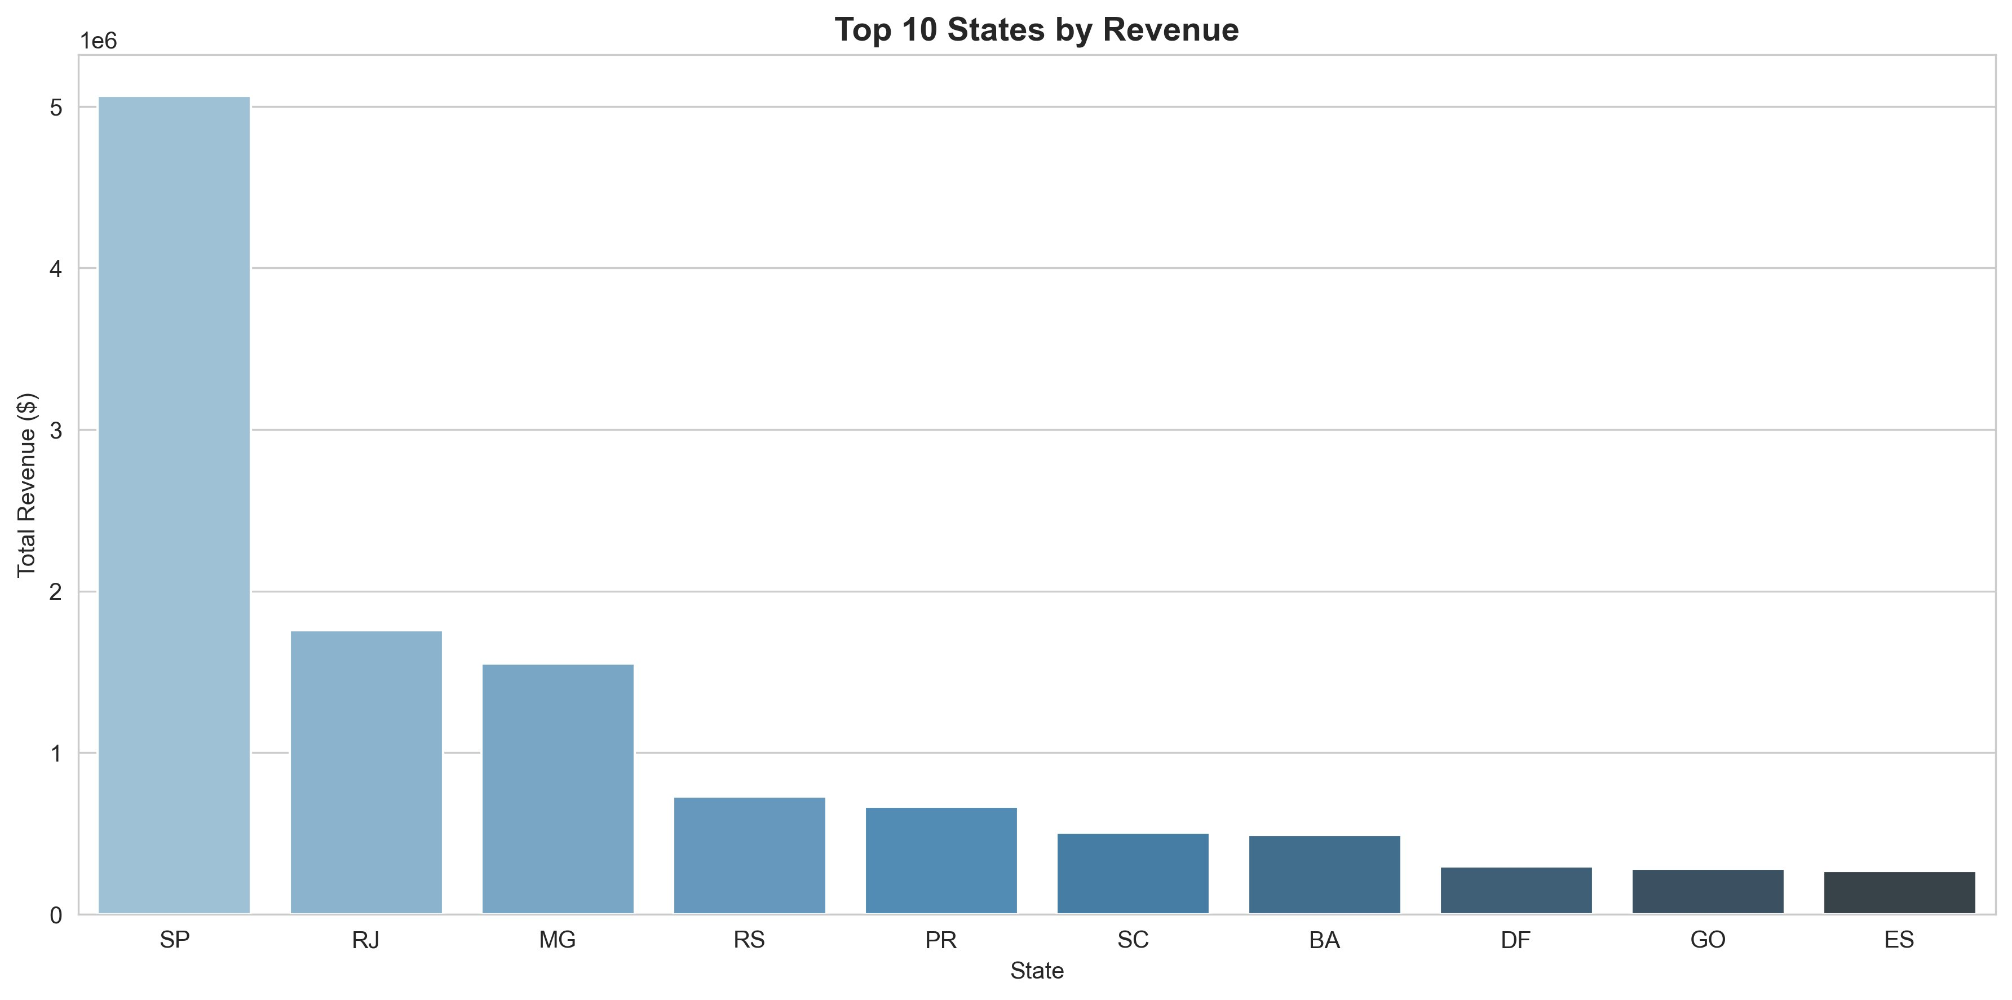
Figure 3 — Top 10 States by Total Revenue
State | Region | Revenue | Opportunity
SP — São Paulo | Southeast | R$ 5.0M+ | Dominant — consolidate
RJ — Rio de Janeiro | Southeast | R$ 1.75M | Strong — grow share
MG — Minas Gerais | Southeast | R$ 1.55M | Strong — grow share
RS — Rio Grande do Sul | South | R$ 0.72M | Mid — target campaigns
North & Northeast states | N / NE | < R$ 0.3M each | Underserved — expand

3.6 Delivery Performance
✅ Under-promise, Over-deliver — But Retention Is Still 0%
Olist estimates 23.3 days on average but delivers in 11.8 days — 11.5 days ahead of schedule. Despite 93.5% of orders arriving early, no repeat purchases occur. Delivery speed alone does not drive retention.

Metric | Value
Average actual delivery | 11.8 days
Average estimated delivery | 23.3 days
Days ahead of estimate | 11.5 days (avg)
Orders on time or early | 89,707 (93.5%)
Orders delivered late | 6,249 (6.5%)
Sample (after cleaning) | 95,956 orders

3.7 RFM Analysis — Methodology Note
RFM scoring was applied to all 96,461 customers. However, because every customer purchased exactly once, the Frequency dimension has zero variance — every customer scores identically on F. As a result, only two of five RFM segments are populated (Potential and Loyal), driven entirely by Recency and Monetary values.

📝 Analytical Limitation — Documented
RFM is retained for methodological completeness. On a single-purchase dataset, Recency + Monetary (RM scoring) is more appropriate. This limitation is flagged as a future improvement in the technical appendix.

4. Business Recommendations

4.1 Implement Post-Purchase Retention Programme — Priority: HIGH
Estimated impact: +15–20% revenue without additional acquisition spend.

- Deploy email sequence at Day 3, 7, 14, and 30 post-purchase
- Introduce points-based loyalty programme to incentivise second purchases
- Target: convert 15% of one-time buyers to repeat customers within 6 months
- Personalise re-engagement with category-matched product recommendations

4.2 Geographic Expansion — North & Northeast — Priority: MEDIUM
Estimated impact: +10–15% new customer base.

- Current revenue concentrated in SP, RJ, MG — North & Northeast underserved
- Pilot digital campaigns in Bahia, Ceará, and Pernambuco
- Partner with regional logistics providers to maintain delivery parity

4.3 Category Cross-Sell Strategy — Priority: MEDIUM
Estimated impact: +8–12% average order value.

- Health & Beauty buyers → target with Watches & Gifts promotions
- Bundle high-margin complementary categories for AOV lift
- Seasonal promotions aligned with Black Friday (Nov) peak demand

4.4 Segment-Based Personalisation — Priority: MEDIUM
Estimated impact: +10% engagement rate.

- High-Value (32.9%): VIP access, free shipping, exclusive product launches
- Mid-Value (34.1%): Loyalty rewards, category discount vouchers
- Low-Value (33.0%): First-repurchase discounts, trial offers, category exploration

5. Technical Appendix

5.1 Tech Stack
Tool | Purpose
Python 3.x / Pandas / NumPy | Data loading, cleaning, transformation, scoring
SQLite (in-memory) | SQL query execution via sqlite3
Matplotlib / Seaborn | Static visualisations — saved as PNG
Plotly | Interactive HTML charts for portfolio
Jupyter Notebook | Analysis environment and documentation
GitHub | Version control and portfolio hosting

5.2 SQL Queries Written
- Query 1: Customer Lifetime Value — JOIN across customers, orders, order_items
- Query 2: AOV by Category — JOIN across products and order_items
- Query 3: Repeat Purchase Rate — nested subquery with customer-level order counts
- Query 4: Geographic Distribution — state-level aggregation
- Query 5: Monthly Revenue Trend — STRFTIME date grouping
- Query 6: Delivery Analysis — JULIANDAY arithmetic for actual vs estimated
- Query 7 (RFM): CTE-based Recency/Frequency/Monetary with JULIANDAY

5.3 Known Limitations
- RFM Frequency = 1 for all customers — no variance; RM scoring more appropriate
- Dataset ends mid-2018; subsequent purchases would not be captured
- Geographic analysis uses customer state, not delivery state
- Some product categories excluded after null cleaning

5.4 Repository
github.com/maxassasine/ecommerce-customer-analysis

Includes: Jupyter notebook, README with business recommendations, static PNG charts, and interactive Plotly HTML charts.

End of Report

