Max Boyington
CIS4930 Data Visualization

Assignment 1
https://github.com/maxb6299/cis4930-assignment-01

Setup and Data Collection
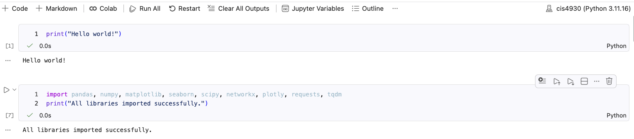
Downloaded 26603 works in data collection stage:
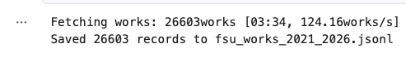
Ran into issues with the “select” param of the API, but once formatted correctly it worked smoothly.

Data Cleaning
The attributes I kept were: id, doi, title, publication year/date, type, venue, citations, authors, primary and all fields. I figured this was more than needed for the following visualizations but it comes at a very low computational and storage cost, so I figured there was little harm in keeping it.
Works with missing concepts, venues, or publication dates simply had an empty cell in the .csv. I figured that although this is important data, it was not absolutely necessary for later visualizations.

Statistics and Charts
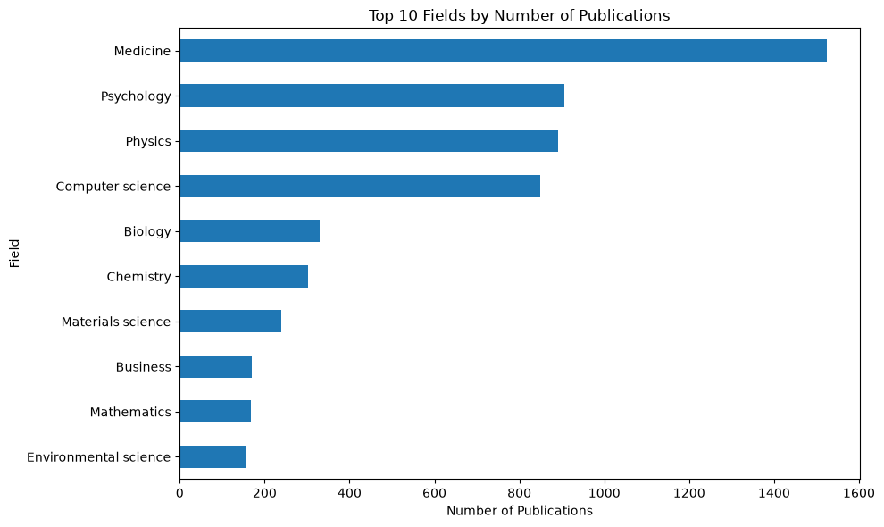
Chart 1 shows FSU's research output is primarily medicine and psychology, however, it hides interdisciplinary papers that involved multiple fields.
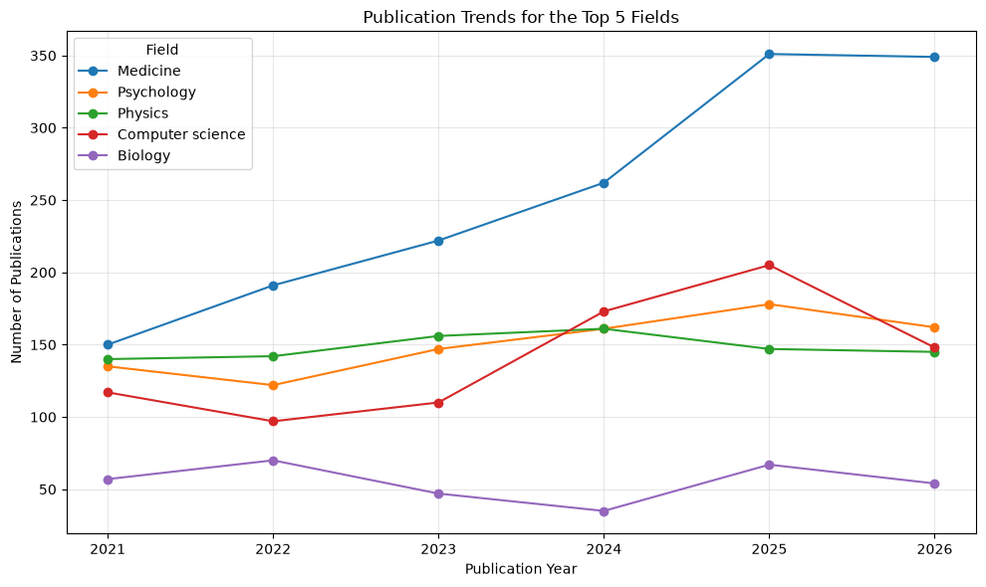
Chart 2 shows FSU's top 5 fields have remained stable or expanded since 2021. However, it hides that the slight decline in 2026 might be that the year is not over yet.
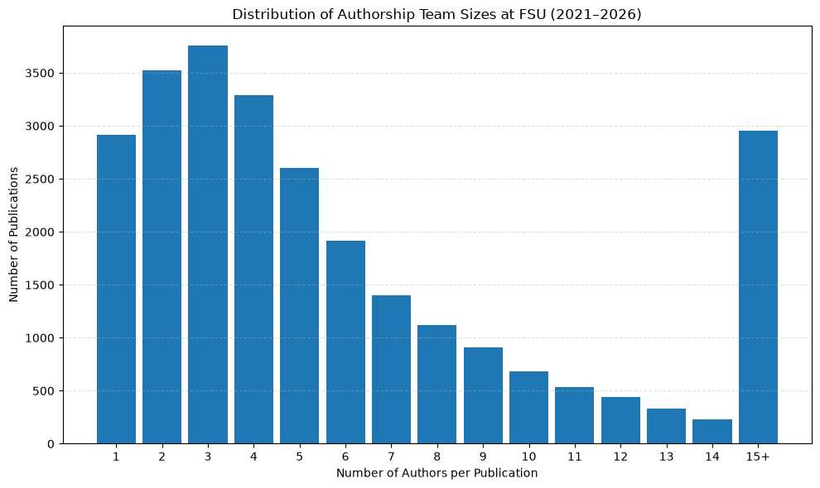

Chart 3 shows that most publications have around 3 authors, however, it hides that maybe this varies a lot between fields.

Citation Network
I picked a sample size 5000, as this was recommended with in the project instructions. It seemed to provide a satisfactory number of connections, but I opted not to do more as it would have taken a long time to download. This was sampled using a random sample of the fsu_works csv. This was unseeded.
The result was
From the graphs below, I can explore the connections between papers. However, a key limitation is I cannot observe the connections outside of FSU.
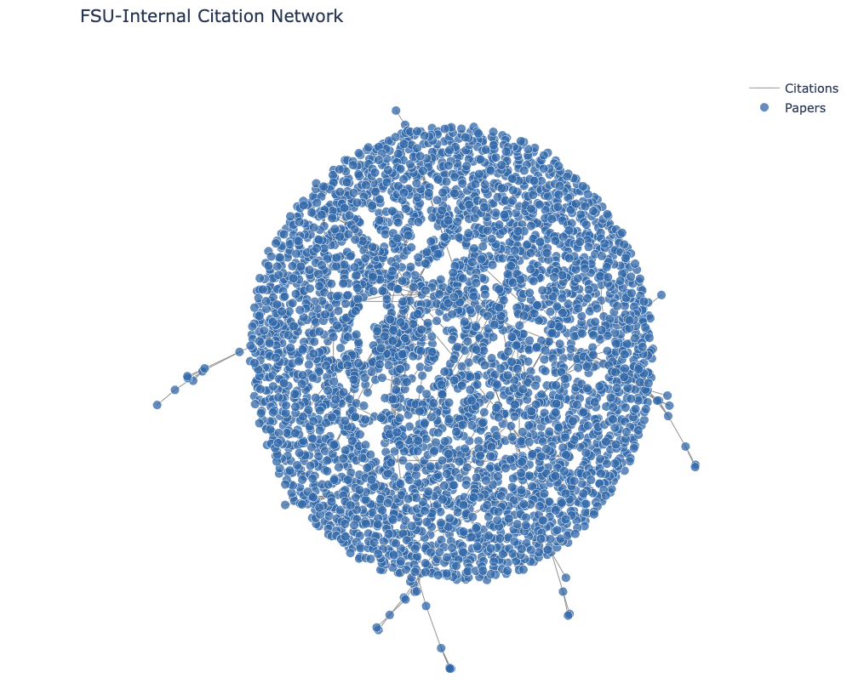
The network drawn with NetworkX positions and Plotly traces
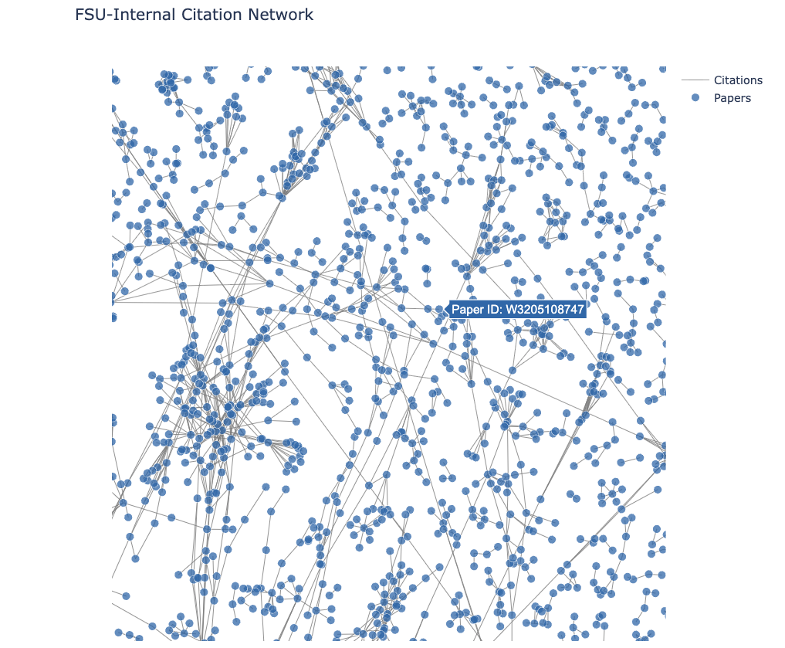
The network after zooming into a region

Interactive D3 Visualization
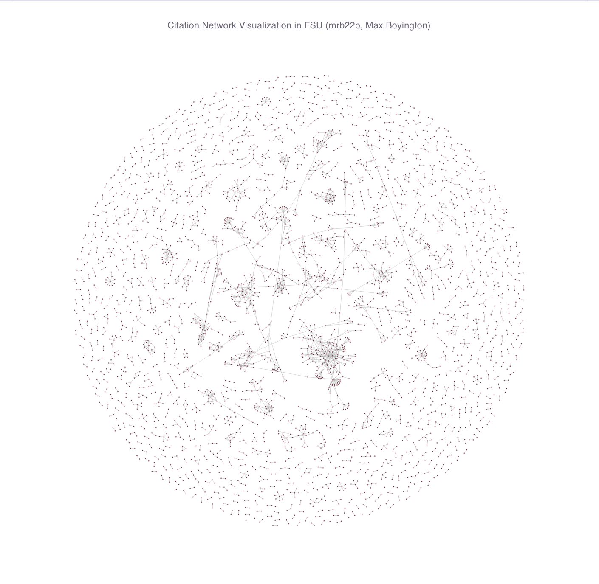
Image of the graph
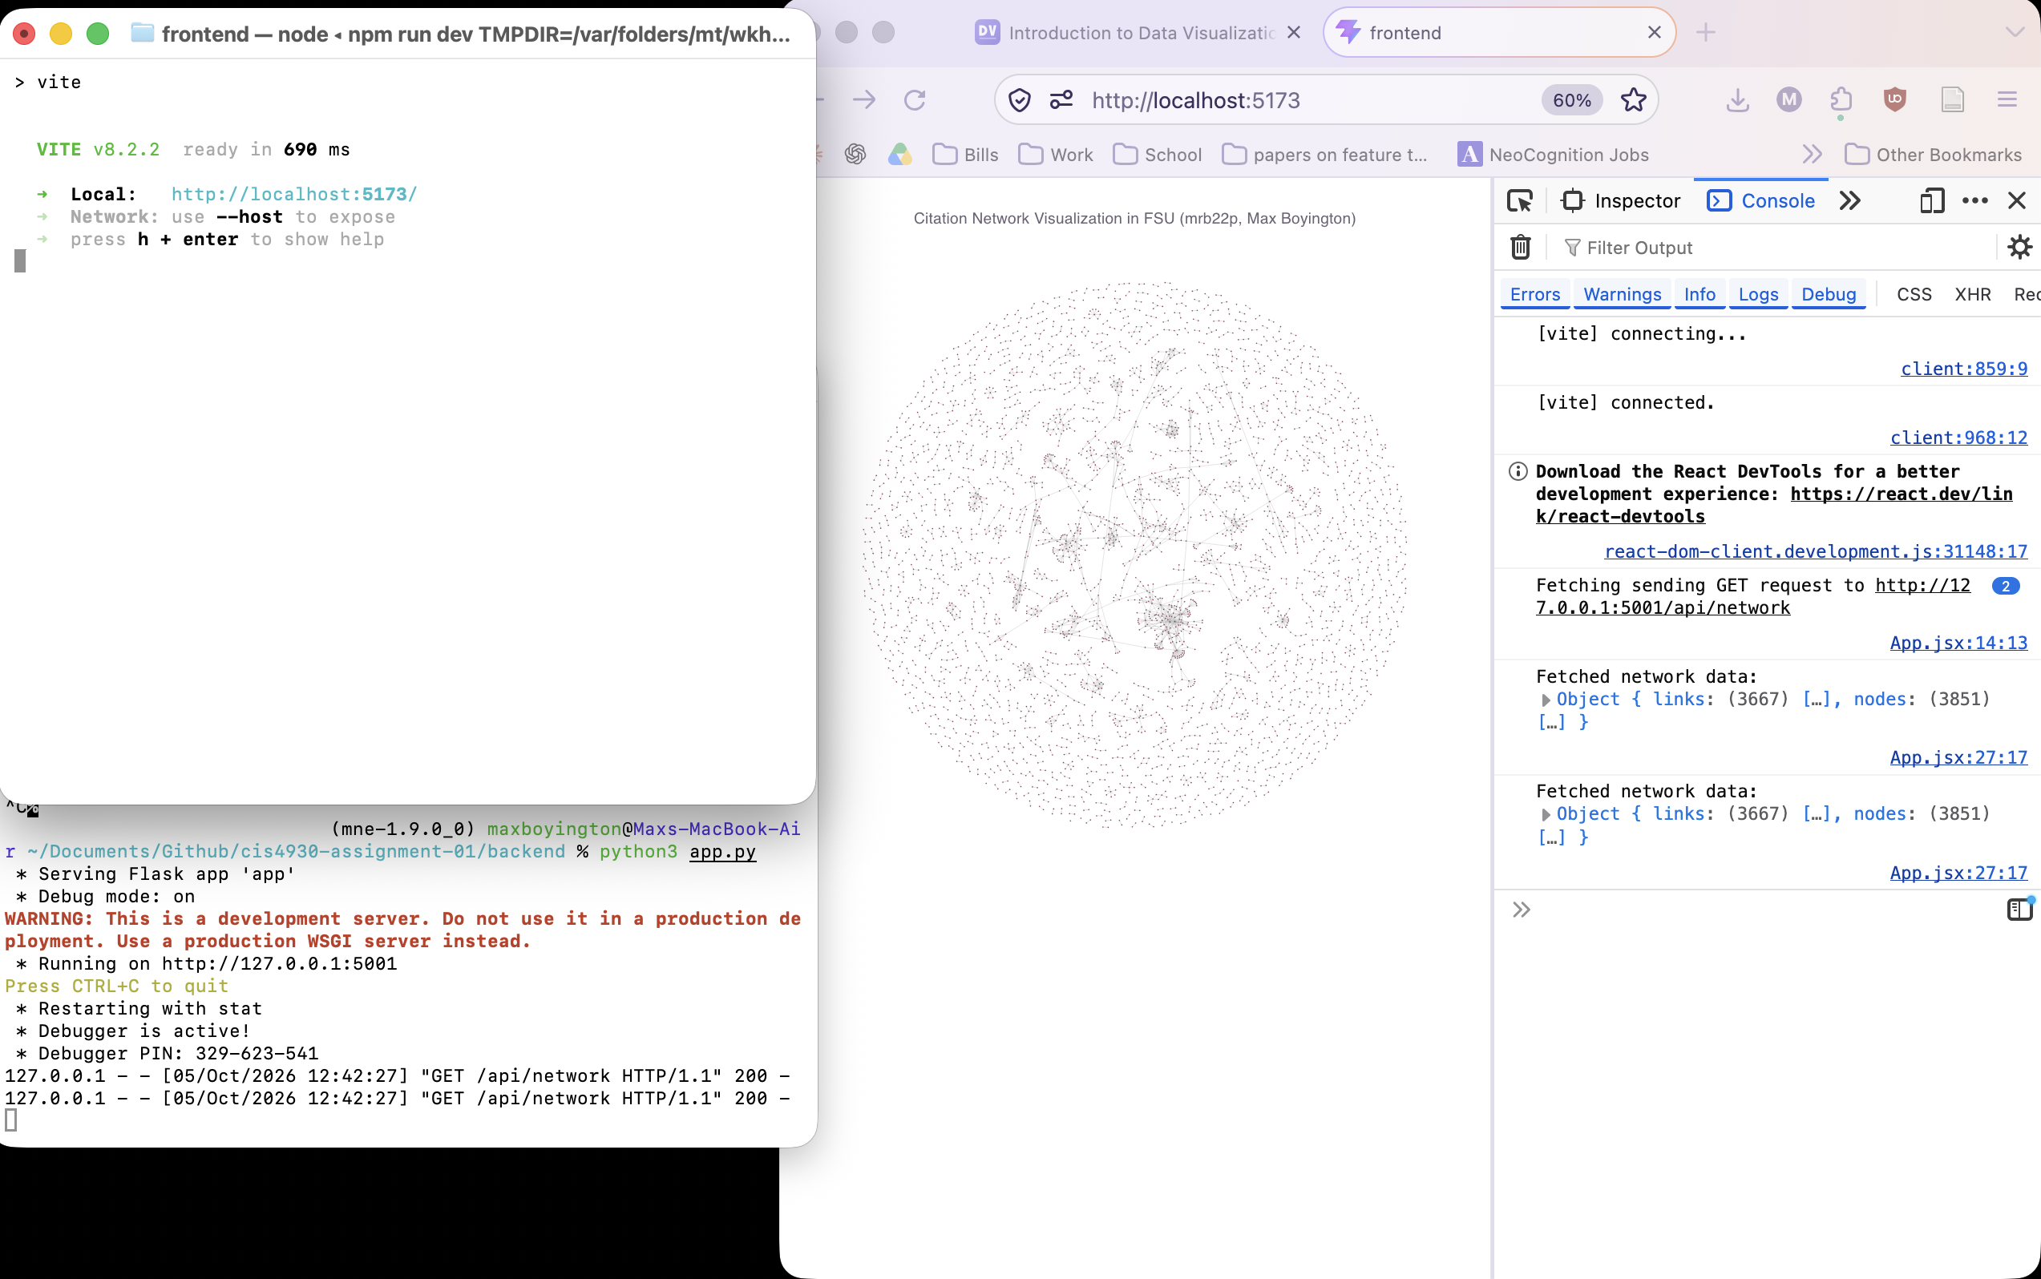
Demonstration that the frontend and backend communicate

Network Analysis
Q1: How large is the citation network?
Total Unique Papers (Nodes): 3,851
Total Unique Directed Citation Links (Edges): 3,667

Q2: What are the 10 most cited papers?
Top 10 Most Cited Papers by OpenAlex Global Citations:
Title | Year | Venue | Citation Count
Review of Particle Physics | 2022 | Progress of Theoretical and Experimental Physics | 6344
Review of Particle Physics | 2024 | Physical review. D/Physical review. D. | 3544
AmberTools | 2023 | Journal of Chemical Information and Modeling | 2145
Fly Cell Atlas: A single-nucleus transcriptomi... | 2022 | Science | 899
Increases in depression and anxiety symptoms i... | 2021 | Psychological Medicine | 787
Polygenic prediction of educational attainment... | 2022 | Nature Genetics | 715
Engagement in language learning: A systematic ... | 2021 | Language Teaching Research | 658
A somato-cognitive action network alternates w... | 2023 | Nature | 649
Ultrahard magnetism from mixed-valence dilanth... | 2022 | Science | 614
Mesenchymal Stem Cell-Derived Exosomes: Applic... | 2021 | Cells | 613

