Lesson 1

The goal of the first lesson is to Create a Simple Signal Generator.
A Signal Generator is a Device that can produce Signals with diffrent Wave Forms. A Common Wave Form is a Sine Wave that looks like this:
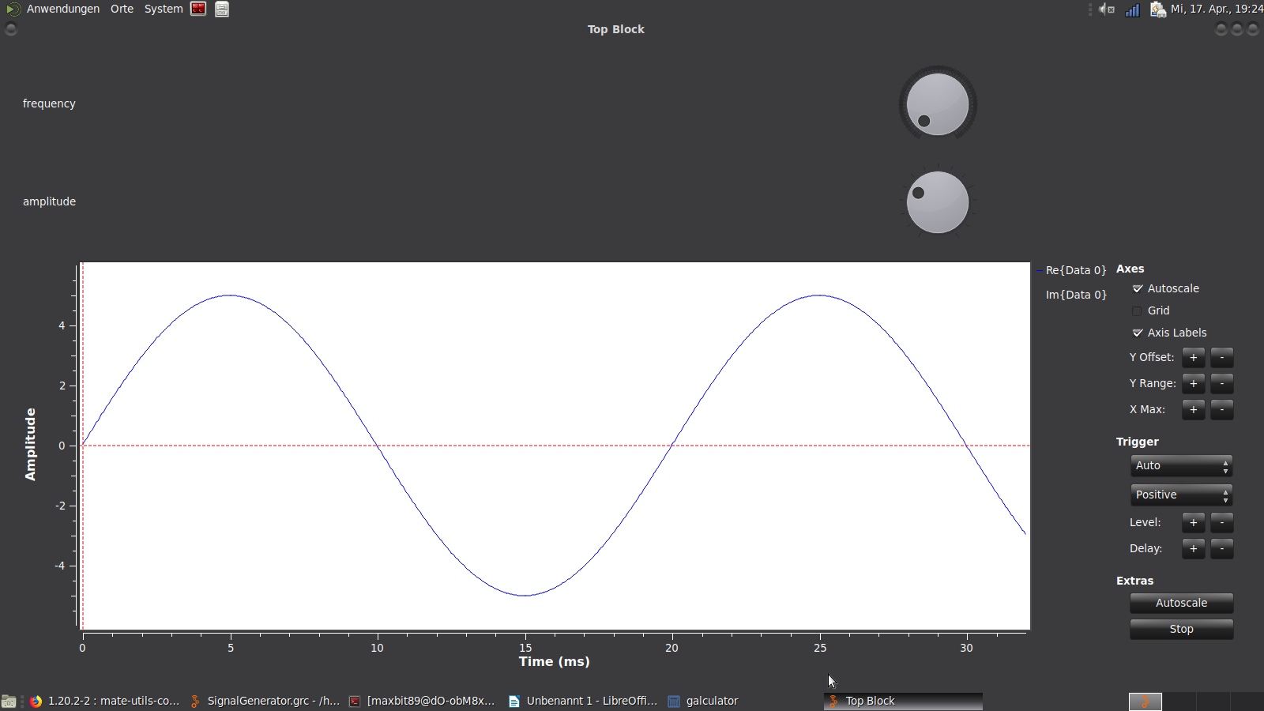

Preconditions

You should already have GnuRadio Installed.

Step 1: Create a new Flow Graph
You shuld start Gnu Radio and Create a new Flow Graph:
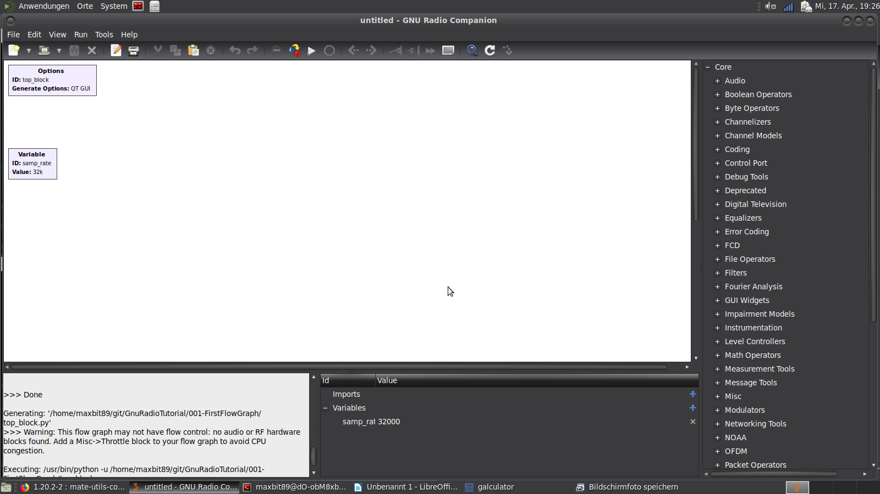
 | Make sure in the Generate Options is set to QT GUI. If this is not available you should update Gnu Radio.

Step 2: Add Knobs
Now we need to add two knobs. The Component we need to add to the FlowGraph is Called: „QT GUI Range“. To add a Component click on the loop Symbol:
After that there should be a Textfield where you can search for Components:
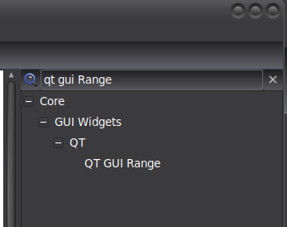

Now you can Add 2 of the Components by simply Drag and Drop the component from the List into the FlowGraph.
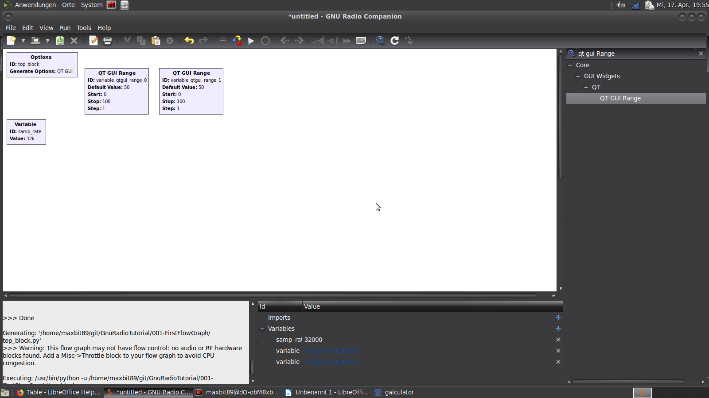
Flow Graph

Component List
We can now execute our FlowGraph by pressing the play Button:
After Saving the Project you should see a Window like that:
