Question 2:
Run the script named Black_Max_Q2.m
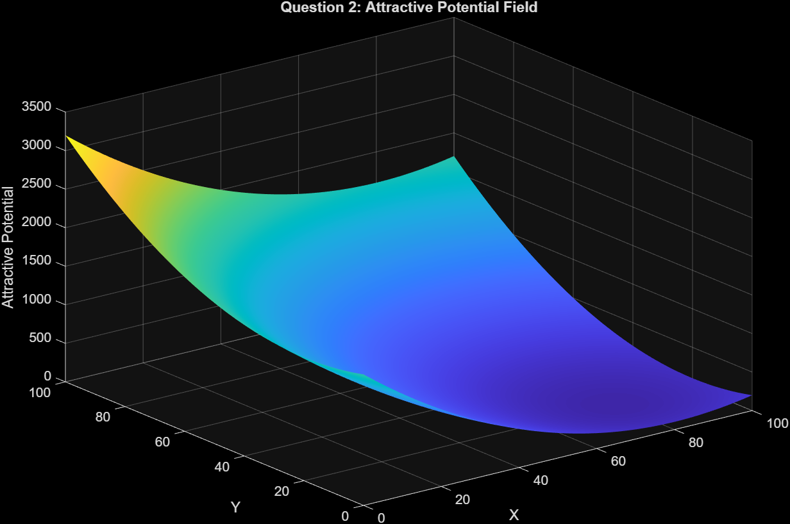
Question 3:
Run the script named Black_Max_Q3.m
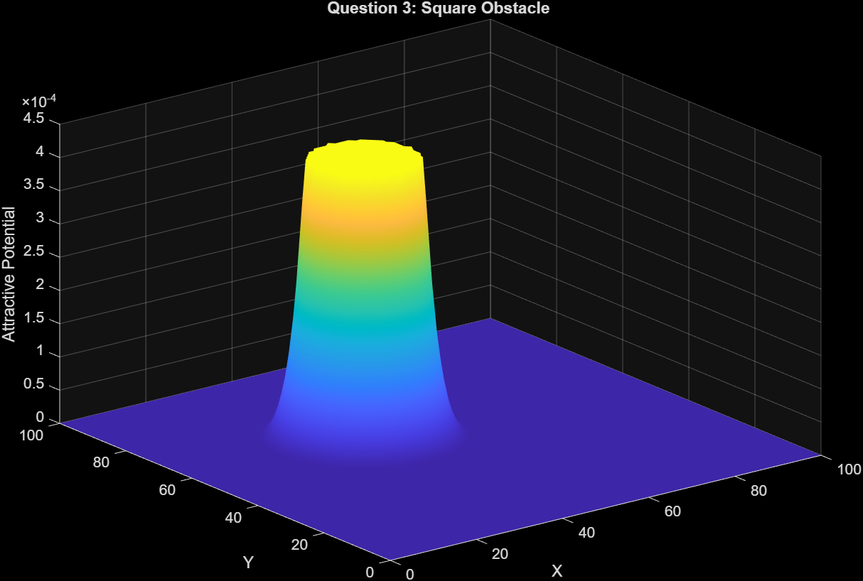
Question 4:
Run the script named Black_Max_Q4.m
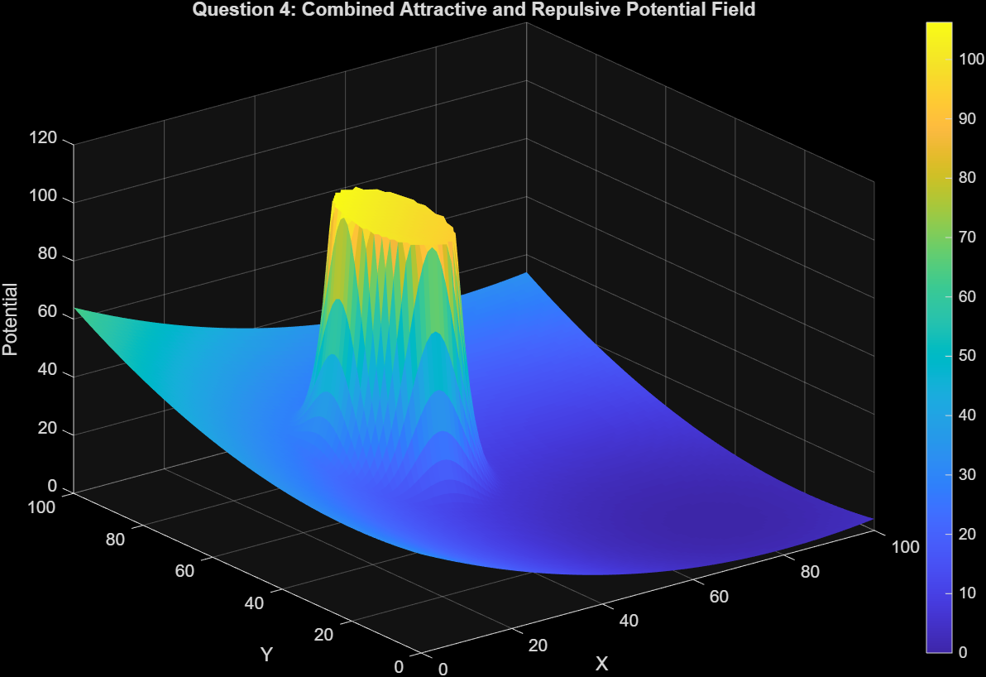
Questions 5 and 6:
Run the scripts Black_Max_Q5.m and Black_Max_Q6.m .
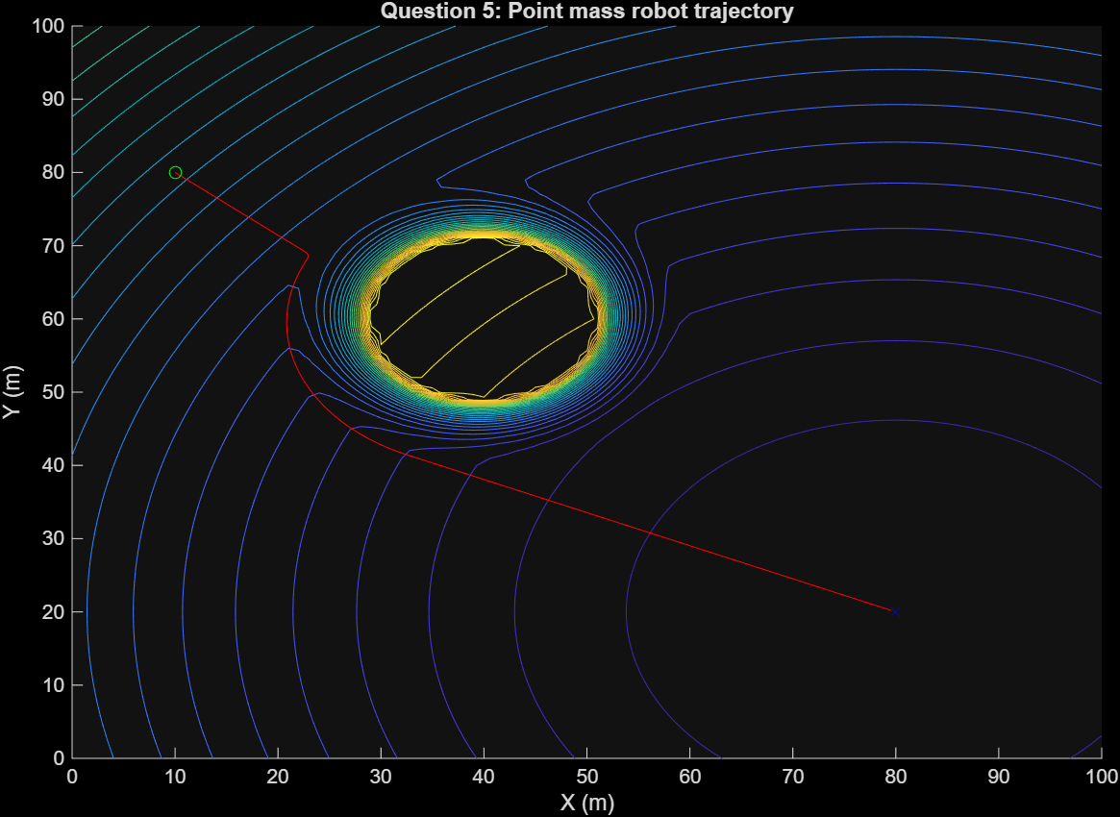
I couldn’t attach either of the visualizations that were made from these files, however, the videos can be found in the zip file of the homework.

