- Sample run of genData and first 800 bits
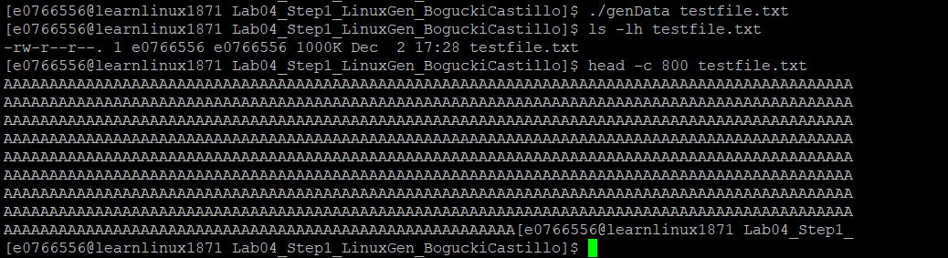
- Sample execution of mycopy
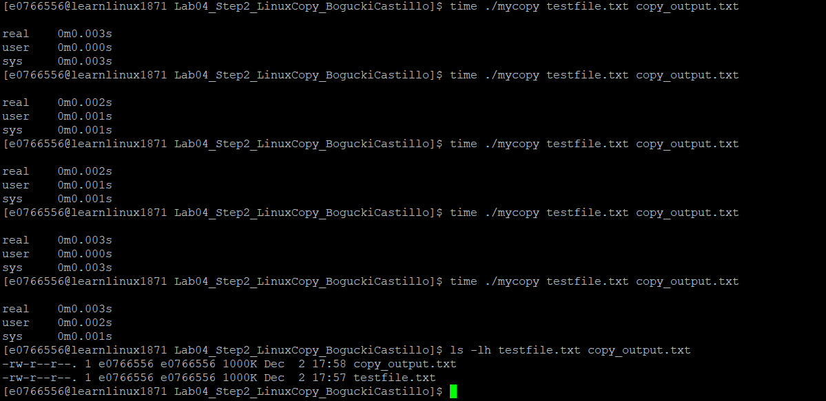
3,4,5. Sample screenshots of sample execution with a call to each command (my copy, mymove, and myremove)
