- Program hello2.c and hello4.c
  - Program hello2.c
    - ./hello2.c file
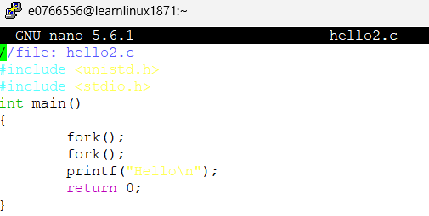
    - Running ./hello2
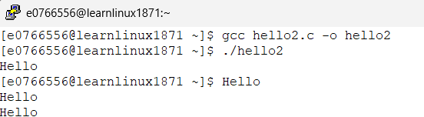
    - [e0766556@learnlinux1871 ~]$ ./hello2 >results2
[e0766556@learnlinux1871 ~]$ cat results2
Hello
Hello
Hello
Hello
    - 4 Hello messages were received and this is because each fork creates a new child process, which in result doubles the amount of processes. In this instance, we first process the first process (parent process). Which then calls the first fork() and creates a child process, leaving us with two total processes now. Now each of those two processes calls the next fork(), which creates two more child processes, leaving us with a total of 4. All 4 processes print Hello and that is how we get 4 Hello messages.
Diagram shown below:
Int main()
{
->fork();
fork();
printf(“Hello\n”);
return 0;
}

Int main()
{
fork();
->fork();
printf(“Hello\n”);
return 0;
}

Int main()
{
fork();
->fork();
printf(“Hello\n”);
return 0;
}

Int main()
{
fork();
fork();
->printf(“Hello\n”);
return 0;
}

Int main()
{
fork();
fork();
->printf(“Hello\n”);
return 0;
}

Int main()
{
fork();
fork();
->printf(“Hello\n”);
return 0;
}

Int main()
{
fork();
fork();
->printf(“Hello\n”);
return 0;
}

  - Programm hello4.c
    - ./hello4.c file
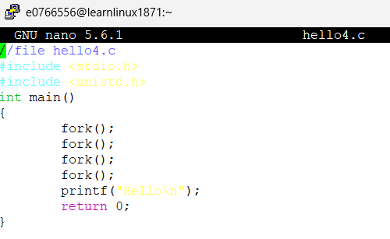
    - Running ./hello4
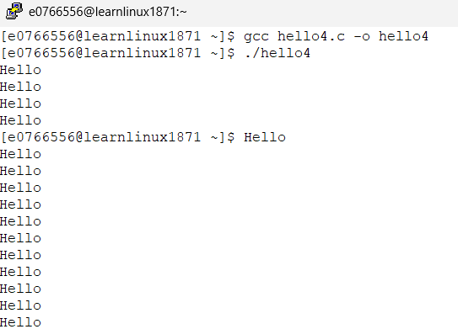
    - [e0766556@learnlinux1871 ~]$ ./hello4 >results4
[e0766556@learnlinux1871 ~]$ cat results4
Hello
Hello
Hello
Hello
Hello
Hello
Hello
Hello
Hello
Hello
Hello
Hello
Hello
Hello
Hello
Hello
    - 16 Hello messages are received and this is because of the same exact reason as mentioned for the hello2.c file, except for the fact we have more hello messages here because we call fork() two more times. As previously said, we start off with our parent process. It calls fork(), creates a child, we now have two total processes. Both those processes now call the next fork(), each create a child, resulting in a total of 4 processes. Now those 4 processes call the next fork(), each creating a new child, resulting in a total of 8 processes. Each of those 8 processes call the last fork(), each creating a new child, resulting in a total of 16 processes. Now lastly, all 16 of these processes print Hello and give us 16 Hello messages.
Diagram shown below (no arrows, were added, but the arrows follow the same idea as our first diagram in part a, just with a greater depth):

Int main()
{
-> fork();
fork();
fork();
fork();
printf(“Hello\n”);
return 0;
}

Int main()
{
fork();
->fork();
fork();
fork();
printf(“Hello\n”);
return 0;
}

Int main()
{
fork();
-> fork();
fork();
fork();
printf(“Hello\n”);
return 0;
}

Int main()
{
fork();
fork();
->fork();
fork();
printf(“Hello\n”);
return 0;
}

Int main()
{
fork();
fork();
->fork();
fork();
printf(“Hello\n”);
return 0;
}

Int main()
{
fork();
fork();
->fork();
fork();
printf(“Hello\n”);
return 0;
}

Int main()
{
fork();
fork();
->fork();
fork();
printf(“Hello\n”);
return 0;
}

Int main()
{
fork();
fork();
fork();
->fork();
printf(“Hello\n”);
return 0;
}

Int main()
{
fork();
fork();
fork();
->fork();
printf(“Hello\n”);
return 0;
}

Int main()
{
fork();
fork();
fork();
->fork();
printf(“Hello\n”);
return 0;
}

Int main()
{
fork();
fork();
fork();
->fork();
printf(“Hello\n”);
return 0;
}

Int main()
{
fork();
fork();
fork();
->fork();
printf(“Hello\n”);
return 0;
}

Int main()
{
fork();
fork();
fork();
->fork();
printf(“Hello\n”);
return 0;
}

Int main()
{
fork();
fork();
fork();
->fork();
printf(“Hello\n”);
return 0;
}

Int main()
{
fork();
fork();
fork();
->fork();
printf(“Hello\n”);
return 0;
}

Int main()
{
fork();
fork();
fork();
fork();
->printf(“Hello\n”);
return 0;
}

Int main()
{
fork();
fork();
fork();
fork();
->printf(“Hello\n”);
return 0;
}

Int main()
{
fork();
fork();
fork();
fork();
->printf(“Hello\n”);
return 0;
}

Int main()
{
fork();
fork();
fork();
fork();
->printf(“Hello\n”);
return 0;
}

Int main()
{
fork();
fork();
fork();
fork();
->printf(“Hello\n”);
return 0;
}

Int main()
{
fork();
fork();
fork();
fork();
->printf(“Hello\n”);
return 0;
}

Int main()
{
fork();
fork();
fork();
fork();
->printf(“Hello\n”);
return 0;
}

Int main()
{
fork();
fork();
fork();
fork();
->printf(“Hello\n”);
return 0;
}

Int main()
{
fork();
fork();
fork();
fork();
->printf(“Hello\n”);
return 0;
}

Int main()
{
fork();
fork();
fork();
fork();
->printf(“Hello\n”);
return 0;
}

Int main()
{
fork();
fork();
fork();
fork();
->printf(“Hello\n”);
return 0;
}

Int main()
{
fork();
fork();
fork();
fork();
->printf(“Hello\n”);
return 0;
}

Int main()
{
fork();
fork();
fork();
fork();
->printf(“Hello\n”);
return 0;
}

Int main()
{
fork();
fork();
fork();
fork();
->printf(“Hello\n”);
return 0;
}

Int main()
{
fork();
fork();
fork();
fork();
->printf(“Hello\n”);
return 0;
}

Int main()
{
fork();
fork();
fork();
fork();
->printf(“Hello\n”);
return 0;
}

  - script2-54
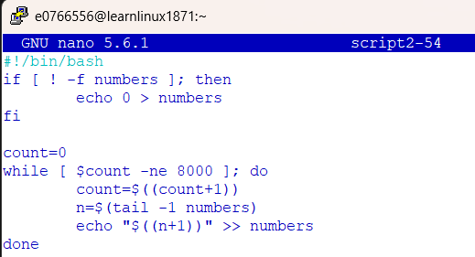
  - run2
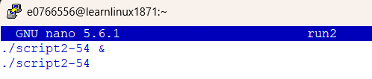
  - Last 10 lines of numbers file
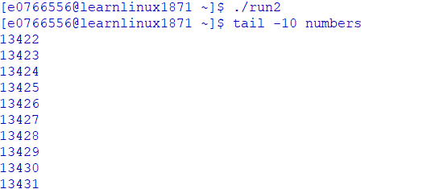
  - There is evidence of a race condition because when we run two instances of the script simultaneously as we did, with each performing 8000 iterations, we would expect the final number in the file to be 16000. But that is not the case as our last number was 13431 as seen above. This is direct evidence of the race condition, and the problem occurs when both processes read the same value from the file before either can write their update. For example, if both the files read 200, they would both calculate 201, which would result in a duplicate entry instead of two sequential numbers. And these collisions happen repeatedly throughout execution which causes the file to have multiple duplicates and not achieve our final goal of 16000 in this case. In the image above where it displays the last 10 numbers, the numbers seem to be in sequential order, but if you look at the last 100 numbers or more, you’ll be able to see an example of the collision.
  - script2-54Fixed and run2Fixed
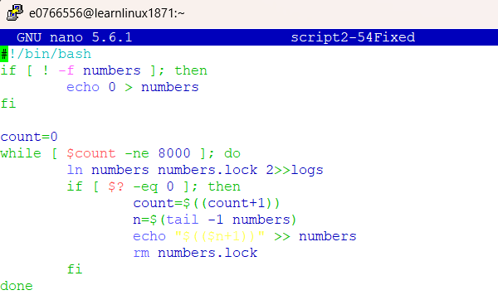
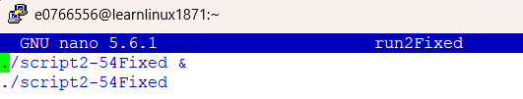
  - Last 10 lines of fixed numbers file
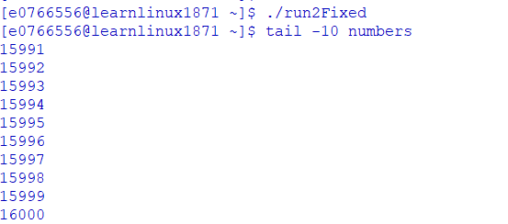
  - My solution fixed the problem because it introduced the use of a file lock using ln numbers numbers.lock. This ensures only one process at a time can update the file. Once the update is complete, the lock is removed so another process can continue. This guarantees that the increment happens in order without any conflicts as we had before.
  - [e0766556@learnlinux1871 ~]$ wc -l logs
32477 logs

The log file has 32477 logs. Each log represents a failed attempt to acquire the lock when another process was writing to the numbers file. This shows that many times the processes wanted to run at the same time, but the file lock system did a good job of preventing conflicts and ensured only one process updated the file at a time.

