First, open Ghidra and select the file safe_hack_demo_esp32c5.elf then analyze everything then In the Program Tree panel on the left, search for “sanity” and click the function raw frame sanity check.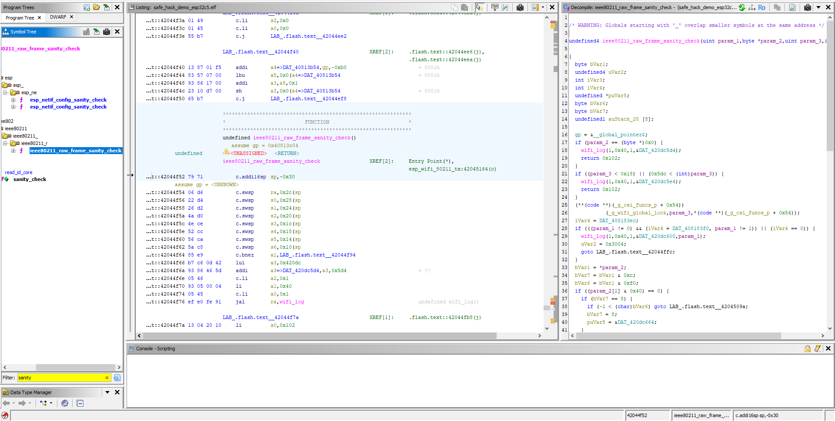Next, scroll a bit further down within the function until you reach the bytes 63 8e c6 02 93 06 00 0d, 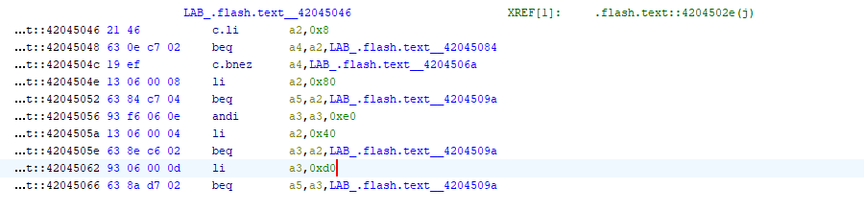You need the bytes 93 06 00 0d specifically: this is where the check for 0xd0 frames is implemented. write 0xc0 and verify the resulting bytes you obtain: 93 06 00 0c, 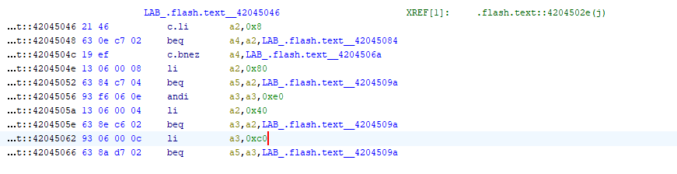These are the bytes that must be inserted into the file safe_hack_demo_esp32c5.bin.

Next, open safe_hack_demo_esp32c5.bin in HxD, press Ctrl+F, and enter the following bytes: 63 8e c6 02.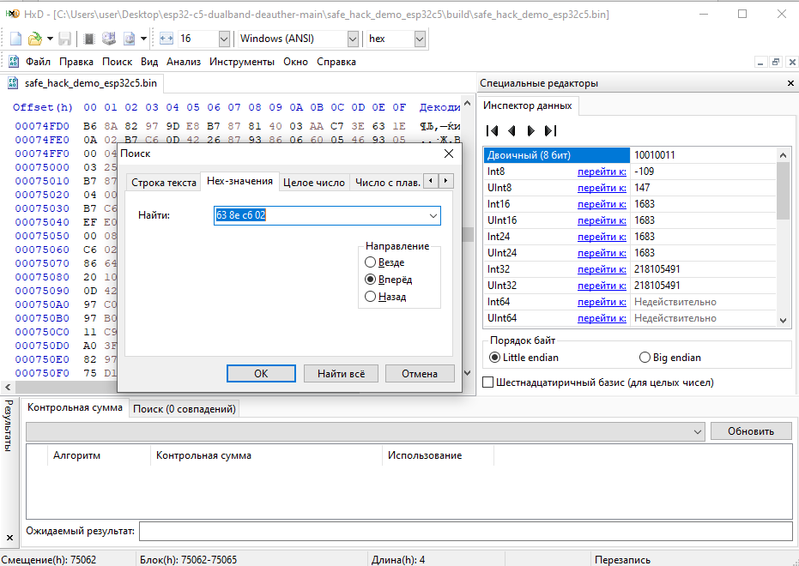
Click Search, and you will be taken exactly to the location we saw in the ELF file.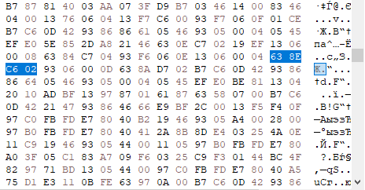We are interested in the bytes 93 06 00 0D; replace the final 0D with 0C and save.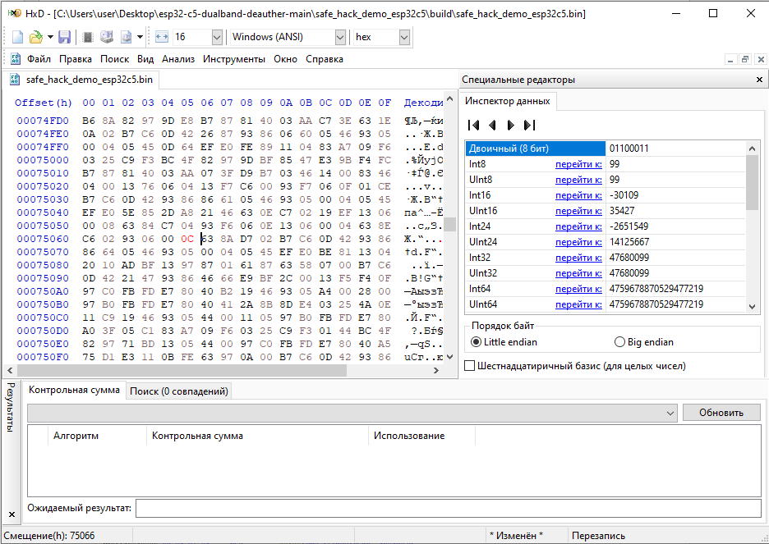

Then open the project in a terminal and run the command python -m esptool image-info .\safe_hack_demo_esp32c5.bin to compute the checksum, which will now differ. As soon as you obtain the new checksum, open the project’s .bin file again and scroll to the very bottom. Select the last two lines and delete them. In the very last byte (the one after which there are only zeros), replace it with the checksum value you obtained in the terminal, paste it, and save. Also, go to analyze, then control sum, select the entire range and choose sha256; copy the value that HxD calculated and paste it at the very end.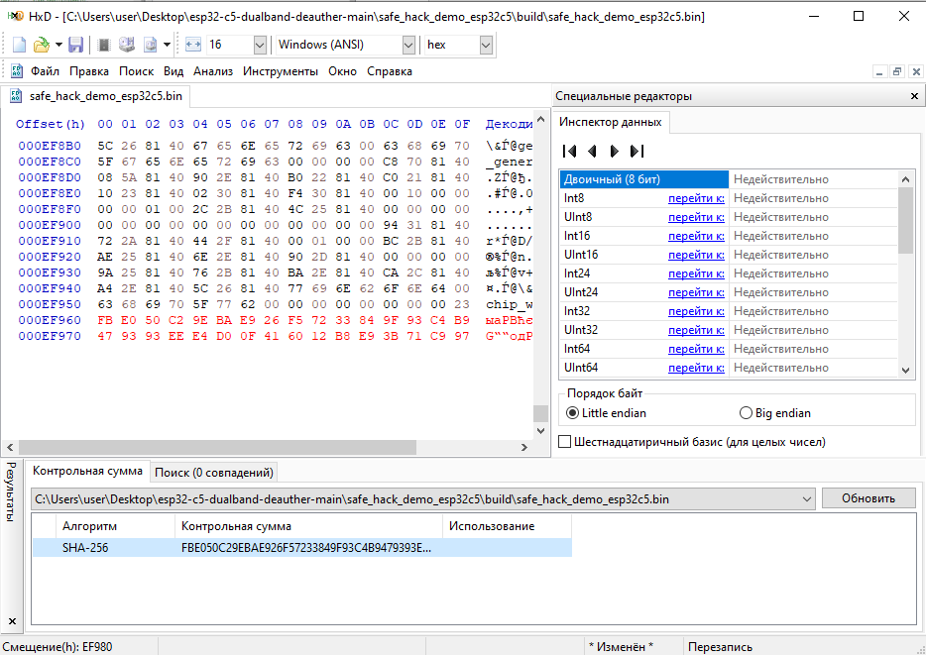
After that, save the changes. Congratulations—you have now applied the patch (DO NOT BUILD THE PROJECT; UPLOAD IT TO THE BOARD!!), and you can use it.
