**Title and Closing Supplier Scorecard**

**Job Aid**

**Version 1**

**Classification Type: Critical**

***November 2016***

**Table of Contents**

1 Document Change Control Log 3

2 Purpose 4

2.1 Objective 4

2.2 Execution Schedule 13

2.3 Roles 13

2.4 Process Map 13

3 Code/Location 14

4 Access Controls 15

5 Error Monitoring 15

6 Report Inputs 16

6.1 Data Inputs 16

6.2 User/Manual Inputs 16

7 Dataset Output 16

8 Monthly Execution Steps 17

8.1 Preparer Steps 17

8.2 Reviewer Steps 17

9 Report Sponsorship/Certification & Distribution 17

9.1 Sponsorship Type (Summary/Trigger/Data) 17

9.2 Distribution Method 18

10 Publishing Report to Fannie Mae Connect 18

10.1 Publishing to Beta Test Environment 18

10.2 Publishing Report to Fannie Mae Connect 18

# Document Change Control Log

|  |  |  |  |  |
| --- | --- | --- | --- | --- |
| **Version Date** | **Version Number** | **Nature of Revision** | **Section / Page(s) Revised** | **Owner/Producer** |
| 10/6/2016 | 1.0 | Document Drafted | All | Max Chen |
| 11/7/2016 | 2.0 | Document Drafted | All | Max Chen |
| 11/11/2016 | 2.0 | Document reviewed and edited | All | Catherine Hu |

# Purpose

## Objective

The daily and monthly Title and Closing Supplier Scorecard serves two primary functions –

1. Provide Fannie Mae’s Suppliers team and senior Real Estate management a functional scorecard to evaluate supplier performance for the Title and Closing processes.
2. Provide Title and Closing suppliers a functional scorecard that displays their performance across the categories below.

* Cover Page
* Scorecard Summary
* Performance Summary
* Historical Trend - Title
* Historical Trend - Closing
* Details - Title
* Details - Closing
* Glossary

This report will be on ***CPM Portal*** which allows business team managers to view the associated metrics, their individual information, and the categories above. This report will also be on ***FM Connect*** for suppliers to view their scorecard and supporting information relative to all other supplier average performance. The scorecard is reported on monthly basis for the selected months since October 2016 and a daily basis for the month-to-date with all metrics based on the title and closing issues that are open, closed or still outstanding within the selected report period.

Data is managed in the Netezza environment, and it is generated as a Tableau report with multiple filters on each page defined.

The next pages show screenshots and summaries for the report.

**Example Output – Tableau Dashboards (Pages) on the internal *CPM Portal***

***Cover Page*** *– Introduction page for the Title and Closing Supplier Scorecard with descriptions for all the pages in the report.*

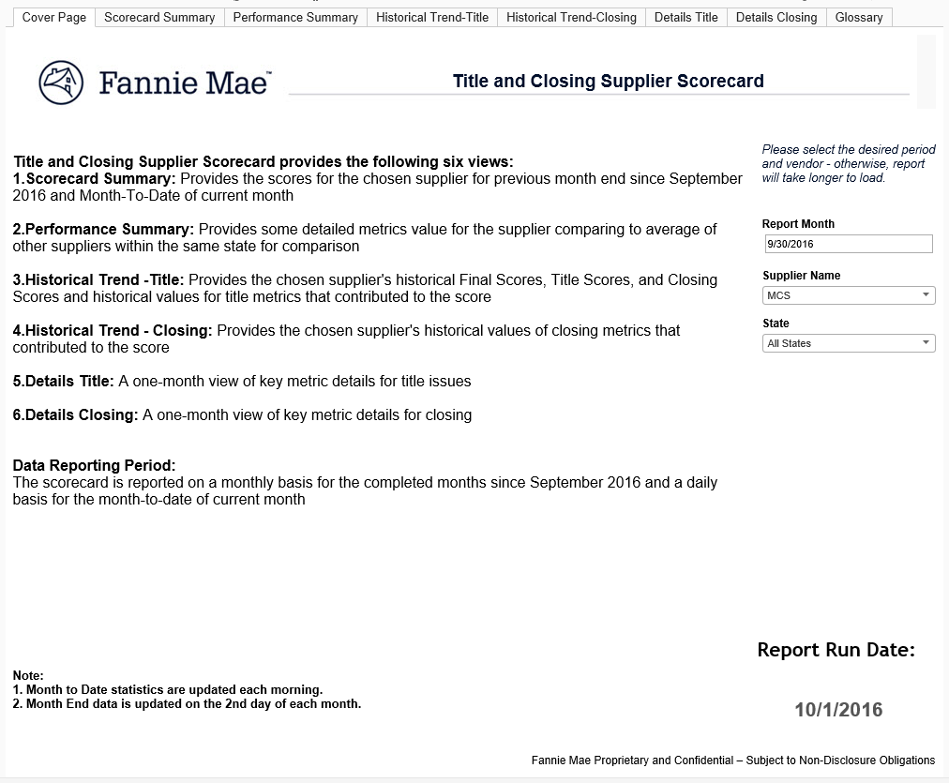

***Scordcard Summary & Performance Summary*** *–* *Scorecard summary is the initial landing page and Performance Summary is the very next page, these two together provide the daily month-to-date and month-end score for the chosen supplier and the detailed metrics for the supplier firm and other supplier.*

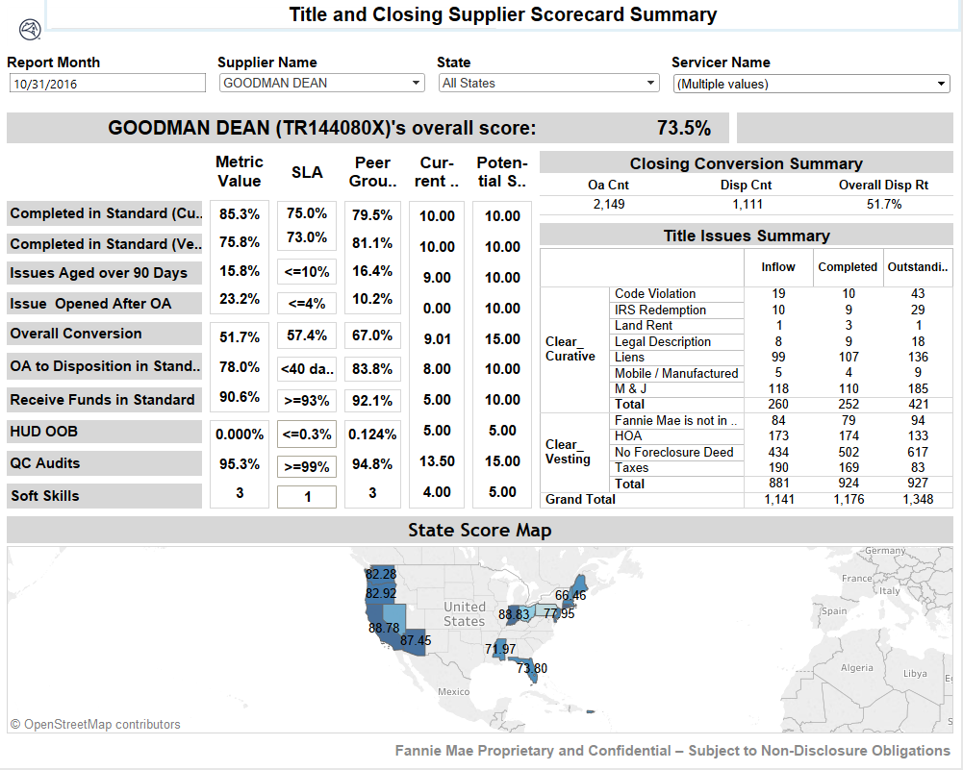

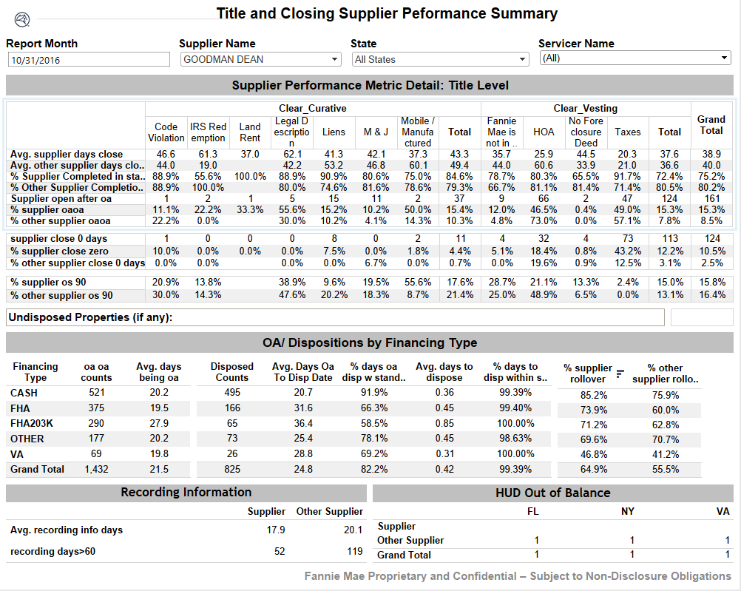

***Historical Trend - Title*** *– Provides the month-to-date and prior months historical scores for the chosen supplier including the historical values for title score, closing score and final score, as well as title performance metrics including Average Days to Completion (Curative & Vesting), % Completed Within Standard (Curative & Vesting), % of Issues Aged Over 90 Days and % Issues Opened After OA.*

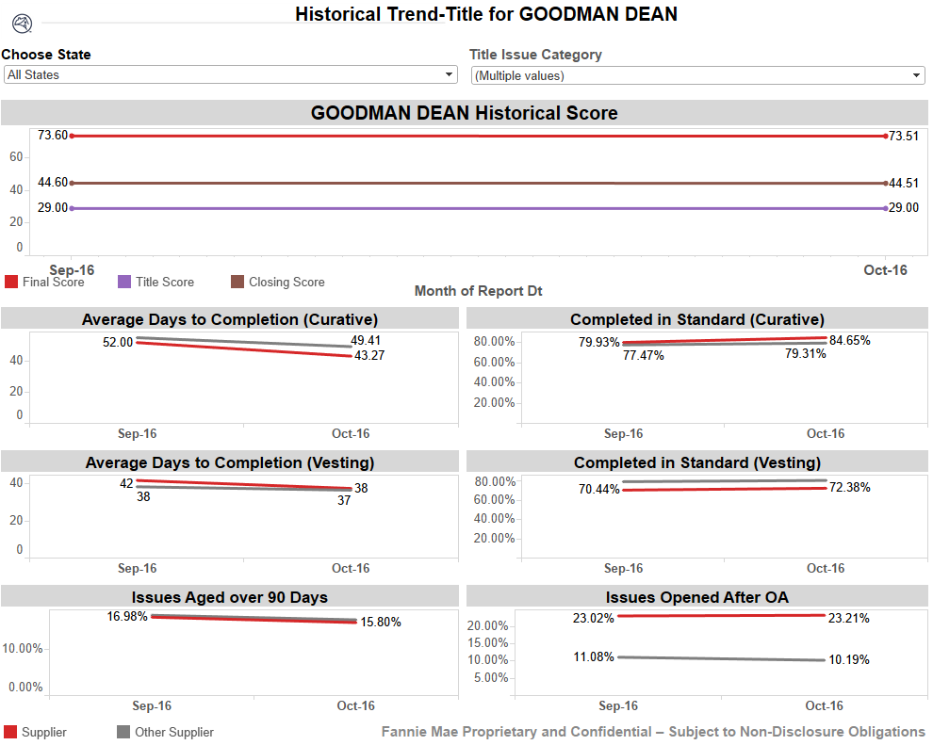

***Historical Trend - Closing*** *– Provides the month-to-date and prior months historical scores for the chosen supplier including the historical values for closing performance metrics – Overall Conversion Rate Historical Trend, Days OA to Dispose Trend, Days to Receive Funds Trend, and Days to Dispose Trend, HUD OOB, QC Audit and Softskill.*

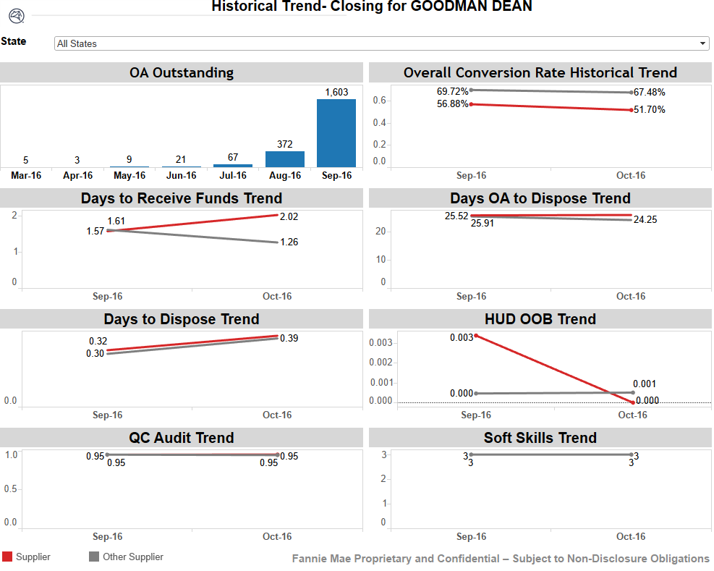

***Details - Title*** *– Provides selected property level details for the month-to-date or selected months for the chosen state including Issues Completed Outside Standard, Issues Completed Within Standard, Issues Outstanding, Issues Opened After OA.*

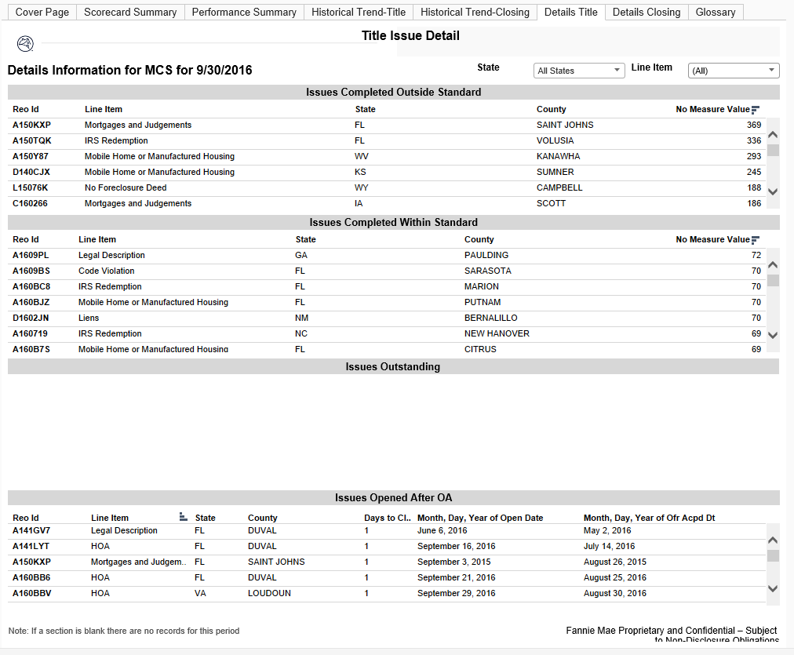

***Detail - Closing****– Provides selected property level details for the month-to-date or selected month for the chosen supplier and state, including Properties with Offer Accepted > 40 Days, Properties Disposed Outside Standard, and Funds Received Outside Standard, and HUD OOB..*

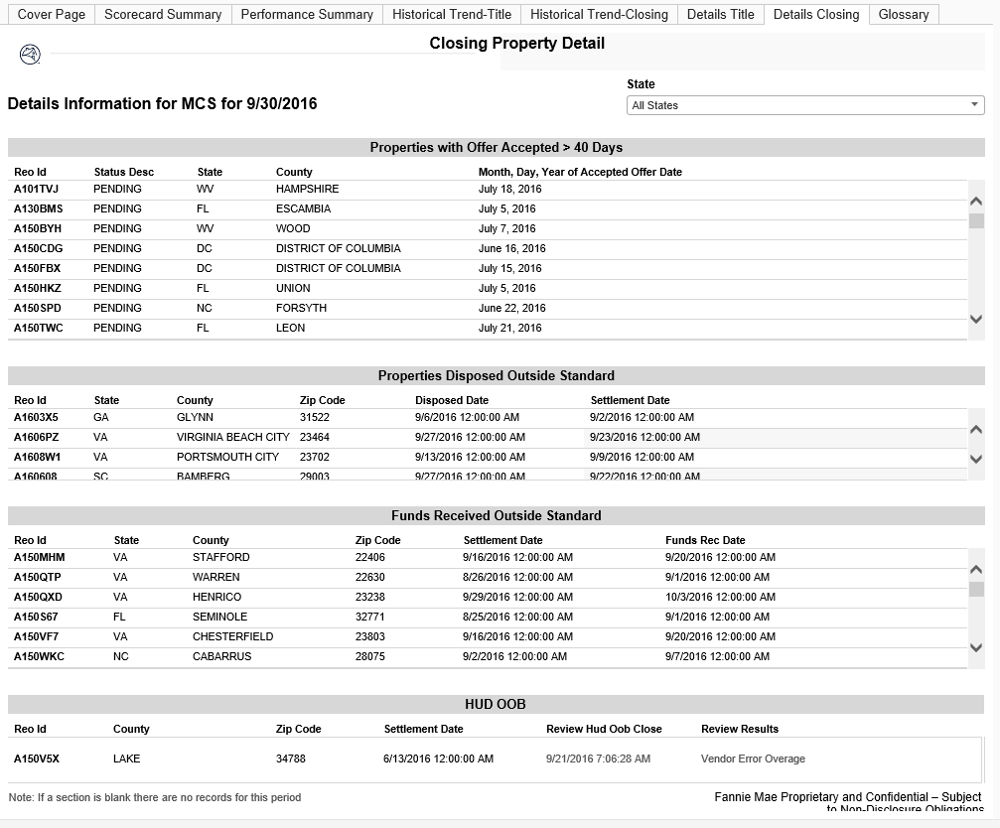

***Glossary****– Provides a list of terms and definitions*

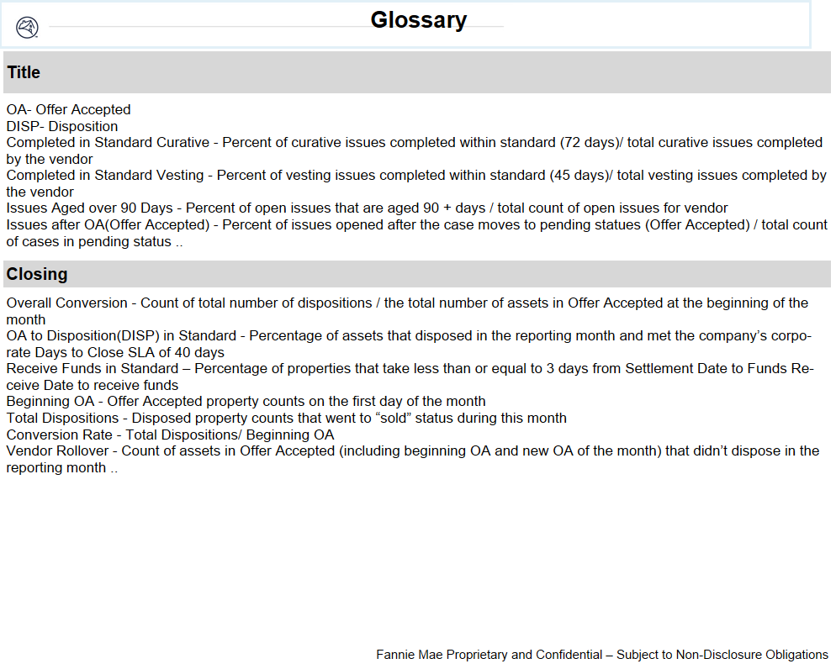

## Execution Schedule

All data will be refreshed on a daily basis for the Month-to-Date, and month end results are available from January 2016. Data sources are Fannie Mae (FMN) Equator ODS and POWEBCLM (CDM) databases. The FMN ODS is updated on a daily basis with the previous day’s information from Equator’s master tables. The CDM is updated on both a daily and month-end basis. The programs will be automatically executed daily and monthly on the 2ND business day dependent upon the system updates.

Autosys job – **BE6#CMD#DAILY_EQ_ODS_JOBS**

Dependencies - **FMN Equator ODS, POWEBCLM, POAU9C1**

## Roles

|  |  |  |  |  |
| --- | --- | --- | --- | --- |
| **Role** | **Name** | **Title** | **Phone** | **Email** |
| Primary Developer | Max Chen | Financial Economist I | 202-752-1376 | Max_chen@fanniemae.com com |
| Secondary Developer/Validator | Ayesha Arshad | Financial Economist I | 202-752-8554 | Ayesha_arshad@fanniemae. |
| Reviewer/Validator | Catherine Hu | Financial Engineer IV | 202-752-3016 | Catherine_hu@fanniemae.com |

## Process Map



# Code/Location

All documentation including Job Aid, Code Review and SAS programs will be located in the ***View Documentation*** section of the CPM Portal for the reports (see links below). Additional documents supporting the scorecard metric calculations and the data dictionary are included below.

**FM CONNECT Portal Tableau Report** – Located at <https://connect.fanniemae.com/>

**CPM Portal Tableau Report** – Located at http://sharepoint/sites/AMREO/Reports/428.aspx

**SAS Programs** – Located at plgrid-usas-gc04/appl/awrprod/pgm

**Requirements/Metrics** – Contains the scored and non-scored metrics for the Title and Closing Supplier Scorecard(s)



**Data Dictionary**



# Access Controls

The SAS code is secured at two levels of access. Only users with access to the server (plgrid-usas-gc04/appl/awrprod/pgm) may view the code. Once access to plgrid-usas-gc04/appl/awrprod/pgm is granted, the code may only be edited by those with sufficient permissions to the folder and/or the code itself. These permissions may only be granted by the CLM MIS Production team and the program developer.

SAS Permissions

|  |  |
| --- | --- |
| Unix Group | AWRPROD |
| Net Group | LIQUID_AWR_PROD_USERS |
| App ID | AWR |

**Oracle Permissions**

|  |  |  |
| --- | --- | --- |
| Database Name | FANNIE MAE EQUATOR ODS | POWEBCLM |
| Roles | n/a | CLM_OLAP |
| Schema | DBO | CLMODS |

**CPM Portal Permissions**

|  |  |
| --- | --- |
| Report Type | Operational |

# Error Monitoring

For the SAS programs generating the report data and the Tableau Report, all error monitoring is managed by the CLM MIS Production team through normal channels. An email is auto-generated when the code fails. Monitoring is done by the awrprod ID and error notifications are sent to the SF Analytics (REO Fulfillment) team.

If the SAS program or the Tableau report should fail for any reason, the CLM MIS Production and SF Analytics (REO Fulfillment) teams work together to correct any errors.

# Report Inputs

## Data Inputs

Two databases contain data inputs to the Title and Closing Scorecard(s) –

1. FMN Equator ODS – The ODS updates each night and the prior day’s information is usually available by 4:00 AM CST.
2. POWEBCLM – The CDM updates once all CLM, TRAX and FALCON dependencies have been met each day and on the morning of the 2nd business day each month for the month-end report version.

## User/Manual Inputs

N/A

# Dataset Output

The master datasets will be output daily and on the 2nd business day of each month (for month end) to the Oracle OASIS Production area and the NETEZZA server via INFORMATICA ETL. The datasets will include both daily and the last 13 months of title and closing data (from January 2016) that is utilized within the Tableau Scorecard (report) and the associated performance reporting by the SF Analytics.

ORACLE Output Location (OASIS) –

Database Name : *POAU9C1*

Schema Name : *oasisprd*

Table Names :

**CLOSING**

* *S_CLOSING_COMBINED*
* *S_CLOSING_DISPOSITIONS*
* *S_CLOSING_FUNDS_REC*
* *S_CLOSING_HUD*
* *S_CLOSING_HUD_OOB*
* *S_CLOSING_OA*
* *S_CLOSING_REC_CONT_PACK*
* *S_CLOSING_RECORD_INFO­*
* *S_CLOSING_UNDISP*

**TITLE**

* *S_TITLE_COMBINED*
* *S_TITLE_BASE_DISPN*
* *S_TITLE_CHECKLIST*
* *S_TITLE_ISSUE_ME*
* *S_TITLE_TASK_MANAGEMENT*
* *S_TITLE_BASE*

**BOTH TITLE/CLOSING**

* *S_SCORE_RANKING_COMBINED*

NETEZZA Output Location –

Database Name : *CMAP*

Schema Name : *LENDER_P*

Table Name :

**S_CLOSING_COMBINED**

**S_TITLE_COMBINED**

**S_SCORE_RANKING_COMBINED**

# Execution Steps

## Preparer Steps

Manual operation is not needed for this program and the Tableau tool unless errors happen in any stage of the automatic process.

## Reviewer Steps

The CLM MIS Production team and/or SF Analytics developer will access the SAS Log on server plgrid-usas-gc04 at the following location (plgrid-usas-gc04/appl/awrprod/pgm) if errors occur. The Tableau report will be accessed on the Tableau Production Server if needed.

# Report Sponsorship/Certification & Distribution

## Sponsorship Type (Summary/Trigger/Data)

N/A

## Distribution Method

The Title & Closing Scorecard is distributed via the ***CPM Portal*** where users with the appropriate access will be able to view the Title and Closing scorecards and filter to an individual firm.

The Title & Closing Scorecard is also distributed via the ***FM Connect*** where external vendors with the appropriate access will be able to view the Title and Closing scorecard of their own performance.

# Publishing Report to Fannie Mae Connect

## Publishing to Beta Test Environment

* Publishing data to Beta Test Environment is the responsibility of the report creator
* Back End tables MUST point to the Netezza Beta environment and be fully tested prior to publication to FM Connect Production
  + Beta Server:  awarehouse-unz01
  + Database:  Lender_A3
  + Report Creator’s application ID login credentials
* Tables used by External reports MUST be joined to the SELR_SRVR_KEY_MAPG table
  + Join the SELR_SRVR_KEY_VAL field to the applicable Seller or Servicer number in the main data
  + Create a parameter, KeyParam
  + Create a calculated field, Key_Filter:
    - If KeyParam = [Selr_Srvr_key_val] then 1 End
  + Add the calculated field to the filters of the report so that the report will ONLY populate data for which the lenders have access
* Report creator publishes the report to <http://awp-e64-a002.fanniemae.com:8000>
  + Contact the technology team for login credentials
  + Make sure to embed the database credentials prior to publication
* Report creator will copy the URL from the tableau server and send it to the technology team for publication to FM Connect – Beta
* Both Internal and External versions must be uploaded to the Beta environment and fully tested before the report is to be published to Production
  + Test cases and report validation evidence must be stored on the respective folder on Fannie Mae Connect SharePoints

## Publishing Report to Fannie Mae Connect

* Publishing data to production Environment is the responsibility of the report creator with help from Level 2 support.
* Change the backend data from awarehouse-unz01 to:
  + Server:  pwarehouse-unz01
  + Database:  Lender_P
  + Report Creator’s application ID login credentials
* Tables used by External reports MUST be joined to the SELR_SRVR_KEY_MAPG table exactly as in bullet three in “Publishing data to Beta Test Environment” above
* Level 2 support will connect to the report creator’s desktop via WebEx.
* Level 2 support will take control and sign in to the production tableau server
* Level 2 support will monitor the report creator’s actions as he/she publishes the report to tableau server
* Report creator will copy the URL from the tableau server and send it to the technology team for publication to FM Connect