Technical Approach
4

Technical Requirements 1
A. BACKGROUND AND SCOPE 1
B. EVIDENCE INTAKE AND TRACKING 3
C. WORK ITEM ASSIGNMENTS 17
D. CASE INQUIRIES AND AD HOC REPORTING 25
E. SYSTEM ADMINISTRATION 32
F. SECURITY AND AUDIT LOG 34
G. HARDWARE 39
H. RELIABILITY AND SYSTEM PERFORMANCE 40
I. ARCHITECTURE 43
J. USERS AND SOFTWARE LICENSES 45
K. USER SUPPORT 45
L. PROJECT MANAGEMENT 48
M. TRANSITION AND IMPLEMENTATION PLAN 49
N. TEST STRATEGY AND PLAN 50
O. TRAINING 51
P. INSPECTION AND ACCEPTANCE PROCESS 52
Q. PROPOSED PROJECT SCHEDULE 53

This Page Intentionally Blank

Technical Requirements

A. BACKGROUND AND SCOPE

Within FDLE’s Criminal Justice Investigations and Forensic Services Program are seven regional crime laboratories. FDLE’s Crime Laboratories provide expert and professional examination of evidentiary materials to aid in the investigation and prosecution of criminal offenses by utilizing the latest forensic equipment and techniques. At present, the Crime Laboratory System utilizes an in-house developed Evidence Management System (EMS) to track evidence, maintain chain-of-custody, prepare reports and collect data. The current system relies on 10-year-old technology and is no longer supportable or able to be upgraded to meet new technological demands. FDLE plans to acquire a commercial Laboratory Information Management System (LIMS). The LIMS will enable the Crime Laboratory System not only to track evidence but to interface with the laboratory instrumentation therefore enhancing existing capabilities. The LIMS will increase effectiveness and efficiency and improve communication with the criminal justice community. This system will also bring the regional laboratories in line with new forensic accreditation standards.
The FDLE Crime Laboratory System operates seven laboratories that provide forensic services for state, local and federal law enforcement agencies throughout Florida. The system provides analysis in the areas of Controlled Substances, Toxicology, Trace Evidence, Firearms, Latent Prints, Crime Scene, Digital Evidence and DNA Analysis. The system received over 90,000 requests for service last fiscal year. It analyzes over 300,000 pieces of evidence each year. In addition to laboratory analysis the laboratory members provide expert testimony for criminal cases. FDLE Laboratory members testified over 1300 times last year.
For the scope of this project, FDLE is interested in contracting with a vendor for the following:
- A commercial-off-the-shelf LIMS product that provides evidence tracking, inventory, and auditing capabilities and can handle multi-discipline services, including but not limited to Biology, Firearms, Chemistry, and Toxicology.
Porter Lee Corporation’s Crime Fighter BEAST LIMS fully meets this requirement. Approximately 80 forensic laboratories currently use our commercial-off-the-shelf LIMS to manage their all of their forensic disciplines. Most of these laboratories are full-service. The Crime Fighter BEAST LIMS is being used in each of the service areas offered by FDLE. In addition, customer needs for Laboratory Asset Management, interfaces to submitting agencies, medical examiners offices, prosecutors and the courts are also met using our LIMS product.
- A product that has demonstrated, operationally, the capability to interconnect a State Forensic Crime Laboratory system which consists of at least 3 individual laboratories and has been accredited by American Society Crime Laboratory Directors (ASCLD/LAB) within the last five years while using the product.
Our proposed LIMS meets this requirement with the following customers:
- New York State Police Forensic Investigation Center
- Pennsylvania State Police
- Ohio Bureau of Criminal Identification and Investigation
- New Jersey State Police
- Alabama Department of Forensic Sciences
- Kansas Bureau of Investigation
- A product that has the capabilities of handling future enhancement such as interfacing with laboratory instrumentation and document imaging.
The Crime Fighter BEAST LIMS has been interfaced to a variety of laboratory instruments, and new implementations are developed as the need arises.
To date, we have created interfaces to the following laboratory instruments.
- ChemStation – GC and GCMS
- TurboChrome/TotalChrome
- ABI7000
- CE310
- CE3100
- CE3130
- Biomek2000
- Biomek3000
- Universal Print Capture of spectra for FTIR etc…
In addition, the Print Manager of the Crime Fighter BEAST LIMS provides for complete document imaging of relevant case forms and reports including worksheets, analytical reports, and technical and administrative review criteria checklists.

B. EVIDENCE INTAKE AND TRACKING
- The system shall document the chain of custody for all evidence from laboratory submission to final disposition (i.e. cradle to grave). Per ASCLD/LAB-International 2006 Supplemental requirements, forensic science laboratories shall be able to demonstrate that the evidence examined and reported on was that submitted to the laboratory. A “chain of custody” record shall be maintained from the time of receipt and reflect all internal transfer. The record shall detail each person taking possession of an item of evidence, or the location of that item. Specific requirements of record content are identified.
Maintaining the chain of custody information for physical evidence is a critical function of any laboratory information management system. The Crime Fighter BEAST LIMS makes maintaining custody information easy, accurate, and very efficient. The Custody and Items tabs in the Receive program may be used to view, print and maintain chain of custody information for case items. Even though chain of custody may be viewed here, any activity (including changes, deletions, additions) are recorded permanently in the Audit Log.
Custody Tab in the Receive program.
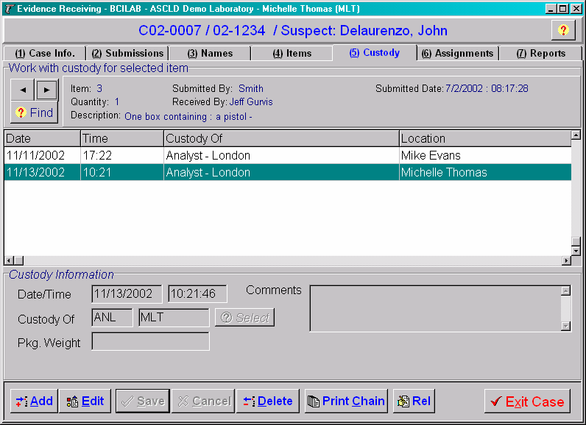
- The system shall provide the ability to print the entire chain of custody for each submitted exhibit.
The chain of custody for any item/exhibit is easily printed from within the Custody Tab by clicking the Print Chain button.
Dialog box for the Print Chain of Custody Feature
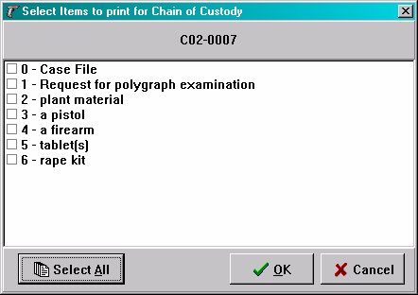
Chain of custody can be viewed/printed/exported using the window that appears after you click the OK button.
Chain of Custody Report View
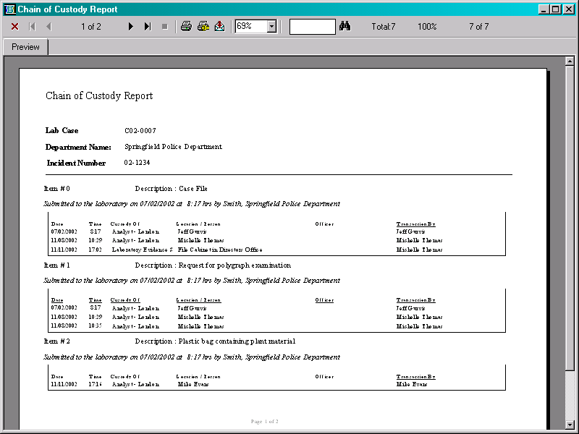

- The system shall be able to perform both single and multiple item(s) transfers while maintaining a record of the chain of custody.
Chain of custody transactions are easily completed through the use of active bar coding. This is a means of beginning a transaction through the scanning of a location bar code without having to be on a certain screen or selecting a button from a menu. It simply recognizes that the user is performing a custody transaction. These transactions can involve single or multiple items from one or multiple cases all in the same step. These items may also be transferred directly from the Items tab in the Receive application by clicking the Transfer button. In addition, this process may be accomplished very quickly by using the barcode scanner to scan a “transfer” command barcode and then scanning the items.
Transfer Items Button on Items Tab
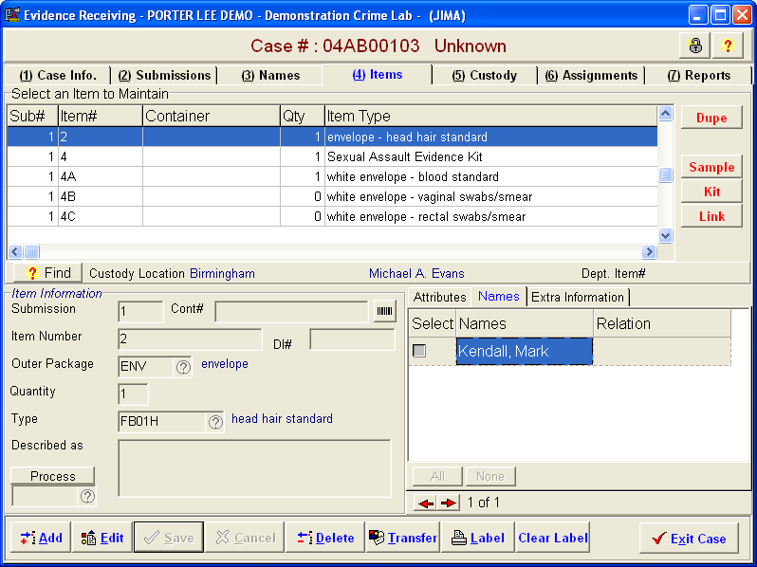
Transfer Items Button
Transfer Items Window
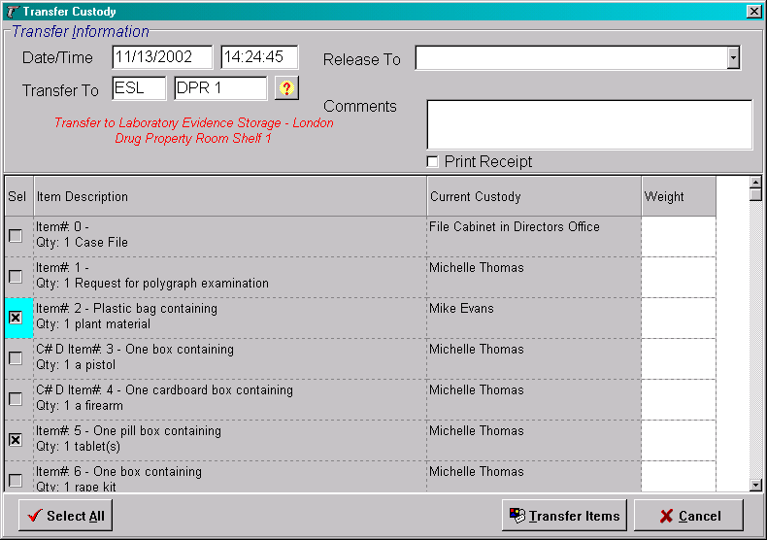
- The system shall allow the ability for evidence to be sub-sampled and tracked back to the original evidence source, independently of a numbering system. Per ASCLD/LAB-International 2006 Supplemental requirements, when evidence is subdivided in the laboratory, sub-items shall be tracked through a documented chain of custody record to the same extent that the original items of evidence are tracked.
The Crime Fighter BEAST LIMS meets this requirement. Items may be sub-sampled to any degree necessary by clicking the Sample button. Sub-items are tracked as independent items with their own chain of custody, descriptions, and packaging. Sub-items may also be sampled. In the screen below, Item C has been sampled, and the sub-items themselves sampled. The numbering of items and sub-items is 100% user definable. To meet the ASCLD requirement for numbering independence, the parent item data is always stored in the database independent of the numbering chosen by the user. This provides for a completely independent numbering system while recognizing the origins of samples and derived evidence.
Item Sampling
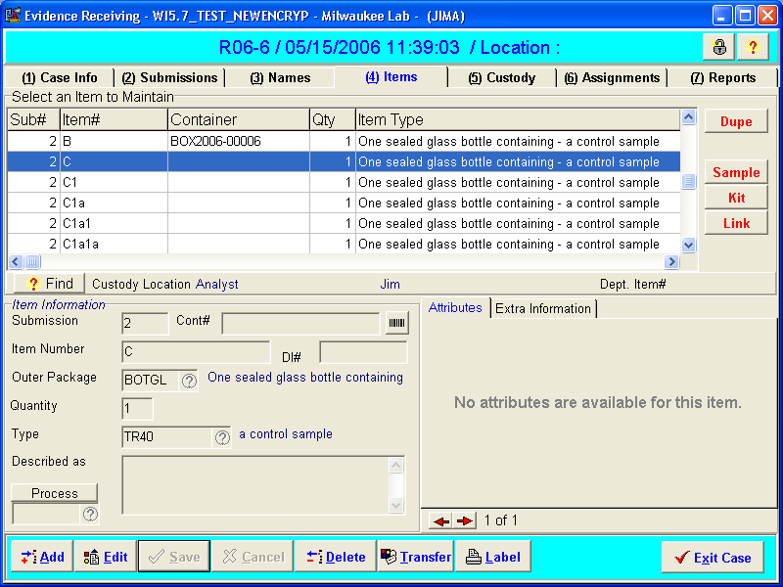
Item C was sampled, and the sub-item sampled to the level of “C1a1a”.
Numbering format is user definable.

- The system shall be able to handle additional evidence received on an existing case.
This is handled as a “Submission”. A lab case can have any number of submissions. The Submission tab in the Receive application documents submission data. In addition, whenever a case is received, a check is made against the case data to determine if a lab case already exists. If a possible match is found, the operator is alerted and may create a subsequent submission to the case.
Submissions Tab
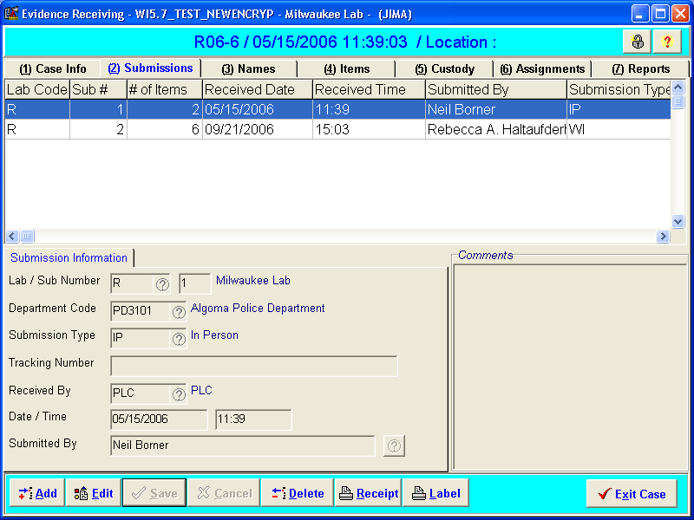

- The system shall use bar coding for evidence receiving, tracking, and inventory.
The Crime Fighter BEAST has been designed around the use of barcodes from its initial conception 10 years ago. In addition to the above requirement, “command” barcodes may be used for shortcuts in the analysis process. Barcodes used in conjunction with our Worklist and Batch features make batch analysis of toxicology/serology or DNA samples much easier. Scanning a Case barcode will open up the case directly without requiring a search. Scanning an Item barcode will open the case to which it belongs and display the Item in the Items tab of the Receive application. The acronym BEAST stands for Barcoded Evidence Analysis and Statistical Tracking; proving that from day one, we have been a barcode-enabled system.

- The system shall print a bar code label for each piece of evidence.
This is fully supported, and user-configurable. If more than one barcode is desired, or no barcode is desired, or if only certain sections need certain types of barcodes…. This is all highly definable to meet the workflow needs of the individual sections. Typically, as evidence is submitted, bar code labels are generated for each item of evidence. These labels are user definable and can be formatted to display any relevant data element for that item.

- The system shall search existing cases on the current submission prior to issuing a new case number.
This is fully supported. As part of the reception process, users enter agency information and case names in a screen that searches the database for existing cases. Users have the option of adding a subsequent submission or creating a new case based on the results they obtain from their search.
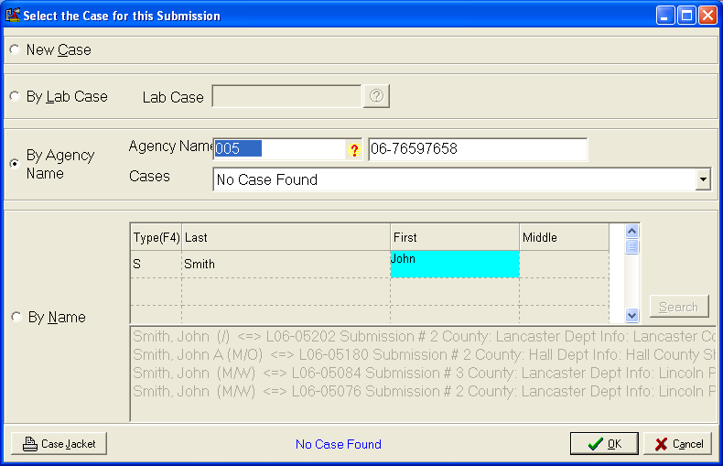

- The system shall print an evidence receipt for the submitting agency as a record of transaction.
This is fully supported and user-definable. A sample receipt is shown below. These receipts can be automatically printed and/or posted to a secure website for agency retrieval.
Sample Submission Receipt
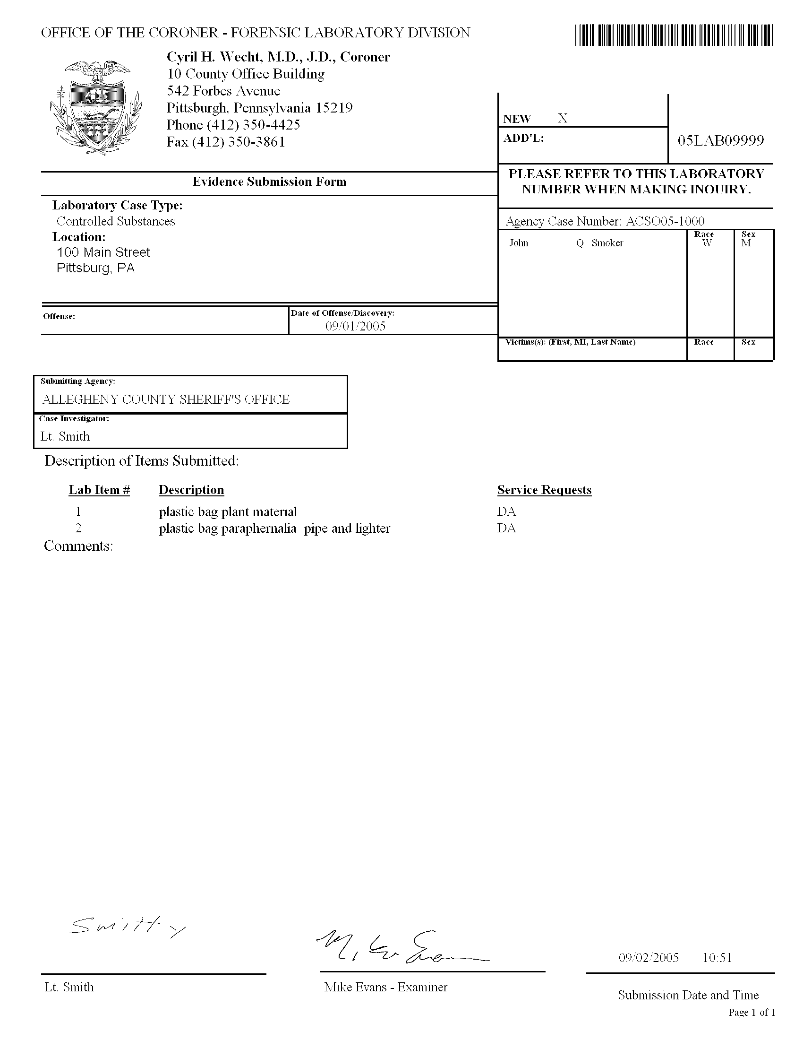

- The system shall have a status function for each discipline that can be updated as the analyses are conducted (e.g. Received, Pending, Completed, Transferred, etc.).
This is fully supported. Status codes may be configured and applied to the Case, to the Assignments for the disciplines, and to the analytical Reports.
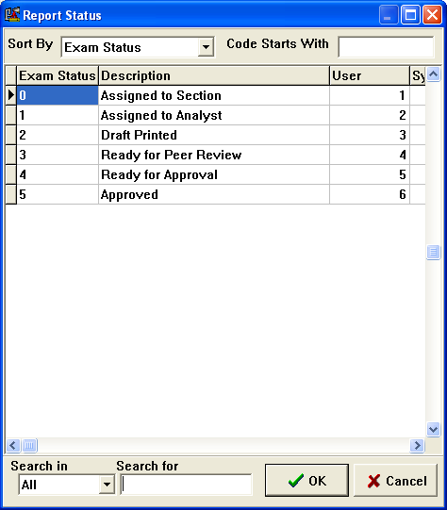
Electronic worksheets have their own independent status for laboratories desiring to become “paperless”.

- The system shall have the ability for law enforcement agencies to upload case and evidence information at time of submission via the web and/or removable media. Due to the volume of evidence submitted, FDLE does not expect its personnel to manually enter case and evidence information for submitting agencies.
This is fully supported. Agencies may use our Web Prelog feature to submit their cases and items. In addition, agencies that utilize our Crime Fighter BEAST Evidence Tracking system may submit via web, disk, PDF417 barcode, or network connection to the laboratory. For agencies that do not have connectivity or internet capability, Porter Lee Corporation offers a shell version of the Crime Fighter BEAST Evidence Tracking system that FDLE may distribute freely.
Sample Web Prelog Window
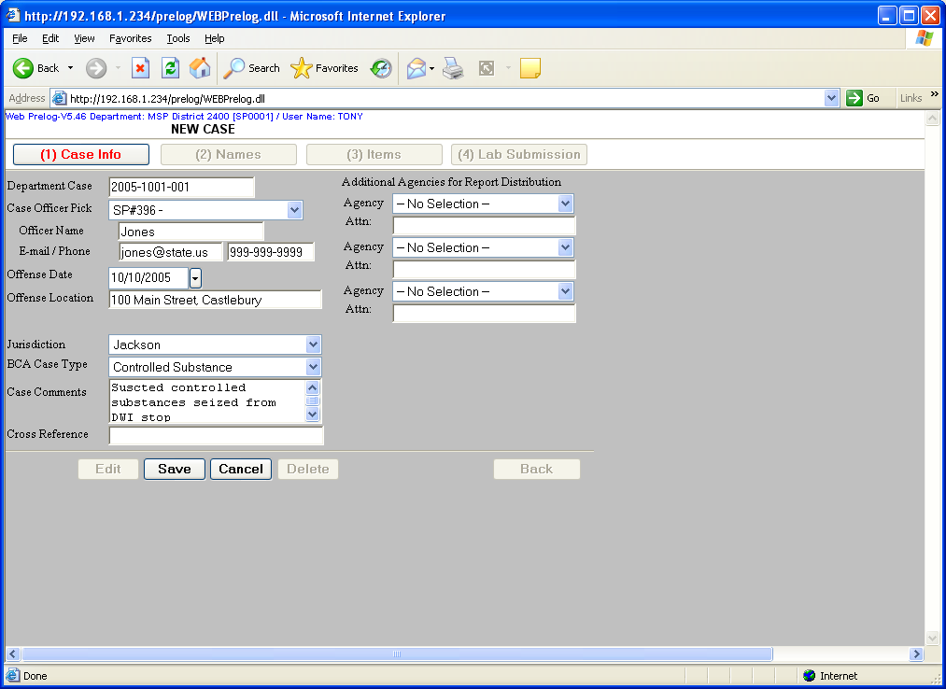

- The system should offer the capability for law enforcement agencies to remotely check their case status via the web.
This is supported via our Web interface. Additionally, analytical reports may be posted by the laboratory and retrieved by the agencies from the Web interface.
Web Inquiry
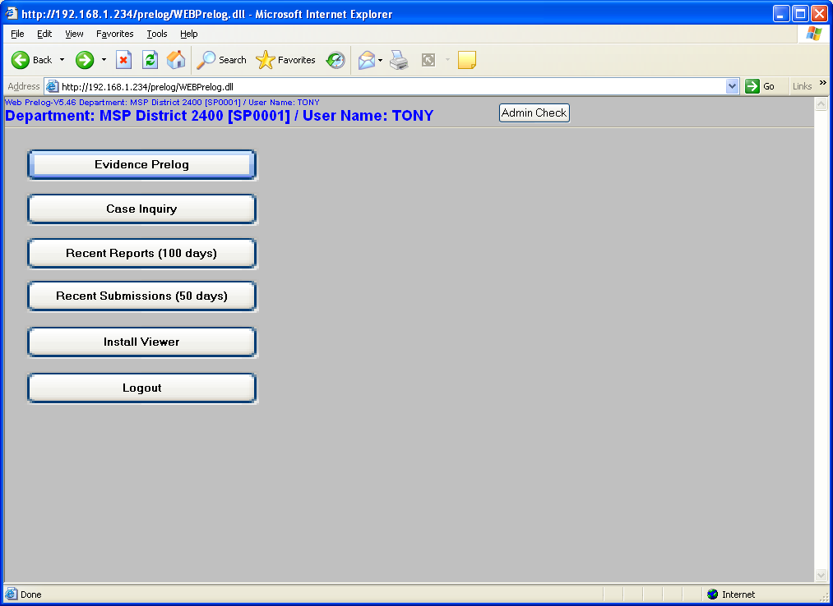
The Case Inquiry, Recent Reports and Recent Submissions buttons allow authorized users to search for case status and reports.

- The system shall provide the evidence intake staff and staff analysts with the ability to conduct inventories of their evidence.
This may be accomplished in a number of ways. A simple report showing the evidence in the custody of a specific location, analyst, or other personnel may be printed using the Custody Inquiry button from the main screen. This brings up a search window in which searches may be as specific or broad as necessary.
The window below shows a search being initiated for a specific analyst
Custody Inquiry
Custody Inquiry Button.

Custody Inquiry Screen on Standard Search. Analyst custody is selected, and a specific Analyst is selected for the search.
These searches can be very detailed as well by specifying more search criteria. The Advanced Search tab provides even more functionality. A sample of the search results are shown below. Double-clicking on any of the returned item records will open the associated case and display the Item information.
Search Results
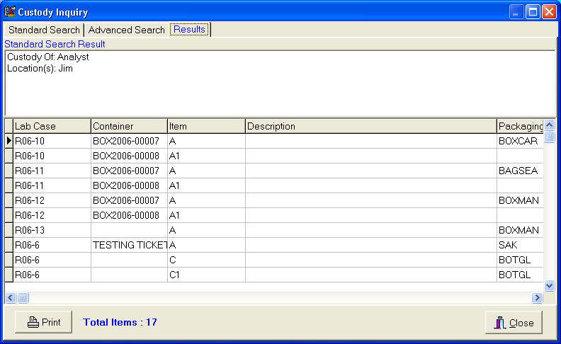

- The system shall provide the ability to conduct inventory reconciliation of a lab, section or a person with print outs of reconciliation results showing evidence assigned to specific person or location.
This is fully supported using our Remote Inventory function. Individual inventories may be conducted simultaneously by different personnel on any location in the laboratory including bins, lockers, or personal storage.
Manual Inventory
Once a location is selected using the windows above, a window appears which allows the inventory to commence. Reconciliation is in real-time, as items that are misplaced become apparent during the inventory process. An inventory report is generated for every inventory.
Inventory Reconciliation
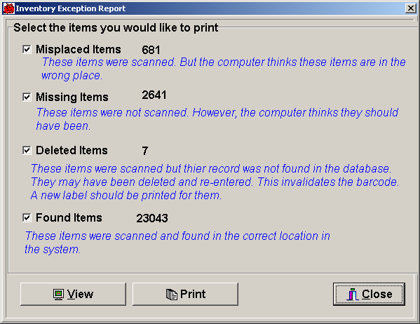
- The system should allow inventories to be conducted by multiple persons using different recording devices.
This is fully supported.
- The system shall allow evidence to be outsourced, with full evidence tracking and other assignment capabilities.
Evidence may be outsourced. Full evidence tracking and assignment capabilities may be maintained. Below is an example of shipping DNA samples to an outside laboratory.
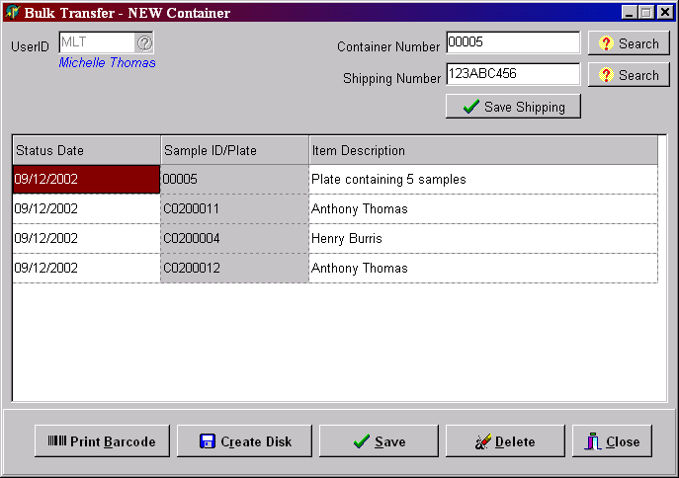
- The system should allow staff to assign evidence to specific locations (i.e., shelf, box, putrid room, etc.).
This is fully supported. Locations can be created and maintained by the laboratory. Default locations may also be configured to save time when receiving new items of evidence.
- The system should allow evidence inventories be done with remote or unattached bar code readers.
This is fully supported. The BEAST Inventory application on the Palm Pilot allows you to collect inventory information remotely, and then download the information to the database.
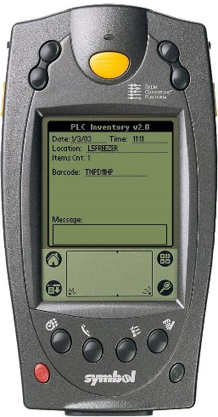
- The system should allow for multi-agency submissions under the same FDLE laboratory case number.
This is fully supported. The Submission tab has multiple fields for agency submissions for precisely this purpose. Each submission can have a different agency, agency number, investigating officer, etc.
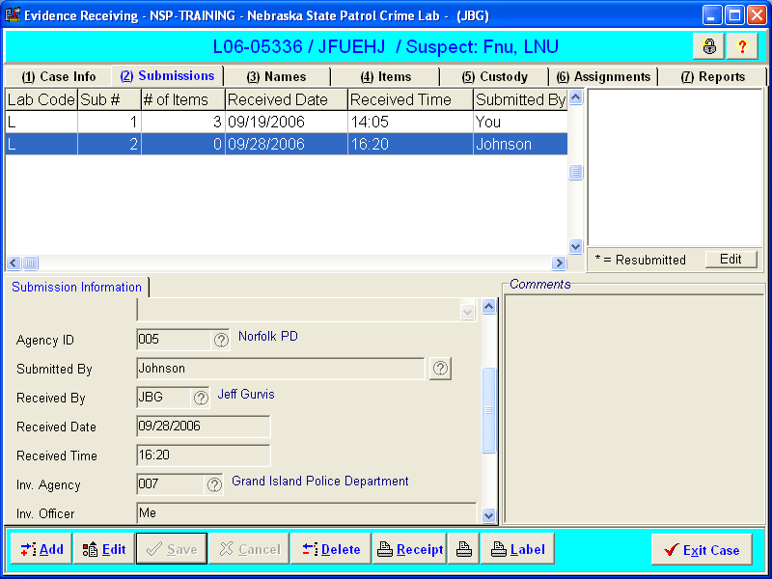
- The system should allow for electronic signature capture capability.
This is fully supported. Electronic signatures may be stored in the database for all personnel and applied on reports and receipts. In addition, signature pads may be used to capture signatures at desired points in the workflow such as evidence receipt, evidence transfer, report review, report completion, etc…

C. WORK ITEM ASSIGNMENTS
- The system shall allow supervisors the ability to assign work to individual analysts. The work assignments shall be by discipline.
This is fully supported. This aspect of the system is highly configurable to meet the needs of individual laboratories and sections/disciplines. Assignments can be made manually, automatically, overridden and changed.
The assignments for a lab case are easily accessed from the Assignments tab.
Assignments Tab
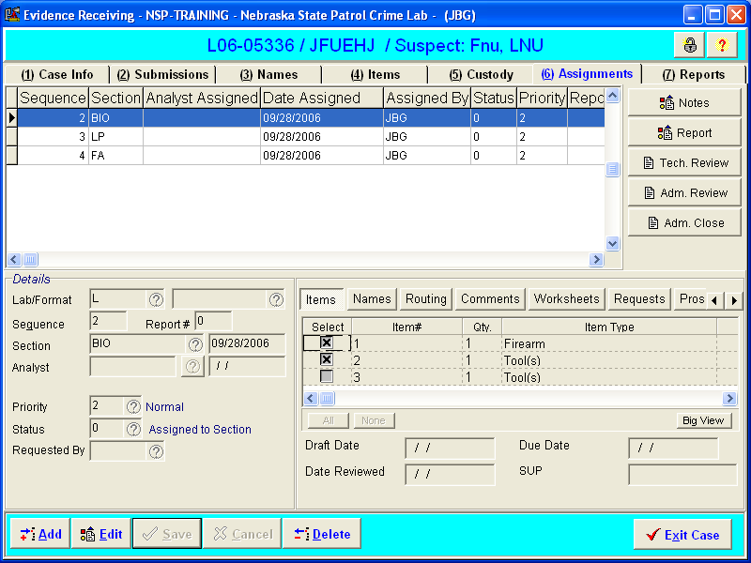
The items for the case appear in this area.
When you create an assignment, part of the process involves checking the box next to the items which are to be analyzed for the assignment.

- The system shall allow the supervisor the ability to review all previous assigned and unassigned work for each discipline.
This is fully supported at the case level and may also be reviewed at the analyst, lab, section, department, priority or task level. A sample of the assignment search window is shown below.
Assignment Search
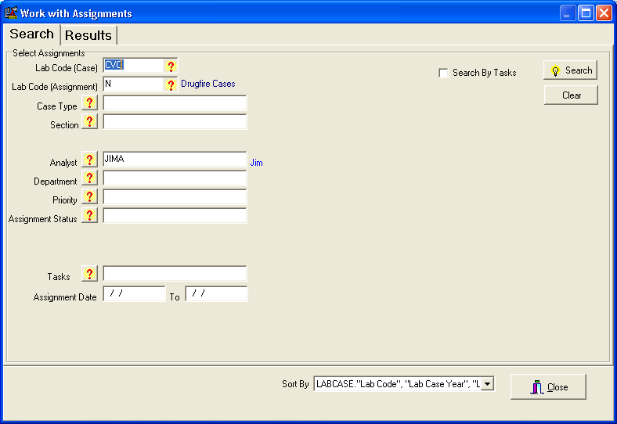
This information may also be accessed using our Ad Hoc reporting tool (“Management Reports”). This is a very full-featured query tool which also provides formatted reports in Detail or Summary formats.
Assignment Search in Management Reports
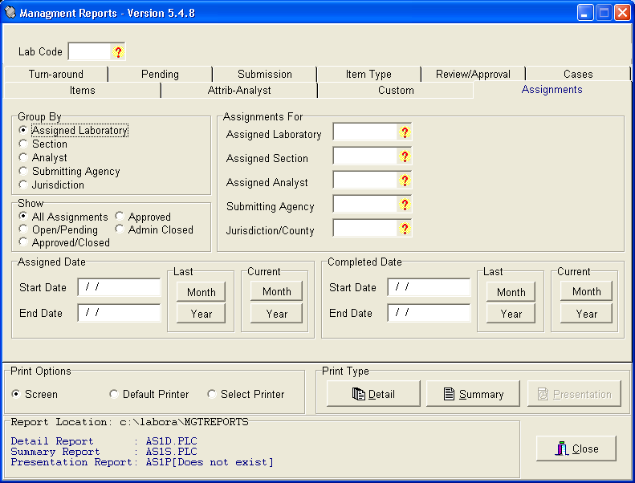
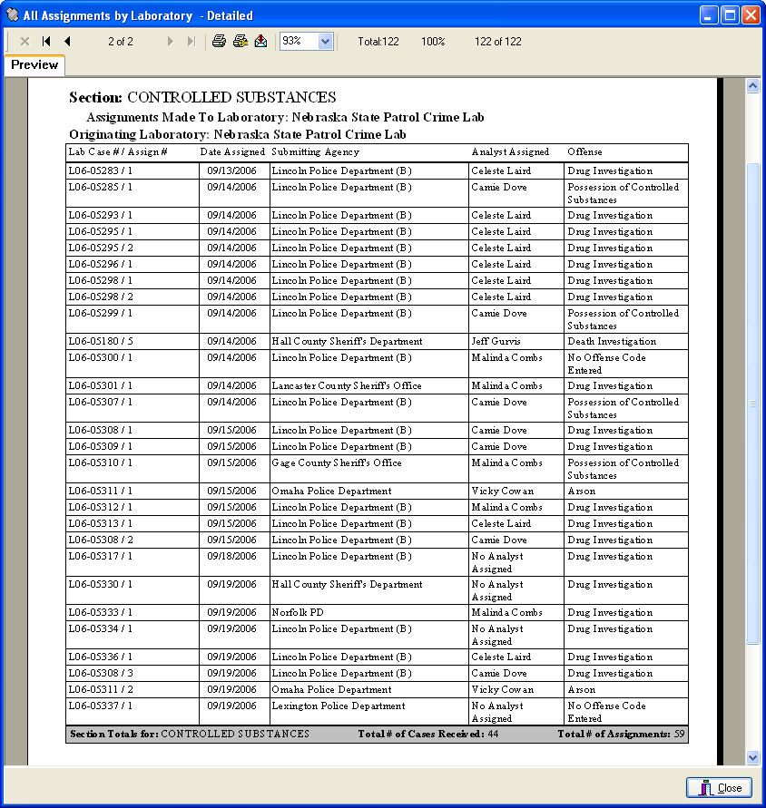

- The system shall allow the analyst and/or supervisor the ability to review all log entry and evidence storage data for items with a pending status prior to assignment.
This is fully supported. The Assignments screen can display all pending cases ready to be assigned. The Case Jacket button quickly provides analysts and supervisors an overall view of case information including items, locations and services requested.
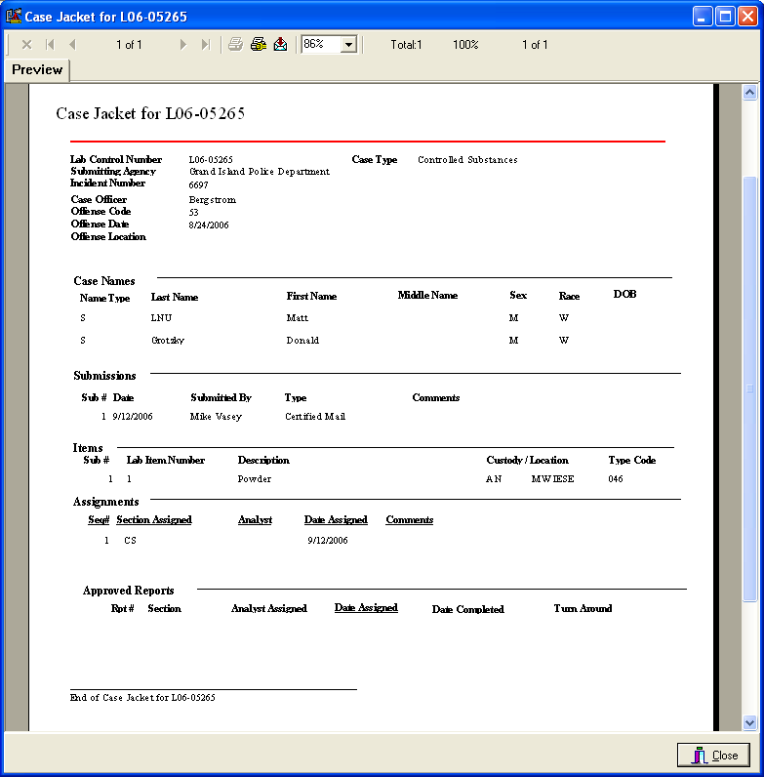
- The system shall allow the analyst and/or supervisor the ability to review all log entry and evidence storage data for the assigned work.
This is fully supported. Assignment data may be reviewed in a number of ways. The Assignments tab allows review of the information for that specific case’s assignments. In addition, all other case information that the user had permissions for is directly accessible from within the Receive application.
- The system shall allow the analyst and/or supervisor the ability to transfer evidence into their personal locker.
This is fully supported. All such transfers are part of the chain of custody record.
- The system shall allow the analyst assigned the ability to record completed activities against the work assignment.
This may be done most easily using the Examination Notes feature. This can take the form of a checklist, freeform notes, or whatever the discipline requires. Below is an example of an online form for a Drug Chemistry Section. These forms are completely configurable by the laboratory.
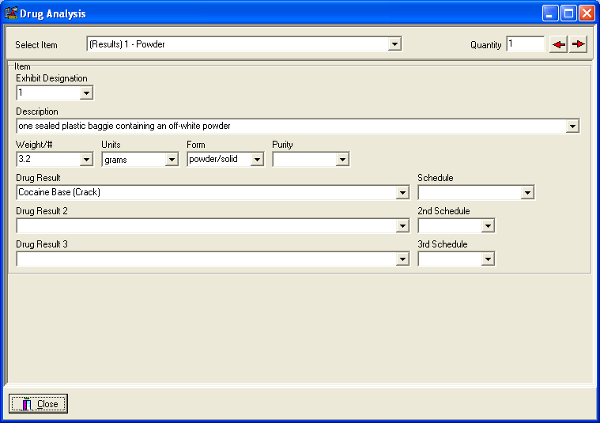
- The system shall provide the ability to list all unassigned work by disciplines.
This is fully supported. Using the Assignment Search feature it is very simple to locate any unassigned work. See the response to requirement C2 above for more information. In addition, the Management Reports application can be used to list and print all cases by their status.
- The system should allow the analyst to record notes into distinct work areas for specific disciplines.
Analytical note taking and report writing is one of distinguishing characteristics of the Crime Fighter BEAST LIMS. Each section in each laboratory can be configured uniquely based on the standard operating procedures, tests performed, data required, etc. For this reason, there are several options for recording of this data. With guidance from laboratory personnel, the Porter Lee implementation team will design each section’s method of note taking and reporting that makes the analytical process easy, efficient, and thorough. Porter Lee has forensic scientists leading its teams to provide the end users with a product that they will enjoy using. Below are some examples.
DNA Allele Table
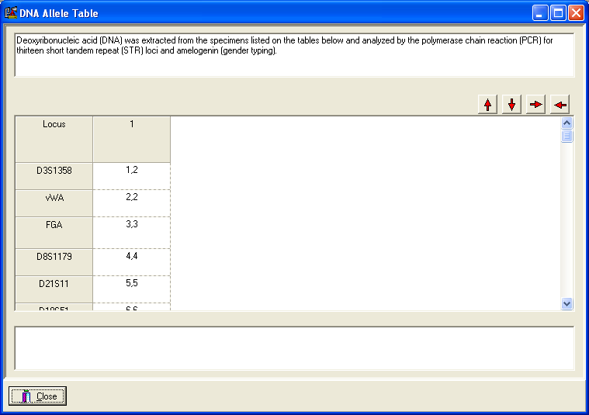
Firearm Exam Log
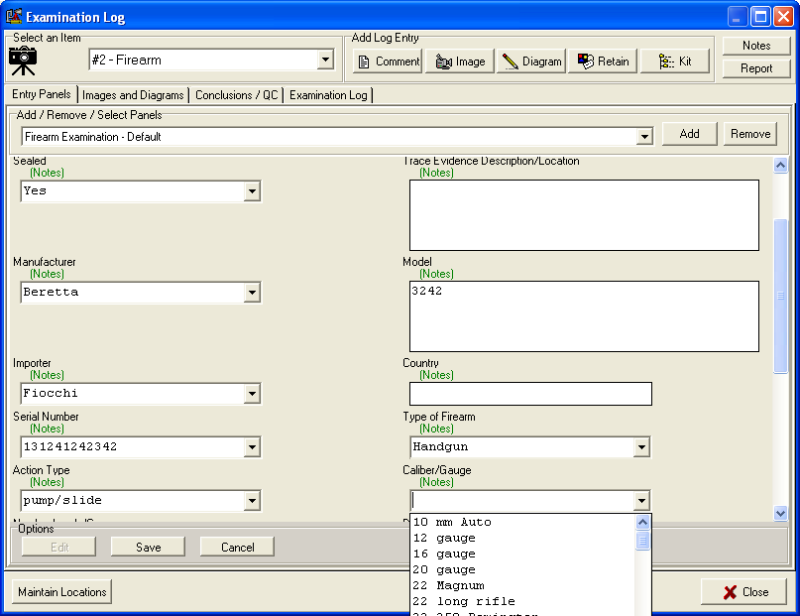
Matrix-Based Analytical Report Creation for Latent Prints
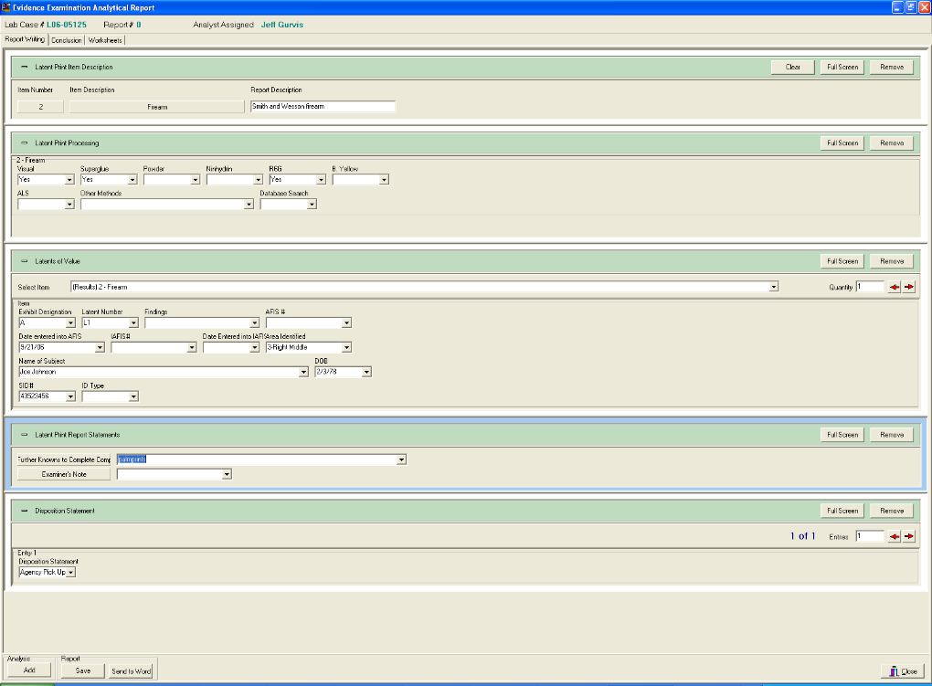
- The system shall provide the ability to record court activities by discipline.
This is fully supported. Court activities are most easily tracked using the Activity Log feature. This application lets you keep a detailed record of the time you expend on various activities. In essence, this is a time and reporting tool that allows the laboratory to track the amount of time spent on each of the different activity types.
Activity Log Window
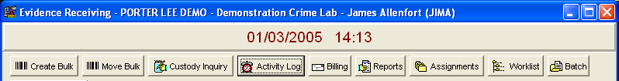

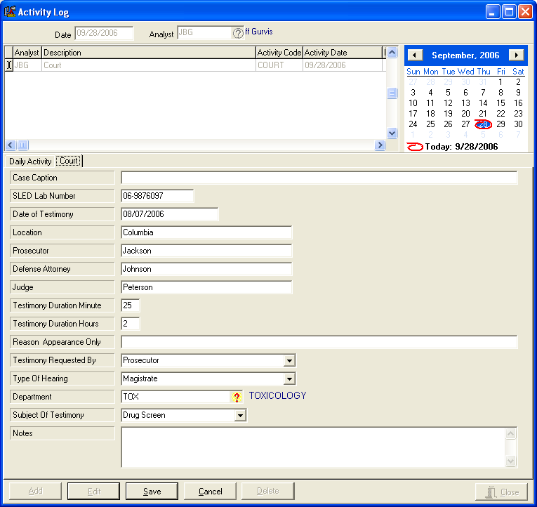

D. CASE INQUIRIES AND AD HOC REPORTING
- The system shall provide the users with the capabilities to query the status of a case. The system shall output the results to the screen and/or printer.
This is fully supported. The easiest way to query the status of a case is to use the “Find a Case” case search feature. This is accessed from the main Receive screen and is commonly used to locate a case to work on. Cases may be located using virtually any type of information that would link to the case (case numbers, names, case locations, case type, etc….
Another method is to use our Ad Hoc reporting feature (“Management Reports”) to locate a case and display its status. This provides enhanced printing capabilities as well.
Find a Case Window
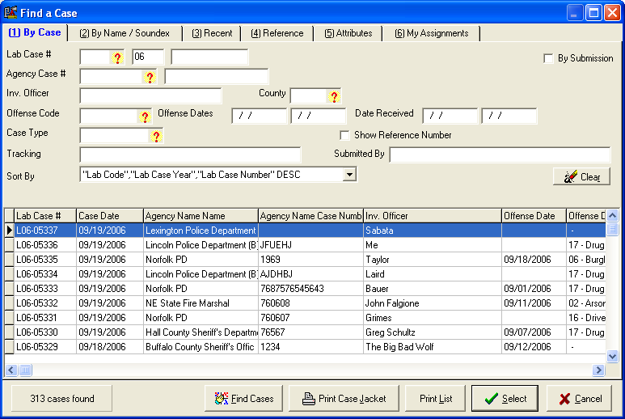
Once a case is located using this window it may be opened directly to access all of the case information.
Ad Hoc Reports “Management Reports”
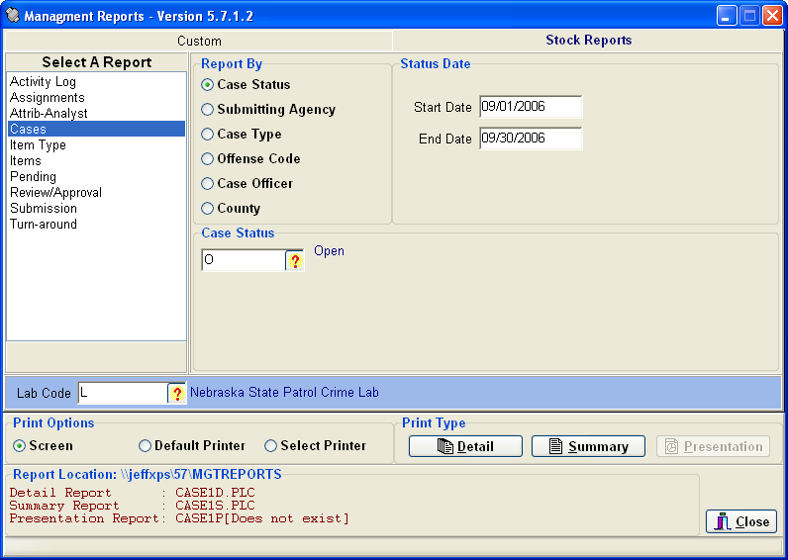
Cases that are located using this Management Reports tool are formatted in either Detail or Summary form for On-Screen viewing, Printing or Export.
Many custom reports exist as well and may be created at any time using Crystal Reports.
Pending Case Report
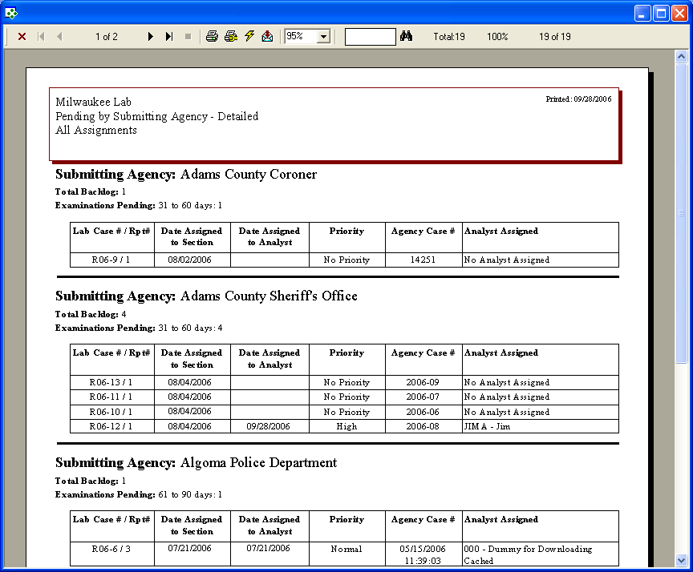
- The system shall provide the users with the capabilities to query the chain of custody of each exhibit or case as a whole. The system shall output the results to the screen and/or printer.
This is fully supported using the Print Chain feature within the Custody tab. The entire case or specific items can be selected. The output can be printed to screen and/or printer.
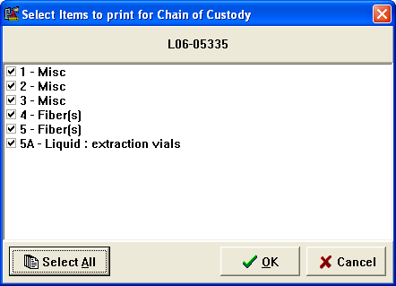
- The system shall provide the capabilities to query a case via all or any combination of the following fields:
  - Case Number
  - Date(s) of Submission
  - Submitting Agency Name
  - Submitting Agency’s Case Number
  - Subject’s Name
  - Victim’s Name
  - Submitting Officer
This is fully supported. See the response to requirement D1 above.
- The system should allow the ability to create ad-hoc (custom) reports using a third party reporting tool similar to Crystal Reports. FDLE desires the system to have custom report format capability (automatic template that users can modify and control).
This is fully supported. Crystal Reports is used in our system to generate ad hoc reports as well as providing the requested Custom report generation capability. The BEAST utilizes ODBC so other reporting tools can query the database as well.
- The system shall produce reports detailing evidence contained within the lab, specific sections, and/or individuals. The report should allow the results to be sorted and printed by various fields.
This is fully supported. Our Management Reports tool has a specific ad hoc report devoted to this requirement (see below).
Items Ad Hoc Report
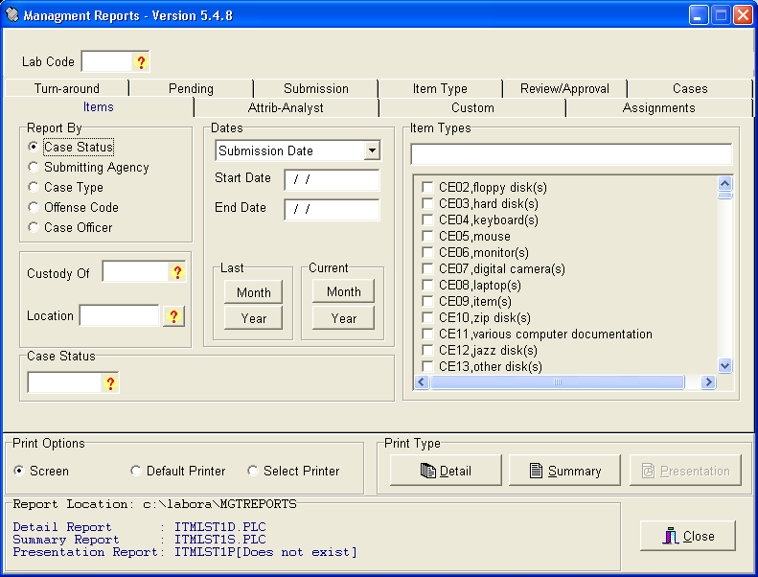
- The system shall produce standardized reports of the results of analysis performed by analyst. FDLE desires that final released reports of analysis be able to be stored within the data base for control and retrieval.
This is fully supported. One of the hallmarks of the Crime Fighter BEAST is the ability to produce standardized reports with minimum effort. Multiple options exist for creating analysis reports. These include Report Wizards, Word Templates and the Porter Lee Reporting Matrix tool. All of the different methods may be employed in the same laboratory. Reports are output in Crystal Report form or via Microsoft Word. Reports are stored in the database as requested.

- The system should provide the capability to manage the chemical drug standard inventory and the firearms reference collection. It should also manage the inventory firearms ammunition, calibration checks on analytical equipment, reagents and testing materials.
This is fully supported. Our Laboratory Asset Manager was designed for just this purpose and is fully integrated with the LIMS. Chemical drug standards, firearms reference collections, purchased and prepared reagents, and instruments can all be catalogued and tracked. Calibration checks may be recorded directly into the Lab Status Info tab of the application (shown below).
Firearms Tab of Laboratory Asset Manager
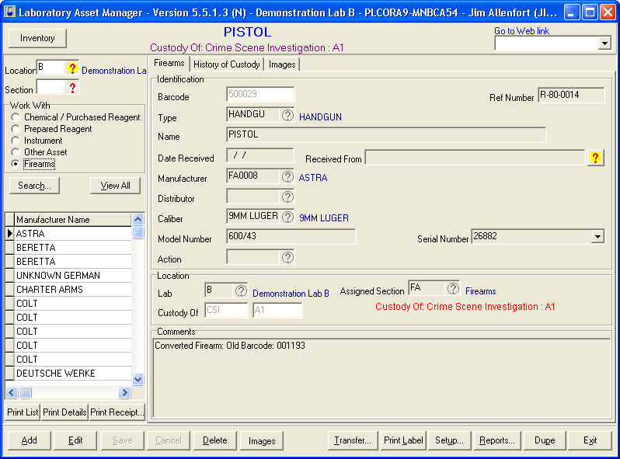
Image Vault Record of Firearm in Laboratory Asset Manager
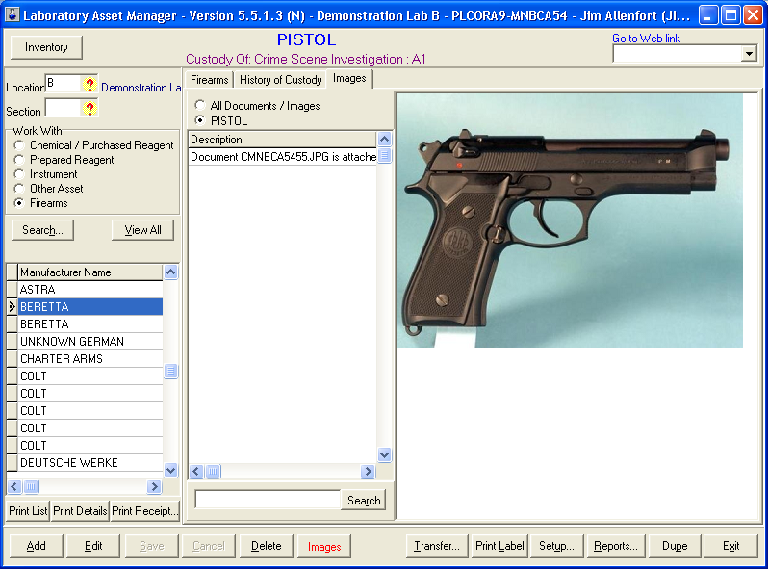
Laboratory Asset Manager: Instrument Service History Tab
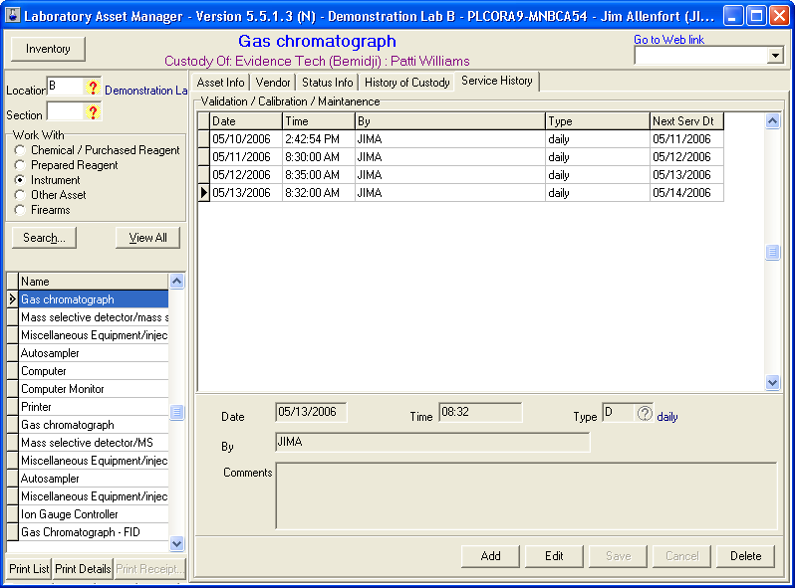
Laboratory Asset Manager: Status Info Tab
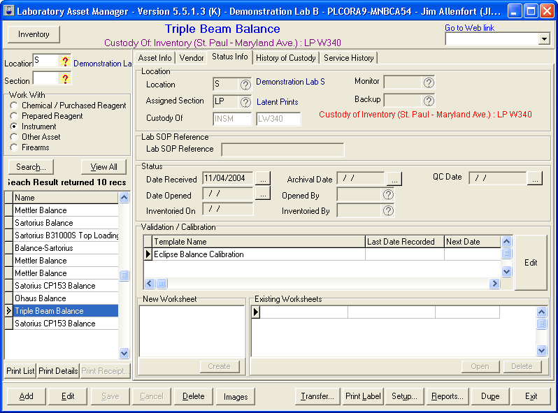

- The system should provide automated analysis reports for blood alcohol testing.
This is fully supported. The exact format of the report and the workflow involved would be part of the system configuration.

E. SYSTEM ADMINISTRATION
- The system shall provide the capability to maintain lookup tables and selection list for data entry. Examples include submitting agencies, facilities, drugs, weapons, etc.
This is fully supported. Most of the features of the LIMS hinge on this ability to store user-definable codes for system variables such as those mentioned. The Configuration program maintains all code lookup tables.
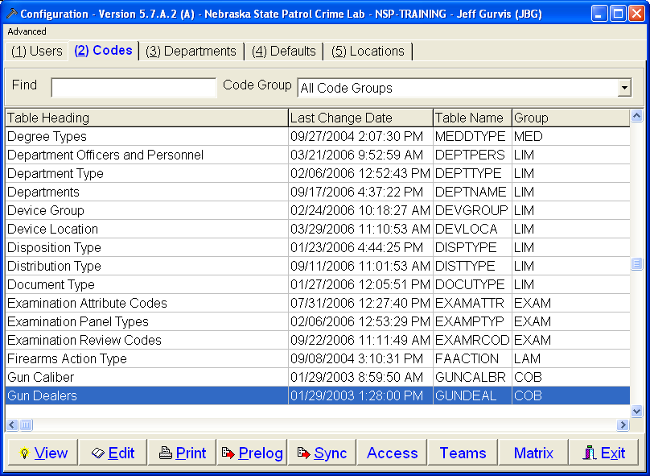

- The system shall provide the ability to modify and delete records.
This is fully supported. For virtually all system features, the Configuration program allows personnel with the proper permissions to modify and delete codes and other records. Although records can be modified and deleted, the Audit Log program stores all modifications, deletions, and additions made to the system.
- The system shall provide the capability to define and maintain user records. The user records maintenance includes staff name, laboratory assignments, user account, and password creation and reset.
This is fully supported through the Configuration application. See sample screen below.
User Tab in Configuration Application
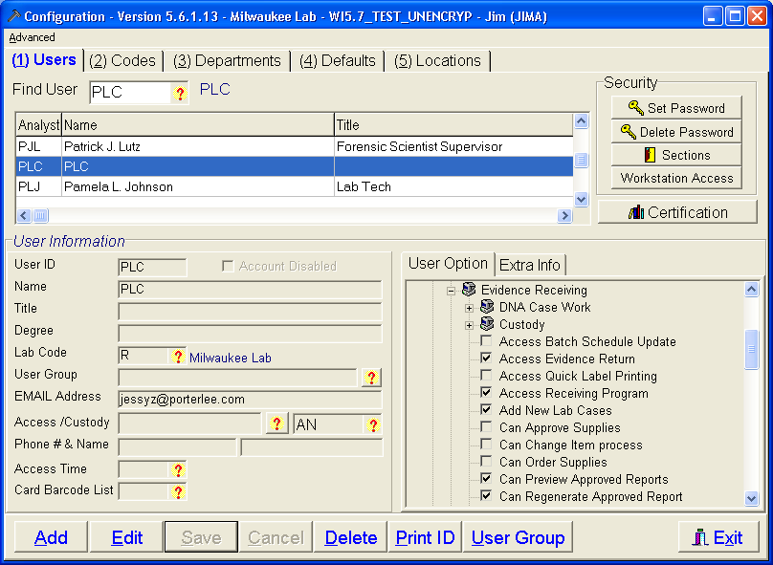

F. SECURITY AND AUDIT LOG
- The system shall employ security to restrict access to the software, to limit user capabilities, and to ensure proper user identification based on defined roles.
This is fully supported. User access may be restricted/permitted in a variety of ways. Users may be assigned to User Groups to define their access, or have permissions individually set for them. See the response to E3 above for a sample screen shot of the interface used to create/edit user profiles for lab personnel.
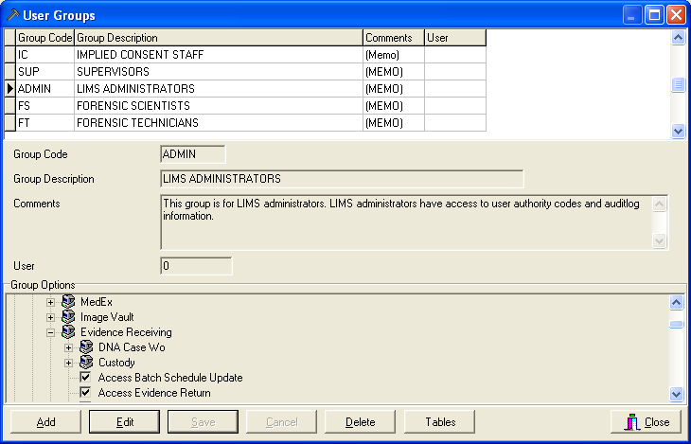

- The system shall implement security measures that ensure that only appropriate application functionality shall be provided to users with associated privileges. The privileges shall be established by the designated FDLE System Administrators.
This is fully supported. See the response to E3 and F1 above.

- The system shall implement security measures that ensure that users shall have access only to data for which they have appropriate privileges. The privileges shall be established by the designated FDLE System Administrators.
This is fully supported. See the response to E3 and F1 above. The Crime Fighter BEAST LIMS also has the ability to “lock” cases. Only those individuals who have the ability to lock cases and those who are assigned these cases will have access to them. This is especially useful for internal investigations or proficiency tests.
- The system should provide the capability to set the password length and expiration time duration.
This is fully supported.
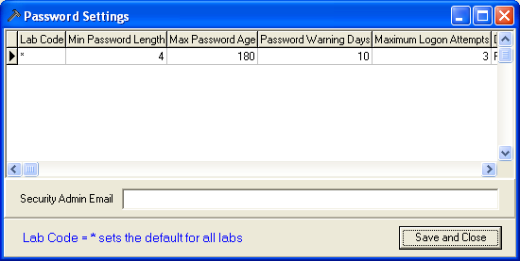
- The system should maintain a history of the user password for a minimum of five durations. The user should not be allowed to re-use a password stored in the history.
This is fully supported. The BEAST stores the passwords for six durations.

- The system shall log the user name, the information that is being modified or deleted and the date and time of occurrence.
This is fully supported via our Audit Log program. All such access is logged and may not be changed or deleted.

- The system shall provide the capability to output the audit log to the screen and/or printer.
This is fully supported.
Audit Log Report (can be viewed, printed or exported)
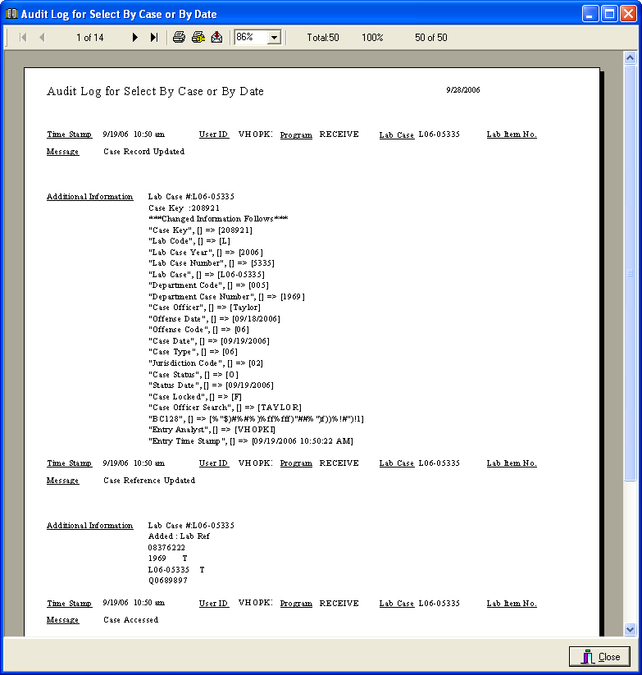
- The system must be able to demonstrate the ability to conform to equipment, software, data, security and functional requirements identified by the American Society of Crime Laboratory Directors/Laboratory Accreditation Board requirements.
A number of our customers are ASCLD/LAB accredited and our LIMS was instrumental in achieving accreditation for a number of them. The following labs which utilize the Crime Fighter BEAST LIMS are ASCLD/LAB accredited (not an exhaustive list).
New York State Police Forensic Investigation Center
Pennsylvania State Police
Minnesota Bureau of Criminal Apprehension
Alabama Department of Forensic Sciences
South Carolina Law Enforcement Division
Kansas Bureau of Investigation

- The system must also be able to demonstrate the ability to conform with requirements of the ASCLD/LAB-International 2006 Supplemental requirements for the accreditation of forensic science testing laboratories (Corresponds to ISO/IEC 17025:2005).
The Crime Fighter BEAST is also in use at the DuPage County Crime Laboratory who has achieved ISO 17025 certification along with the ASCLD/LAB-International 2006 Supplemental requirements.
- The contractor shall implement security measures, in compliance with Federal Guidelines as stated in the Criminal Justice Information Services (CJIS) Security Policy, to ensure that data transmission, processing, and storage are secure.
We will comply with this requirement.
- Per ISO/IEC 17025/2005, the LIMS must provide the ability to backup records stored electronically and to prevent unauthorized access to or amendment of these records.
This is fully supported.
- Per ISO/IEC 17025/2005, the LIMS must provide an audit trail.
This is fully supported using our Audit Log application.

- Per ISO/IEC 17025/2005, in the case of records stored electronically, measures shall be taken to avoid loss or change of original data.
This is fully supported. Any level of data security may be implemented.

- Per ISO/IEC 17025/2005, when computers or automated equipment are used for the acquisition, processing, recording, reporting, storage or retrieval of test or calibration data, the laboratory shall ensure that:(a) computer software developed by the user is documented in sufficient detail and is suitably validated as being adequate for use. Note: Commercial off-the-shelf software (e.g. word-processing, database and statistical programs) in general use within their designed application range may be considered to be sufficiently validated. However, laboratory software configuration/modification should be validated.
We comply with this requirement and will provide whatever documentation you require.

G. HARDWARE
- The vendor shall be responsible for planning and implementing sufficient hardware capacity to support laboratory and criminal justice users while meeting performance requirements.
We will work with the FDLE to determine exact hardware needs to meet this requirement.
- The vendor shall be responsible for planning and implementing sufficient storage capacity to support the crime laboratory.
We will work with the FDLE to determine exact hardware needs to meet this requirement. We currently have tools to assist in determining storage requirements

- The vendor shall provide a listing of the required hardware (i.e. servers, barcode scanners, barcode printers, etc.) needed to implement the system.
Central Database Server
Application File Server at each Lab
If images will be used extensively, a central Image SAN
Bar code Printers (Zebra TLP 2844,3842)
Bar code Scanners (Symbol 2208, 4400)
Signature Capture Pads (TT1500)
Palm Pilots (SPT 1800)

H. RELIABILITY AND SYSTEM PERFORMANCE
1. The vendor shall provide technical assistance based on the following performance standards:
General Performance Standards
A. The Scheduled Maintenance Window shall be each Saturday from 10:00 pm until Sunday 5:00 am; Eastern Time.
We can work within this maintenance window. The LIMS generally requires no scheduled maintenance, other than system backups which are automated.

B. When problems with the System are reported or identified, vendor shall designate a Severity Level for each problem as defined below. If FDLE disagrees with the Severity Level assigned by vendor, a change to the Severity Level will be discussed and mutually agreed upon. The Severity Levels are detailed below:
i. Severity Level 1 (Critical Problem). The System is unavailable, resulting in a critical impact to operations that require fast resolution.
ii. Severity Level 2 (Major Problem). FDLE-designated users can access the System; however material functions are not available.
iii. Severity Level 3 (Minor Problem). FDLE-designated users can access the System, and one or more of the less important functions are not available resulting in a minor impact.
iv. Severity Level 4 (Minor Problem/Enhancement Request). The impact is insignificant to users, and the Parties agree that problem resolution will require new functionality or an enhancement to be made at a mutually agreed upon date, at no cost to FDLE.
Porter Lee Corporation will conform to this problem classification scheme.
C. Vendor shall respond, i.e., begin working toward a resolution, to problems based on the Severity Level as described in the following table, with resolution being either a final solution or a workaround. The Response Time and Resolution Time intervals begin when FDLE reports the problem into vendor’s Helpdesk System and a ticket is generated for this particular report. Upon consultation with and approval by an authorized FDLE representative, the times given below can be extended.

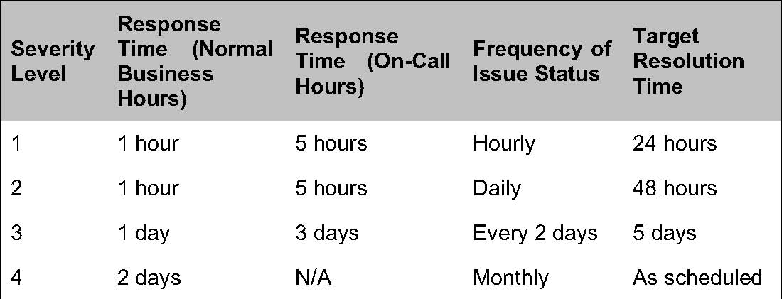
Note: Any time expressed in days represents business days and not calendar days.
Porter Lee Corporation’s normal support policies exceed those required. Our response time for all calls during normal business hours is one hour. During on-call hours it is 3 hours. We will meet or exceed these requirements unless agreed upon otherwise.
For more information regarding our standard Support and Maintenance policies, see the Contracts Tab 6.
2. The vendor shall ensure that the system provides timely responses to inquiries. The vendor shall provide a list of standard inquiries / transactions available through the proposed system with associated response times.

Application functional benchmarks – (These times are typical for an experienced user.)
Item | Description | Time
Create a Case | Create a new 5 item case in the LIMS, print and affix barcodes. Print receipt. | 2 minutes
Add a user | Create a new user in the LIMS and assign all permissions and defaults | 30 seconds
Transfer an item | Use the barcode scanner to transfer custody of 10 items to the same location and print a receipt for the transaction. | 1 minute
Write a report | Create a simple controlled substance report using the matrix. Data entered for 5 items with each item including weight, description, substance found, schedule and notes. | 3 minutes
Approve a report | Perform administrative review or approval of a batch of 20 reports using the barcode scanner. | 30 seconds
Screen specific Transactional benchmarks

Item | Description | Time
Search for a case | Display a list of recent 100 cases for a user. | 2 seconds
Load a case | Access the electronic case file for a case that has been double clicked on the case find form (Case, Submission, name, item and report data) | 2 seconds
Save Case Record | Time it takes to save changes to the “Case Info” tab after clicking the “Save” button. | 2 seconds
Save a submission record | Time it takes to save changes to the Submission tab after clicking the “Save” button. | 1 second
Save an item record | Time it takes to save changes to the “Item” tab after clicking the “Save” button. | 1 second
Save a name record | Time it takes to save changes to the “Name” tab after clicking the “Save” button. | 1 second
Save a custody record. | Time it takes to save changes to the “Custody” tab after clicking the “Save” button. | 1 second
Save an assignment record. | Time it takes to save changes to the “Assignment” tab after clicking the “Save” button. | 2 seconds

I. ARCHITECTURE
- The vendor shall be responsible for converting and migrating FDLE’s existing data into the proposed system.
This is fully supported.
Porter Lee Corporation will design a custom migration plan after the customer has delivered the existing legacy data. Porter Lee Corporation designs data migration plans to meet the following objectives.
Objective 1 - Porter Lee Corporation will move all case related data into the LIMS database. This is accomplished by converting data into existing LIMS fields; Data which does not match an existing data element can be placed into comments. In addition, all tables from the source database are placed into LIMS supplemental tables. This insures that the legacy data is always available in its original form.
Objective 2 - Porter Lee Corporation will refine the conversion to insure the customer is satisfied with the presentation of the converted data within the LIMS. Many times this requires the conversion plan to be adjusted and the program to be re-run.
Objective 3 - Porter Lee Corporation will insure the customer is satisfied with the presentation of the converted data within the LIMS. Many times this requires the conversion plan to be adjusted and the program to be re-run before acceptance.
Objective 4 – Porter Lee Corporation will complete the conversion before training takes place. This allows the plan to include procedures for working with converted cases that were open at the time of the conversion, as well as cases that were created in the LIMS from the beginning.
Conversion Approach
Porter Lee Corporation (PLC) takes the follow the following steps while converting laboratory case information into the Crime Fighter BEAST LIMS.
1. The Lab will provide the database(s) to PLC on CDROM. It is important that all the data be submitted to PLC, not just a sampling. This allows full testing to occur so that any exceptions are identified. The Lab should include any descriptive information available for the data. This includes a data dictionary, application screen shots or documentation if possible.
2. The data will be evaluated by PLC and an outline of the conversion process will be provided to the Lab. The Lab will work together to refine this document. This will require the programmer and the Lab’s representative to discuss the data and the relationship between tables.
3. After the first pass of conversion has taken place the Lab will be able to review the converted data in there own database. PLC will assist the Lab in comparing the data in the LIMS to the data in the existing computer system. If it is determined that there is a need to change the conversion Porter Lee Corporation will make the required changes and re-run the conversion. During this time period, Porter Lee Corporation cleanup work is normally done on certain table such as department names and item types.
4. Once all changes are done and the converted data is acceptable to the customer, the final conversion is scheduled a day before the Lab goes live with the BEAST LIMS. The Lab should provide the final data on or before the same day the final conversion will take place. The final data should be in the same format as the original data.
5. When the final converted data is in place and the Lab is live with the LIMS, the Lab may still request changes with the converted data. All data from the provided database will be converted into the LIMS database unless otherwise noted.
6. Porter Lee Corporation and the Lab will work together to create guidelines for LIMS users to continue work on cases that were in-progress when converted.

- The vendor shall propose a centralized architecture capable of handling the expected volume of cases with minimum impact on overall performance.
Our proposed centralized architecture is outlined in detail in Attachment A in this tab of the proposal.
- The system should be implemented in the latest version of Oracle RDBMS or Microsoft SQL Server. If Oracle RDBMS is selected it shall be installed in a Linux environment.
This requirement is fully supported. Our LIMS runs on the latest version of Oracle and has been installed in a Linux environment before.
- The system shall use the existing local and wide area networks.
The proposed system will utilize FDLE’s existing network infrastructure.

J. USERS AND SOFTWARE LICENSES
- The system shall have the capacity to support a minimum of 450 named users with an estimated 150 simultaneous users during peak periods.
The proposed system complies with this requirement.
- The vendor should provide an optional price for additional user licenses (i.e. 1, 50, 250, unlimited, etc.). this will not be a factor in awarding points for cost.
Please see our cost proposal for this information.
- As a requirement of the support and maintenance, the vendor shall provide software updates at no additional cost.
Software updates are at no cost to all customers who are on a current support and maintenance contract.
- The user and equipment break down are as follows:

Laboratory | User License | Bar Code Printer | Bar Code Wands
Pensacola | 32 | 4 | 21
Tallahassee | 75 | 5 | 38
Jacksonville | 63 | 5 | 35
Orlando | 109 | 12 | 66

Daytona | 19 | 4 | 17
Ft. Myers | 31 | 4 | 21
Tampa | 121 | 12 | 68

K. USER SUPPORT
- The vendor shall provide a help desk available 7 x 24 for the service provided.
Help desk support will be provided as required.
- The vendor shall be capable of tracking all help requests and/or system problems. The vendor shall demonstrate the ability to do the following:
    - Log all calls received,
    - Track all calls through out the process until the solution or information is relayed back to the customer,
    - Give every call a unique number for tracking purposes, preferably a "ticket #"
    - Produce a report of all outstanding tickets in a given time period,
    - Produce a report of all closed tickets in a given time period,
    - Search by any field,
    - Track all work requests, complaints, and informative calls
    - Support copy and paste with other Windows applications
    - Assign authorized FDLE members to access the System and other security functions
Porter Lee Corporation is available 24 hours a day, 7 days a week. All of the requirements of K2 are met using our advanced Trouble Ticket Tracking application (see sample window below which shows an in-house ticket for a system enhancement). This system is our main interface to customer-support issues. Customers may utilize our support web site to access their tickets and check the status of any outstanding issues.
Trouble Ticket Display
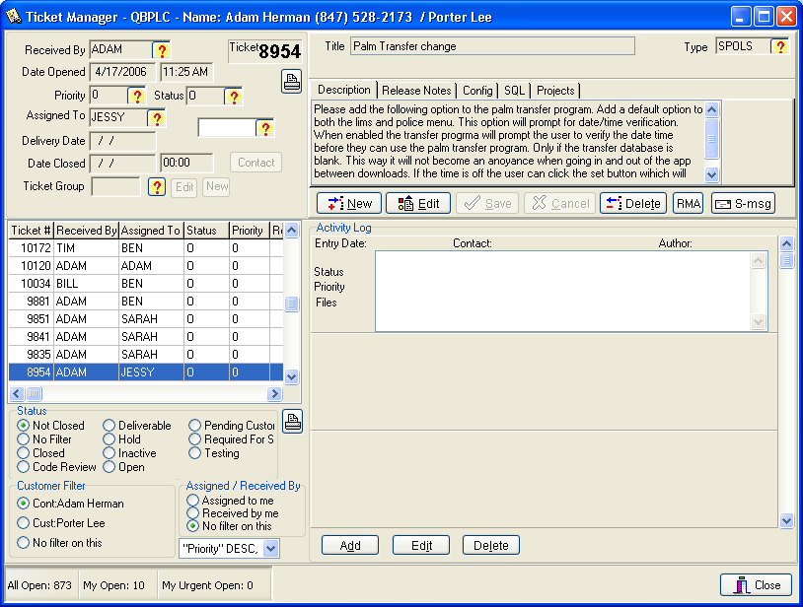
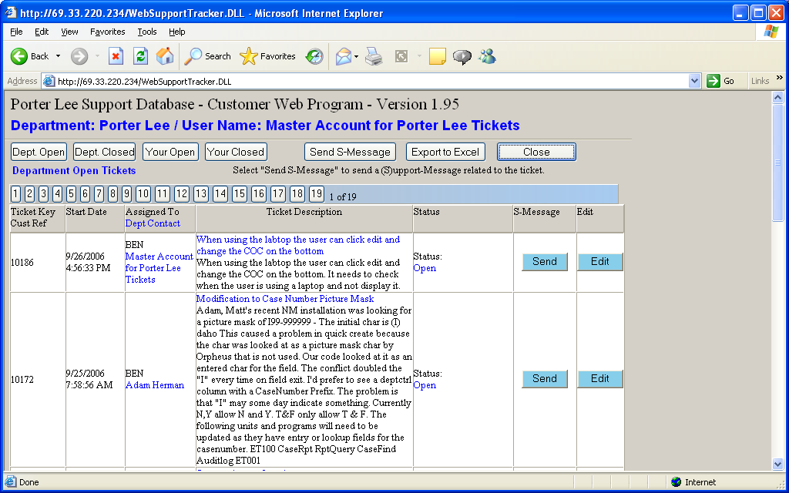
- The vendor shall provide customer and technical support with professionals dedicated to the following:
    - answer questions
    - document comments/suggestions
    - provide technical or administrative information regarding the system
Currently, 50% of our staff are devoted to these activities full-time. The other 50% of our staff are available for overflow or highly skilled support activities.
- The target response time to issues received by the help desk is 24 hours for the services provided.
Our response time will meet or exceed this requirement.

L. PROJECT MANAGEMENT
- Proposers shall submit a Project Management Plan (PMP) with the initial proposal. FDLE will work with the selected vendor to refine the PMP.
Please see the attached Project Management Plan document in this tab.
- The vendor shall appoint a Project Manager (PM). The vendor’s PM shall work full-time throughout the life of the project. The vendor’s PM shall have authority to make managerial and technical decisions concerning the project. The vendor’s PM shall serve as the primary point of interface between the vendor and FDLE. Communications between the Vendor and FDLE shall be coordinated with the vendor’s PM.
Our project management procedures will follow this requirement. Porter Lee Corporation will assign a full-time employee as the Project Manager for this project.
- FDLE reserves the right to require the vendor to replace the Project Manager at any time. FDLE shall give the vendor a ten (10) work day notice if it desires to have the PM replaced. Such notice shall contain FDLE’s explanation for PM replacement for the vendor to assess the appropriate action and find a suitable replacement.
Porter Lee Corporation will comply with this requirement.
- The Project Management Plan may be changed only by written agreement by the Vendor and the Department. For each change, a Project Change Request form shall be prepared. Each Project Change Request shall be assigned a unique request number. If a change has no impact on cost or major milestone schedule, a written agreement between the Vendor and the Department may be made using the Project Change Request form. If the change impacts cost, major milestone schedule, or any other contractual term and/or condition, a formal amendment to the contract, signed by both parties, shall be required.
These requirements mirror our standard operating practices. We will comply with this requirement. Please see the attached Project Management attachment.
- No request for any alteration or modification to the Project Management Plan shall be valid unless agreed upon in writing by the Vendor and the Department. No oral statement of any person shall in any manner affect the Project Management Plan.
Agreed.
- Vendor shall assist FDLE in implementing a Communication Plan (CP). The Communication Plan shall be used to guide communication between the vendor and FDLE.
Agreed.

M. TRANSITION AND IMPLEMENTATION PLAN
- The vendor shall provide a plan for transitioning from current system to proposed system operational mode.
Porter Lee Corporation will comply with this requirement.
The key elements to a successful transition from any legacy system to the proposed LIMS involves the preparation of facility, data and people as well as continuous risk management throughout the life of the project.
Based on our extensive experience the following are examples transitional factors in these categories:
Facility preparations
• Workstations and server installation verified (peripheral equipment)
• Database installation verified
• Backup routines and fail-over
• Support/remote access
• Legacy database system is read-only access for go-live
• Barcode labels for locations and procedures for handling existing evidence.
Data
• Conversion (Key FDLE person identified to assist in mapping of data from legacy system new LIMS)
• The conversion process begins with the most recent years first and moves backwards.
• Testing of converted data by all functional units.
People
• Training occurs on converted data so that all users are familiar where data resides.
• Training occurs immediately prior to go-live for retention of new knowledge.
• Users are trained on procedures for converted cases versus new cases.
• Business processes are clearly defined and quick reference sheets are available for common functions.
• SOPs are modified and distributed prior to go-live
- The vendor shall provide a detailed implementation plan that describes how the system will be put into production.
Please see our initial Project Management Plan attached.
- The vendor shall assume all operational and specified support responsibility for the life of contract from time of acceptance by FDLE.
Agreed.
- The vendor shall provide support personnel on site, as appropriate, to assist FDLE in the transition to the new system. The areas of support need to be for, at a minimum:
    - operating system and environmental software,
    - application software,
    - data communications hardware and software,
    - database software,
    - operations staff, and
    - data update scripts/processes.
Agreed. We will work closely on site with your staff to assist the transition as specified.

N. TEST STRATEGY AND PLAN
- The vendor and FDLE shall agree on a test strategy and plan.
Upon award part of the project manager’s duties will be to collaborate with FDLE to create this plan.
- The test strategy shall propose in detail the testing approach recommended by the vendor.
Agreed.
- The test plan shall detail all the system processes and have a comprehensive test script for each process.
Agreed.
- The test plan shall include a stress test to measure the performance of the system and to establish a baseline.
Agreed
- FDLE reserves the right to conduct its own test(s) independent of any testing performed by the vendor.
Agreed.
- The system acceptance will be determined solely by FDLE’s testing.
Agreed.

O. TRAINING
- Vendor shall provide training sessions for small groups at FDLE’s site. This training is to be of a nature that those trained shall be able to train others in the use of the system. Training shall be included in the cost of the system.
Please see our attached Sample Training Plan (Attachment 4B). This document is simply a starting point for determining your exact training needs.
- Vendor shall provide an estimated timeframe for conducting training for this type of environment.
After award, part of the Project Plan Development process will be to determine the exact timeframes for each of the sections as well as system administrators. Our project plan estimates approximately 25 days of training for all sections and the System Administrators.
- Vendor shall prepare and provide how-to-guides, quick reference cards, and other reference materials.
Agreed.
- The system shall provide on-line help screens.
The system currently offers multiple methods for providing on-line help.
- The system should provide an on-line tutorial detailing business processing.
Remote access methods may be used for providing on-line demonstration, instruction and tutorials using VPN, VNC, PC-Anywhere and GoToMyPC (Citrix corp).

P. INSPECTION AND ACCEPTANCE PROCESS
- The Vendor shall notify FDLE’s Project Manager in writing when the System is ready for the FDLE’s testing and acceptance. This will be done by delivering to FDLE’s Project Manager a signed Certificate of Acceptance.
Agreed.
- Using the test plans described within section P above, FDLE will test the system. If FDLE identifies deficiencies in the System, FDLE’s Project Manager will provide the Vendor with written notice of the deficiencies. The Vendor shall correct the deficiencies at no additional charge, during a period acceptable to the Department. If FDLE requires additional time to review the System, FDLE’s Project Manager shall notify the Vendor in writing.
Agreed.
- If, in FDLE’s sole opinion, deficiencies continue to exist in the System after the corrective action period, FDLE may terminate the contract or negotiate an equitable adjustment.
Agreed.
- When FDLE is satisfied with the System, FDLE’s Project Manager will sign the Certificate of Acceptance for the System.
Agreed.

Q. PROPOSED PROJECT SCHEDULE
- The vendor shall provide estimated timeframes for the life of the project including the data migration, functionality testing, training, and statewide implementation.
An initial estimate is attached as Attachment 4c in this Tab.
This Page Intentionally Blank

