Bayesian Inference II

Maxwel Cheruiyot

SCM223-0138/2019

2023-07-10

draw_y_given_x<-function(x){  
 y<-runif(1,min = x,max = 2 - x)  
 return(y)  
}  
draw_x_given_y<-function(y){  
 x<-runif(1,min = 0,max = 1)  
}  
gibbs_sampler<-function(num_iterations) {  
 x<-0.5  
 y<-1.5  
 samples<-matrix(NA, nrow = num_iterations, ncol = 2)  
 for (i in 1:num_iterations){  
 y<-draw_y_given_x(x)  
 x<-draw_x_given_y(x)  
 samples[i, ]<-c(x,y)  
 }  
 return(samples)  
}  
num_iterations<-10000  
samples <-gibbs_sampler(num_iterations)  
hist(samples[, 1], breaks = 30, freq = FALSE,main = "Marginal Density: ∏(x)",xlab = "x")

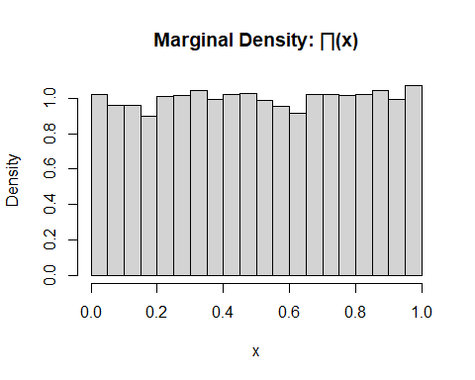

hist(samples[, 2], breaks = 30, freq = FALSE,main = "Marginal Density: ∏(y)",xlab = "y")

