Survival Data Analysis

Erick Bala

SCM223-0190/2018

2023-10-19

## 

library(survival)  
Leukemia<-read.csv(file.choose(),header =TRUE)  
View(Leukemia)  
attach(Leukemia)  
str(Leukemia)

## 'data.frame': 21 obs. of 2 variables:  
## $ Time : int 6 6 6 7 10 13 16 22 23 6 ...  
## $ Status: int 1 1 1 1 1 1 1 1 1 0 ...

Time

## [1] 6 6 6 7 10 13 16 22 23 6 9 10 11 17 19 20 25 32 32 34 35

Status

## [1] 1 1 1 1 1 1 1 1 1 0 0 0 0 0 0 0 0 0 0 0 0

#Construct Survival object  
Leukemia_Patients<-Surv(Time,Status)  
Leukemia_Patients

## [1] 6 6 6 7 10 13 16 22 23 6+ 9+ 10+ 11+ 17+ 19+ 20+ 25+ 32+ 32+  
## [20] 34+ 35+

#Kaplan_Meier Survival fit  
KP_Meier_fit<-survfit(Leukemia_Patients~1)  
summary(KP_Meier_fit)

## Call: survfit(formula = Leukemia_Patients ~ 1)  
##   
## time n.risk n.event survival std.err lower 95% CI upper 95% CI  
## 6 21 3 0.857 0.0764 0.720 1.000  
## 7 17 1 0.807 0.0869 0.653 0.996  
## 10 15 1 0.753 0.0963 0.586 0.968  
## 13 12 1 0.690 0.1068 0.510 0.935  
## 16 11 1 0.627 0.1141 0.439 0.896  
## 22 7 1 0.538 0.1282 0.337 0.858  
## 23 6 1 0.448 0.1346 0.249 0.807

#Plot Kaplan Meier survival curve with no confidence intervals  
Curve1<-plot(KP_Meier_fit,conf.int = F,xlab = "Time",ylab = "Survival Probability",main = "Kaplan Meier Survival Plot")

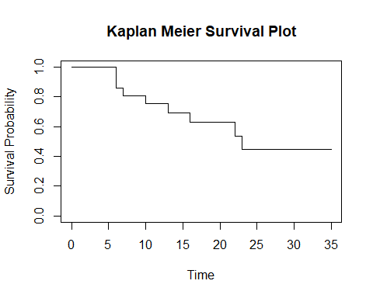

Curve1

## $x  
## [1] 35  
##   
## $y  
## [1] 0.4481793

#plotting the Kaplan meier with confidence intervals

Curve2<-plot(KP_Meier_fit,conf.int = T,xlab = "Time",ylab = "Survival Probability",main = "Kaplan Meier Survival Plot")

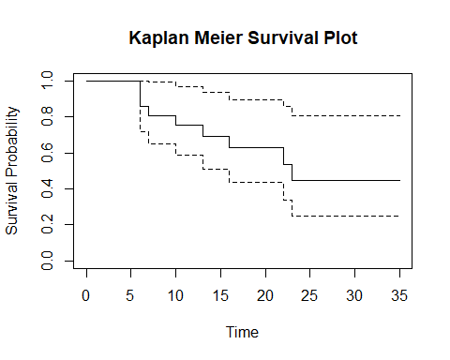

Curve2

## $x  
## [1] 35  
##   
## $y  
## [1] 0.4481793

#plotting the Kaplan meier with confidence intervals with censored points

Curve3<-plot(KP_Meier_fit,conf.int = T,xlab = "Time",ylab = "Survival Probability",main = "Kaplan Meier Survival Plot",mark.time = T)

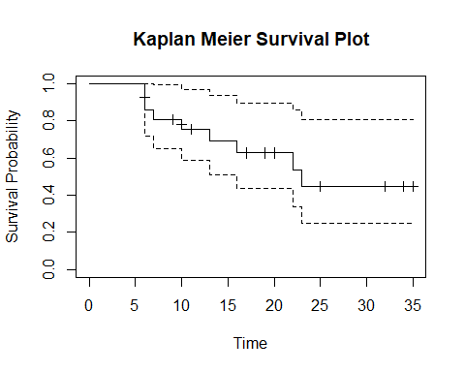

Curve3

## $x  
## [1] 35  
##   
## $y  
## [1] 0.4481793