Team Nuggets:

Maximilian Christ, Jon Galindez, Caitlin Kwan, Jessica Lin, and Kenneth Lofstrom

**Project Documentation:**

Marketing:

Description of Application:

The application is a game meant to be played in landscape mode on an Android phone. It is an endless game that grew out of the famous riddle “Why did the chicken cross the road?” The game starts the player off with four lives, with the goal of bringing the chickens as far across the road as they can. The player must time their road crossing with the speed of cars traveling horizontally across the screen, to prevent their chicken from being run over and turned into a chicken nugget. The farther the player progresses the faster and more frequent cars will be driving down the road in front of the chicken making the game much more difficult the better the player is. After the player has used up their four lives, a game over screen will appear telling the player they have helped to contribute to a delicious four-piece chicken nugget meal. This game is perfect for anyone who enjoys playing games on their phone and has free time on their hands. It’s great for anyone who rides the train to work or school. And the high score feature makes competitive people strive to beat their personal best, and to see which of their friends can get the chicken to cross the farthest!

Application Processing (backend code):

Excluding the GUI, the application code consists of 8 major files, including 4 objects.

Objects:

|  |
| --- |
|  |
| The x size of the plane |
| The y size of the plane |
| Contructs a double by double plane |
| Constructs default plane |
| Determines if two points have the same location |

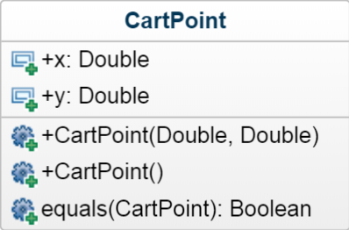

|  |
| --- |
| The current location of the Car |
| The previous location of the Car |
| The current speed of the Car |
| Default Car constructor |
| Constructor that determines car location and speed |
| Changes the previous location of the Car |

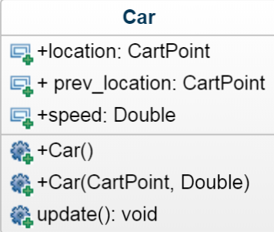

|  |
| --- |
| The current location of the chicken |
| How far the player has progressed |
| Default Player constructor |
| Finds the x location of Player |
| Finds the y location of Player |
| Finds both x and y location of Player |
| Moves the player up one spot |
| Moves the player down one spot |
| Determines the current progression of Player |

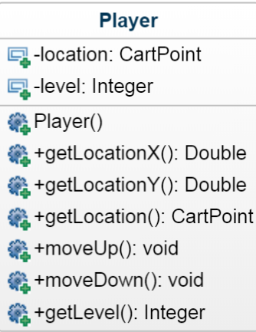

|  |
| --- |
| Creates an array of Car models |
| Creates the model of the chicken |
| Default Model constructer that makes all Car models |
| Determines the direction of movement for the chicken model |

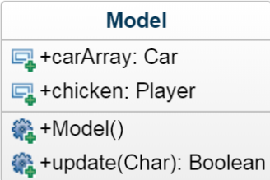

Activity Files:

Game_Command.java:

This file determines whether or not the chicken is dead, returning true if the Player’s location is the same as any of the Car’s locations. This is done using the update function from the Model class, so when the player moves either up or down their location is compared to the location of any of the Cars on the screen, determining whether or not the chicken would have been hit.

MainActivity.java:

Creates the Player character on the screen, and initializes the lane the Player starts in as well as the number of lives the player has. Loops as long as the player is playing the game, hasn’t quit out, and the number of lives is greater than 0, constantly checking to see if the Player is dead or not. If true, the player will lose a life. This file also contains the controls for the Player object, causing the on screen changes for when the user presses either the up or down buttons.

main.java:

The main file interfaces between the GUI and the backend code, constantly scanning for user inputs while the user is playing the game and has more than 0 lives. It keeps track of the score of the user by getting the location of the chicken model and recording this as the lane number for the player. If the player has the same location as a car it also removes a life from the Player.

Graphical User Interface(GUI):

Structure/Navigation:

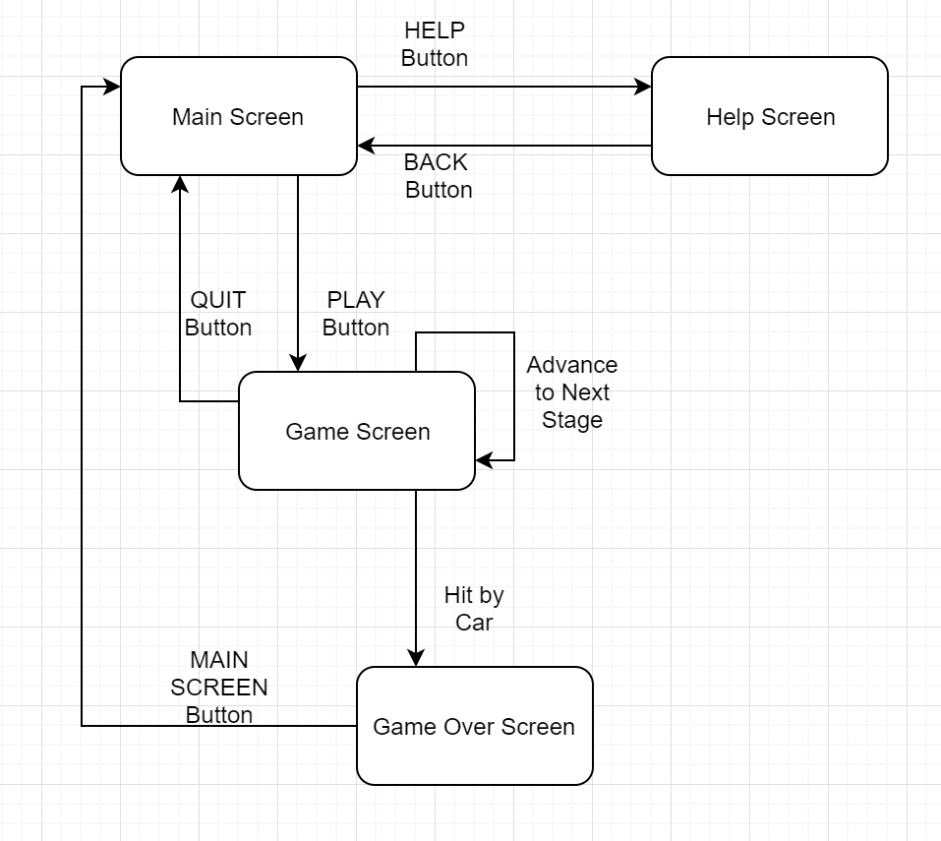

Screen Descriptions:

* Main Screen:

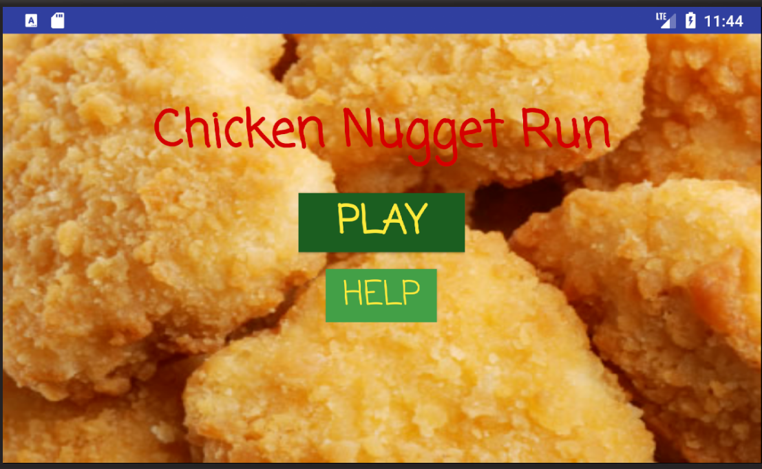

The main screen displays the title of the application, “Chicken Nugget Run” across the top of the phone screen. There are two buttons in the center of the main screen, PLAY and HELP. Pressing the Play button will bring you to the game screen and pressing the help button will bring the user to the help screen. All of the buttons and text sit on a background of chicken nuggets that take up the whole screen.

* Game Screen:

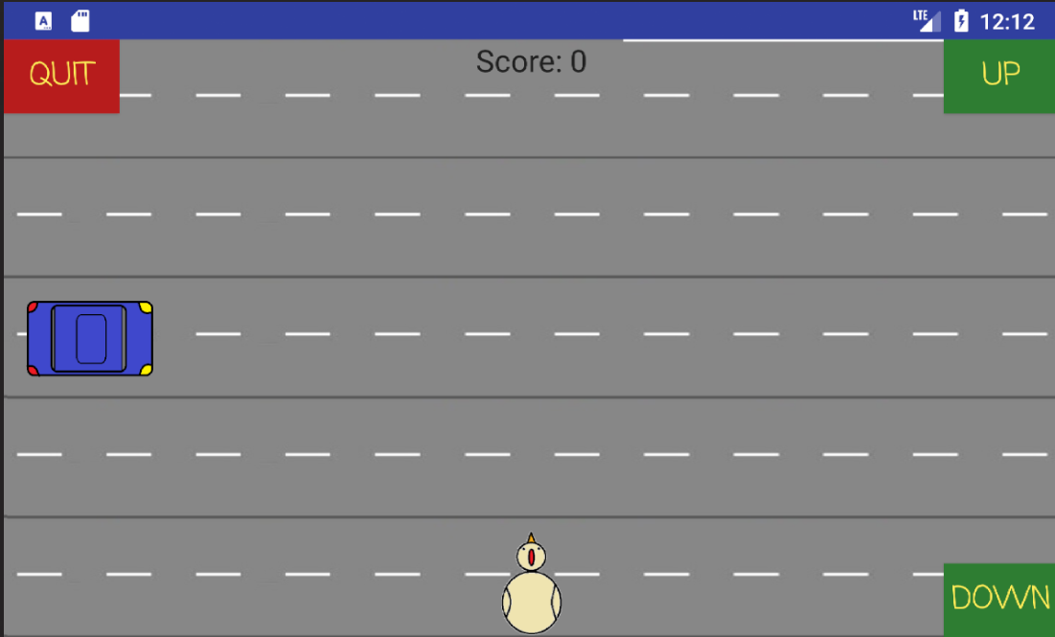

The game screen is where players will spend the majority of time with the app. This screen is accessed by pressing the play button on the main screen. The chicken nugget background is replaced with a 5 lane road. The player object, the chicken, begins in the bottom middle of the game screen. The chicken can be controlled using either the up or down buttons located in the top right and bottom right corners of the screen, respectively. In the top left corner of the screen is a red quit button that allows the user to quit to the main screen. In the top center in black text the players current score is kept, changing with each lane the user travels.

* Help Screen:

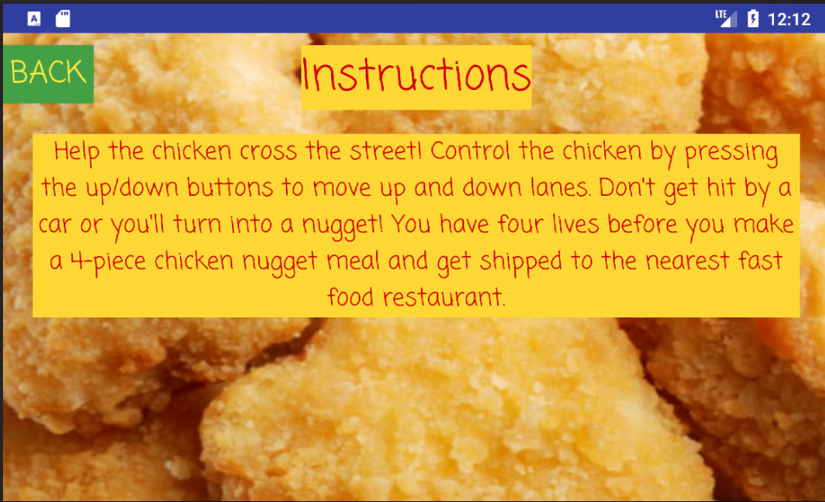

The help screen is made up of two text boxes, one button, and the same chicken nugget background as the title screen. Across the top middle of the screen is a text box labeled “Instructions”. Below the directions for how the game is to be played is described for the player. In the top left corner of the help screen is a back button, which will bring the user back to the Main Screen. This can also be done using the Android’s built in back button.

* Game Over Screen:

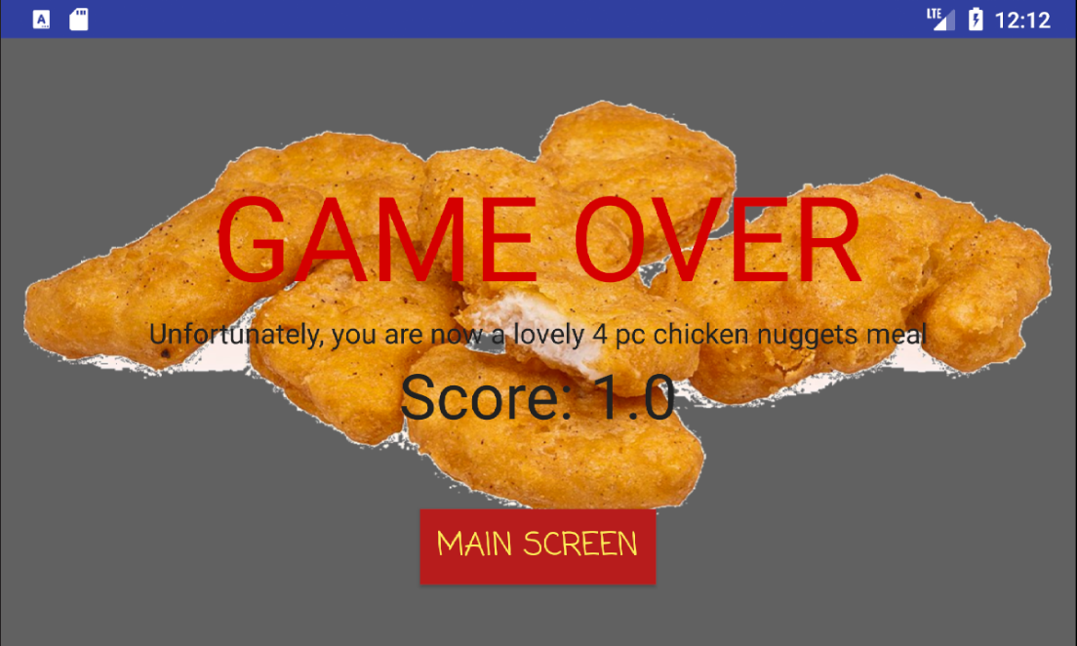

The Game Over Screen displays an image of a collection of chicken nuggets over a gray background. Overlaid on the image is a variety of text, the most prominent being a large red GAME OVER, followed by the statement that “Unfortunately, you [the user] are now a lovely 4 pc chicken nuggets meal”, and finally the finishing score of the player is displayed. Below the nuggets image in a button that will bring the user back to the main screen, so the user can play again.