Copula Usage
Max
10/22/2020
library(MASS)
library(mvtnorm)
library(plotly)
## Loading required package: ggplot2
##
## Attaching package: 'plotly'
## The following object is masked from 'package:ggplot2':
##
## last_plot
## The following object is masked from 'package:MASS':
##
## select
## The following object is masked from 'package:stats':
##
## filter
## The following object is masked from 'package:graphics':
##
## layout
library(copula)
## Warning: package 'copula' was built under R version 4.0.3
library(VineCopula)
## Warning: package 'VineCopula' was built under R version 4.0.3
##
## Attaching package: 'VineCopula'
## The following object is masked from 'package:copula':
##
## pobs
library(ggplot2)
library(GGally)
## Registered S3 method overwritten by 'GGally':
## method from
## +.gg ggplot2
library(plot3D)
## Warning: package 'plot3D' was built under R version 4.0.3
Generating values from multivariate normal distribution
set.seed(100)
X_bar = matrix(c(2,3), nrow=2)
S = matrix(c(2,-1,-1,2), nrow=2, ncol=2, byrow=TRUE)
normVals = mvrnorm(n=700, mu=X_bar, Sigma = S)
var(normVals)
## [,1] [,2]
## [1,] 1.881065 -1.016577
## [2,] -1.016577 2.219619
cor(normVals)
## [,1] [,2]
## [1,] 1.000000 -0.497507
## [2,] -0.497507 1.000000
ggplot(data.frame(normVals), aes(x=X1)) +
geom_histogram(bins=30, color = 'darkorchid3', fill = 'orchid3') +
ggtitle('Histogram of Simulated Normal Values with mu = 2, var = 2') +
ylab('Frequency') +
coord_cartesian(ylim = c(0,70), xlim = c(-3,8))
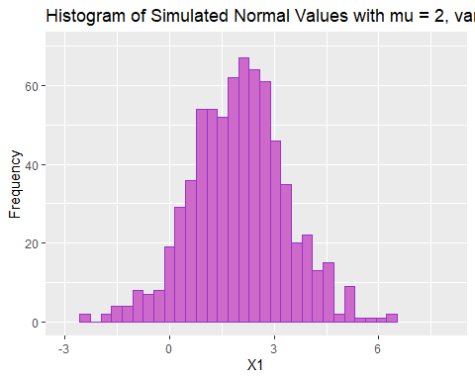
ggplot(data.frame(normVals), aes(x=X2)) +
geom_histogram(bins=30, color = 'darkorchid3', fill = 'orchid3') +
ggtitle('Histogram of Simulated Normal Values with mu = 3, var = 2') +
ylab('Frequency') +
coord_cartesian(ylim = c(0,70), xlim = c(-3,8))
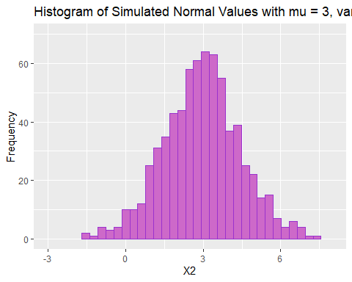
ggpairs(data.frame(normVals))
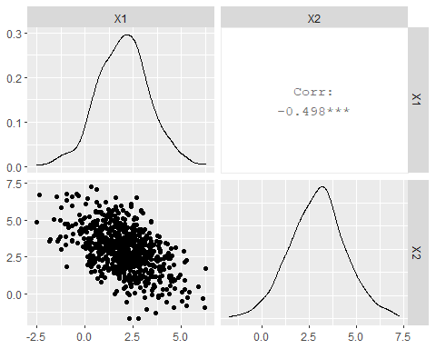
Pairsplot and histogram of simulated bivariate normal values.
pvals = cbind(pnorm(normVals[,1], mean=2, sd=sqrt(2)), pnorm(normVals[,2], mean=3, sd=sqrt(2)))
ggplot(data.frame(pvals), aes(x=X1)) +
geom_histogram(bins=30, color = 'darkorchid3', fill = 'orchid3') +
ggtitle('Histogram of Simulated F(X1) Values Using pnorm') +
ylab('Frequency') +
coord_cartesian(ylim = c(0,40))
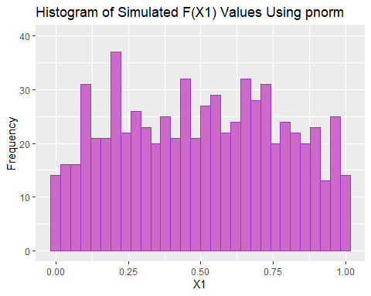
ggplot(data.frame(pvals), aes(x=X2)) +
geom_histogram(bins=30, color = 'darkorchid3', fill = 'orchid3') +
ggtitle('Histogram of Simulated F(X2) Values Using pnorm') +
ylab('Frequency') +
coord_cartesian(ylim = c(0,40))
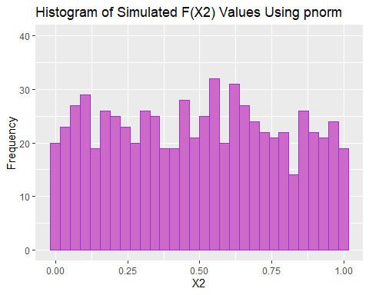
ggpairs(data.frame(pvals))
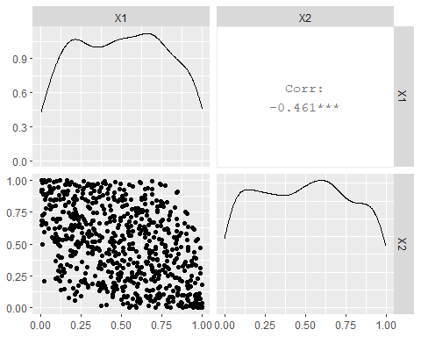
epvals = cbind(pobs(normVals[,1]),pobs(normVals[,2]))
ggplot(data.frame(epvals), aes(x=X1)) +
geom_histogram(bins=30, color = 'darkorchid3', fill = 'orchid3') +
ggtitle('Histogram of Simulated F(X1) Values Using Cumulative Density Estimation') +
ylab('Frequency') +
coord_cartesian(ylim = c(0,40))
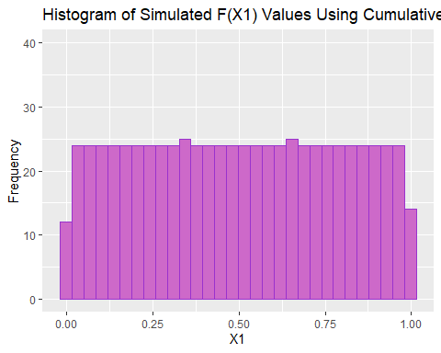
ggplot(data.frame(epvals), aes(x=X2)) +
geom_histogram(bins=30, color = 'darkorchid3', fill = 'orchid3') +
ggtitle('Histogram of Simulated F(X2) Values Using Cumulative Density Estimation') +
ylab('Frequency') +
coord_cartesian(ylim = c(0,40))
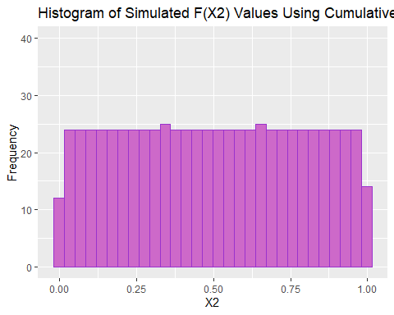
tmp = BiCopSelect(pvals[,1],pvals[,2])
summary(tmp)
## Family
## ------
## No: 1
## Name: Gaussian
##
## Parameter(s)
## ------------
## par: -0.49
##
## Dependence measures
## -------------------
## Kendall's tau: -0.32 (empirical = -0.31, p value < 0.01)
## Upper TD: 0
## Lower TD: 0
##
## Fit statistics
## --------------
## logLik: 98.54
## AIC: -195.08
## BIC: -190.53
Estimated copula and parameters when using true cumulative.
tmp = BiCopSelect(epvals[,1],epvals[,2])
summary(tmp)
## Family
## ------
## No: 1
## Name: Gaussian
##
## Parameter(s)
## ------------
## par: -0.5
##
## Dependence measures
## -------------------
## Kendall's tau: -0.33 (empirical = -0.31, p value < 0.01)
## Upper TD: 0
## Lower TD: 0
##
## Fit statistics
## --------------
## logLik: 97.48
## AIC: -192.97
## BIC: -188.42
Estimated copula and parameters when using estimated cumulative.
normCop = normalCopula(dim=2)
copFit = fitCopula(normCop,as.matrix(pvals))
copFit
## Call: fitCopula(copula, data = data)
## Fit based on "maximum pseudo-likelihood" and 700 2-dimensional observations.
## Copula: normalCopula
## rho.1
## -0.4881
## The maximized loglikelihood is 98.54
## Optimization converged
Fitted gaussian copula
copSim = rCopula(n=700, normalCopula(param=coef(copFit),dim=2))
cov(copSim)
## [,1] [,2]
## [1,] 0.08308707 -0.03691963
## [2,] -0.03691963 0.08581900
cor(copSim)
## [,1] [,2]
## [1,] 1.0000000 -0.4372189
## [2,] -0.4372189 1.0000000
ggplot(data.frame(copSim), aes(x=X1)) +
geom_histogram(bins=30, color = 'darkorchid3', fill = 'orchid3') +
ggtitle('Histogram of Simulated F(X1) Values Using Gaussian Copula') +
ylab('Frequency') +
coord_cartesian(ylim = c(0,40))
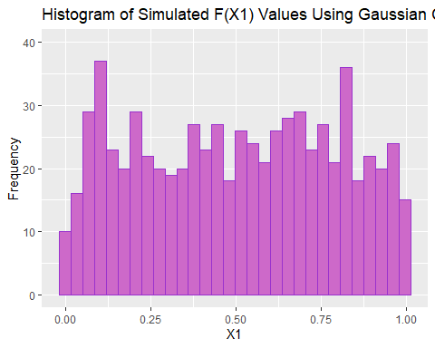
ggplot(data.frame(copSim), aes(x=X2)) +
geom_histogram(bins=30, color = 'darkorchid3', fill = 'orchid3') +
ggtitle('Histogram of Simulated F(X2) Values Using Gaussian Copula') +
ylab('Frequency') +
coord_cartesian(ylim = c(0,40))
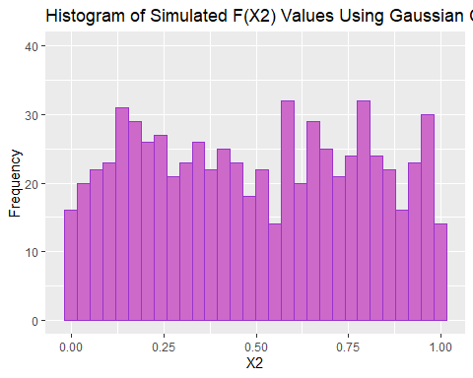
Copulas preserve the correlation structure between the cumulative values used to construct the copula.
cop_x1 = qnorm(copSim[,1], mean = 2, sd = sqrt(2))
cop_x2 = qnorm(copSim[,2], mean = 3, sd = sqrt(2))
simData = data.frame(x1 = c(normVals[,1] ,cop_x1), x2 = c(normVals[,2] ,cop_x2), Source = c(rep('Bivariate Normal', 700), rep('Gaussian Copula', 700)))
colMeans(cbind(cop_x1,cop_x2))
## cop_x1 cop_x2
## 2.009433 2.986581
var(cbind(cop_x1, cop_x2))
## cop_x1 cop_x2
## cop_x1 1.9890024 -0.9464527
## cop_x2 -0.9464527 2.1266386
ggplot(simData, aes(x = x1, y = x2, color = Source)) +
geom_point() +
ggtitle('Distribution of Simulated Data from Bivariate Normal and Gaussian Copula')
