**Requirements**

**1. System Requirements**

**1.1.** Operating System: Android

**1.2.** Minimum system requirements:

- SDK Version 16

**2. Functional requirements for Fraction Calculator**

**2.1.** Main functions:

- counting of fractions

- filling fields

- clear input fields

- Addition, division, multiplication and subtraction of fractions

**2.2.** Operating modes:

• digital:

- data type: digits

- data range from 0 to 9999

**2.3.** Controls:

• buttons:

- "Clear" button deletes all entered fractions

- "Calculate" button performs information counting

• input fields:

- first column with two fields for first fraction

- second column with two fields for second fraction

- third column with two fields for result fraction

- centered edit text for select mathematical symbol (addition, division, multiplication or subtraction)

**2.4.** Counting of fractions (examples for checking the correctness of application)

• Addition:

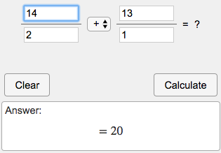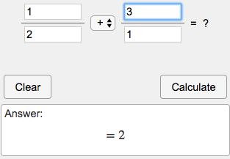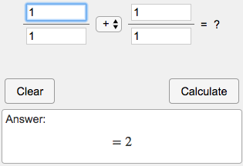

• Subtraction:

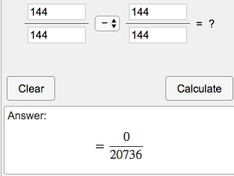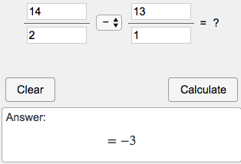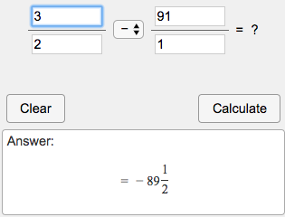

* Multiplication:

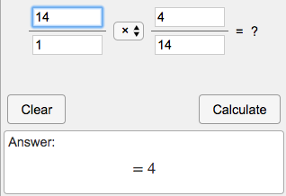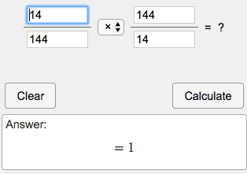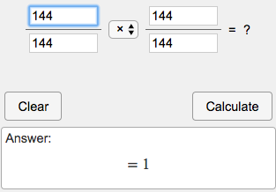

* Division (division by zero is forbidden, when you try to divide by zero to show the message)

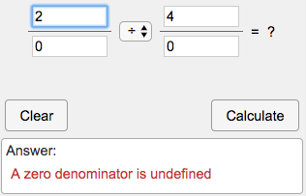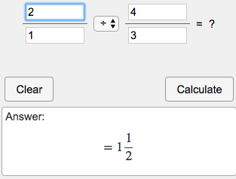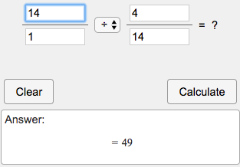

**2.5.** General requirements for design:

- placing buttons and text fields in any order

- “Clear” button color – Color.RED

- “Calculate” button color – Color.GRAY

- Input fields color – Color.WHITE

- Background color - Blured Donald Trump’s photo with Kim Chen In

- Toolbar color – Color.DARK_BLUE

- Application name “Fration Calculator”