Not sure what the issue is. Works for me.  
  
Try to verify in this order:  
  
1. Key lines from .bashrc.ext  
2. Interactive shell  
3. executing profiles_gen  
  
J.

export ATOM=/global/cfs/cdirs/atom

if [ "$GACODE_PLATFORM" == "" ] ; then

export GACODE_ROOT=$ATOM/atom-install-cori/gacode-source-mkl

export GACODE_PLATFORM=CORI_KNL_HT2_MKL

. ${GACODE_ROOT}/shared/bin/gacode_setup

. ${GACODE_ROOT}/platform/env/env.$GACODE_PLATFORM

fi

/global/cfs/cdirs/atom/atom-install-cori/gacode-source-mkl

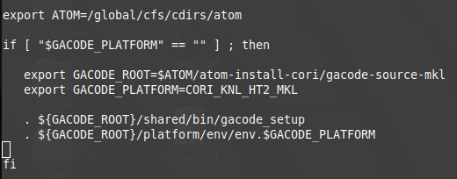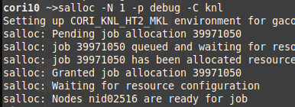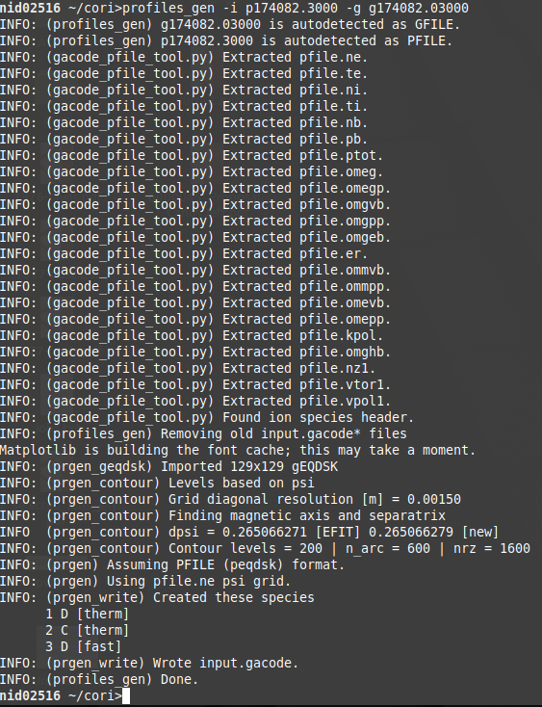

profiles_gen -i p175823.04100_f7099 -g g175823.04108_257X257

That’s it. In the ION SPECIES segment in the pfile, remove the last line and change the 3 to 2 on the line where ION SPECIES appears.

Once you have an input.gacode file, use “salloc -N 8 -p debug -C knl” to start another debug shell. Ssh into it, and run “profiles_gen -vgen -i input.gacode -er 2 -vel 1 -in 2 -ix 2"

salloc -N 8 -p debug -C knl

salloc -N 8 -p regular -t 5:00:00 -C knl

Just do ssh nid**** where the asterisks are just the number for the assigned node.

For the plotting

profiles_gen -i p175823.04100_f7099 -g g175823.04108_257X257

salloc -N 8 -p debug -C knl

salloc -N 8 -p regular -t 5:00:00 -C knl

ssh nid000000

cd /global/u1/m/maxcurie/NEO

profiles_gen -vgen -i input.gacode -er 2 -vel 1 -in 2 -ix 2

profiles_gen_plot -i input_gacode

profiles_gen -loc_rho 0.98 -i input.gacode

neo -e .