evaluating strategies to promote sea turtle conservation | Introduction to Modeling (in Stella)  CPaT, Modeling/Stats Spring 2013  Judy Cushing and Aaron Skomra  Adapted from the lab by Steven K. Rice

Student Lab Report Date:___4/13/2013`_________

Name_____Judy Cushing_________________________ Name_______Aaron Skomra_____________________

Part I. Study the Problem. As we will learn from our study of Scientific Models (Clark, William C., Dixon D. Jones, C.S. Holling. 1979. Lessons for Ecological Policy Design. Ecological Modelling, pp. 1-53), the first step in modeling is to understand the underlying physical processes. Be sure to read very carefully the problem statement on pp. 1-2 of the handout.

Null and Alternative Hypotheses: In the space provided below, write null and alternative hypotheses that might explain the outcomes of the various management scenarios. (the alternative hypothesis will be the one you believe to be true in the natural world).

Distinguish the Research Hypothesis (in plain English what it is that you hope your study will show), from the Null and Alternative Hypotheses (determined once you have decided which statistical tests to run and then cast into statistical terms). You were not asked to give the research hypothesis for this question, but it is often useful to state it (in writing) before you try to articulate the null and alternative hypotheses!

RH: We want to demonstrate that one (or more) of the proposed policies are likely to make a significant difference in viability (total population) of the loggerhead turtles.

H0 (Null Hypothesis): There is no difference among the three policy alternatives, and no difference between the status quo and any of the policy alternatives.

Ha (Alternative Hypothesis): One of the three policy alternatives is superior to the others and there is a difference between the status quo and that policy alternative.

NB: by running a stella model, we will not demonstrate the statistical significance of our Ha; however, we will be able to watch its dynamics.

Part II. Familiarize yourself with the Tools you will use for modeling.

How does changing the birth fraction change the Turtle Population?

Increasing the birth fraction increases the rate at which the population grows; decreasing it decreases the population growth rate.

Is this model realistic (enough)? Why or why not?

The model is not realistic because it does not take mortality into account.

After you have added the “turtles dying” flow out of the Turtle Population Stock, say how adding a mortality rate changes the Model. In what sense is the model more realistic?

Adding (or increasing) a mortality rate lowers the total population growth rate; decreasing mortality rate raises it. If mortality were equal to birth rate, the population would reach steady state.
In your own words (no fair looking ahead!) how do you think the model might be changed?

Use numbers for birth and death rates that correspond to what happens in the real world. Conduct observations and collect data to get these numbers.

Part III. Evaluating Management Strategies for the Loggerhead Sea Turtle

Part III a. Extending the Simple as Possible Population Model , developing a more realistic model. Using the information on page. 6 (Table 1), design an extension to your simple as possible loggerhead Model.

Read carefully Part IIIa, p. 5, of the lab document: Evaluating Management Strategies for the Loggerhead Sea Turtle. Extend the simple as possible model you ran in Part II, as suggested, then implement it (you will find it easier to do this from scratch, rather than using the SAP model).

Is the population increasing, decreasing or remaining constant? Explain why you think this is happening.

The adult population crashes quickly, with a hatchling peak before crashing, followed by a juvenile peak and crash. This happens because adults are dying off faster than they are being replenished. In other words, egg/hatchling and juvenile survival is not adequate to replace the adults.

Part III b. Designing and running a sensitivity analysis on your new model. Carefully read Part III b, p. 5, of loggerhead document.

Examine the simulation parameters (bolded) that you will use for your sensitivity analysis of the new model. Try to understand how these were calculated. Start with the simplest ones. Then consider the more complicated parameter (50% decrease in D-stage 2). If you had time, you would want to recreate the calculation in a program you write or an excel spreadsheet to satisfy yourself that you understand that parameter.

How do you think the parameters for the policy options were calculated? In particular, consider “stage 2 G (proportion growing to the next stage)”.

Simulation parameters | stage 1 | G  stage 2 | stage 3 | stage 1 | D  stage 2 | stage 3 | Population size  at 200 time units
values from table 2 | 0.675 | 0.000384 | 0.00 | 0.325 | 0.268 | 0.191 | ??
50% decrease in D-stage 1 | 0.838 | 0.000384 | 0.00 | 0.162 | 0.268 | 0.191 | ??
50% decrease in D-stage 2 | 0.675 | 0.00653 | 0.00 | 0.325 | 0.134 | 0.191 | ??
50% decrease in D-stage 3 | 0.675 | 0.000384 | 0.00 | 0.325 | 0.268 | 0.0950 | ??

Parameters for stages D1, D2, and D3 are straightforward; each policy option proposes decreasing the death rate at stages 1,2,3 (respectively) by 50%, and 0.162 = 0.325/2, 0.134 = 0.268/2, and 0.0950 = 0.191/2.

G1 and G3 are also straightforward: G1) 0.838 = 0.675 + 0.162, and G3 does not change, since turtles do not “grow” (move to another life stage) from adult-hood. G2 is a little more complicated, and takes into account the fact that stage 2 occurs over many years. Try (1 - D stage 2) ^ years in stage 2!

For each policy option, think about the extent to which the population increases, decreases or remains constant (compared to no mortality reduction).

50% decrease in D-stage 1: Still decreases; crashes in about 50 years

50% decrease in D-stage 2: increases over 200 years!

50% decrease in D-stage 3: eventually declines, but much more slowly than for 1. Check!

After you have run the simulation using the three alternative policy option, answer the Final Lab Questions:

- Which age stages seem to affect the population most when the mortality rate is manipulated?
Manipulating Juvenile mortality affects the population in a satisfactory manner.

- Looking at the data in Table 1, explain the result above.
The point is to maximize the adult population so they can reproduce (the most eggs and hatchlings), thus increasing the juveniles advancing to adulthood (over 20 years!) helps a great deal, as is having adults reproduce for twice as long. The adults next life stage is death – so increasing their mortality doesn’t help much.

- Are you able to reject one of your hypotheses? What management strategy would you support?
The null hypothesis is likely to be rejected (though we have not demonstrated this statistically). All tree options produce better results than doing nothing. Policy alternative #2 is better, as long as the TED (Turtle Exclusion Device) would actually produce survival rates that match the parameters in the model. Of course, the TED would reduce mortalities in both juveniles and adults, so it is the best choice.

- What assumptions are required to use this model to make predictions about real loggerhead sea turtle populations?
We assume that we are making an accurate prediction of what survival rates the three alternatives of protecting the beach, or installing TEDs, would have on the stocks. In other words, an absence of externalities such as what might happen if increasing the population of turtles increases the population of predators (and thus changes the mortality rates).

- What are some advantages and disadvantages to using modeling to test hypotheses?
The advantage is that it allows you to sanity check your analysis, do sensitivity tests on the parameters. The disadvantage is that you have to simplify and make assumptions that do not necessarily represent reality. There could also be human errors in the modeling.

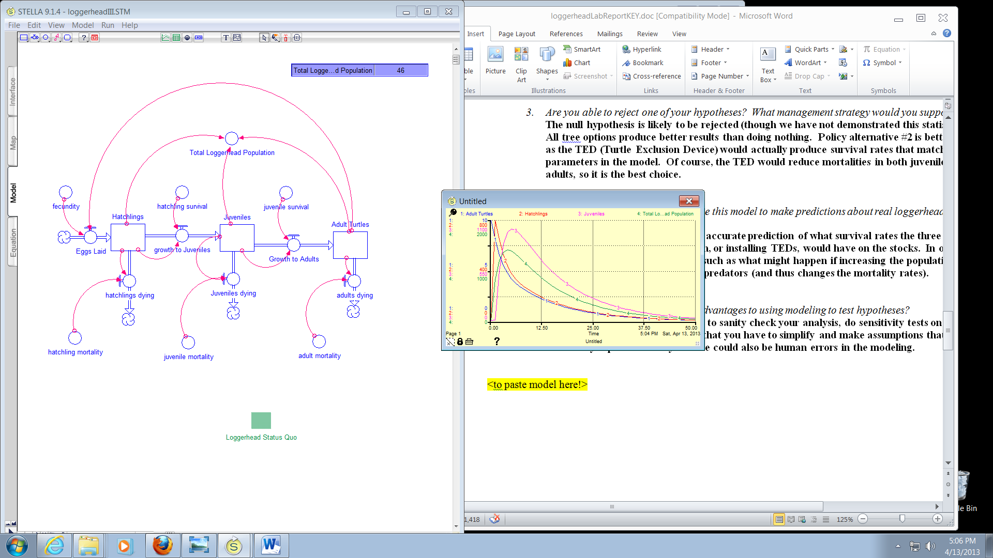

 | 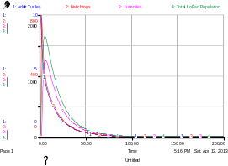 | 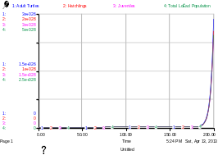 | 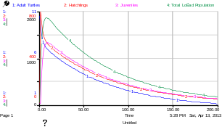
Status Quo | Hatchlings - 50% Death | Juveniles -50% death  adult_mortality = .191  fecundity = 80  hatchling_mortality = .325  hatchling_survival = .675  juvenile_mortality = .134  juvenile_survival = .00653 | Adults -50% death  adult_mortality = .0950  fecundity = 80  hatchling_mortality = .325  hatchling_survival = .675  juvenile_mortality = .268  juvenile_survival = .000384  Total_Loggerhead_Population = Juveniles + Hatchlings + Adult_Turtles

Model Equation:
Adult_Turtles(t) = Adult_Turtles(t - dt) + (Growth_to_Adults - adults_dying) * dt
INIT Adult_Turtles = 10
INFLOWS:
Growth_to_Adults = Juveniles * juvenile_survival
OUTFLOWS:
adults_dying = Adult_Turtles * adult_mortality
Hatchlings(t) = Hatchlings(t - dt) + (Eggs_Laid - growth_to_Juveniles - hatchlings_dying) * dt
INIT Hatchlings = 10
INFLOWS:
Eggs_Laid = Adult_Turtles * fecundity
OUTFLOWS:
growth_to_Juveniles = Hatchlings * hatchling_survival
hatchlings_dying = Hatchlings * hatchling_mortality
Juveniles(t) = Juveniles(t - dt) + (growth_to_Juveniles - Juveniles_dying - Growth_to_Adults) * dt
INIT Juveniles = 10
INFLOWS:
growth_to_Juveniles = Hatchlings * hatchling_survival
OUTFLOWS:
Juveniles_dying = Juveniles * juvenile_mortality
Growth_to_Adults = Juveniles * juvenile_survival

adult_mortality = .191
fecundity = 80
hatchling_mortality = .325
hatchling_survival = .675
juvenile_mortality = .268
juvenile_survival = .000384

Total_Loggerhead_Population = Juveniles + Hatchlings + Adult_Turtles

Dept. of Biological Sciences, Union College, Schenectady, NY 12308. We gratefully acknowledge Prof. Rice’s permission to use this lab at Evergreen. Any errors in or suggestions for this version should be reported to Judy Cushing, judyc@evergreen.edu. Prof. Rice, as original author retains all rights to the exercise or portions of it, which may be copied and used for educational purposes if distributed free of charge and author is acknowledged.
See section 6.4 in Caswell 2001. Matrix Population Models, 2nd ed. Sinauer.

