Week 2 - CPAT Statistics Lab 1:
Probability, Variables, Summary Statistics

- Using the binomial probability distribution equation, create a histogram for the following: Out of 20 coin flips, create a histogram that describes the frequency of every possible outcome (1, 2, 3, …20 heads out of 20 flips). Create the histogram in excel or your favorite graphing program and insert the graph here:
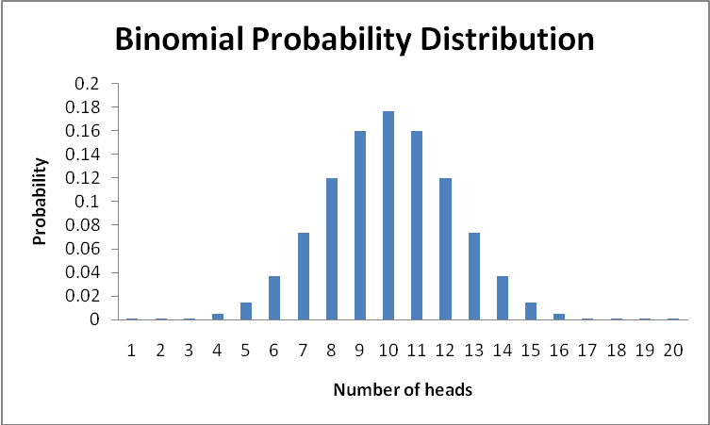

- Using what you’ve learned about probability, what is the probability of getting exactly 13 heads out of 20?
.074

- What is the probability of getting exactly 10 heads out of 20?
0.17619
0 .176 (better)

- What is the probability of getting 10 or fewer heads? Remember the rules about compounding probabilities…
0.58809
0.588 (better)

- Now, run 5 trials of 20 coin tosses each (take 5 samples), keeping track of the number of heads you get out of each set of 20 tosses. Describe how your results correspond to your histogram?
Answers will vary by student – just make sure yours don’t look too weird (like all 10s!) My values were 12, 10, 11, 12 – the binomial distribution suggested that the probability of 10 = .176, 11 = .16, 12 = .12. This agrees with the histogram above – my tosses were smack in the middle!

- Did you get extremely few or extremely many heads in any trial? If so, what was the number of heads and the probability associated with your extreme sample?
Again – will vary by student. Make sure you associate the right probability with your number of heads. I got no extreme values on my coin toss

7. Sort the data by tree species in excel (use Data > Sort > by species). What are the populations of interest in this data set?
Tree diameters of two species, PSME and CACH

8. For the CACH trees, using Excel and equations in Excel (please type them in by hand so you learn about the functions of each equation), please calculate the range, mode, median, mean, standard deviation, and standard error for that sample of trees. Make a table of these values and insert it here:
range | mode | median | mean | standard deviation | standard error
8.6 | 11 | 10.2 | 9.414 | 2.6323 | 0.5612

9. Now, since that is kind of cumbersome, use JMP to calculate those values and double-check your answers. Copy the whole block of data for both tree species from excel (including the column of species names!), open a new data table in JMP (but don’t click inside the table!) and select Edit > Paste with column headings. Choose Tables > Summary > to open the dialog box. Click on “Species” and place it in the “Group” box; Click on DBH and then choose the summary statistics you want the program to calculate (all of those from Q #2 – JMP won’t calculate the mode). Please paste a table of summary statistics for both CACH and PSME below (tip: COPY with column names and paste into excel first to create the nicest looking table, then paste into word):
Species | N(Dbh (0.1 cm)) | Range(Dbh (0.1 cm)) | Median(Dbh (0.1 cm)) | Mean(Dbh (0.1 cm)) | Std Dev(Dbh (0.1 cm)) | Std Err(Dbh (0.1 cm))
CACH | 22 | 8.6 | 10.2 | 9.413636 | 2.632271 | 0.561202
PSME | 91 | 50.7 | 29.4 | 29.96791 | 10.20251 | 1.069514

10. Since the 50% quantile is the median, calculate the 25% quantiles to show how much spread there is around the median for each species (CACH and PSME). Paste in a table below:
Species | N Rows | Quantiles25(Dbh (0.1 cm))
CACH | 22 | 7.075
PSME | 91 | 23.7

11. Calculate the CV for each species and paste in a table below:
note formula for Coefficient of Variation is:
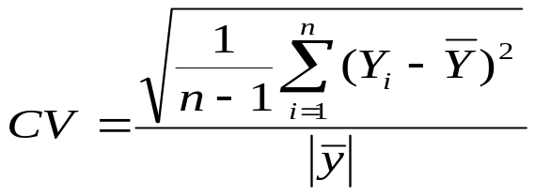
Could be presented as decimals or % (100 times this amount – that is how JMP calculates them – both would be correct).
Species | N Rows | CV(Dbh (0.1 cm)) | CV(JMP)
CACH | 22 | 0.2796232 | 27.96232
PSME | 91 | 0.3404479 | 34.04479

12. Based on your summary statistics of central tendency and spread, which species is largest (in terms of diameter)?
PSME

13. Which species is most variable when it comes to DBH?
PSME

14. Now, create a bar graph (using either excel or JMP) that shows mean DBH ± 1SE on the y-axis and tree species on the x-axis. Please paste your graph below.
