CPaT Statistics Lab 1: Probability, Variables, Summary Statistics

Please turn in a hard copy of your lab report (typed answers and graphs), including only the questions and your answers (but not the rest of the lab). Your answers should be in bold in your report.

We strongly suggest that you work with the same partner for all labs, and that you create a workspace that you both can access, rather than using Cubbies. We will return one hard copy lab – you are responsible for preparing ONE portfolio for you and your partner (or, if you work with different partners – individual portfolios. You will need to save for your portfolio all hard copy labs, with faculty notes.

Please also submit the Excel spreadsheet you use to complete the lab; append your name to the Excel spreadsheet you used, and copy it with the appropriate filename to the fileshare: programs/cpt/Workspace/_StatsLabReports/Lab2. Filename should be the concatenation of your last names, e.g., CushingSkomra.xlsx.

This lab assignment is due by 9:30am (in lab) next Tuesday. You may work with another student or a tutor or outside of class; however, you must complete the lab report individually.

Binomial Probability:

We will use Excel to complete the first part of this lab. You can type equations into each cell in Excel starting with the “=” symbol. You will need to figure out how to translate the binomial probability distribution equation into a formula in Excel. You can use many parentheses to make sure Excel doesn’t get confused – but keep track of your parentheses! Remember, your results will NOT be just like those in Table 2.1 in the text (Gotelli & Ellison) because you won’t have the same “n.”

Once you have set up your equations in Excel, create a histogram by plotting the outcome (# of heads, X) on the x-axis and the probability (calculated from the equation) on the y-axis.

- Using the binomial probability distribution equation, create a histogram for the following: Out of 20 coin flips, create a histogram that describes the frequency of every possible outcome (1, 2, 3, …20 heads out of 20 flips). Create the histogram in Excel or your favorite graphing program and insert the graph here:

Replace this text with your Graph

- Using what you’ve learned about probability, what is the probability of getting exactly 13 heads out of 20?

- What is the probability of getting exactly 10 heads out of 20?

- What is the probability of getting 10 or fewer heads? Remember the rules about combining probabilities….

- What is the probably of getting more than 10 heads?

- Now, actually toss a coin! Run 5 trials of 20 coin tosses each, keeping track of the number of heads you get in each set of 20 tosses. Describe how your results correspond to your histogram from Question 1.

- Did you get extremely few or extremely many heads in any trial? If so, what was the number of heads and the probability associated with your extreme sample(s)?

Descriptive Statistics:
After data are collected, they can be analyzed statistically to better determine whether the data support or reject a given hypothesis. The first step in analyzing data is often to calculate a set of statistics that describe two aspects of the data: (1) central tendency and (2) dispersion.

(1) Measures of Central Tendency: The central tendency provides information on how the values of the data cluster around some single middle value. There are three measures of central tendency that are used in the analysis of data:

- Mode: the most frequently observed value of the data. If there are two values that appear most frequently, the data set is said to be bimodal, and both values are reported.

- Median: the middle value when the data set is ordered in sequential rank (i.e.
highest to lowest, or lowest to highest). If there is an even number of values, take the average of the two middle values.

- Mean: average value. The mean is the most commonly used measure of
central tendency. It is estimated using the sum of all the individual values
(x_{i}) divided by the total number of individuals in the sample (n):

Mean (X-bar): A sample estimate of the population mean (μ)
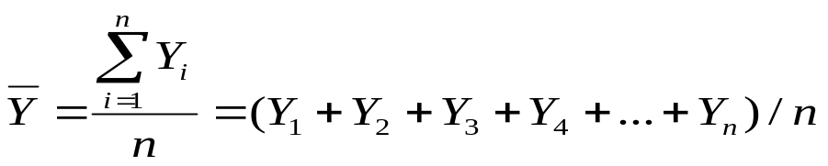

(2) Measures of Dispersion: Other commonly used descriptive statistics describe how spread-out the data are.

- Range: The highest value minus the lowest value (if the values are all positive). The range is sometimes reported as [lowest value..highest value].

- Variance: The variance is the sum of each of the differences or deviations
between each individual value and the mean value. True population variance (δ) is, of course, unobtainable, so we’ll have to settle for an estimate, the sample variance (s²). To obtain this statistic, the total difference of each observation and the estimated mean is divided by the number of individuals in the sample minus one:

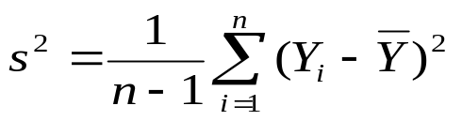

The “-1” is important because it corrects for the tendency of estimates of s² to underestimate σ².

- Standard deviation: The square root of the variance.

- Sample standard deviation:
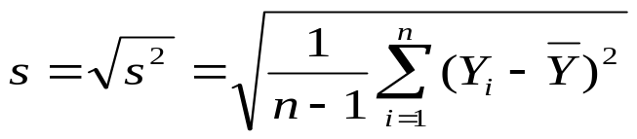

- Standard error: The standard error is the standard deviation divided by
the square root of the sample size (n):

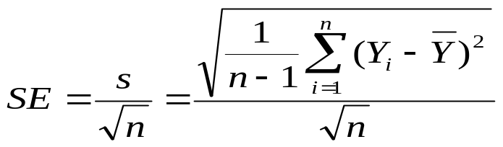

Note: The standard error is especially important since it is probably the most commonly used estimate of variance around means for figures in scientific papers in biology. Why? Does this make sense? One convenience of the SE is that the 95% CI (confidence interval) often (though sometimes not, depending on sample size) = 1.96*SE.

An example:
For the data: { 3, 3, 4, 5, 6, 6, 6, 6, 7, 8, 10 } that could represent a set of measurements of tree diameters:

MODE = 6,
MEDIAN = 6
MEAN = (3 + 3 + 4 + 5 + 6 + 6 + 6 + 6 + 7 + 8 + 10)/11 = 5.82
SAMPLE VARIANCE = 4.363636
STANDARD DEVIATION = 2.088932
STANDARD ERROR = 0.629837

Check these statistics using the above definitions to make sure you get the same results!

STATISTIC | Expected CALC | YOUR CALC | YOUR COMMENT
MODE | 6
MEDIAN | 6
MEAN | 5.82
SAMPLE VARIANCE | 4.363636
STANDARD DEVIATION | 2.088932
STANDARD ERROR | 0.629837

Other common measures of dispersion include quantiles (e.g., 25%, 50%, 75%, etc.) and 95% confidence intervals.
- Quantiles: Quantile estimates are generally used for describing data dispersion along with the median. Briefly, here is a description shamelessly stolen from Wikipedia:
“Quantiles are points taken at regular intervals from the cumulative distribution function (CDF) of a random variable. Dividing ordered data into q essentially equal-sized data subsets is the motivation for q-quantiles; the quantiles are the data values marking the boundaries between consecutive subsets. Put another way, the kth q-quantile for a random variable is the value x such that the probability that the random variable will be less than x is at most k / q and the probability that the random variable will be more than x is at most (q − k) / q. There are q − 1 quantiles, with k an integer satisfying 0 < k < q.”
Basically, quantiles are the result of ordering the data values in a sample, and then dividing the list into equal sized chunks (e.g., the first 25%, 50% etc.). For example, if you have 100 measurements of tree diameter, and you order them from smallest to largest, the first 25% quantile (first quartile) would include the first 25 measurements (regardless of their values). If the number of data values is odd, then the median value (or 2nd quartile) is the value found at (#values + 1)/2. Similarly, other quantile boundaries are rounded up when there is an issue with fractions.
- Coefficient of variation (CV). Measures the variability of values in a sample relative to the magnitude of the sample mean (). This value gives an index of population variability that is comparable across measurements and populations. Recognize that the numerator is the sample standard deviation and the denominator is the absolute value of the mean:

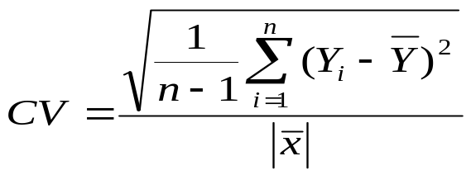

The CV is often converted to a percent (%) by multiplying this value by 100. A CV of 10% implies that the standard deviation of measurements in the sample is about +/-10% of the sample mean.

The rest of this lab:
Consider tree stand measurements (taken by my MES students fall OF 2011 at HJ Andrews LTER), we want to characterize the tree species in that forest by their size (diameter at breast height, aka DBH). Please do the following:

8. Sort the data by tree species in Excel (use Data > Sort > by species). What are the populations of interest in this data set?

9. For the CACH trees, using Excel and equations in Excel (type them in by hand so you learn the equations and the functions used for each), please calculate the range, mode, median, mean, standard deviation, and standard error for that sample of trees. Make a table of these values and insert it here:

Your Excel Table Here!

10. Now, since using Excel is kind of cumbersome, use JMP to calculate those values and check the answers you got from Excel.

Copy the whole block of data for both tree species (CACH and PSME) from Excel (including the column with species names).
- open a new data table in JMP (but don’t click inside the table!).
- select Edit > Paste with column headings.
- Choose Tables > Summary > to open the dialog box.
- Click on “Species” (in Select Columns) and place it in the “Group” box;
- Click on DBH and then choose the summary statistics (from Statistics pull down menu) that you want the program to calculate (all of those from Q #2 – JMP won’t calculate the mode).

Please paste JMP’s table of summary statistics for both CACH and PSME below (tip: COPY with column names and paste into Excel first to create the nicest looking table, then paste into Word):

Your JMP Table Here!

11. Since the 50% quantile is the median, use JMP to calculate the 25% quantiles (aka quartiles) to show the spread around the median for each species (CACH and PSME). (try using Help to figure this out for yourself!)
Paste the resulting table below:

Your JMP Table Here!

12. Use JMP to calculate the CV for each species and paste in a table below:

Your JMP Table Here!

12. Based on your summary statistics of central tendency and spread, which species is largest (in terms of diameter)?

13. Which species is most variable when it comes to DBH?

14. Now, create a bar graph (using either Excel or JMP) that shows mean DBH ± 1SE on the y-axis and tree species on the x-axis. Please paste your graph below.

Your JMP Graph Here!

15. Just for fun, think about any additional statistics (or diagrams/figures) you could generate from this dataset that might be helpful in studying the stands where these data were collected. Write down your top three below (no need to actually calculate or draw them, just brainstorm).

“Run 5 trials of 20 coin tosses each” is another way of saying “Take 5 samples, each with20 coin tosses.”

