Week 3 CPAT Statistics Lab # 2,: KEY (judy, aaron, robyn, kara, carri)

Section 1: Experimental Design

Q1: Comparing a treatment to a control (analyze using a t-test)

I would like to know whether MES graduate students collect data as well as the professional field staff at HJA. I will use data from the stem maps of plots surveyed by MES gCORE students in Fall 2011. I will pay professional field technicians to survey those same plots.

My research The sample size is the number of trees in the plots. We will look at only DBH, and compare the DBHs for each tree. I will assume that the field technicians have made correct measurements Mf, and then subtract Mm (dbh measured by MES students) from Mf. I will want a two sided t-test, because I want to see if MES students consistently under- or over-measured.

The table would look like something like this:
tree tag | DBH-field tech | DBH-MES student
 | Mf | Mm | Mf - Mm
7777 | 38 | 38 | 0
7983 | 27 | 27 | 0
4642 | 26.6 | 28.6 | -2
4293 | 27.4 | 29.4 | -2
4694 | 24.9 | 23.9 | 1
5915 | 38.5 | 35.5 | 3
4821 | 40.7 | 38.7 | 2
5658 | 34.5 | 35.5 | -1
5401 | 16 | 16 | 0
5659 | 22 | 22 | 0
7779 | 27.5 | 27.5 | 0
4586 | 19.2 | 21.2 | -2
2575 | 18.3 | 19.3 | -1
2078 | 38.3 | 36.3 | 2
4798 | 23.1 | 24.1 | -1
5408 | 39.5 | 36.5 | 3
5950 | 16.7 | 16.7 | 0

I will then compare the differences Mf - Mm with 0.

- My research hypothesis is that there is likely a difference between Evergreen graduate students and professional field technicians.
- H0: (null hypothesis) there is no difference
Ha: There is a difference (since it’s a 2-sided difference, I hope to determine in which direction, but we haven’t studied that yet!)
- independent variable(s)? The two data collection groups (Professional Field Technicians and Evergreen graduate students)
- dependent variable(s)? the field measurements
- predictions for the outcomes of my study? I think Evergreen students are still learning field techniques, so I suspect there will be a difference.

- Find one scientific paper that reports on a similar experiment – list the bibliographic entries for two papers (one on a topic similar to your experiment in Q1, and another similar to your experiment in Q2).
  - Learning landscape ecology: a practical guide to concepts and techniques, SE Gergel… - 2002
  - The “freezing” of science: consequences of the dogmatic teaching of ecology, [PDF] from uba.ar, R GONZÁLEZ DEL SOLAR… - BioScience, 2001 – BioOne
  - J. M. Laflen, M. Amemiya, and E. A. Hintz, Measuring crop residue cover, Journal of Soil and Water Conservation November/December 1981 vol. 36 no. 6 341-343. The photographic, meterstick, and line-transect methods of measuring the percentage of land covered with crop residue were evaluated and the line-transect method shown preferable for field use, particularly if technicians are carefully trained in its use and in self-calibration so that overestimation of crop residue can be avoided.
Q2: Linear relationships: Correlation or regression (you choose which)

I am interested in knowing the relationship between DBH and height for Douglas fir trees, so that I can measure DBH and use that to compute height. DBH is easier to measure than height.

I will collect DBH and height data for 100 Douglas fir trees chosen at random on the Evergreen campus.

I will do a correlation, since it is unlikely that cancer is caused by working at Evergreen.

There is a built in confounding factor here – what is it? how would I design a study that corrects for that?

- My research hypothesis is simply that there is a relationship between DBH and height, and that I would be able to use that to calculate DBH from height or vice versa.
- H0: There is no correlation between DBH and height.
Ha: There is a correlation between DBH and height, and it is ____.
- independent x variable: it doesn’t matter for correlation, but since I want to predict height from DBH, I will set my independent variable as DBH.
- dependent variable: height (see above).
- I predict that there will be a relationship, since it makes sense that the wider the girth of a tree, the taller the tree, but I don’t know what the relationship is.
- bibliographic citations:
  - Rich, Paul M., et al. 1986. Height and stem diameter relationships for dicotyledonous trees and arborescent palms of Costa Rican tropical wet forests, BULLETIN OF THE TORREY BOTANICAL CLUB (113,3) pp. 241-246, JULY-SEPTEMBER, 1986. Allometric relationships between stem diameter and height were studied for dicotyledonous trees and arborescent palms in a tropical wet forest of Costa Rica. In a mixed population of dicotyledonous trees, stem diameter varies with the 3/2 power of height.
  - Bartelink H.H. 1996. Allometric relationships on biomass and needle area of Douglas-fir, Forest Ecology and Management (86 1), 15 October 1996 , pp. 193-203(11), Elsevier. Allometry between DBH and height is probably so well understood that little is now published on it. Most of the articles I found relate to predicting biomass from more easily measured variables (as did this one).
  - Still looking for a source that gives the generally accepted DBH-height relationship so I can check my findings.

Section 2: Comparing two means

Q3. Thinking about differences between older and younger folks in this class, what would your research hypothesis be?

The variable I chose to examine height. Younger folks might be taller than older folks. We know that post world war II Japanese children (e.g., born after 1975) are taller than their parents (born in the first 15-20 years after the war, or grandparents (born prior to the war).

It is possible that post-World War II dietary changes in the U.S. happened so long ago that there is no longer any difference in height for younger vs. older folks in our program, who are likely be younger than the (U.S.) population at large. It is also possible that the differences in age are not great enough to show a difference in height.
If we were doing correlation, we could look at the relationship between height and shoe size.

There might also be a difference in commute difference; I would hypothesize that younger students have shorter commute differences.

Q4. What is your null hypothesis?

H0: That there is no difference between heights of younger and older folks in our program.

Q5. How many times were your shuffled differences larger than the actual difference?

 | Height | Shoe Size | Commute
#timesLarger | 424 | 803 | 10
p-value | 0.424 | 0.803 | 0.01

Q6. What is your p-value? This is the number of times out of 1000 you would find a difference as large as or larger than your real difference due to chance alone.

See above

- You should report the effect size (difference between actual younger) and the p-value in your results and on your final graphs.

Q7. Interpret your p-value as you would for a scientific paper. Write a short paragraph that describes this result. Remember, write about the dependent and independent variables, not the statistics (p-values, etc.).

I sampled 51 students from the CPAT Spring 2013 program at The Evergreen State College, and divided them into “younger” and “older” categories. The median age of students was 22.73, and the average 25.76.

Median Age | 23 |  | Younger | <23 | 22.73 to be exact!
Max Age | 66.84 |  | Older | >=23
Min Age | 18.43
Average Age is 25.76
median age |  | N | 51

I then used resampling statistics (shuffled 1000 times) to determine whether the differences in height, shoe size, and commute distance differed between younger and older students.

Average observed differences were as follows:
See also Excel Spreadsheet
 | Younger | Older | Absolute Difference | p-value
Height | 70.10714286 | 69.2173913 | 0.889751553 | 0.424
Shoe Size | 43.35714286 | 43.06521739 | 0.291925466 | 0.803
Commute | 5.446153846 | 31.02391304 | 25.5777592 | 0.01

Observed differences in height and shoe size between younger and older students were not statistically significant, but the difference (25.6 miles) in average commute distance was significant (p<=.01).

Q8. Create a column graph in Excel with one vertical bar for younger and one for older folks. Plot the means ± 1 standard error for the values for both. Report the actual difference and p-value on your chart. Write a Figure Caption for your figure and paste or write it below your figure. Insert the chart here:

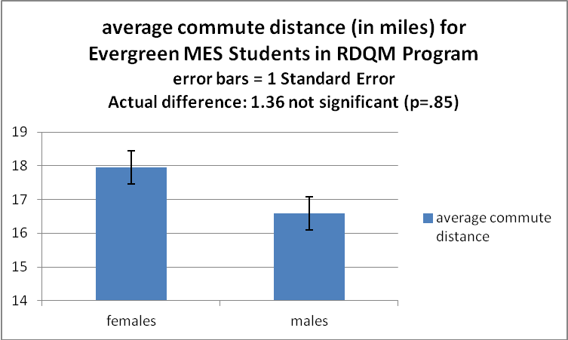

Figure 1: Average Commute Distance (in miles) for Evergreen MES Students in the Spring 2012 RDQM program. Data collected April 17, 2012.

Q9. Now, going back to your “results” sheet - use the histogram function in Resampling Stats to make a histogram of your random outcomes. Insert your histogram here:

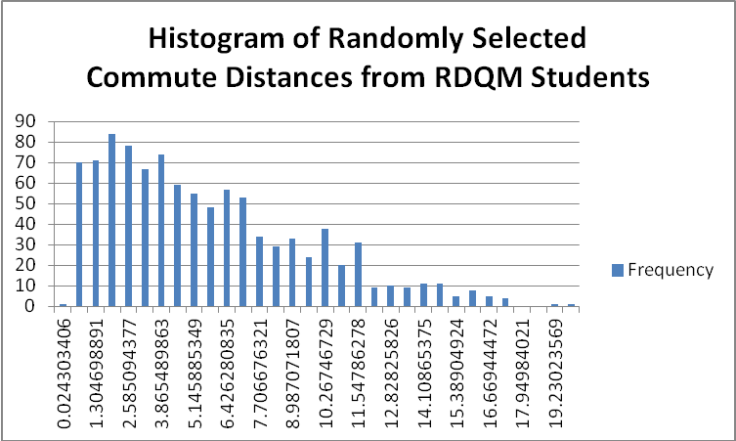 | Histogram of Randomly Selected  Compute Distances from CPaT Students  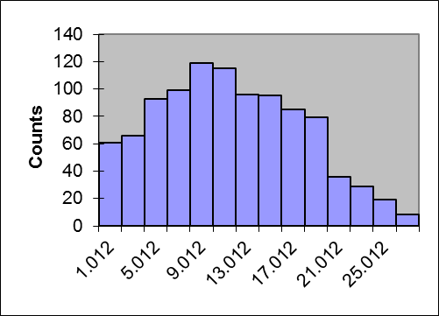

Histogram of Randomply Selected  Heights from CPaT students  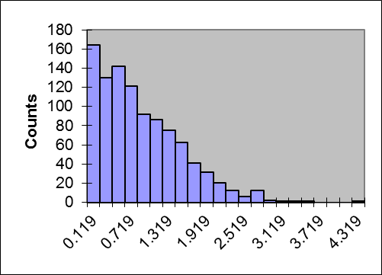 | Histogram of Randomply Selected  Shoe Sizes from CPaT students  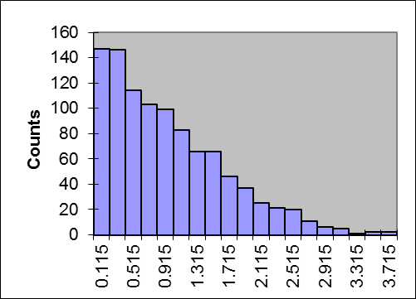

Q10. Does your histogram look like half of a bell-shaped distribution?

YES – All histograms resemble the right hand side of a bell-shaped distribution.

For Commute Distances: For CPAT students (at right), the histogram looks less like a bell shaped curve – probably because the compute distances for CPaT and RDQM students are different – do RDQM students generally have shorter commute distances?

For height and shoe size, however, both histograms closely resemble a bell shaped curve – probably because CPAT students’ physical characteristics are quite like the population at large.

Q11. If so, why is it just half of a bell-shaped curve? If not, why not?

The histogram is just half of a bell-shaped curve because we computed (and shuffled) the absolute value (which is always positive) of the commute differences. The center of the curve is “0”, and there are no negative differences in commute distances.

If I were reporting this in a publication, I would redo the histogram and graph with bin sizes that have only two digits to right of decimal. This would make the bin ranges easier to read.

