Summary Statistics – Height

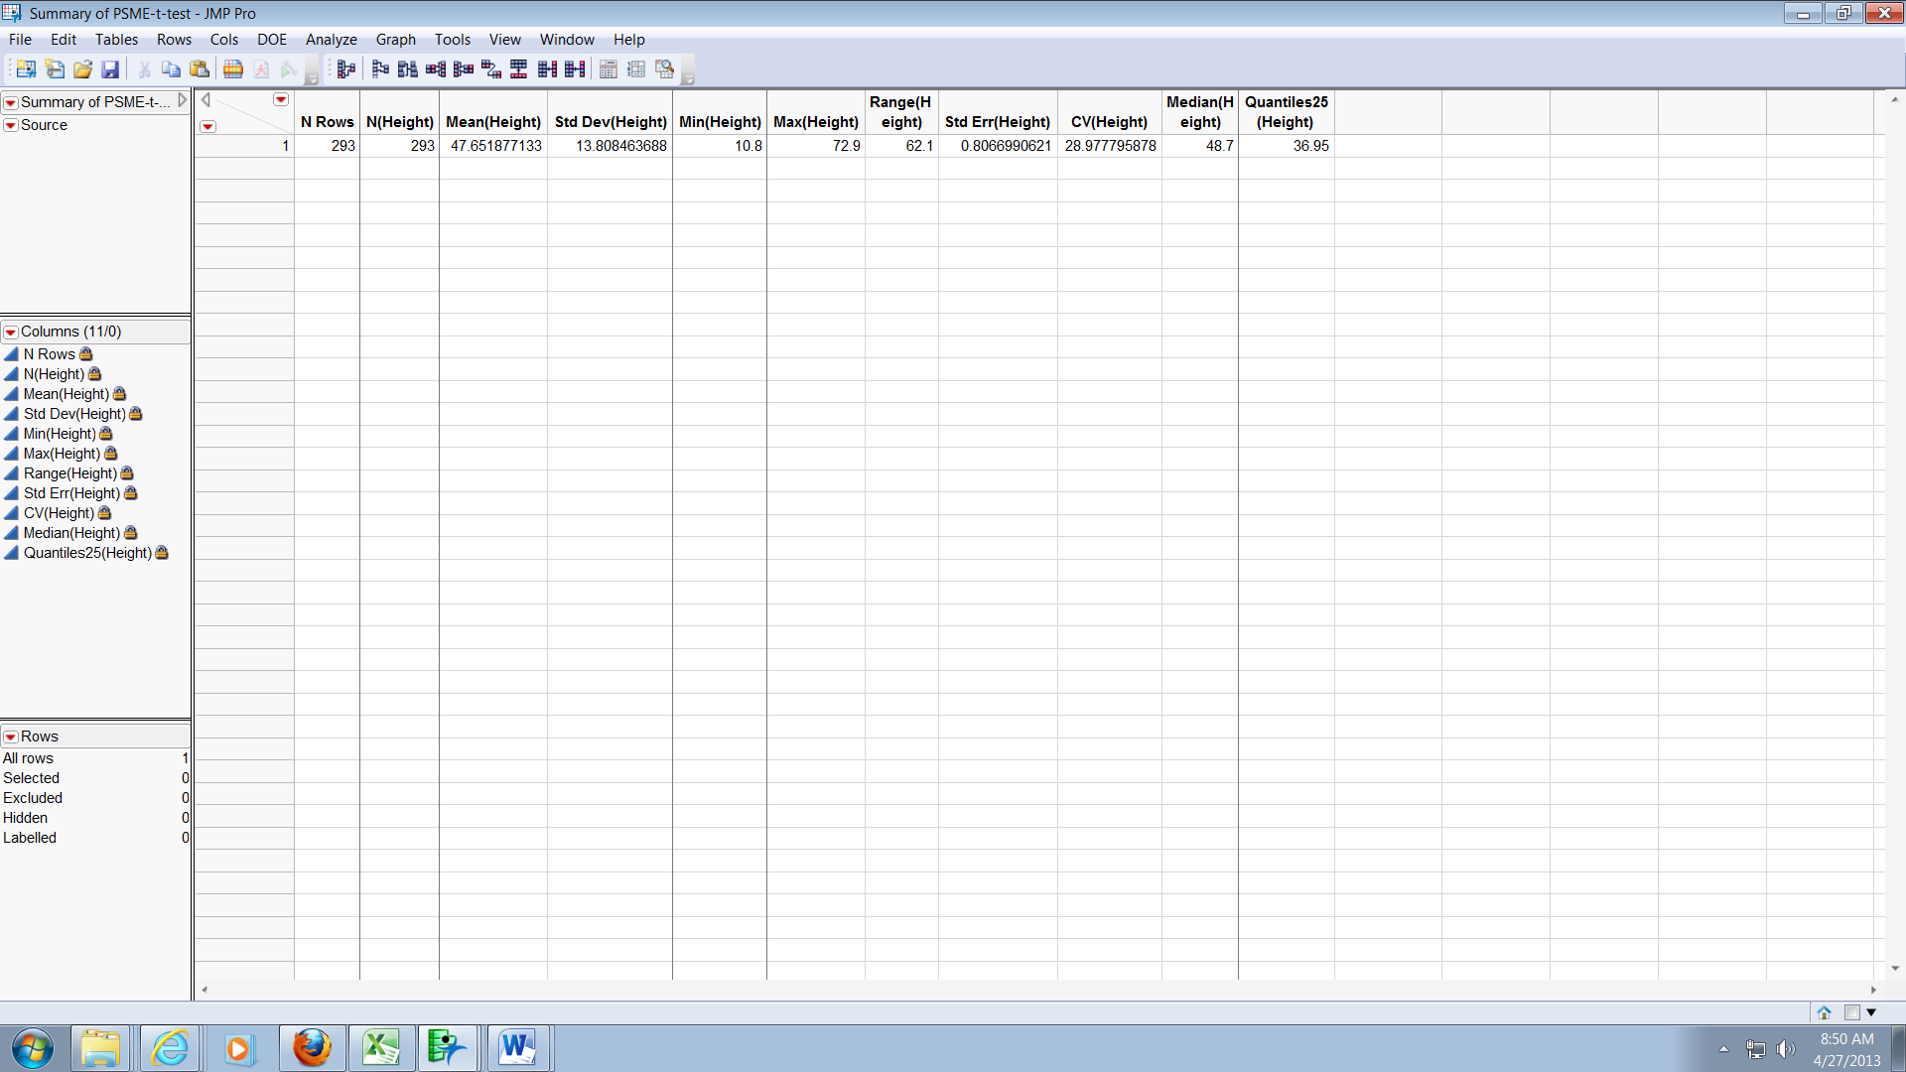

|  |  |
| --- | --- |
| OH | MC |
|  |  |

tTest results OH-MC – the two samples are different, p<0.0001

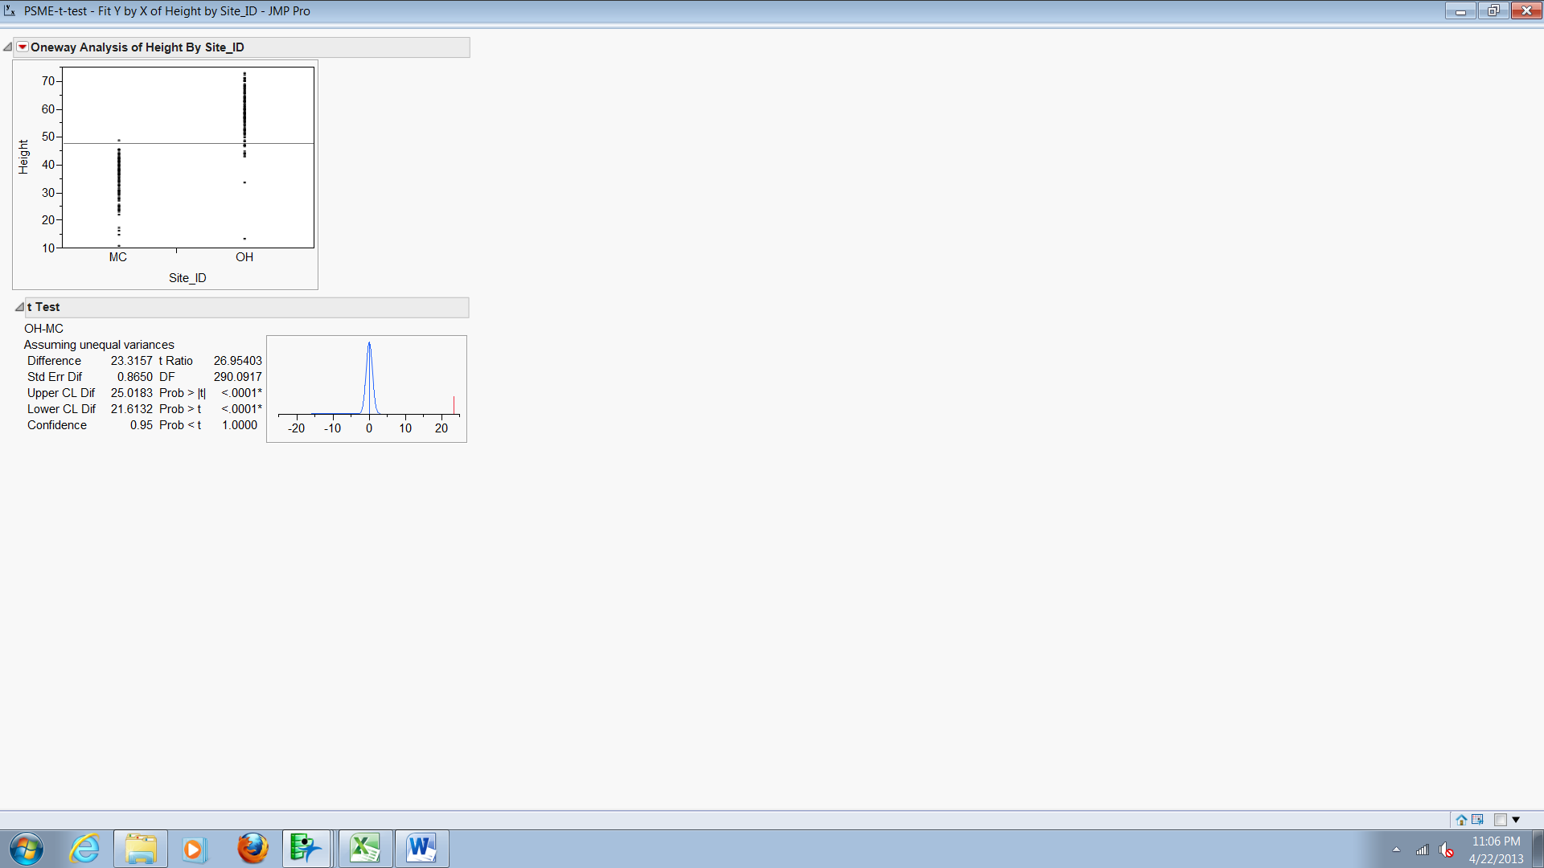

|  |  |
| --- | --- |
| **One way ANOVA OH-MC –**  the two samples are different | **3-way ANOVA MC, PC, TC**  The three samples are different |
|  |  |

|  |  |
| --- | --- |
| **But which of the 3 groups are different?**  **Tukey’s HSD:** |  |

|  |  |
| --- | --- |
| But, was I justified in running a parametric ANOVA?  Use Shapiro wilk to test **each sample** for normality. You should also check for equal variances….  Look for p > .05  Here, I’ve just tested one of the three.  p < .0001, so it’s not normal…. |  |

|  |  |
| --- | --- |
| Levene’s test for unequal variances:  you want p > 0.05  Here, p = .0214, so the variances of the three samples are not equal.  This means I can’t trust the results of a parametric ANOVA, and I must run a resampling ANOVA. |  |