**CPaT Stats Week 4: t-tests and ANOVA - KEY**

Name: Judy

Name: Aaron

Name: Robyn

Name: Kara

Due Week 5, hardcopy in Lab next week (Tuesday).

**Part 1: Hypothesis Testing**

**Q1**. Please fill out the following table. Read and understand the table’s labeled rows and columns, prior to filling in the table (Hint – they are not exactly like the book!!):

Please fill in the blanks with “correct” or “error”, showing when we would be making a correct decision and when we would be making an error. For extra credit: if “error” denote which type of error we are making (Type I or Type II).

Table 1. A table outlining the outcomes of any experiment –

a description of the world of hypothesis testing.

|  |  |  |
| --- | --- | --- |
| **Your Decision** | **Truth value of H0 in the “real world”** | |
| **Null Hypothesis is false** | **Null Hypothesis is true** |
| **Fail to Reject H0** | **Error Type II** | **Correct** |
| **Reject Ho** | **Correct** | **Error**  **Type I** |

**Example to help you remember this:**

Failing to reject a False H0, such as “Climate change is not due to human activity”, or “DDT will not harm the environment” is a Type II error.

**Q2**. Using your own words, describe what is meant by a p-value:

**A p-value is the probability that the result you have with your sample data (e.g., the means differ - your Ha) is due to chance variation in the population.**

**Q3**. Using your own words, describe what is meant by the power of an experiment: **The power of an experiment is the chance of committing a Type II error, such as rejecting a true null hypothesis such as “Climate change is not due to human activity.”**

**Part 2: t-tests**

**Data for the rest of the lab are in the spreadsheet: wk4_1kcsStemMap.**

**Data for Part 2 is in the worksheet: PSME-T-test**

**Q4:** Use Excel to calculate the difference in the means of the two groups, and report Excel results here.

|  |  |  |
| --- | --- | --- |
| Excel Calc | DBH | Height |
| MC | 43.76742 | 34.84015 |
| TC | 93.56584 | 58.1559 |

**Q5:** report JMP t-test results here

|  |  |  |  |  |  |  |  |
| --- | --- | --- | --- | --- | --- | --- | --- |
| site Ht | N rows | N heights | mean Ht | std dev | std error | CV | Median |
| overall | 293 | 293 | 47.65 | 13.81 | 0.81 | 28.98 | 48.7 |
| MC | 132 | 132 | 34.84 | 6.87 | 0.598 |  |  |
| OH | 161 | 161 | 58.156 | 7.93 | 0.625 |  |  |

**Part 3: ANOVA – Comparing 2 means**

**Use the same data for Part 3 as you did for Part 2: PSME-T-test**

**Q6**: report results of the ANOVA test on the 2 means:

**Difference in the means is 23.32, which is a significant difference, p<0.001.**

**Part 4: ANOVA – Comparing many means**

**Use the worksheet ANOVA-PSME-2-3-5-JMP for this part of the lab.**

**Q7:** In your own words, say how parametric analysis and resampling analysis differ:

**Parametric analysis differs from resampling analysis in that the p-values depend upon well understood (and published) distributions. In many cases, certain assumptions must be met, such as means of the population samples must be normally distributed, or all (test) samples must be normally distributed and variances equal.**

**Resamplinig analysis, on the other hand, uses many (say, 1000) random shufflings of the data among groups to compute a p-value.**

**The only assumptions that must be met are that the samples be randomly selected, and independent from one another (i.e., that measurement 1 does not effect measurement 2, etc.). Parametric analyses are also subject to these assumptions!**

**Q8**. Run Shapiro-Wilks tests for each age class. Which age classes are likely taken from normal populations and which are not? Fill out the table below (go back to Lab #3 if you forget how to run these tests):

|  |  |  |  |  |
| --- | --- | --- | --- | --- |
|  | **Site** | **W value** | **P value\*\*\*** | **Normal?** |
| **Group1** | 1. **MC** | **0.9425** | **<0.0001** | **NO** |
| **Group2** | 1. **PC** | **0.9004** | **<0.0001** | **NO** |
| **Group3** | 1. **TC** | **0.9827** | **<0.7764** | **YES (see screen print below!)** |

***rather exceptionally, for Shaprio-Wilks a p-value > .05 indicates normality.   
If the p-value > .05 we reject H0 that the data are not normal. We’ll say why next Monday!

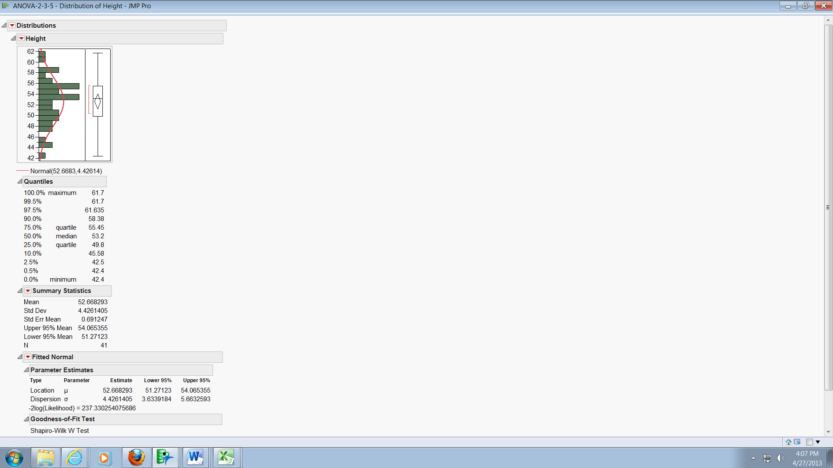

**Q9**

* What is the Levene’s F statistic? **3.87**
* What is the p-value***?  **0.021**
* Do the three samples have equal variances? **NO**

**Q10. What are your null and alternative hypotheses?**

**H0: There are no differences among groups.**

**Ha: at least two groups differ.**

**Q11.** Report your ANOVA results by filling in the blanks in the table below:

**ANOVA Summary of Fit**

|  |  |
| --- | --- |
| **Rsquare** | **0.29656** |

**Analysis of Variance**

| Source | DF | Sum of Squares | Mean Square | F Ratio | Prob > F |
| --- | --- | --- | --- | --- | --- |
| Age Class | 2 | 11,459.01 | 5829.50 | 102.86 | <.0001 |
| Error | 488 | 27,654.57 | 56.67 |  |  |
| C. Total | 490 | 39,313.58 |  |  |  |

**Q12.** In your own words, what do you think these results mean?

**These results (not taking into account that the data do not meet the assumptions for parametric ANOVA since the 3 samples are not normal and the variances not equal), indicate that the samples are indeed taken from different populations.**

**Q13.** Create a vertical bar graph of mean tree height +/- 1 standard error by height class. Insert your graph below.

**The table below is ‘extra’ – just for you to check your own values.**

|  |  |  |  |  |  |  |
| --- | --- | --- | --- | --- | --- | --- |
|  |  |  |  | **Diff in Means** | | |
| **Level** | **Mean** | **Std Err** | **N** | **MC** | **PC** | **TC** |
| MC | 34.63 | 0.476 | 250 | 0 | 3.84 | 18.04 |
| PC | 38.47 | 0.532 | 200 | 3.84 | 0 | 14.2 |
| TC | 52.67 | 1.176 | 41 | 18.04 | 14.2 | 0 |

**Q14.** For which (if any) plots (age classes) does it appear that heights differ?

**Heights for TC are quite different, MC and PC are closer, but still different by about 10%.**

**Q15** in JMP run a Tukey’s HSD test to determine which age classes are significantly different from the others. You will want to report your F(x,x) = X.XX, p = X.XXXX (an F with x,x degrees of freedom = X.XX, p = X.XXX) and Tukey’s lowercase letters on the graph you will make in Q10 below.

**Heights for the three plots (TC, PC, and MC), which represent different age classes, are significant different (F(2,488) = 102.87, p = 0.0001).**

**Q16 (optional)**. Please interpret your results as you would in a scientific paper.

**Trees in three plots (TC, PC, and MC), representing three age classes (100, 155, and 500 years, respectively), were measured for the Thousand Year Chronosequence Study (1kcs) in the Pacific Northwest (1999-2006). A subsequent statistical analysis showed that heights in the three plots were significantly different, with older trees being taller. See Figure Q16 below.**

**Figure Q16: Tree Heights (meters) of 3 Age Classes differ significantly ((F(2,488) = 102.87, p = 0.0001). Error bars show +1 SE.**

**Part 5: Resampling ANOVA**

**Q17. Fill in the following table with your calculations:**

What is your (actual) SSamong? **940586928.7**

|  |  |
| --- | --- |
| ***Number of groups (a)*** | **3** |
| ***sample size for each group (ni)*** | |  | | --- | | **Group 1: 250** | | **Group 2: 200** | | **Group 3: 41** | |
| ***overall mean* (*Ybar)*** | **36.41** |
| ***average for each group (Ybari where i=1,a)*** | |  | | --- | | **Group 1: 34.63** | | **Group 2: 38.47** | | **Group 3: 52.67** | |
| ***Total Sum of Squares (SStotal)*** | **40,135.82** |
| ***SS Among (SSamong)*** | **940,575,305** |
|  |  |

**Q17**. *What is your Resampling Stats p-value? Is it comparable to your ANOVA p-value from JMP? Speculate as to why or why not.*

***P<= 0.0001 – there were NO shuffled values that were less than the calculated SS-Among! Thus, I can conclude from the Monte Carlo Analysis that the three groups are indeed different, even though the data do not meet the requirements for a parametric ANOVA.***

***This is indeed the same p-value that was calculated using the parametric ANOVA is JMP.***