README

The document provides key information on the Hierarchical IDEAL tool included in the fat-water toolbox from the ISMRM Workshop on Fat-Water Separation, 2012.

For more information on this particular tool, please do not hesitate to contact the authors:
- Jeffrey Tsao – jtsao2@hotmail.com
- Yun Jiang - yun.jiang@case.edu

You may also contact members of the organizing committee for the Fat-Water Separation Workshop:
- Diego Hernando - dhernando@wisc.edu
- Harry Hu - houchunh@usc.edu

About Hierarchical IDEAL

Hierarchical IDEAL is an MRI reconstruction method for separating multiple chemical species by hierarchical decomposition and direct estimation of phase.
The method is partly described in:
- Tsao J, Jiang Y. Hierarchical IDEAL: robust water-fat separation at high field by multiresolution field map estimation. In: Proceedings of the 18th Annual Meeting of ISMRM, Toronto, ON, Canada, 2008. p 653
- Jiang Y, Tsao J. Fast and robust separation of multiple chemical species from arbitrary echo times with complete immunity to phase wrapping. In: Proceedings of the 20th Annual Meeting of ISMRM, Melbourne, Australia 2012.

Key properties

- Handle 3+ echoes at arbitrary echo times
- Handle any chemical species in addition to water and fat. Feature tested with phantom data with acetone or silicon.
- Handle any multi-peak spectral model. Feature available to edit chemical shifts and add new spectral models.
- Perform complex-valued fitting
- Determine single R₂* for all species
- Yield independent water/fat phase
- Perform separation in image space

Brief instructions to use the package

Start with 'testHierarchicalIDEAL.m', which opens up a dialog window as below:

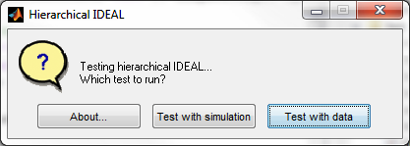
- 'Test with simulation': This button loads a numerical dataset for testing the algorithm. It will pop up several dialog windows to guide your selection.
- 'Test with data': This button loads data from a .mat file. It will pop up the following window for selecting a dataset
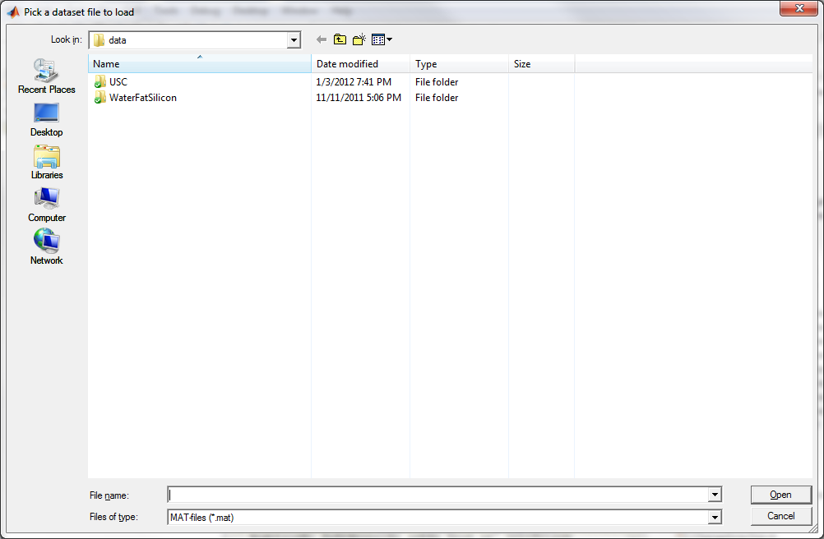
Once the dataset is selected, the 'Input parameters' window allows the user to select the spectral models used in separation. Chemical shifts of various models can be edited and saved. Shown below is selecting water and a 6-peak fat model for separation:
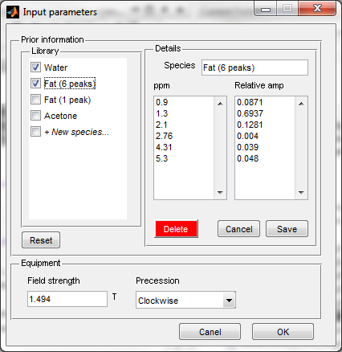
After clicking the OK button, the following window pops up to show the reconstruction progress.
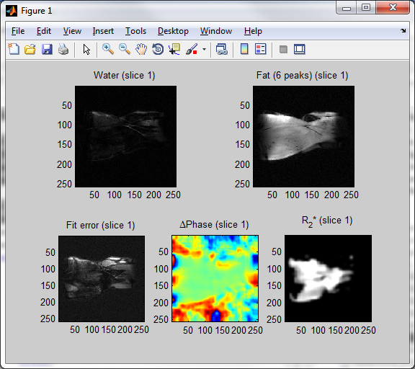
Results will be shown in the following window.
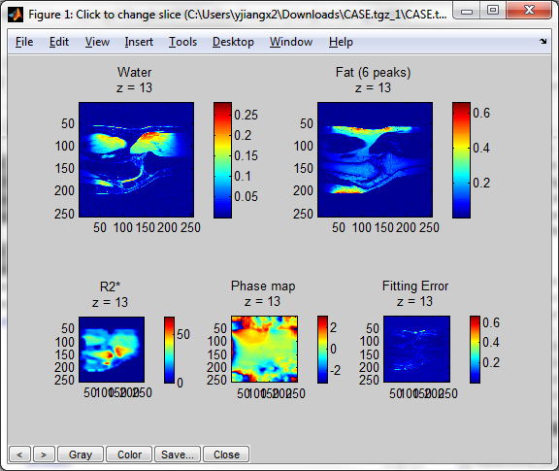
- The user can view different slices of the dataset by clicking 'left' (increase slice number) or 'right' (decrease slice number) mouse button.
- The final result can be saved to the current Matlab session or as a MAT file by clicking 'Save...' button at the bottom left corner of the window.

Have fun!!!

