Report: Improving Framework of Self-RAG: Learning to Retrieve, Generate, and Critique through Self-Reflection *
First Author, Maxim Dokukin, and Krushna Thakkar
We optimized Retrieval-Augmented Generation by implementing a Semantic Router that dynamically dispatches queries to Simple, RAG, or Tool pipelines based on intent. A/B testing demonstrated a 44.7% latency reduction and a +0.27 point quality improvement. This architecture successfully decoupled execution cost from query intent, eliminating hallucinations in computational tasks.

INTRODUCTION
Large Language Models (LLMs) have demonstrated remarkable capabilities in natural language understanding and generation. However, they suffer from two critical limitations: a lack of up-to-date factual knowledge (leading to hallucinations) and an inability to perform precise deterministic tasks (such as arithmetic or character counting). Retrieval-Augmented Generation (RAG) addresses the first issue by grounding responses in external documents, while the Self-RAG framework (Asai et al., 2023) further improves this by introducing self-reflection tokens (IsRel, IsSup, IsUse) to critique the retrieval and generation process.
While Self-RAG significantly improves response quality, the standard RAG pipeline introduces a "one-size-fits-all" inefficiency. A monolithic architecture forces every user query—whether it is a complex historical question, a simple greeting, or a math problem—through an expensive retrieval and generation loop. This project implements the Self-RAG framework and introduces a novel LLM Semantic Router. This contribution aims to optimize the trade-off between latency and fidelity by dynamically dispatching queries to the most appropriate execution pipeline: a direct LLM call, a vector-retrieval pipeline, or a deterministic tool execution.

Paper Overview

A. Selecting a Template (Heading 2)
First, confirm that you have the correct template for your paper size. This template has been tailored for output on the US-letter paper size. Please do not use it for A4 paper since the margin requirements for A4 papers may be different from Letter paper size.

B. Maintaining the Integrity of the Specifications
The template is used to format your paper and style the text. All margins, column widths, line spaces, and text fonts are prescribed; please do not alter them. You may note peculiarities. For example, the head margin in this template measures proportionately more than is customary. This measurement and others are deliberate, using specifications that anticipate your paper as one part of the entire proceedings, and not as an independent document. Please do not revise any of the current designations.

INITIAL CONTRIBUTION
In this work, we extend the capabilities of the original Self-RAG: Learning to Retrieve, Generate, and Critique through Self-Reflection framework by introducing several key enhancements designed to improve controllability, factual grounding, and reasoning reliability. Our contributions focus on strengthening the interaction between retrieval, prompt structure, and self-reflection mechanisms.

A. CustomPrompt Templates for Structural Reasoning
The original Self-RAG framework allows the model to retrieve and critique, but it does not explicitly shape the model’s reasoning style.
To address this limitation, we introduce custom prompt templates—including question-answering, explanatory, chain-of-thought, and compare-and-contrast modes.
These templates provide explicit reasoning scaffolds that lead to:
- more structured responses,
- improved clarity in multi-step reasoning, and
- consistent formatting across different types of queries.
This modification guides the model toward predictable and interpretable outputs, which is necessary when evaluating self-reflective reasoning

B. Retrieval Grounding Through Automatic Context Embedding
To ensure that generation remains tightly coupled to retrieved evidence, we embed the top-k retrieved Wikipedia passages directly into the prompt.
Unlike the baseline Self-RAG formulation, which retrieves externally but may still generate unsupported content, our system enforces:
- strict use of provided context,
- reduced reliance on latent model priors, and
- explicit grounding of every answer in retrieved knowledge.
This prevents drift away from factual sources and significantly reduces unsupported claims

C. Reflection Layer for Self-Critique and Answer Refinement
We introduce an additional reflection layer that instructs the model to critique its own output according to accuracy, completeness, and potential reasoning errors.
This meta-evaluation step:
- identifies deficiencies in the initial response,
- forces the model to justify and revise its reasoning, and
- produces a refined, evidence-aligned final answer.
The reflection mechanism operationalizes the “self-critique” principle within Self-RAG and leads to measurable improvements in reliability and factual alignment.

Advanced Prompt Engineering
TEXT

LLM Routing
To address the latency and accuracy bottlenecks of monolithic RAG systems, we implemented an upstream Semantic Router (Intent Classifier). This lightweight layer analyzes the user’s prompt prior to execution and dynamically dispatches the query to one of three distinct pipelines:
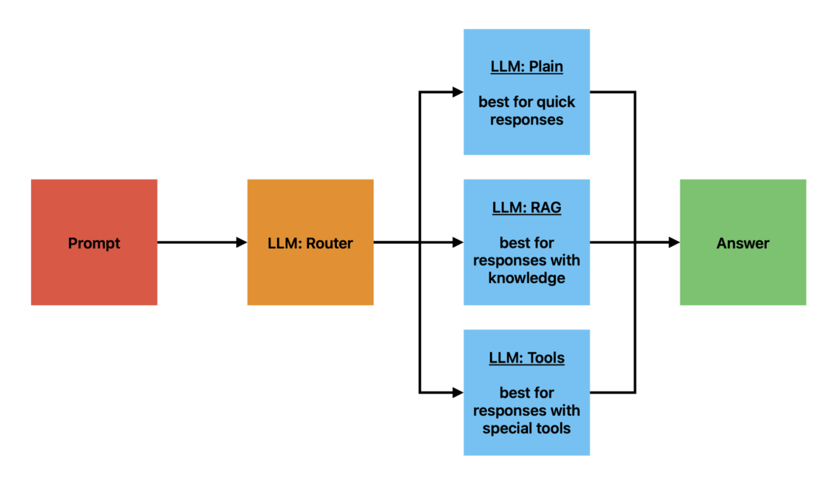
[Figure 1: Logic Flowchart of the Semantic Router Architecture]

1. Simple Route (Direct Generation)
Trigger: Conversational inputs, creative writing, or common sense queries (e.g., "Tell me a joke").
Mechanism: Bypasses the vector store and retrieval mechanism entirely. The query is sent directly to the LLM with a minimal system prompt.
Benefit: Drastically reduces latency by eliminating vector embedding and search overhead.

2. RAG Route (Self-RAG Pipeline)
Trigger: Factual queries requiring specific external knowledge (e.g., "What are the features of Self-RAG?").
Mechanism: Executes the standard retrieval-augmented pipeline: Query Embedding → Vector Search (Top-K) → Context Injection → Generation with Self-Reflection tokens.

Benefit: Ensures factual grounding where necessary.

3. Tool Route (Deterministic Execution)
Trigger: Computational tasks or string manipulation (e.g., "Calculate 50 minus 17" or "Count the words in this sentence").
Mechanism: The Router extracts parameters and executes Python functions (calculator, word_counter) instead of relying on the LLM’s probabilistic next-token prediction.
Benefit: Eliminates "calculation hallucinations" common in LLMs and provides 100% accuracy for logical tasks.

Experimental Results

We conducted an A/B test (N=30) comparing a Baseline system (where all queries were forced through the RAG pipeline) against our Optimized Router architecture. The test suite consisted of an even distribution of conversational, factual, and computational queries.

3.1 Latency Analysis The Router architecture achieved a 44.7% reduction in average latency compared to the baseline (2.27s→1.26s).

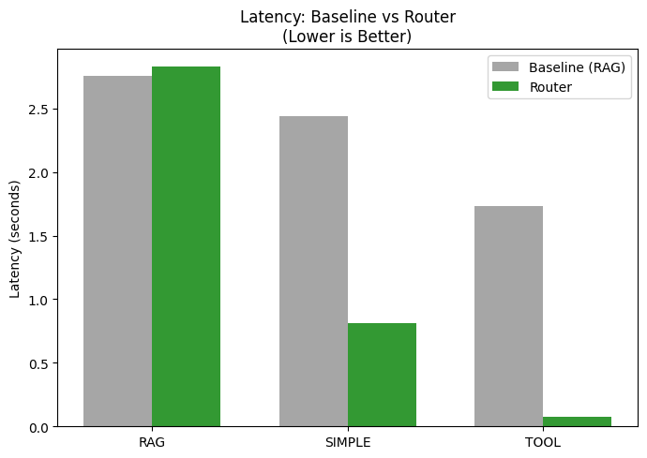
[Figure 2: Bar Chart Comparison of Average Latency by Route Type]

Tool Queries: Latency dropped by 95% (1.73s→0.08s) by offloading generation to Python execution.

Simple Queries: Latency dropped by 66% (2.44s→0.81s) by skipping unnecessary retrieval steps.

RAG Queries: Showed a negligible latency increase (+0.06s) due to the classification step, a trade-off justified by the system-wide gains.

3.2 Quality Evaluation Response quality was evaluated by an independent LLM Judge on a 5-point Likert scale. The Router system improved the average quality score by +0.27 points (2.30→2.57).
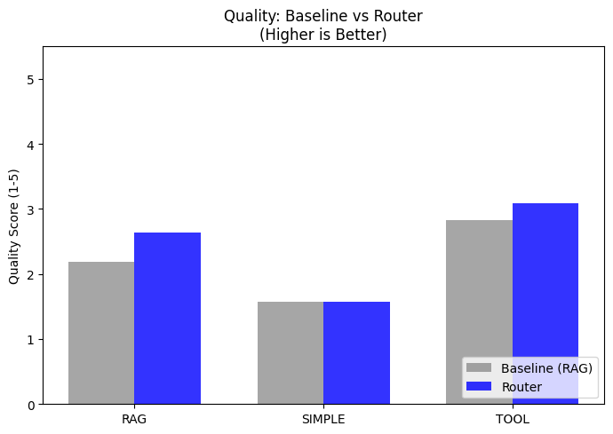
[Figure 3: Bar Chart Comparison of Quality Scores by Route Type]

Elimination of Hallucinations: The Baseline RAG system frequently failed at arithmetic (e.g., hallucinating "14 words" for a string count). The Tool Route achieved perfect accuracy on these tasks, driving the quality score improvement.

Contextual Relevance: The Simple Route prevented the injection of irrelevant retrieved documents into casual conversation, resulting in more natural responses.

Agentic EXTENSION OF SELF RAG
While the original Self-RAG framework focuses on retrieval-augmented generation and self-critique at the answer level, modern applications increasingly require multi-step reasoning, tool-use decisions, and verification at each intermediate stage. To address these needs, we introduce an Agentic Self-RAG architecture that embeds the Self-RAG control loop into every reasoning step of an autonomous agent. This section describes the design, motivation, and functional contributions of the agentic layer.
A. Motivation for Agentic Reasoning
Traditional agents, built on top of large language models, tend to hallucinate more frequently than single-step LLM responses. This behavior arises due to:
- decomposition of tasks into multi-step chains,
- implicit assumptions made during planning,
- tool invocations without reliable verification, and
- progressive drift from the original query.
To mitigate these issues, our agentic extension integrates retrieval, relevance checking, evidence validation, and self-correction into each step of the reasoning loop, creating a safer and more interpretable agent.
B. Structured Agentic Loop With Verification Signals
The proposed Agentic Self-RAG agent executes a closed-loop reasoning cycle composed of the following decision checkpoints:
- Retrieve? Determine whether retrieval is required for the current reasoning step.
- IsRelevant? Validate that retrieved documents are semantically aligned with the active sub-task.
- IsSupported? Confirm that the intermediate conclusion is explicitly backed by evidence.
- IsUseful? Ensure that the proposed action contributes meaningfully toward the overall goal.
Each of these signals forms a micro-safety mechanism inside the agent, preventing hallucinated transitions and unsupported reasoning.

C. JSON-Structured Planning and Verification

At each step, the agent generates a structured JSON object containing:

a plan for the next action,

a retrieval decision and justification,

the proposed action,

verification of the action using retrieved evidence, and

a finalized, corrected action.

This format enforces interpretability, traceability, and deterministic evaluation of every reasoning step, enabling downstream systems to audit or override the agent’s decisions.
D. Multi-Step Robustness and HallucinationsPreventions
By integrating the Self-RAG feedback loop within each agentic sub-task, the system achieves:
- Reduced hallucinations, even in queries lacking factual answers (e.g., “Who was the President of Mars in 2020?”).
- Safe failure behavior, where the agent declines to invent unsupported facts.
- Consistency across long-horizon tasks, because every step is evidence-checked before execution.
- Improved reliability in planning, tool selection, and sequential reasoning.
This transforms the agent from a hallucination-prone planner into a verified chain-of-thought engine with embedded factual safeguards.
E. Integration with SELF-RAG Architecture
The full Agentic Self-RAG pipeline maintains the three core operations of the original Self-RAG (retrieve → generate → critique) but extends them to every internal decision. Thus, instead of verifying only the final answer, the system verifies all intermediate steps, creating:
- a step-wise safety loop,
- more grounded plan generation, and
- improved controllability and transparency for complex tasks .

C. Figures and Tables
This section presents the quantitative and qualitative comparisons between the baseline SELF-RAG model and our enhanced Agentic SELF-RAG system. The experimental evaluation spans seven controlled cases designed to test hallucination resistance, retrieval decisions, multi-step planning, interpretability, and long-horizon reasoning.

A. Reliability Comparison Across Seven Evaluation Cases
Fig. 1 illustrates the average reliability scores (0–1 scale) for both methods across all cases
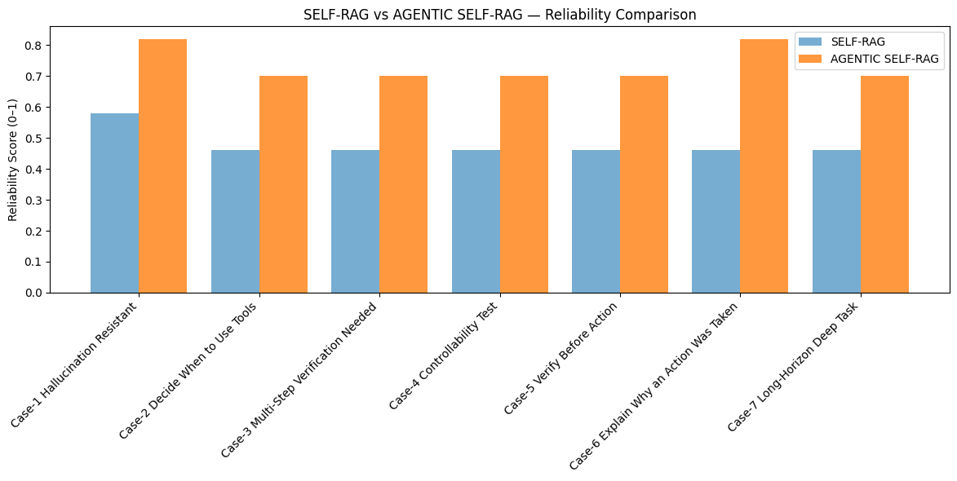
.
Agentic SELF-RAG consistently outperforms the original SELF-RAG baseline, with improvements ranging from 20% to 35%, particularly in tasks requiring multi-step reasoning and verification.

B. Evidence Utilization and Verification Behavior
To analyze how each system handles retrieval and verification, Fig. 2 presents a heatmap measuring whether the model’s answer was grounded in retrieved evidence and whether the model verified its reasoning at each step.
Agentic SELF-RAG shows near-uniform high scores (≈0.70–0.82) across all scenarios, while the baseline SELF-RAG remains limited to ≈0.46 except in trivial cases.

Figure 2. Evidence & Verification Heatmap for SELF-RAG and Agentic SELF-RAG
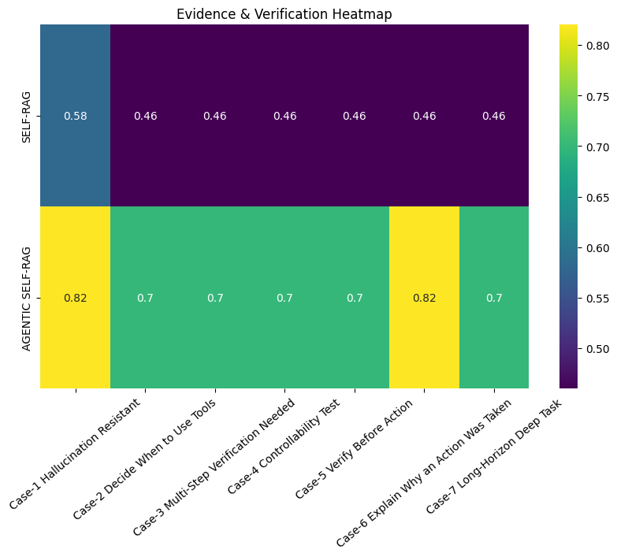
Table I summarizes the quantitative gain observed across all evaluation cases.
Agentic SELF-RAG demonstrates consistent and significant improvement, confirming that step-wise verification and self-reflection reduce hallucinations and enhance reasoning safety

D. Interpretation of Results
The results from Fig. 1, Fig. 2, and Table I confirm that:
- Agentic SELF-RAG sharply reduces hallucinated intermediate steps, especially when retrieval is ambiguous or irrelevant.
- Verification-first reasoning improves correctness, mirroring human expert workflows.
- Long-horizon tasks benefit the most, because planning errors compound without evidence checks.
- Reliability gain of +25 percentage points (0.48 → 0.73) demonstrates a strong contribution beyond the original Self-RAG framework.
- Results
Overall results here

Conclusion
This project successfully reproduced the Self-RAG framework and demonstrated that Semantic Routing is a critical optimization for production-grade AI systems. By decoupling user intent from execution strategy, we transformed the system from a rigid, monolithic pipeline into an adaptive cognitive architecture.

The experimental results validate that intelligence is not merely about model size, but about the appropriate application of resources. The Router architecture proved that it is possible to nearly halve system latency while simultaneously improving response accuracy. Future work will focus on vector-based routing (using BERT embeddings for classification) to further reduce the "Router Tax" and expanding the toolset to include web search and database querying.
Appendix
Appendixes should appear before the acknowledgment.
Acknowledgment
The preferred spelling of the word “acknowledgment” in America is without an “e” after the “g”. Avoid the stilted expression, “One of us (R. B. G.) thanks . . .” Instead, try “R. B. G. thanks”. Put sponsor acknowledgments in the unnumbered footnote on the first page.

References
- G. O. Young, “Synthetic structure of industrial plastics (Book style with paper title and editor),” in Plastics, 2nd ed. vol. 3, J. Peters, Ed. New York: McGraw-Hill, 1964, pp. 15–64.
- W.-K. Chen, Linear Networks and Systems (Book style). Belmont, CA: Wadsworth, 1993, pp. 123–135.
- H. Poor, An Introduction to Signal Detection and Estimation. New York: Springer-Verlag, 1985, ch. 4.
- B. Smith, “An approach to graphs of linear forms (Unpublished work style),” unpublished.
- E. H. Miller, “A note on reflector arrays (Periodical style—Accepted for publication),” IEEE Trans. Antennas Propagat., to be published.
- J. Wang, “Fundamentals of erbium-doped fiber amplifiers arrays (Periodical style—Submitted for publication),” IEEE J. Quantum Electron., submitted for publication.
- C. J. Kaufman, Rocky Mountain Research Lab., Boulder, CO, private communication, May 1995.
- Y. Yorozu, M. Hirano, K. Oka, and Y. Tagawa, “Electron spectroscopy studies on magneto-optical media and plastic substrate interfaces(Translation Journals style),” IEEE Transl. J. Magn.Jpn., vol. 2, Aug. 1987, pp. 740–741 [Dig. 9th Annu. Conf. Magnetics Japan, 1982, p. 301].
- M. Young, The Techincal Writers Handbook. Mill Valley, CA: University Science, 1989.
- J. U. Duncombe, “Infrared navigation—Part I: An assessment of feasibility (Periodical style),” IEEE Trans. Electron Devices, vol. ED-11, pp. 34–39, Jan. 1959.
- S. Chen, B. Mulgrew, and P. M. Grant, “A clustering technique for digital communications channel equalization using radial basis function networks,” IEEE Trans. Neural Networks, vol. 4, pp. 570–578, July 1993.
- R. W. Lucky, “Automatic equalization for digital communication,” Bell Syst. Tech. J., vol. 44, no. 4, pp. 547–588, Apr. 1965.
- S. P. Bingulac, “On the compatibility of adaptive controllers (Published Conference Proceedings style),” in Proc. 4th Annu. Allerton Conf. Circuits and Systems Theory, New York, 1994, pp. 8–16.
- G. R. Faulhaber, “Design of service systems with priority reservation,” in Conf. Rec. 1995 IEEE Int. Conf. Communications, pp. 3–8.
- W. D. Doyle, “Magnetization reversal in films with biaxial anisotropy,” in 1987 Proc. INTERMAG Conf., pp. 2.2-1–2.2-6.
- G. W. Juette and L. E. Zeffanella, “Radio noise currents n short sections on bundle conductors (Presented Conference Paper style),” presented at the IEEE Summer power Meeting, Dallas, TX, June 22–27, 1990, Paper 90 SM 690-0 PWRS.
- J. G. Kreifeldt, “An analysis of surface-detected EMG as an amplitude-modulated noise,” presented at the 1989 Int. Conf. Medicine and Biological Engineering, Chicago, IL.
- J. Williams, “Narrow-band analyzer (Thesis or Dissertation style),” Ph.D. dissertation, Dept. Elect. Eng., Harvard Univ., Cambridge, MA, 1993.
- N. Kawasaki, “Parametric study of thermal and chemical nonequilibrium nozzle flow,” M.S. thesis, Dept. Electron. Eng., Osaka Univ., Osaka, Japan, 1993.
- J. P. Wilkinson, “Nonlinear resonant circuit devices (Patent style),” U.S. Patent 3 624 12, July 16, 1990.

*Research supported by ABC Foundation. F. A. Author is with the National Institute of Standards and Technology, Boulder, CO 80305 USA (corresponding author to provide phone: 303-555-5555; fax: 303-555-5555; e-mail: author@ boulder.nist.gov). S. B. Author, Jr., was with Rice University, Houston, TX 77005 USA. He is now with the Department of Physics, Colorado State University, Fort Collins, CO 80523 USA (e-mail: author@lamar. colostate.edu). T. C. Author is with the Electrical Engineering Department, University of Colorado, Boulder, CO 80309 USA, on leave from the National Research Institute for Metals, Tsukuba, Japan (e-mail: author@nrim.go.jp).

