Input packets (assuming 8 bytes wide input 0..7):

Each frame encapsulates #MSG messages.
Each message is built of 3 fixed size fields and a Variable section of Extra Fields. The number of Extra Fields is #ExtraFields. Each EF is of fixed size.

For example:

The upstream StateMachine effectively splits the frame up in to multiple separate messages.

The kernel then processes each message separately.

Realigning of the message data is done in the Kernel. Since the messages need to be realigned, a gap cycle needs to be inserted between each message.

Practically, when we split a frame, the data is no longer tightly packed. What used to take 10 cycles to stream, would now need 11. To work around this effective slow down, we can run our splitting & downstream logic at a faster clock frequency than the rate of the incoming frame.

The kernel sees 2 separate frames with a gap cycle in between them, each frame contains 1 message and an alignment field which points to the position of the #EF field:

The alignment field for the first frame is 4 and for the second frame it's also 4. Realigning a frame based on a fixed (for the duration of the frame) offset is easy.

Once the kernel realigns the frames, they appear to be:

Which is more convenient to process.

The Filtering Kernel does 2 things:

1. Realigns the frame based on the alignment data passed from the State Machine.
2. Filter the frames based on Field C: Outputs the frame only if Field C is found inside a collection of 1024 values given by the CPU.

The search is implemented using a tree structure. We duplicate Field C (F) 1024 times so that we can compare it in parallel to all scalar inputs.

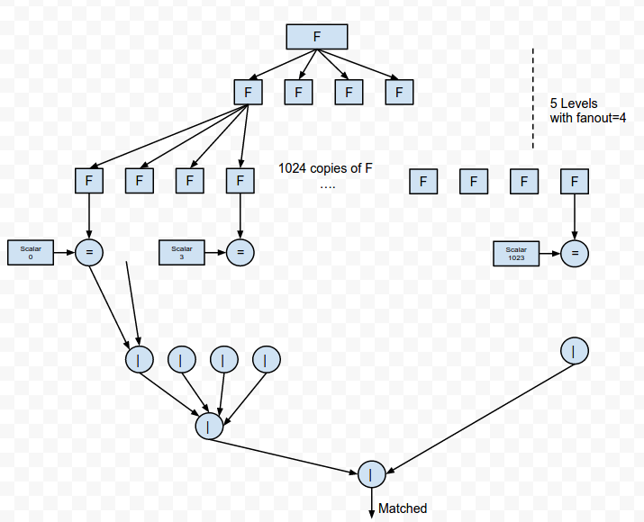

We use scalar inputs in this example because it provides parallel access to all the data.
However, scalar inputs have a few caveats:
1. They are implemented through registers, therefore not nearly as efficient as Block Memory (M20Ks)
2. Updating them in run-time is slow and stalls the kernel while they are being written (a few 10s of microseconds).

