BusBidder Spain
A flexible bus-booking and weighted offer-ranking platform
ACIT4420 Problem-solving with scripting, 2026
Department of Computer Science, OsloMet
[Your name]
[Student number]
[Date of submission]
[Link to GitHub repository]

Table of contents

Abstract
Write here.

1 Introduction and problem interpretation

1.1 Background and motivation
Write here.

1.2 Central question and objectives
Write here.

1.3 Requirements, assumptions and scope
Write here.

1.4 Report structure
One short paragraph that tells the reader what each section does.

2 Design and architecture

2.1 Architecture overview
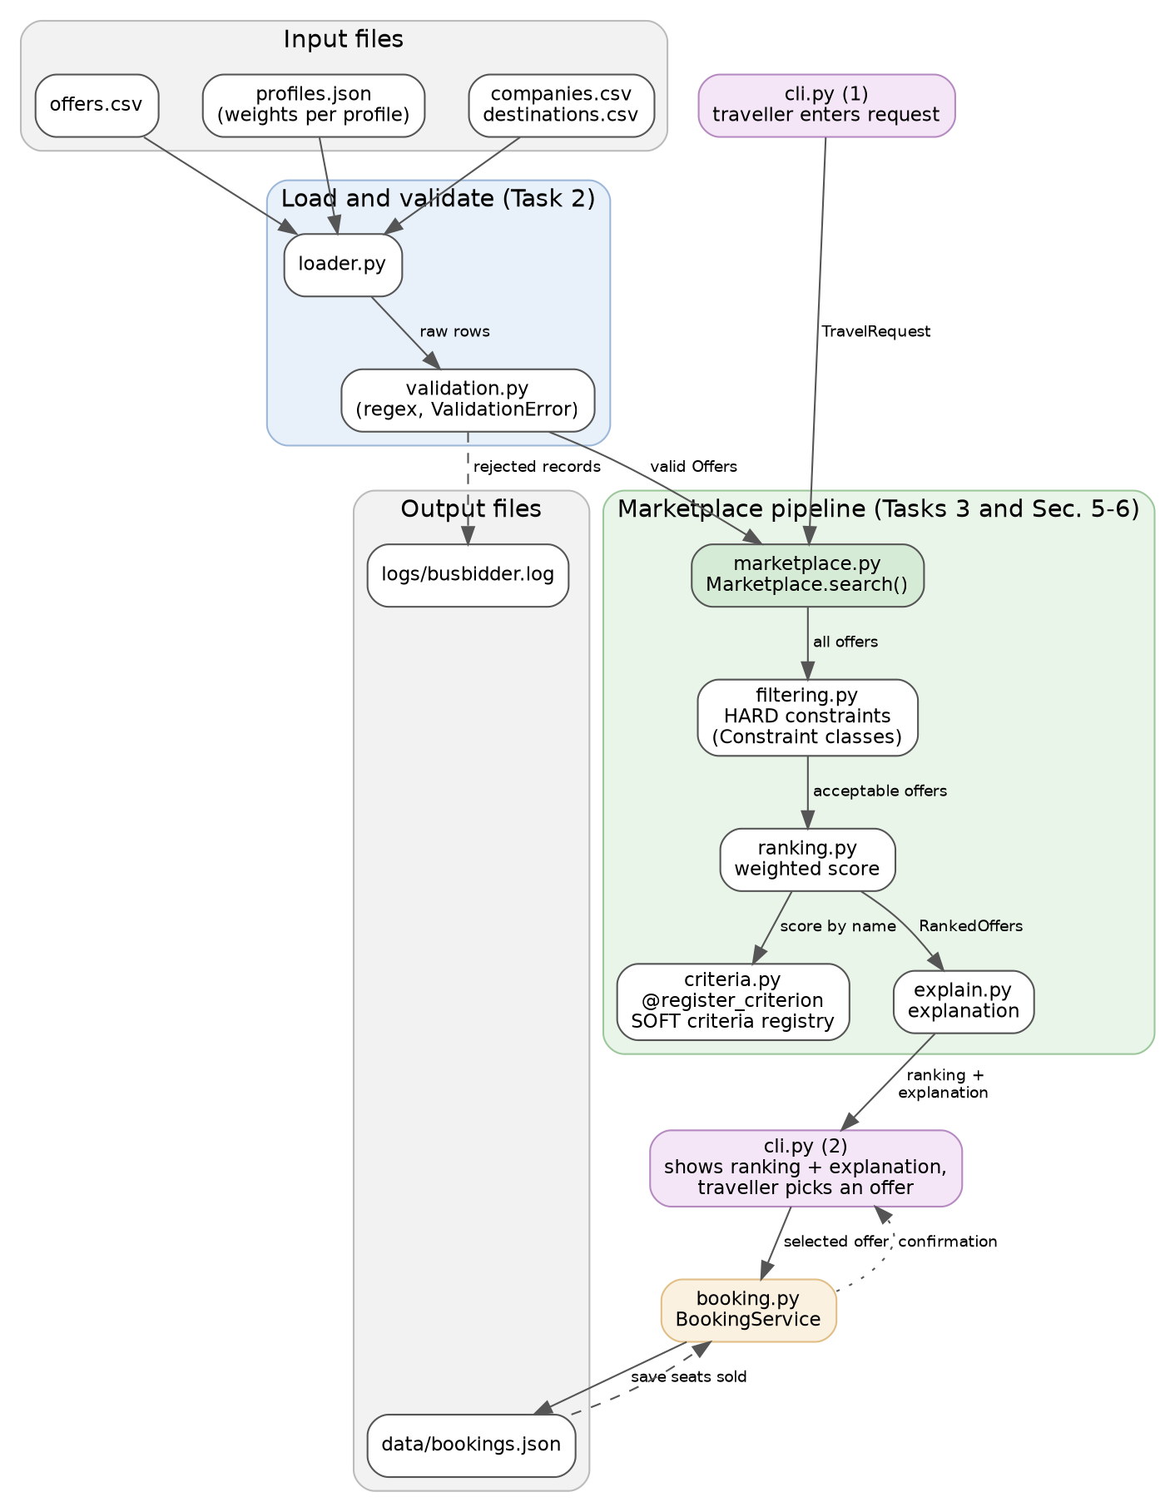
Figure 1: Main components and flow of information (first draft).
Write here: explain the figure step by step.

2.2 Class design
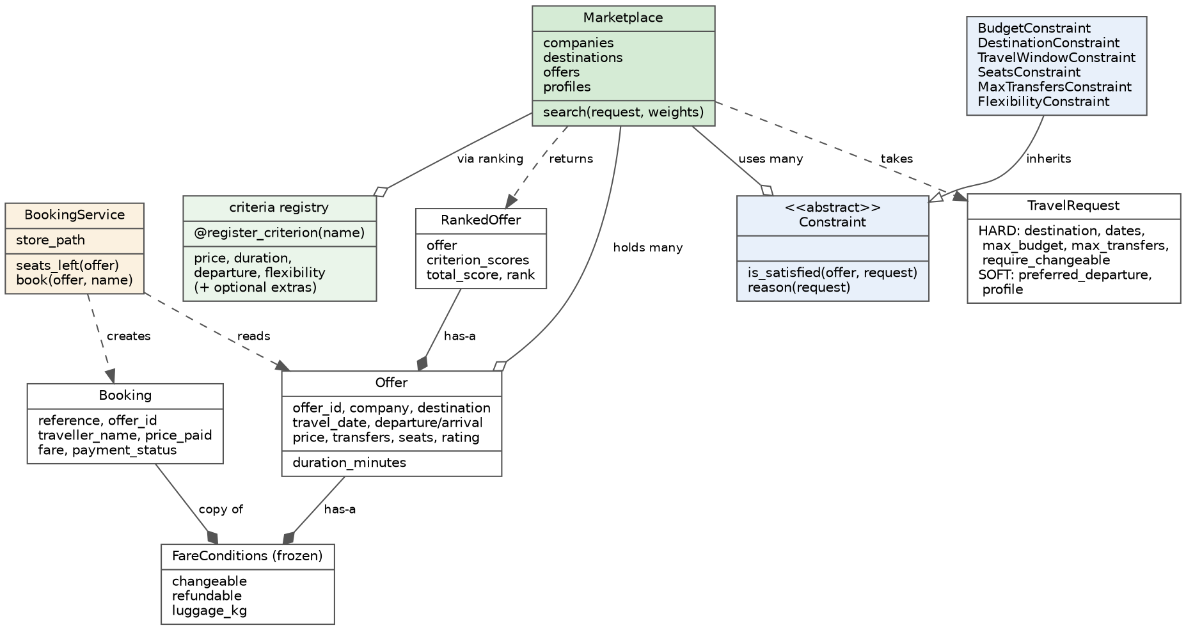
Figure 2: Main classes and their relations (first draft).
Write here.

2.3 Inheritance and composition
Write here.

2.4 Metaprogramming: a registry of scoring criteria
Write here.

2.5 Hard constraints and soft preferences
Condition | Hard or soft | Justification
Destination | Hard (proposed)
Travel window | Hard (proposed)
Maximum budget | Hard (proposed)
Seats available | Hard (proposed)
Maximum transfers | Hard (proposed)
Changeable ticket | Hard if required, otherwise soft
Preferred departure time | Soft (proposed)
Journey duration | Soft (proposed)

3 Dataset and validation

3.1 Dataset description
Company | Profile (from spec) | How my data differs (prices, times, fares)
SolRuta | Low-cost daytime services
Camino Express | Fast direct connections between major cities
CostaLink | Strong coverage of coastal destinations
VerdeBus | Environment-focused services and modern vehicles
NocheVia | Overnight and late-evening services

3.2 File formats and loading
Write here: which files, which fields, how text is converted to types (dates, times, numbers, yes/no).

3.3 Validation rules
Rule | Example of an invalid record | Handling | Test
Price must not be negative
Destination must be known
Date must be valid
Arrival must be after departure
Rating within the chosen scale
Seats available must be above 0
Required field present
Offer id matches the pattern (regex)

3.4 Handling of invalid records
Write here.

3.5 Custom exceptions, logging and regular expressions
Write here.

4 Implementation

4.1 Filtering with hard constraints
Write here: how filter_offers applies the Constraint objects, and how the removed offers are counted and shown to the user ('removed: 4 over budget').

4.2 Weighted scoring model
Write the general formula first, then fill in the table.
Criterion | Raw value | Better when | Normalisation to 0-100 | Weight source
Price | Euro | Lower |  | profiles.json
Duration | Minutes | Lower |  | profiles.json
Departure convenience | Minutes from preferred time | Smaller difference |  | profiles.json
Flexibility | Changeable / refundable (categorical) | More flexible |  | profiles.json

Weights and validation
Write here.

Ties, missing values and extreme values
Write here.

Preventing one criterion from dominating
Write here.

4.3 Generated explanation
Write here.

4.4 Booking
Write here.

4.5 User interface
Write here: what the user sees and does. Screenshots of a typical session work well.

5 Testing and experimental evidence

5.1 Test strategy
Write here: what you test, how the tests are organised in tests/, and how to run them (python -m pytest -v).

5.2 Test overview
Area | Case type | What is checked | Result
Loading | Normal
Loading | Missing file / field
Validation | Invalid
Filtering | Boundary
Ranking | Normal (hand-calculated)
Ranking | Boundary / extreme
Booking | Last seat / sold out

5.3 Reproducing the results
Write here: exact commands, fixed random seed (if any), and where the output examples used in this report are stored.

6 Traveller profiles and observed rankings

6.1 Example request
Preference | Value
Journey | Madrid to Malaga
Travel window | 12-14 July
Maximum budget | EUR 50
Preferred departure | Morning
Maximum transfers | 1
Changeable ticket | Required

6.2 Profiles and weights
Profile | Price | Duration | Departure | Flexibility
Budget traveller | 0.55 | 0.15 | 0.10 | 0.20
Business traveller | 0.15 | 0.40 | 0.30 | 0.15
Flexible tourist | 0.25 | 0.15 | 0.10 | 0.50

6.3 Observed results

Profile | Top-ranked offer | Total score | Runner-up | Why (generated explanation)
Budget traveller
Business traveller
Flexible tourist

6.4 Discussion
Write here.

7 Evaluation, limitations and critical reflection

7.1 Are the rankings reasonable?
Write here.

7.2 Sensitivity to weights and data
Write here.

7.3 Limitations and possible unfair outcomes
Write here.

7.4 Reflection on the design
Write here.

7.5 Possible improvements
Write here: concrete next steps (e.g. extra criteria, return trips, a web interface), ordered by value.

8 Reproducibility and traceability

8.1 How to run the program and the tests
Write here: Python version, libraries, entry point, exact commands (copy from the README, they must be identical).

8.2 Requirement traceability
Requirement (spec) | Implemented in | Tested in | Report section
Load and validate data (Task 2) | loader.py, validation.py
Custom exceptions and logging (Task 2) | exceptions.py, log_setup.py
Hard constraints (Task 3) | filtering.py
Weighted ranking, 4+ criteria (Sec. 5) | ranking.py, criteria.py
Explainable recommendation (Sec. 6) | explain.py
3+ traveller profiles (Sec. 6) | config/profiles.json
Simulated booking (Sec. 6) | booking.py
Metaprogramming technique (Sec. 7) | criteria.py
Interface (Sec. 7) | cli.py

9 Declaration of generative-AI use
Generative AI (Claude, Anthropic) was used as an assistant during this project. The use was as follows.

What it was used for
- Planning and structure: breaking the specification into phases, the structure of the README and the outline of this report.
- Code: first drafts of the project skeleton, the class design, the data generation script and the tests.
- Illustrations: the architecture diagram and the class diagram (Figures 1 and 2), generated with Graphviz.
- General questions and discussion of design alternatives.

How the output was checked
The program and the tests were run, the generated code and documents were read through, the diagrams were compared with the code, and everything was compared with the specification. The data generator is covered by automated tests.

Which parts are my own
I reviewed and agreed with the design decisions (docs/decisions.md), I edited the README and the documentation myself, and the report text is written by me. I am responsible for all design decisions and for everything in the submission.

10 Conclusion
Write here.

References
[1] ACIT4420 Final Project Specification: BusBidder Spain. OsloMet, 2026.

Appendices

Appendix A: Selected program output
Write here.

Appendix B: Selected log excerpt
Write here.

Appendix C: Test run summary
Write here.

