### Baseline Assessment

DSY1 2020, High Emission Scenario, 50%

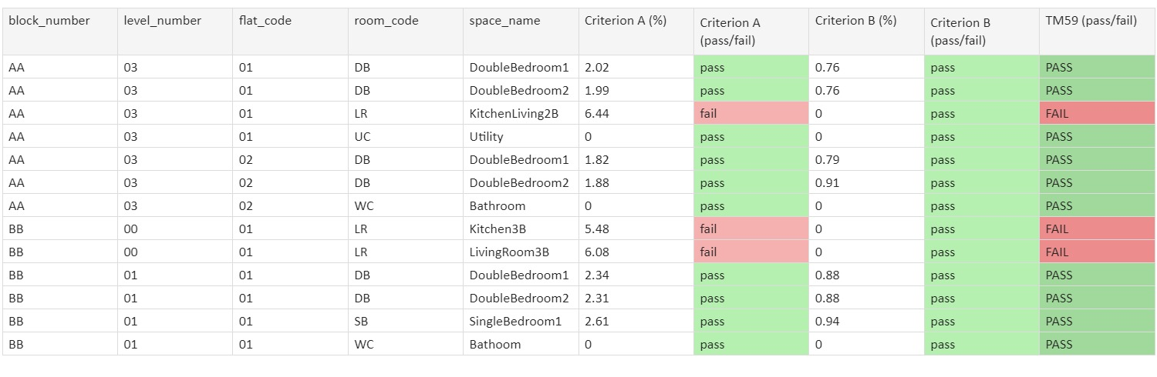

### Heatwave Assessment

DSY2 2020, High Emission Scenario, 50%



DSY3 2020, High Emission Scenario, 50%



### Future Assessment

DSY1 2030, High Emission Scenario, 50%



### Results Breakdown: Proposed Design

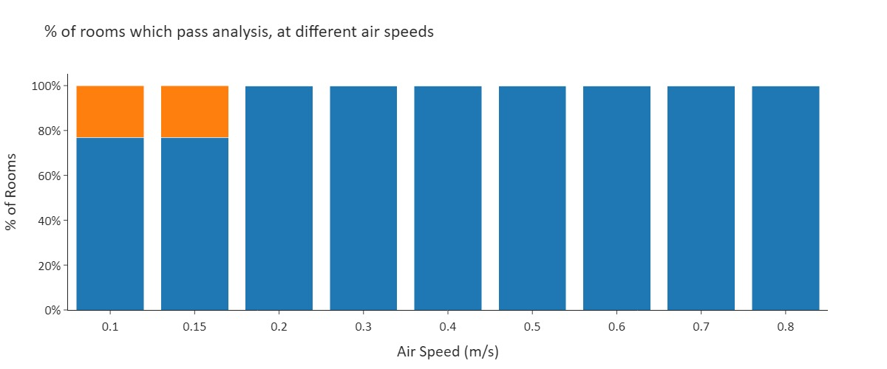

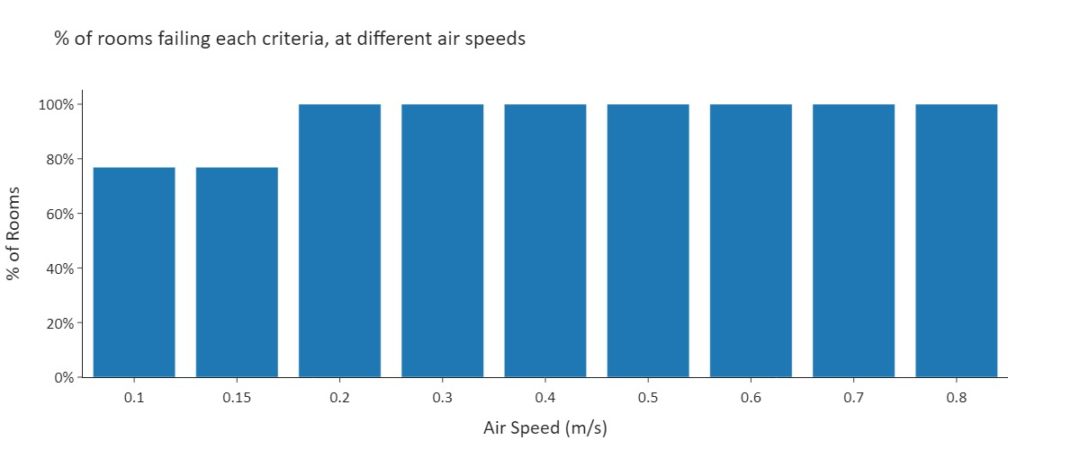

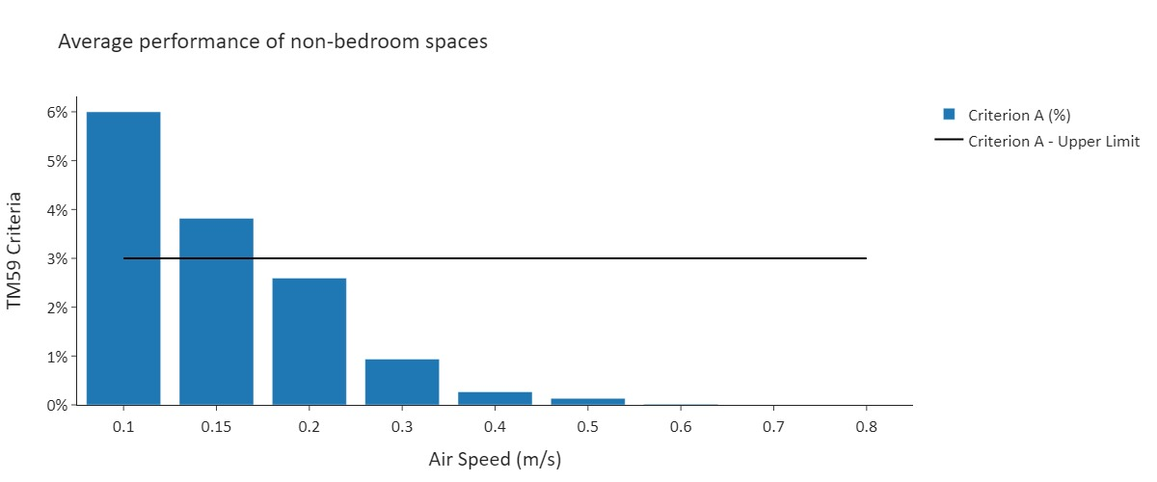

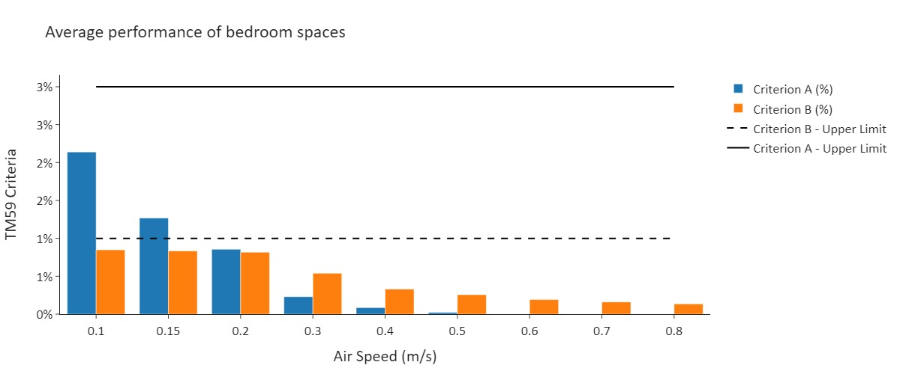

### Temperature Breakdown: Proposed Design

|  |  |
| --- | --- |
| Graphs of Example Rooms |  |
|  |  |
|  |  |
|  |  |