### Baseline Assessment

DSY1 2020, High Emission Scenario, 50%

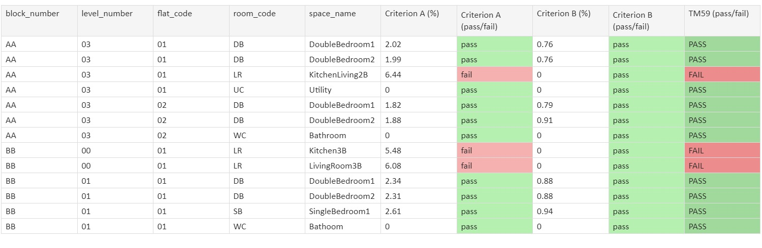

### Results Breakdown: Proposed Design

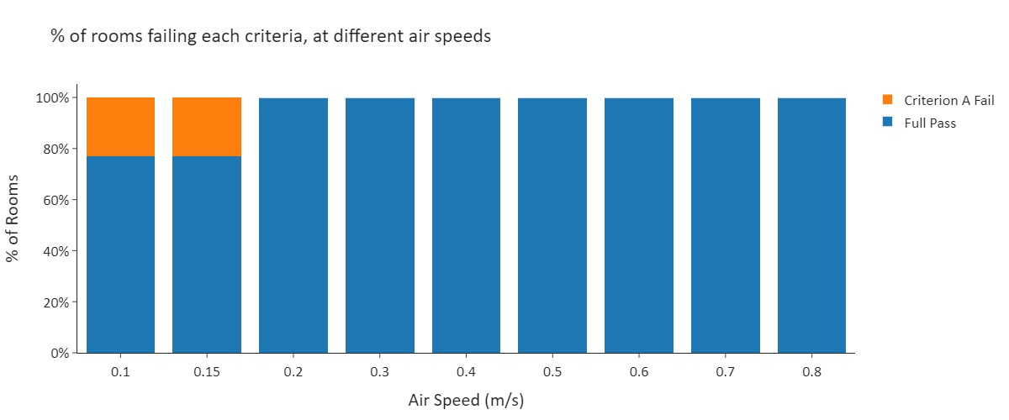

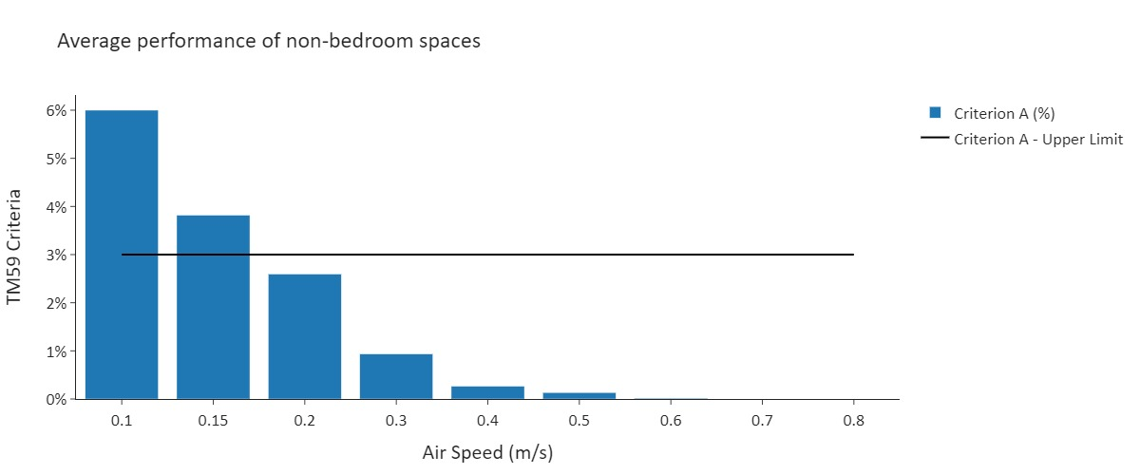

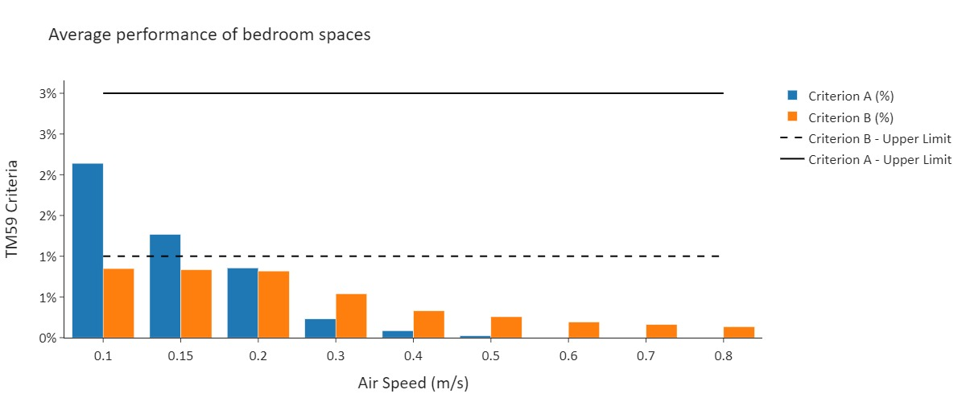

|  |  |
| --- | --- |
| Graphs of Example Rooms |  |
|  |  |
|  |  |
|  |  |