### Baseline Assessment

DSY1 2020, High Emission Scenario, 50%

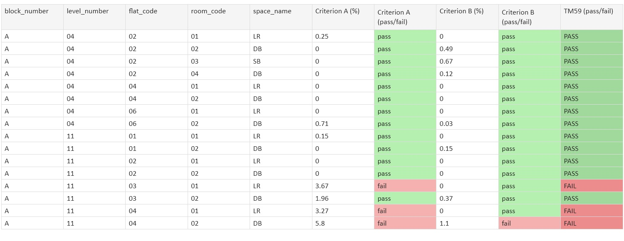

### Heatwave Assessment

DSY2 2020, High Emission Scenario, 50%

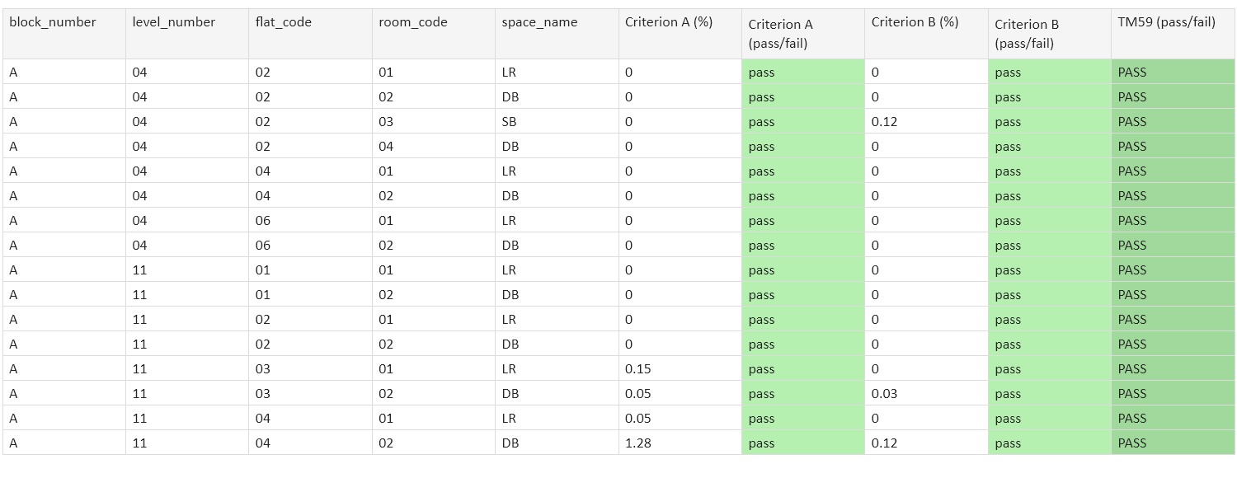

### Future Assessment

DSY1 2030, High Emission Scenario, 50%



### Results Breakdown: Proposed Design

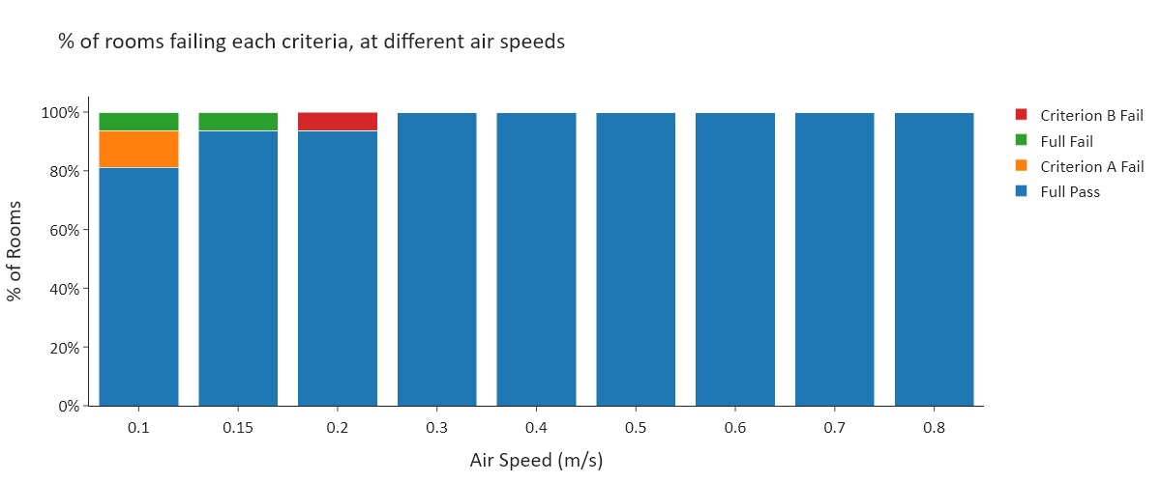

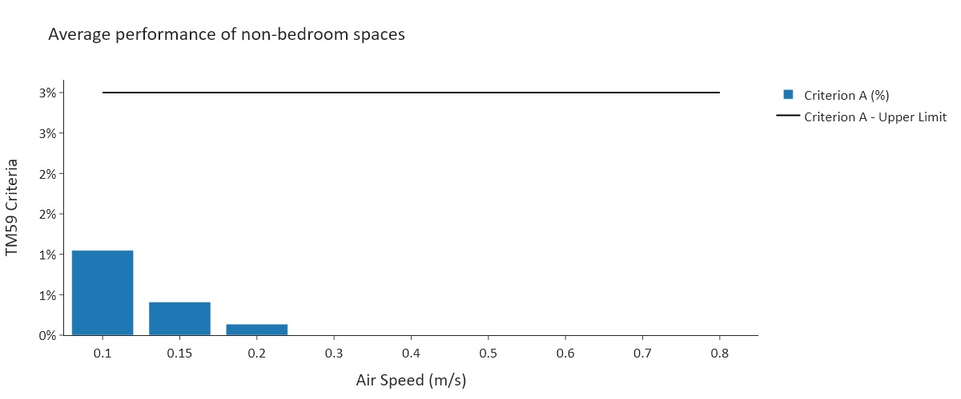

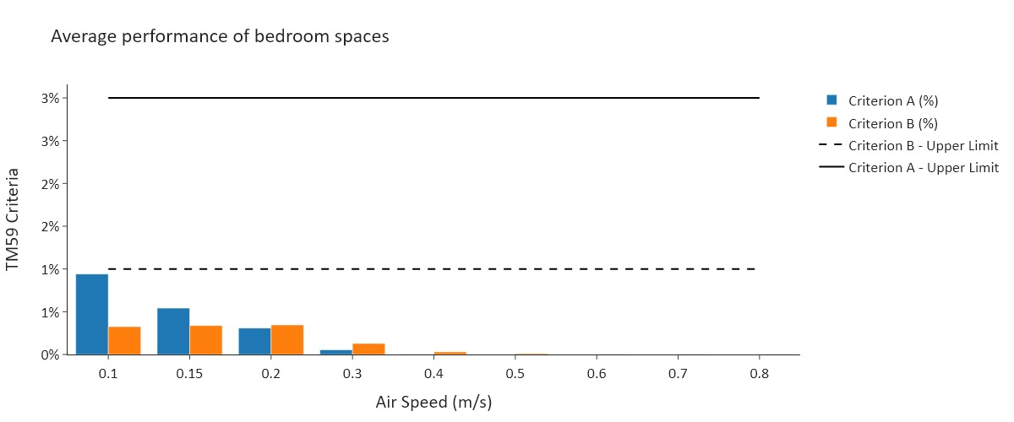

### Temperature Breakdown: Proposed Design

|  |  |
| --- | --- |
| Graphs of Example Rooms |  |
|  |  |

|  |  |  |  |
| --- | --- | --- | --- |
|  | DSY1 2020, High Emission Scenario, 50% | DSY2 2020, High Emission Scenario, 50% | DSY1 2030, High Emission Scenario, 50% |
| Mechanically Ventilated? | False | False | False |
| Air Speed | 0.1 | 0.1 | 0.1 |
| Model Desc |  |  |  |
| Average Glazing Ratio | 55.1 | 55.1 | 55.1 |
| G-value | 0.4 | 0.4 | 0.4 |
| Window Frame Factor | 0.9 | 0.9 | 0.9 |
| Door Frame Factor | 0.9 | 0.9 | 0.9 |
| Air Permeability | 3 | 3 | 3 |
| Thermal Mass | Lightweight | Lightweight | Lightweight |
| Vent Desc | Nat Vent | Nat Vent | Nat Vent |
| Openable Area: Bedrooms | All Windows | All Windows | All Windows |
| Opening Profile: Bedrooms |  |  |  |
| Openable Area: Other | All Windows | All Windows | All Windows |
| MVHR system heat recovery? | True | True | True |
| Gains Desc | As per TM59 | As per TM59 | As per TM59 |
| Gains: Technical Params | N/A | N/A | N/A |
| Cooling Desc | No Cooling | No Cooling | No Cooling |
| Cooling: Technical Characteristics | N/A | N/A | N/A |
| Adjacent buildings included? | False | False | False |
| Trees included? | False | False | False |