## Analysis Details

This section outlines the details of the overheating analysis

##### Software

IES VE 2018

##### Site Location

Croydon, London

##### Site Image

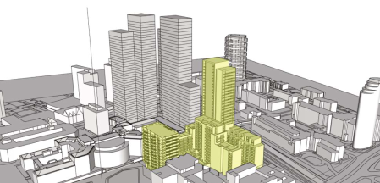

##### IES Modelling Image

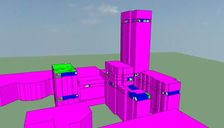

## TM59 Results

This section outlines the results from CIBSE TM59 analysis.

The CIBSE TM59 standard outlines a methodology for the assessment of overheating risk in homes. Two criteria are defined within this standard:

* Criterion A: For living rooms, kitchens and bedrooms: the number of hours during which DT is greater than or equal to one degree (K) during the period May to September inclusive shall not be more than 3% of occupied hours.
* Criterion B: For bedrooms only: the operative temperature from 10 pm to 7 am shall not exceed 26C for more than 1% of annual hours (33 hours)

In order to pass TM59, bedrooms have to pass both criteria while living rooms have to pass just Criterion A.

### Benchmark

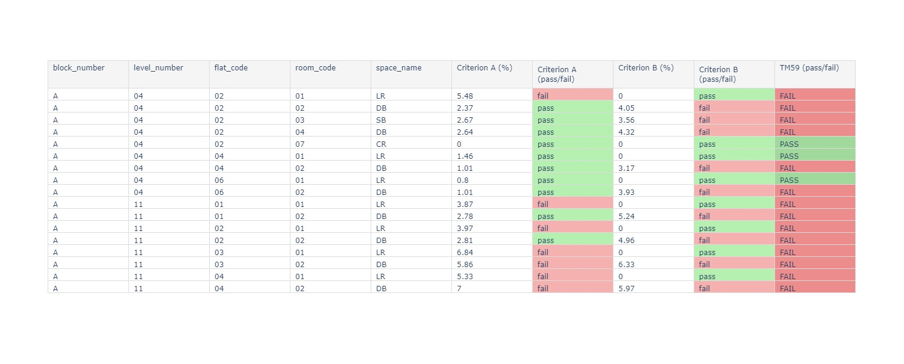

### As Designed



## Individual Model Details

This section outlines the assumptions and design inputs used within the overheating modelling, for both the *Benchmark* and *As Designed* models

### Benchmark

##### Description

This is the description of the benchmark model

##### Fabric

The parameters of the building fabric are detailed in the following table:

|  |  |  |
| --- | --- | --- |
|  | Parameter Values |  |
| Average Glazing Ratio | 55.1 | (%) |
| U-Value: Walls | 0.1 | (W/m^2.K) |
| U-Value: Floor | 0.1 | (W/m^2.K) |
| U-Value: Roof | 0.1 | (W/m^2.K) |
| U-Value: Opaque Doors | 0.1 | (W/m^2.K) |
| U-Value: Windows | 1.0 | (W/m^2.K) |
| G-value | 0.4 |  |
| Window Frame Factor | 0.9 |  |
| Door Frame Factor | 0.9 |  |
| Air Permeability | 3 | At 50Pa, Units: m3/h.m2 |
| Thermal Mass | Lightweight |  |

##### Ventilation Description

Nat Vent

##### Cooling Description

No Cooling

##### Summer (Elevated) Air Speed

* 1. m/s

### As Designed

##### Description

This is the description of the as designed model

##### Fabric

The parameters of the building fabric are detailed in the following table:

|  |  |  |
| --- | --- | --- |
|  | Parameter Values |  |
| Average Glazing Ratio | 55.1 | (%) |
| U-Value: Walls | 0.1 | (W/m^2.K) |
| U-Value: Floor | 0.1 | (W/m^2.K) |
| U-Value: Roof | 0.1 | (W/m^2.K) |
| U-Value: Opaque Doors | 0.1 | (W/m^2.K) |
| U-Value: Windows | 1.0 | (W/m^2.K) |
| G-value | 0.4 |  |
| Window Frame Factor | 0.9 |  |
| Door Frame Factor | 0.9 |  |
| Air Permeability | 3 | At 50Pa, Units: m3/h.m2 |
| Thermal Mass | Lightweight |  |

##### Ventilation Description

Nat Vent

##### Cooling Description

No Cooling

##### Summer (Elevated) Air Speed

0.1 m/s

## Indoor Temperature Graphs

This section compares the indoor temperatures for both the *Benchmark* and *As Designed* models, for a typical summer week.

A number of example rooms were used, to show an overview of the indoor temperatures across the building.

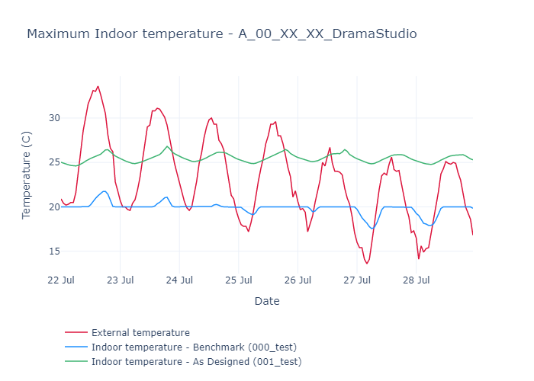

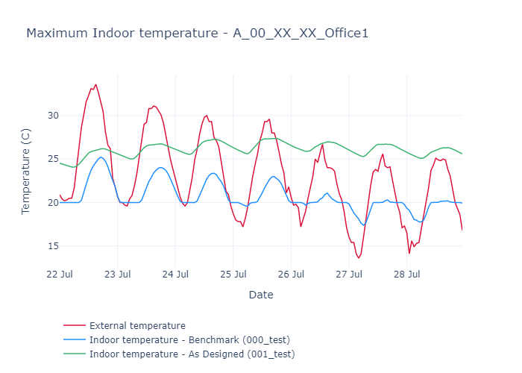

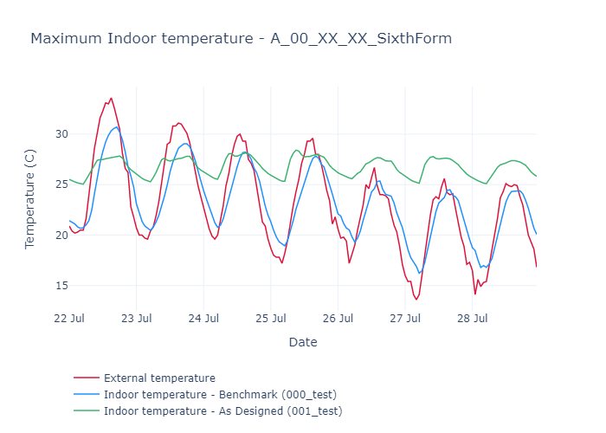

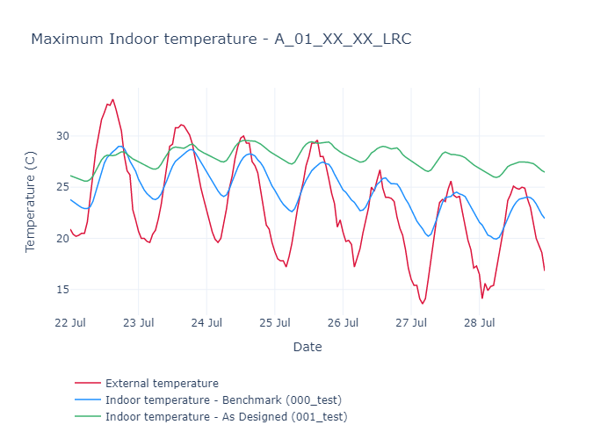

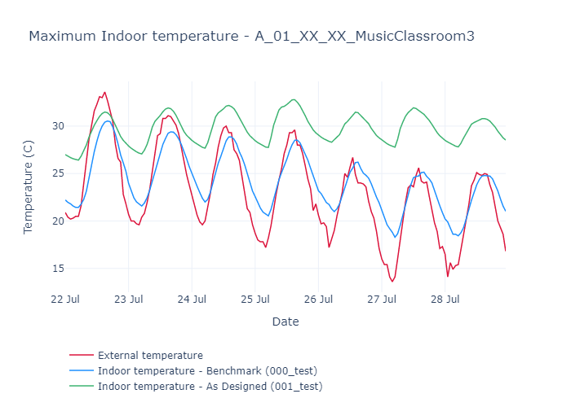

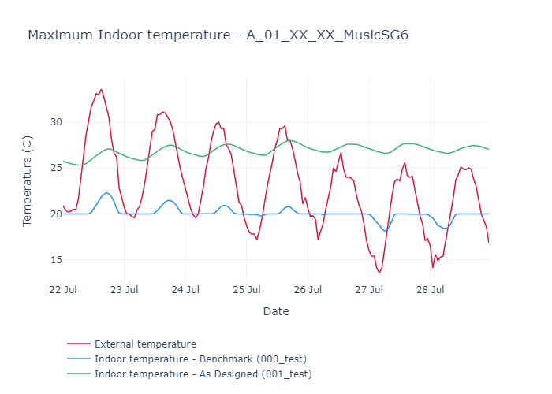

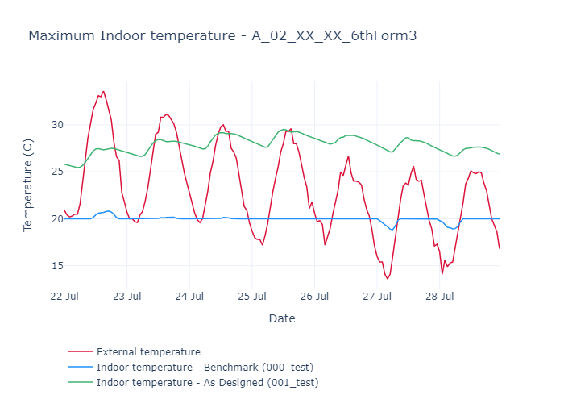

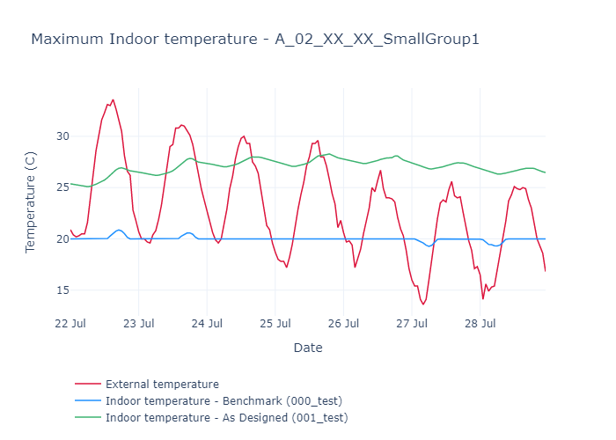

## Appendix A: Full Model Details

This section outlines all model inputs, for both the *Benchmark* and *As Designed* models

### Benchmark

|  |  |  |  |
| --- | --- | --- | --- |
|  | Parameter Values |  | Category |
| Model Desc |  | General Description of the Model | Misc |
| Date | 2020-01-01 | Date of Model Creation | Refs |
| General Reference | TM59 overheating analysis |  | Refs |
| London Plan Reference | CIBSE TM59: 2017 | Reference Document Title, for London Plan | Refs |
| Model File Path | C:_mf\05 Model Files\001_Holmsdale_blkA_TM59Overheating\102_Overheating.mit | File path of the IES model (.mit) | Linked Files |
| DWG Reference |  | File path of the DWG file | Linked Files |
| Average Glazing Ratio | 55.1 | (%) | Fabrics |
| U-Value: Walls | 0.1 | (W/m^2.K) | Fabrics |
| U-Value: Floor | 0.1 | (W/m^2.K) | Fabrics |
| U-Value: Roof | 0.1 | (W/m^2.K) | Fabrics |
| U-Value: Opaque Doors | 0.1 | (W/m^2.K) | Fabrics |
| U-Value: Windows | 1.0 | (W/m^2.K) | Fabrics |
| G-value | 0.4 |  | Fabrics |
| Window Frame Factor | 0.9 |  | Fabrics |
| Door Frame Factor | 0.9 |  | Fabrics |
| Air Permeability | 3 | At 50Pa, Units: m3/h.m2 | Fabrics |
| Thermal Mass | Lightweight |  | Fabrics |
| Vent Desc | Nat Vent | General Description of Ventilation Strategy | Ventilation |
| Openable Area: Bedrooms | All Windows |  | Ventilation |
| Opening Profile: Bedrooms |  | (Living Room & Kitchen Spaces) | Ventilation |
| Openable Area: Other | All Windows | (Living Room & Kitchen Spaces) | Ventilation |
| Background Mechanical? | True |  | Ventilation |
| MVHR system heat recovery? | True |  | Ventilation |
| Gains Desc | As per TM59 | General Description of Internal Gains | Internal Gains |
| Gains: Technical Params | N/A |  | Internal Gains |
| Cooling Desc | No Cooling | General Description of Cooling Strategy | Cooling |
| Cooling: Technical Characteristics | N/A |  | Cooling |
| Adjacent buildings included? | False |  | Context |
| Trees included? | False |  | Context |
| Air Speed | 0.1 | Summer (Elevated) Speed, Units: m/s | Context |

### As Designed

|  |  |  |  |
| --- | --- | --- | --- |
|  | Parameter Values |  | Category |
| Model Desc |  | General Description of the Model | Misc |
| Date | 2020-01-01 | Date of Model Creation | Refs |
| General Reference | TM59 overheating analysis |  | Refs |
| London Plan Reference | CIBSE TM59: 2017 | Reference Document Title, for London Plan | Refs |
| Model File Path | C:_mf\05 Model Files\001_Holmsdale_blkA_TM59Overheating\102_Overheating.mit | File path of the IES model (.mit) | Linked Files |
| DWG Reference |  | File path of the DWG file | Linked Files |
| Average Glazing Ratio | 55.1 | (%) | Fabrics |
| U-Value: Walls | 0.1 | (W/m^2.K) | Fabrics |
| U-Value: Floor | 0.1 | (W/m^2.K) | Fabrics |
| U-Value: Roof | 0.1 | (W/m^2.K) | Fabrics |
| U-Value: Opaque Doors | 0.1 | (W/m^2.K) | Fabrics |
| U-Value: Windows | 1.0 | (W/m^2.K) | Fabrics |
| G-value | 0.4 |  | Fabrics |
| Window Frame Factor | 0.9 |  | Fabrics |
| Door Frame Factor | 0.9 |  | Fabrics |
| Air Permeability | 3 | At 50Pa, Units: m3/h.m2 | Fabrics |
| Thermal Mass | Lightweight |  | Fabrics |
| Vent Desc | Nat Vent | General Description of Ventilation Strategy | Ventilation |
| Openable Area: Bedrooms | All Windows |  | Ventilation |
| Opening Profile: Bedrooms |  | (Living Room & Kitchen Spaces) | Ventilation |
| Openable Area: Other | All Windows | (Living Room & Kitchen Spaces) | Ventilation |
| Background Mechanical? | True |  | Ventilation |
| MVHR system heat recovery? | True |  | Ventilation |
| Gains Desc | As per TM59 | General Description of Internal Gains | Internal Gains |
| Gains: Technical Params | N/A |  | Internal Gains |
| Cooling Desc | No Cooling | General Description of Cooling Strategy | Cooling |
| Cooling: Technical Characteristics | N/A |  | Cooling |
| Adjacent buildings included? | False |  | Context |
| Trees included? | False |  | Context |
| Air Speed | 0.1 | Summer (Elevated) Speed, Units: m/s | Context |