Atmospheric CO2 at Mauna Loa

Summary
These notes accompany the annual mean carbon dioxide record from Mauna Loa Observatory, Hawaii. The record is the longest continuous series of direct atmospheric CO2 measurements and is widely used as a reference for the background concentration of the Northern Hemisphere.

Data and method
The annual means are published by the NOAA Global Monitoring Laboratory. Values are expressed as a mole fraction in dry air in parts per million (ppm). Data from March 1958 through April 1974 were obtained by C. David Keeling of the Scripps Institution of Oceanography. The values for the most recent year are provisional and can change after recalibration of the reference gases. All figures in this report are computed in the linked analysis workbook; tables and charts update when the workbook changes.

Results
Decade means rose from 316.0 ppm in the 1950s to 420.4 ppm in the 2020s (computed in the linked workbook).
Decade | Mean CO2 (ppm) | Change vs previous decade
1950s | 315.98
1960s | 320.29 | 4.31
1970s | 330.86 | 10.57
1980s | 345.65 | 14.80
1990s | 360.58 | 14.93
2000s | 378.77 | 18.19
2010s | 400.41 | 21.64
2020s | 420.37 | 19.95
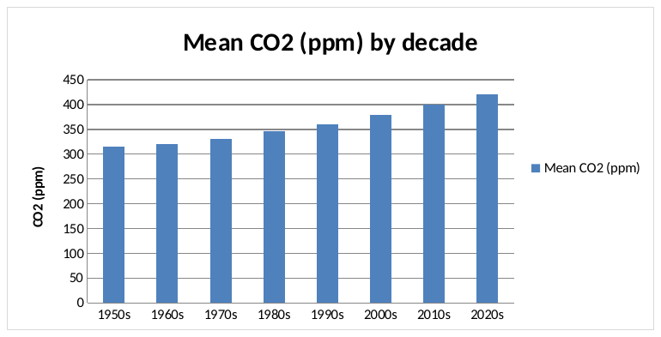
Figure 1. Mean CO2 by decade (rendered from the workbook chart)

Discussion
The analysis in this report is limited to describing the published annual means and their decade averages; it does not attempt attribution or projection.
Readers should note the gap in on-site measurements after the eruption of Mauna Loa in late November 2022: observations from December 2022 to July 2023 come from the Maunakea Observatories, about 21 miles to the north.

References
- Research notes (text; used as reference)
- Mauna Loa CO2 annual means (NOAA GML) (spreadsheet; used as context)

