**Smpp lite**

**Prerequisites**

* Git:
* Node.js and npm - v20.12.2

**Description**

SMPP Lite is a standalone Node.js application designed for testing and load evaluation of SMPP servers. When executed, the application prompts the user to specify a file name, then connects to an SMPP server based on the configuration provided in a config.yaml file located in the same directory. After successfully binding to the SMPP server, the application sends a test message and can perform a load test by sending multiple messages concurrently. Upon completion, it generates detailed logs and a summary file that captures the outcomes of the test, including connection status, message delivery results, and load test performance.

**Simple block diagram**

Smpp lite (this module)

Smpp server

**Steps to Set Up and Run the Project**

1.Clone the Repository

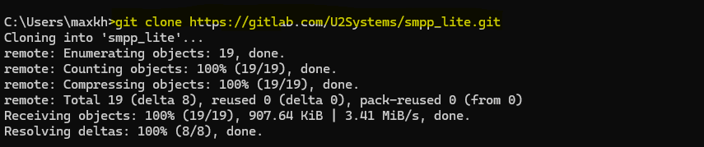

git clone https://gitlab.com/U2Systems/smpp_lite.git

2. Navigate to the Project Directory



cd smpp_lite

3. Install Dependencies

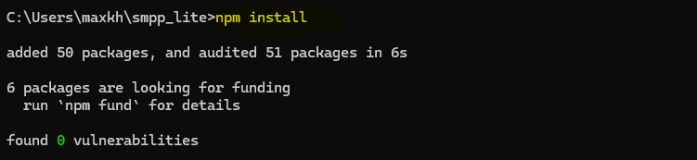

Npm Install

4. Configure the settings in the `config.yaml` file.

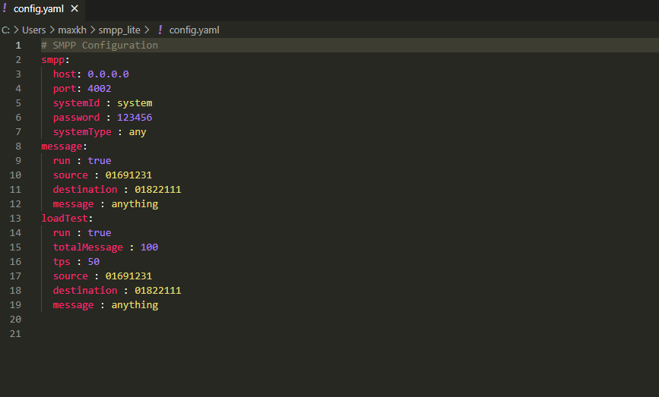

5. Run the project

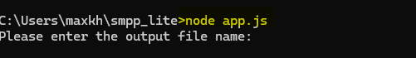

Node app.js

6. Enter the desired file name.

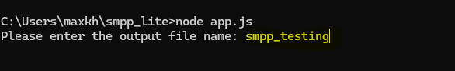

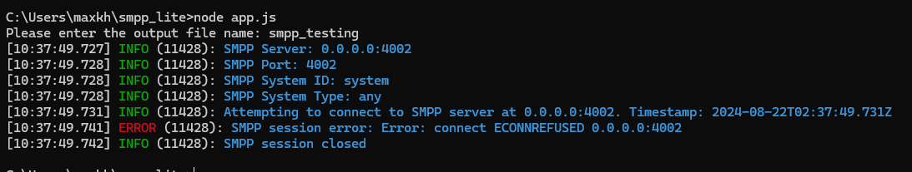

7. Verify that the new file has been created.

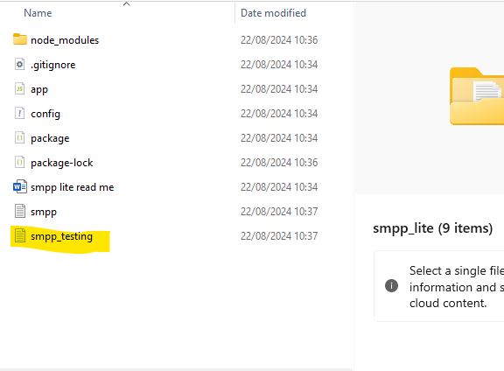

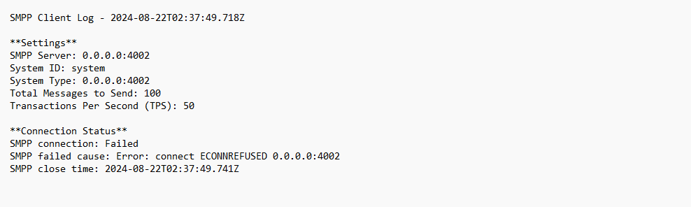

8. Contents of the file if the SMPP server is functioning correctly.

