**Unknown, S001, F1, M1, AII**

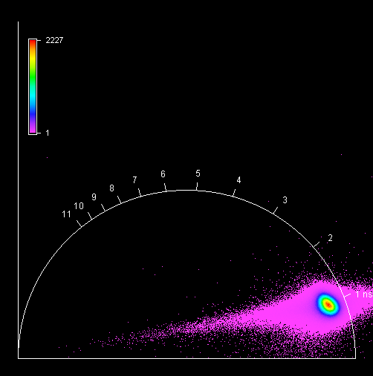

**Unknown, S001, F1, M2, AII**

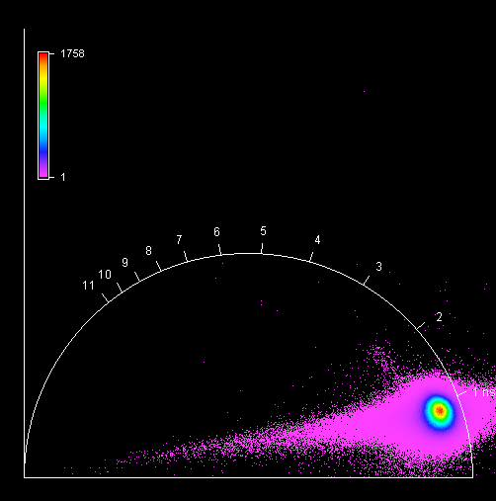

**Unknown, S001, F1, M3, AII**

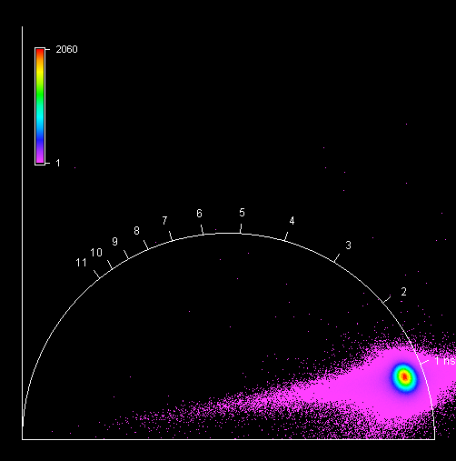

**Unknown, S001, F1, M4, AII**

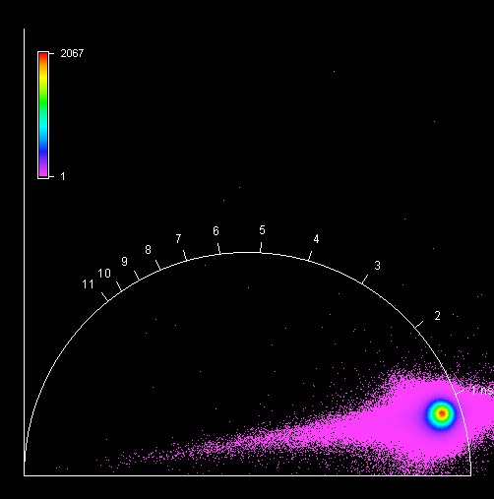

**Unknown, S001, F2, M1, AI**

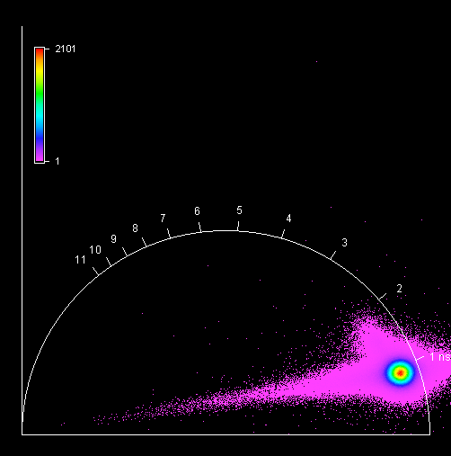

**Unknown, S001, F2, M2, AI**

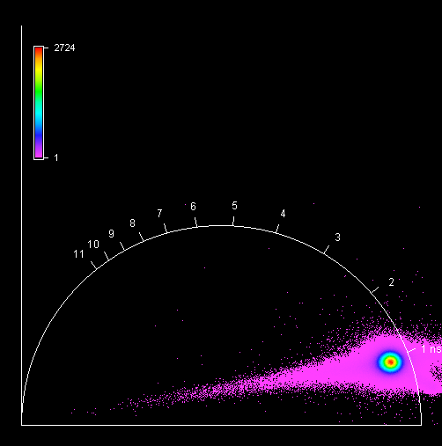

**Unknown, S001, F2, M3, AI**

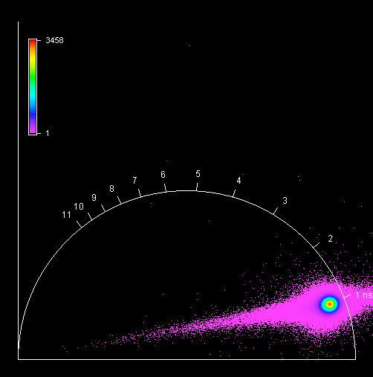

**Unknown, S001, F2, M4, AI**

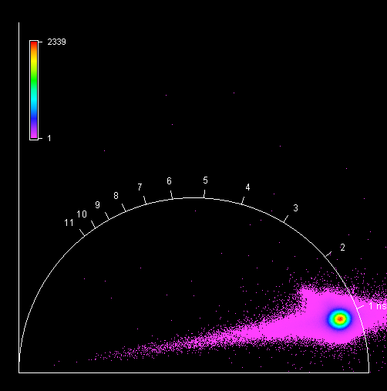

**Unknown, S002, F1, M1, AII**

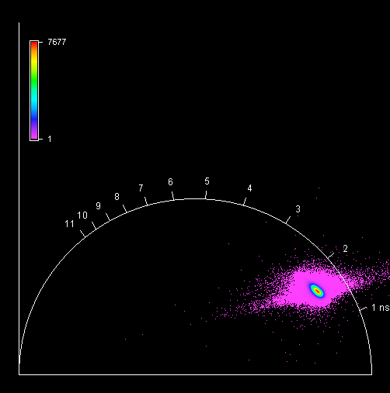

**Unknown, S002, F1, M2, AII**

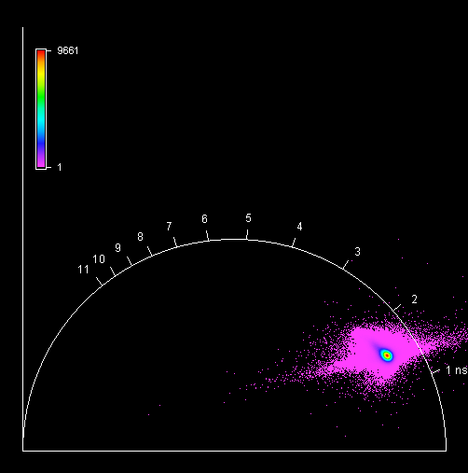

**Unknown, S002, F1, M3, AII**

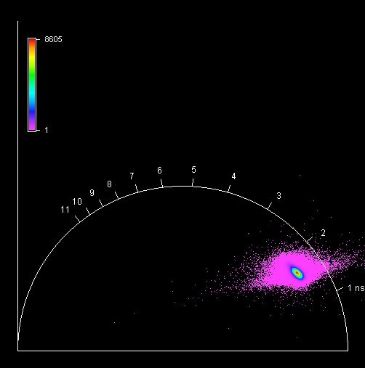

**Unknown, S002, F1, M4, AII**

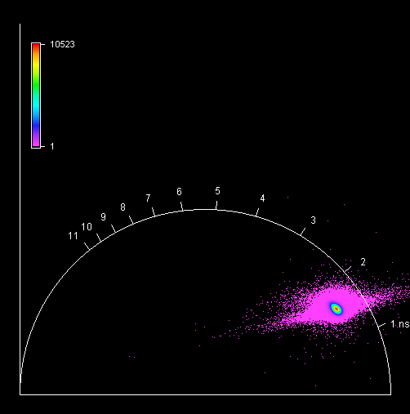

**Unknown, S003, F1, M1, AIII**

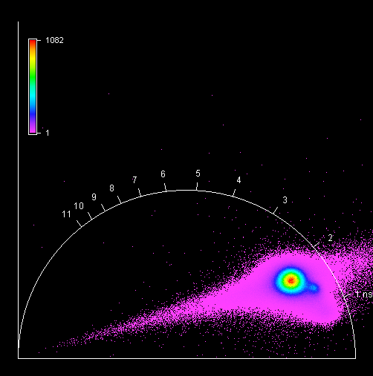

**Unknown, S003, F1, M2, AIII**

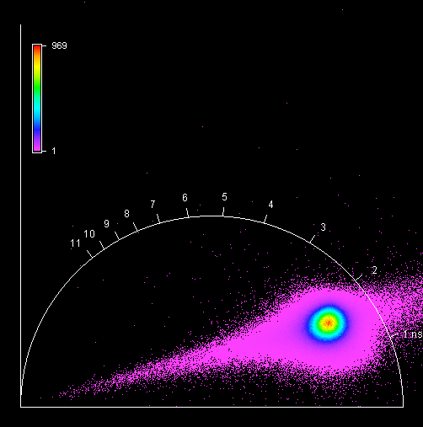

**Unknown, S003, F1, M3, AIII**

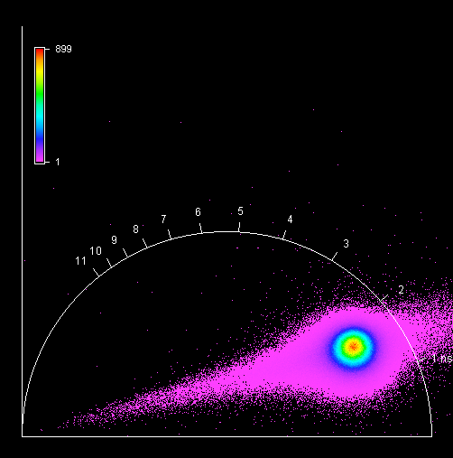

**Unknown, S003, F1, M4, AIII**

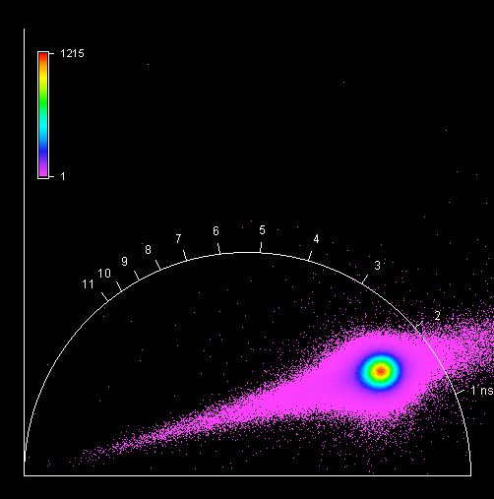

**Unknown, S003, F2, M1, AII**

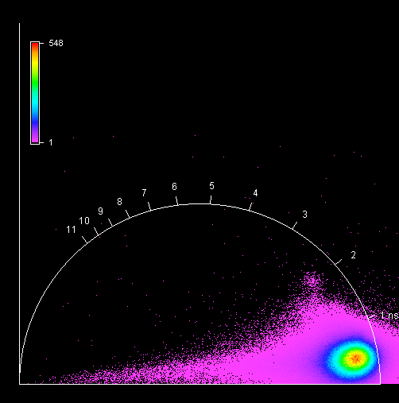

**Unknown, S003, F2, M2, AII**

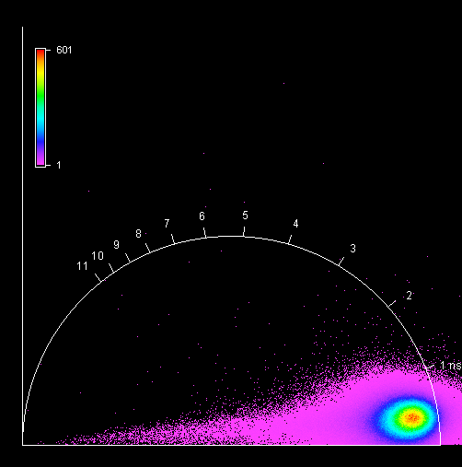

**Unknown, S003, F2, M3, AII**

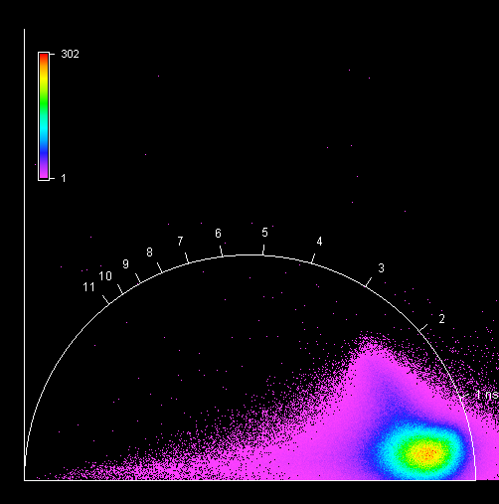

**Unknown, S003, F2, M4, AII**

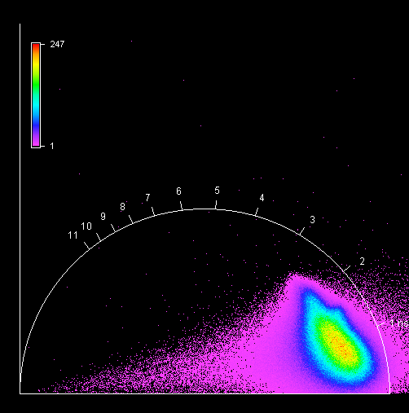

**Unknown, S004, F1, M1, AI**

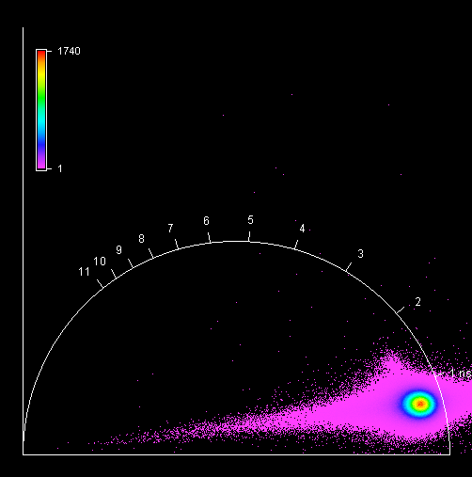

**Unknown, S004, F1, M2, AI**

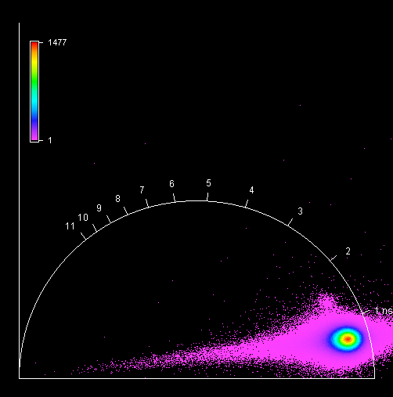

**Unknown, S004, F1, M3, AI**

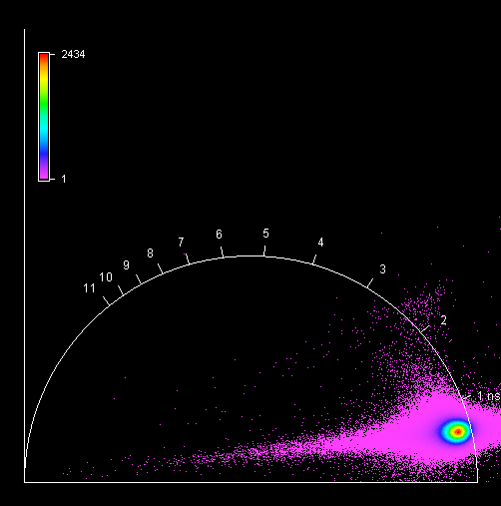

**Unknown, S004, F1, M4, AI**

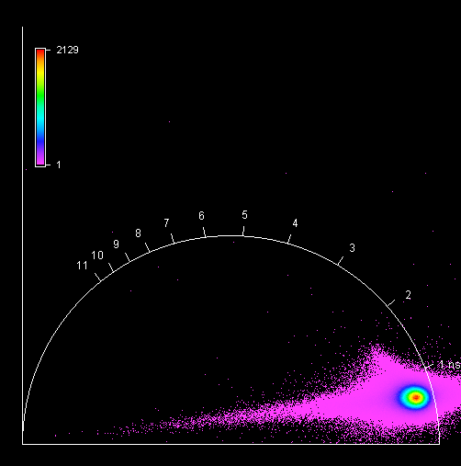

**Unknown, S005, F1, M1, AI**

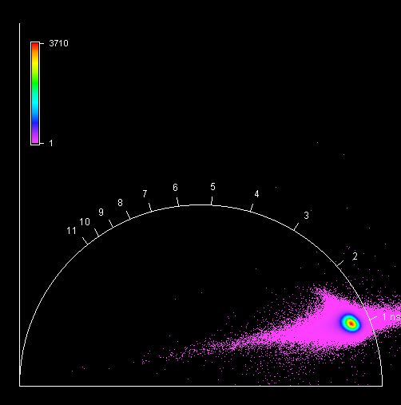

**Unknown, S005, F1, M2, AI**

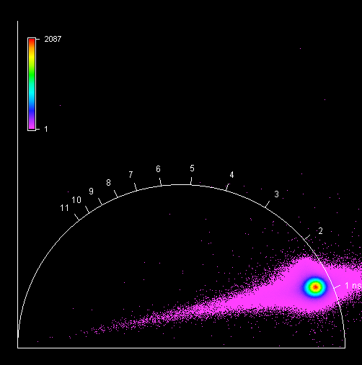

**Unknown, S005, F1, M3, AI**

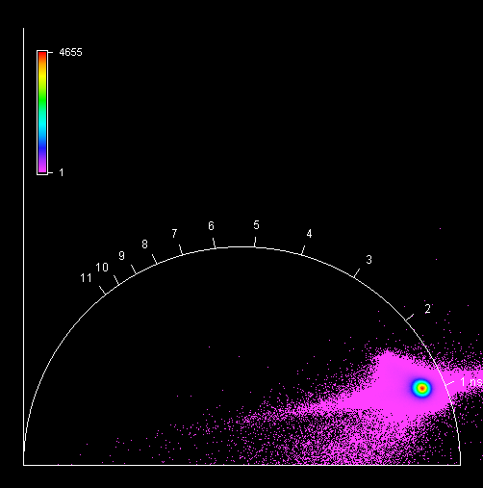

**Unknown, S005, F1, M4, AI**

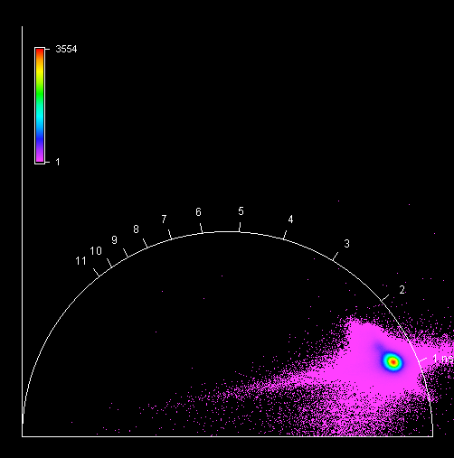

**Unknown, S006, F1, M1, AI**

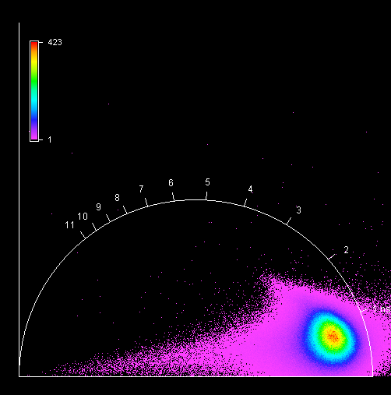

**Unknown, S006, F1, M2, AI**

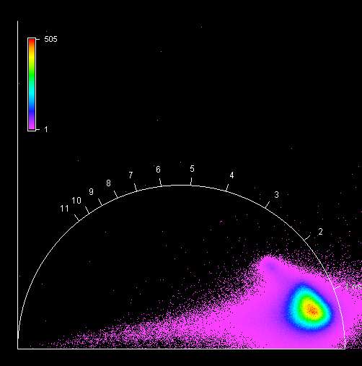

**Unknown, S006, F1, M3, AI**

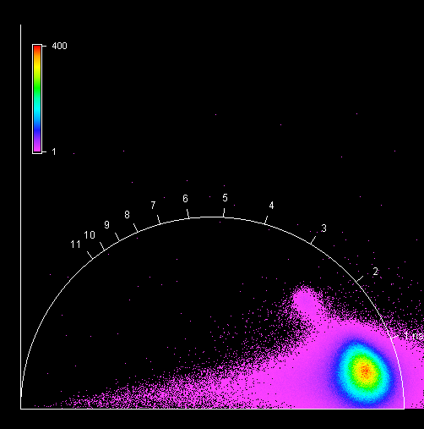

**Unknown, S006, F1, M4, AI**

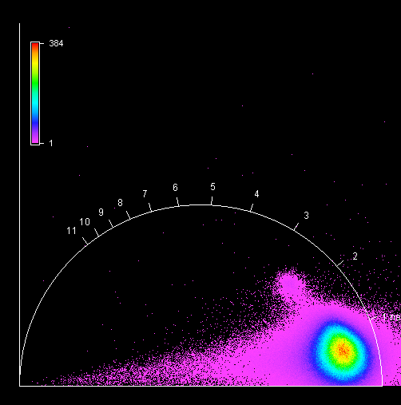

**Unknown, S007, F1, M1, AIII**

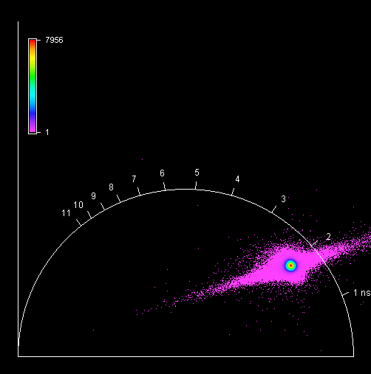

**Unknown, S007, F1, M2, AIII**

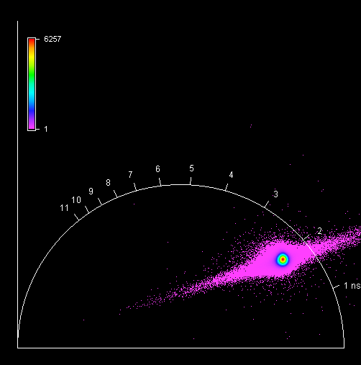

**Unknown, S007, F1, M3, AIII**

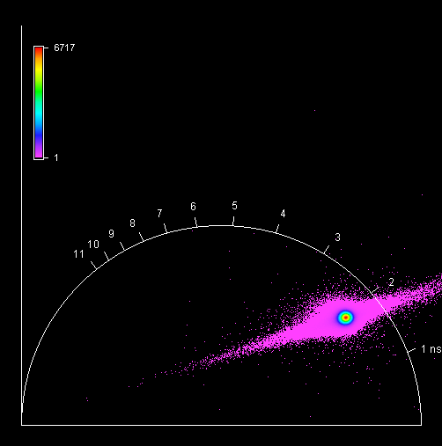

**Unknown, S007, F1, M4, AIII**

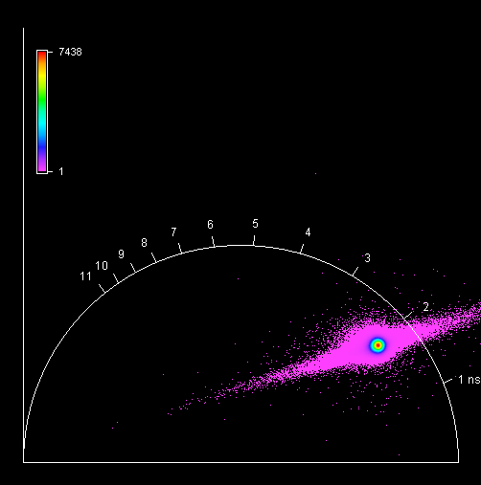

**Unknown, S008, F1, M1, AII**

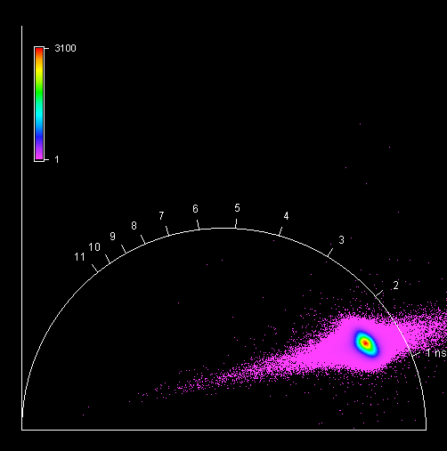

**Unknown, S008, F1, M2, AII**

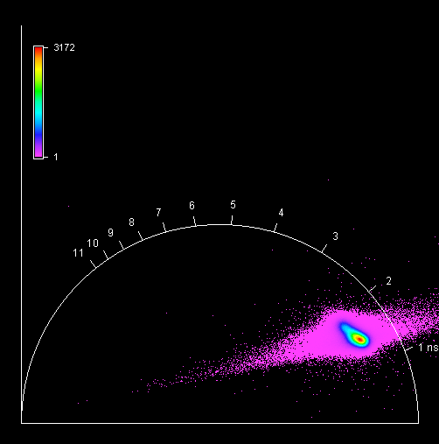

**Unknown, S008, F1, M3, AII**

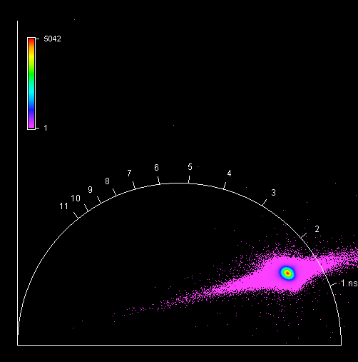

**Unknown, S008, F1, M4, AII**

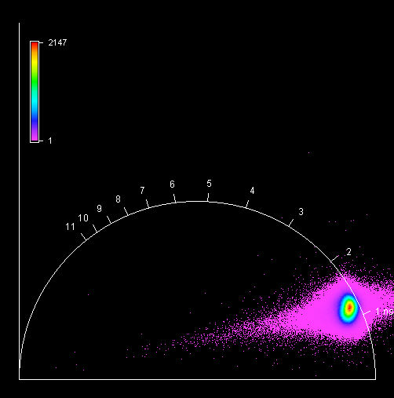

**Unknown, S009, F1, M1, AIII**

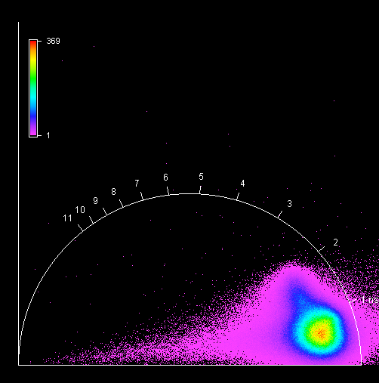

**Unknown, S009, F1, M2, AIII**

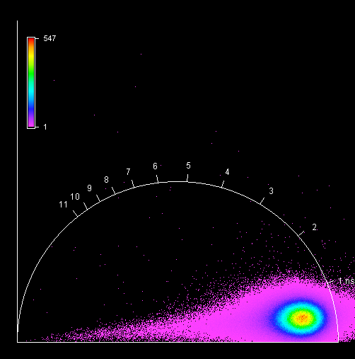

**Unknown, S009, F1, M3, AIII**

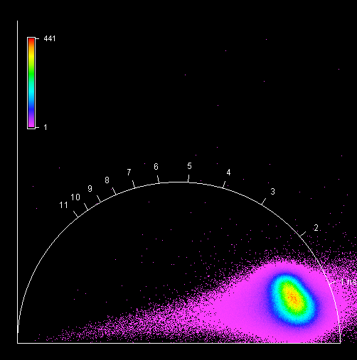

**Unknown, S009, F1, M4, AIII**

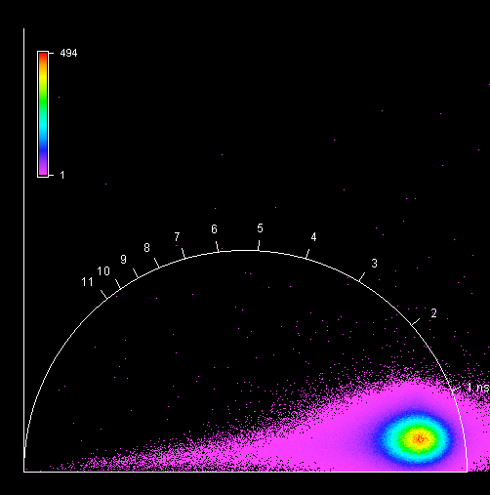

**Unknown, S010, F1, M1, AII**

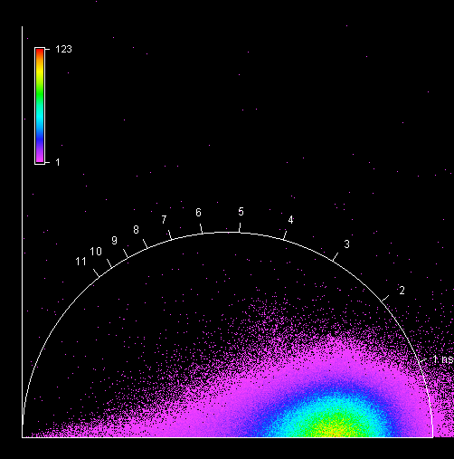

**Unknown, S010, F1, M2, AII**

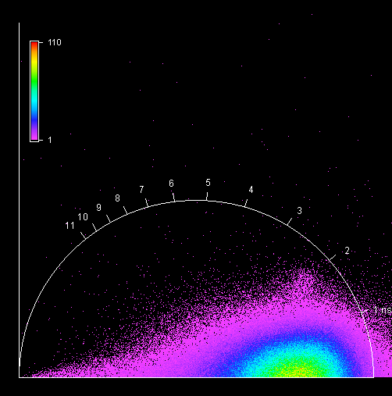

**Unknown, S010, F1, M3, AII**

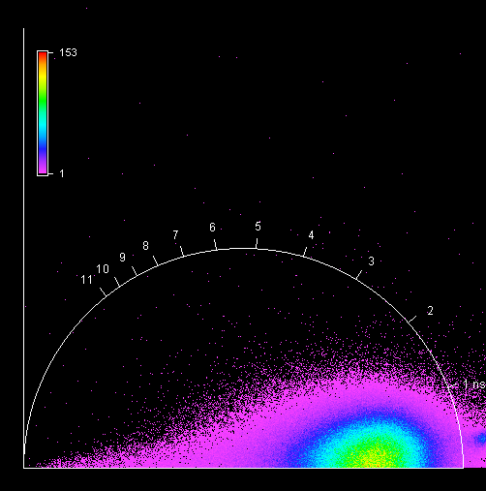

**Unknown, S010, F1, M4, AII**

