**Unknown, S121, F1, M1, AII** 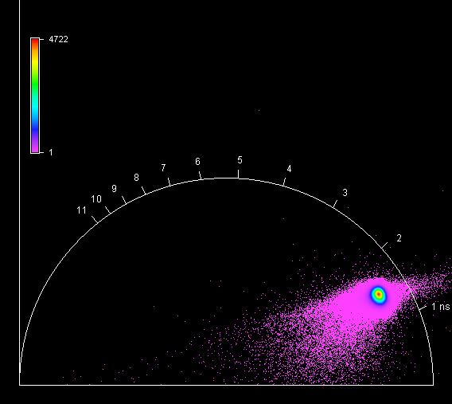

**Unknown, S121, F1, M2, AII** 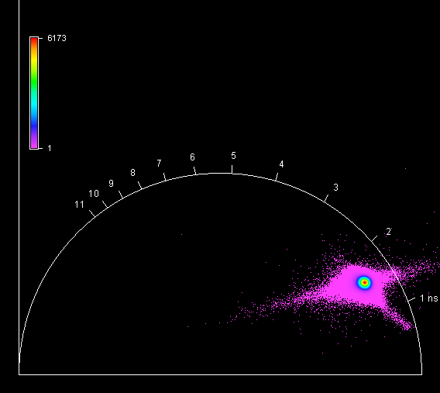

**Unknown, S121, F1, M3, AII** 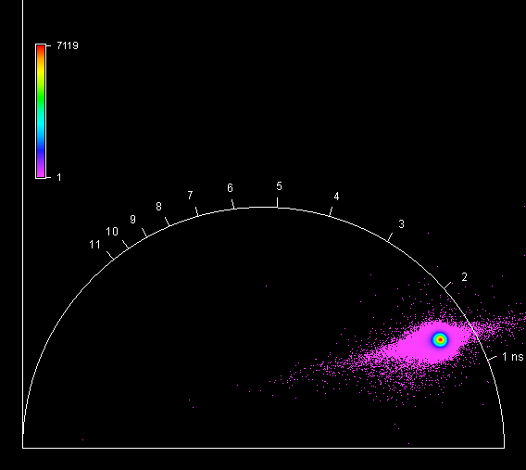

**Unknown, S121, F1, M4, AII** 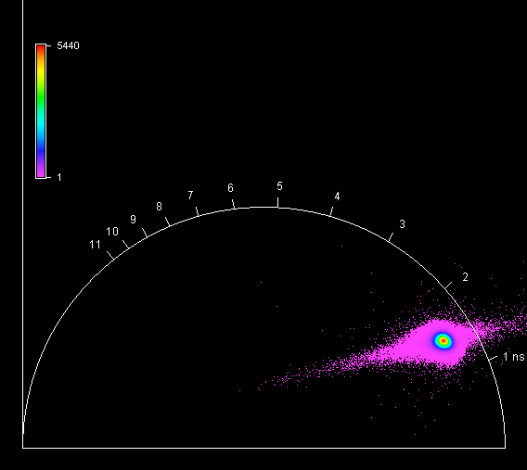

**Unknown, S122, F1, M1, AIII** 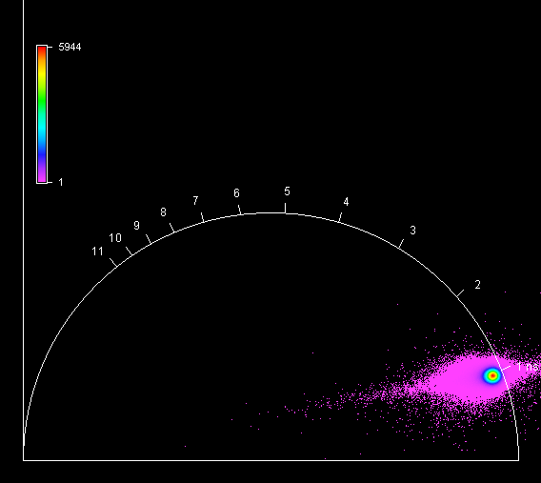

**Unknown, S122, F1, M2, AIII** 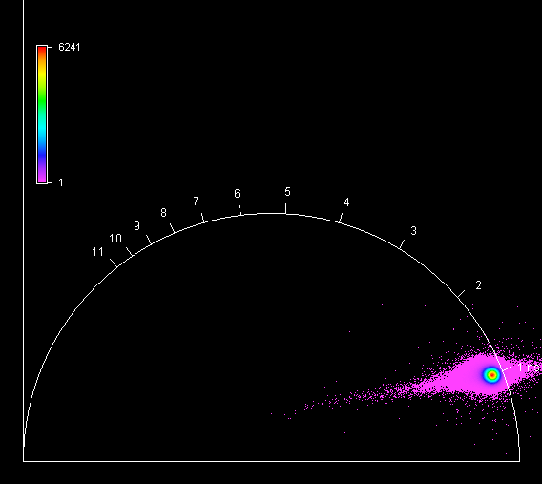

**Unknown, S122, F1, M3, AIII** 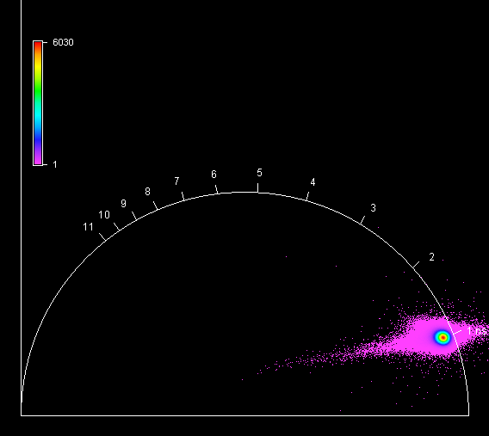

**Unknown, S122, F1, M4, AIII** 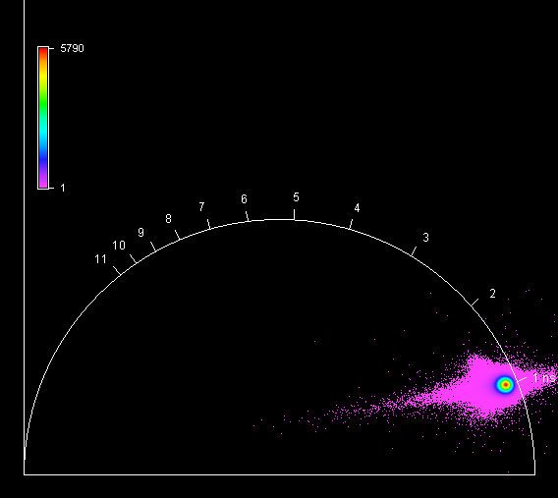

**Unknown, S123, F1, M1, AII** 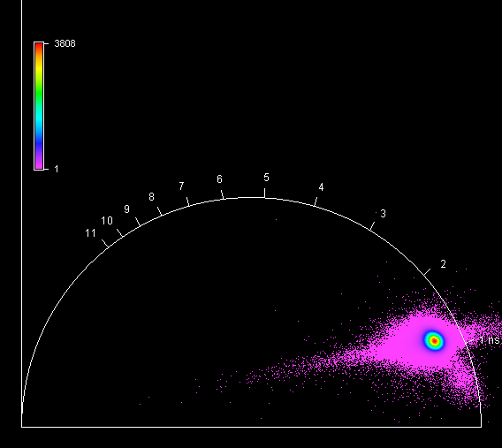

**Unknown, S123, F1, M2, AII**

**Unknown, S123, F1, M3, AII**

**Unknown, S123, F1, M4, AII**