**Unknown, S027, F1, M1, AIII**

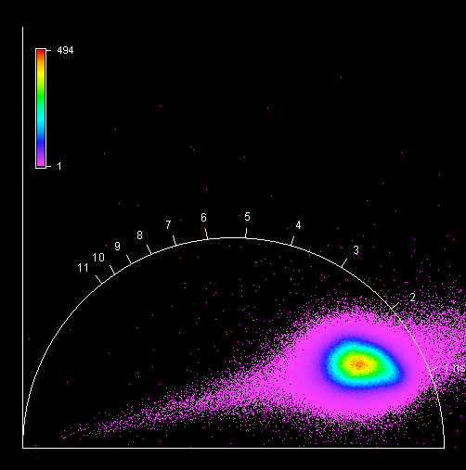

**Unknown, S027, F1, M2, AIII**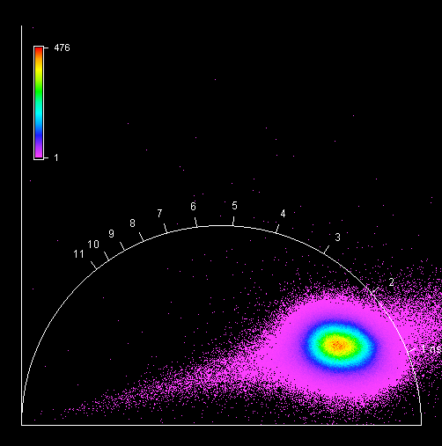

**Unknown, S027, F1, M3, AIII**

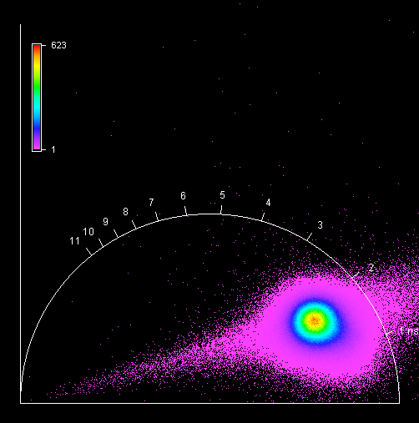

**Unknown, S027, F1, M4, AIII**

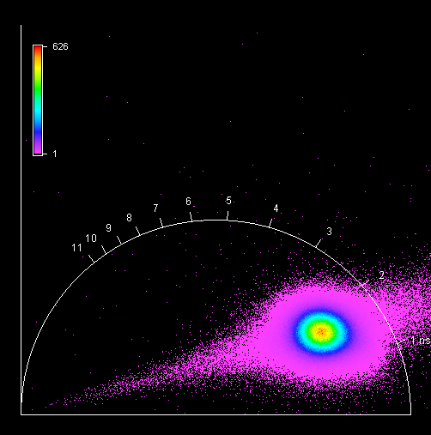

**Unknown, S028, F1, M1, AII**

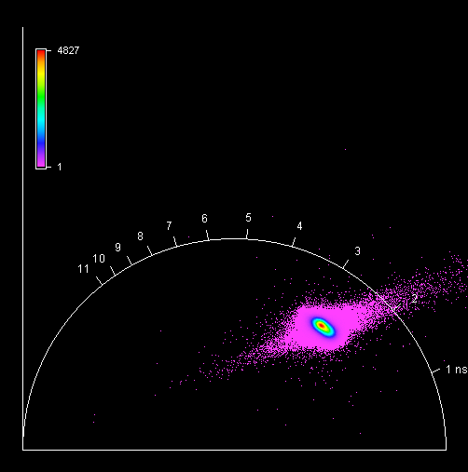

**Unknown, S028, F1, M2, AII**

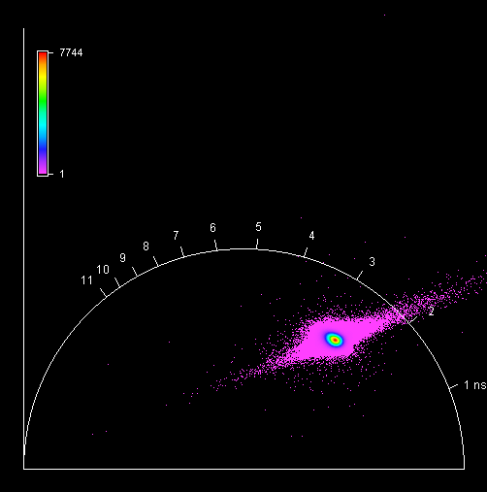

**Unknown, S028, F1, M3, AII**

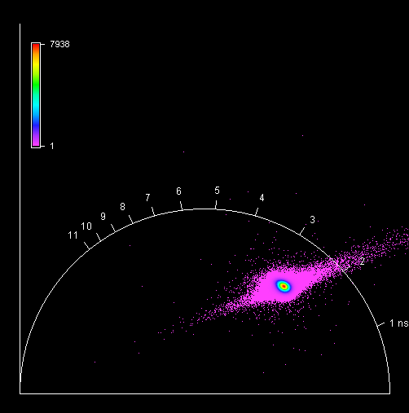

**Unknown, S028, F1, M4, AII** 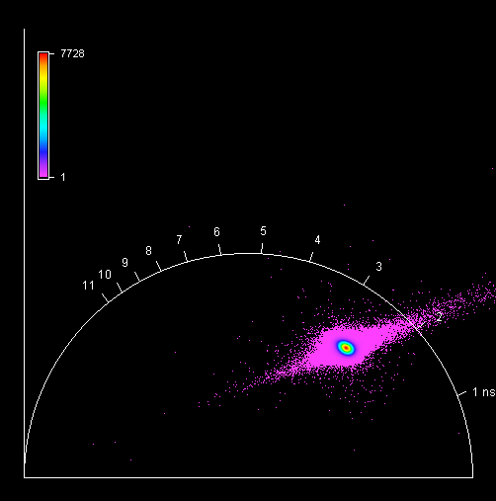

**Unknown, S029, F1, M1, AIII** 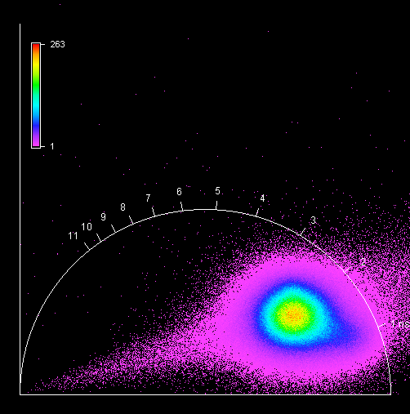

**Unknown, S029, F1, M2, AIII** 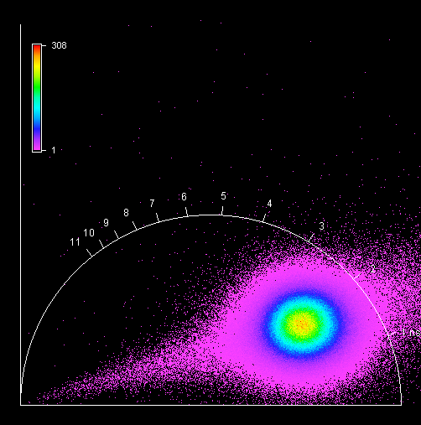

**Unknown, S029, F1, M3, AIII**

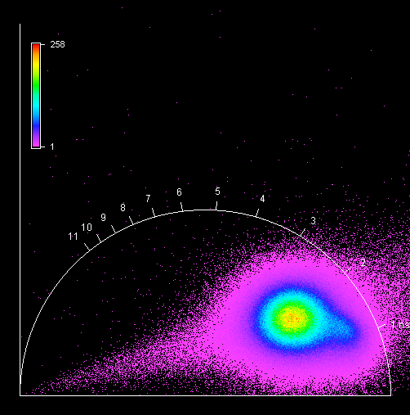

**Unknown, S029, F1, M4, AIII**

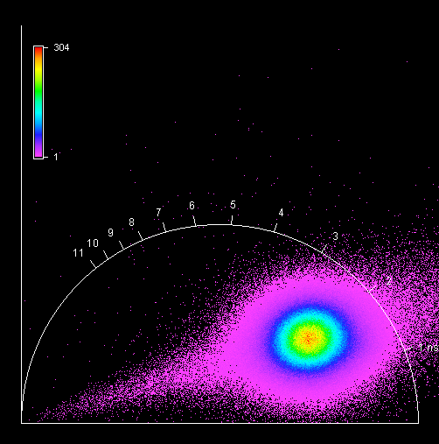

**Unknown, S030, F1, M1, AII** 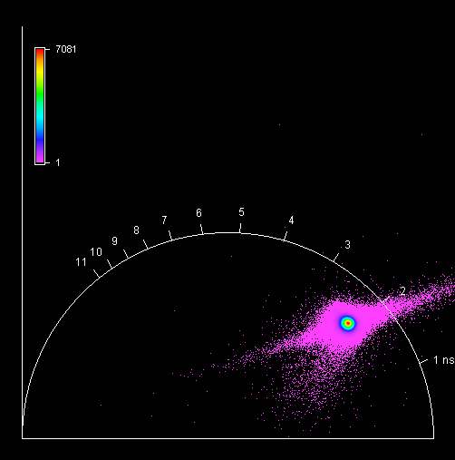

**Unknown, S030, F1, M2, AII** 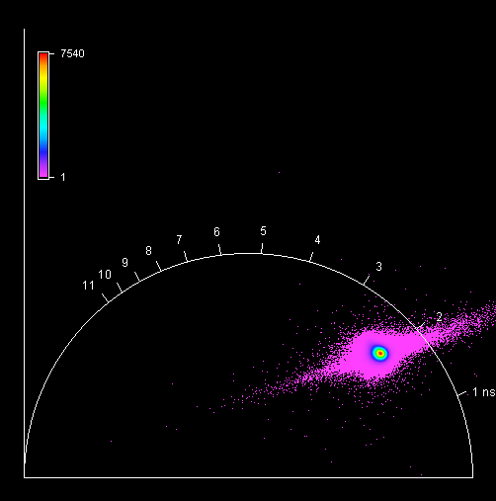

**Unknown, S030, F1, M3, AII**

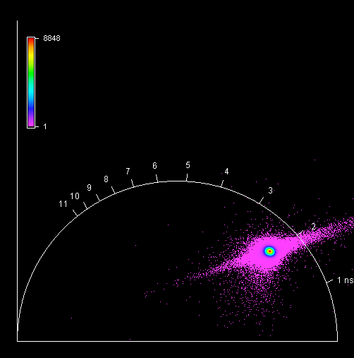

**Unknown, S030, F1, M4, AII** 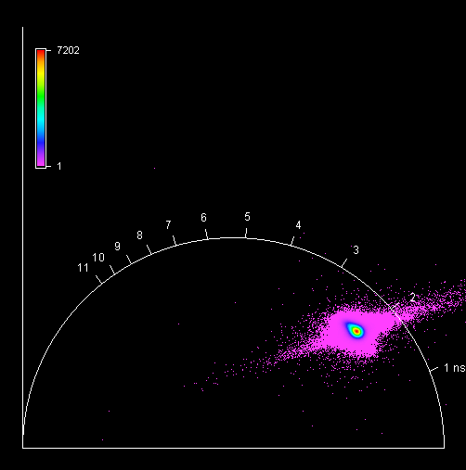

**Unknown, S031, F1, M1, AIII** 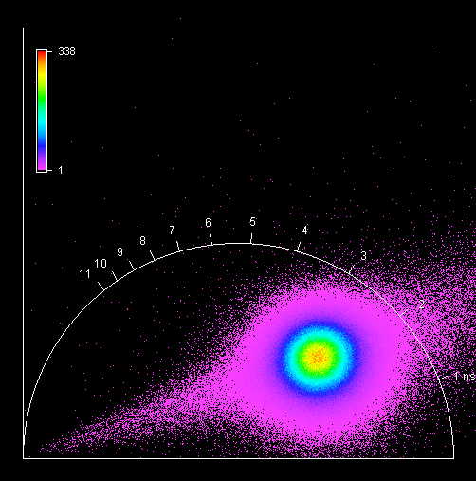

**Unknown, S031, F1, M2, AIII** 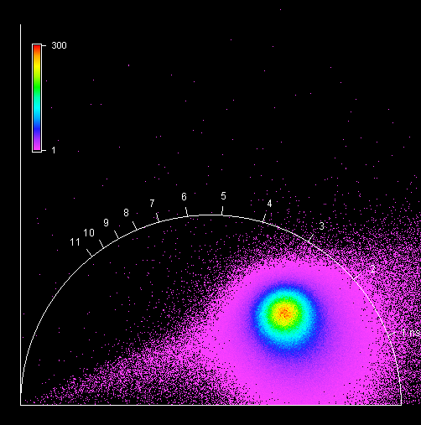

**Unknown, S031, F1, M3, AIII** 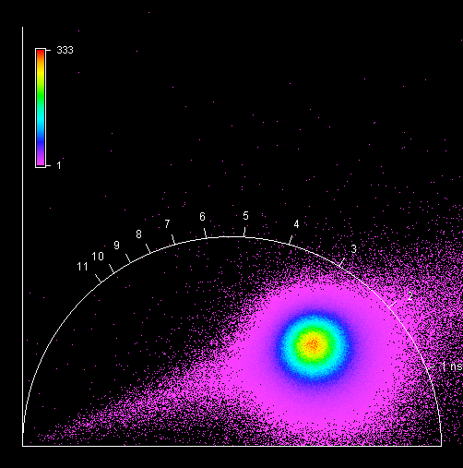

**Unknown, S031, F1, M4, AIII** 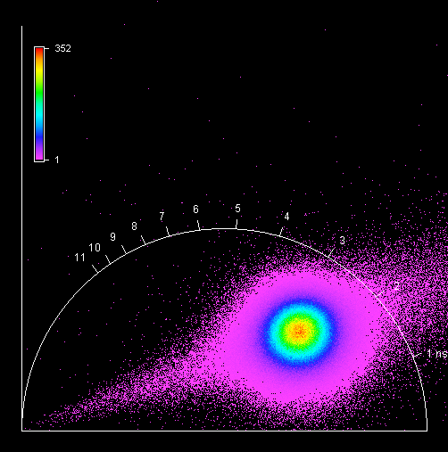

**Unknown, S032, F1, M1, AIII** 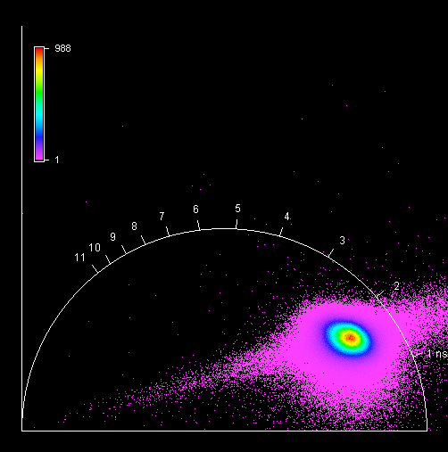

**Unknown, S032, F1, M2, AIII** 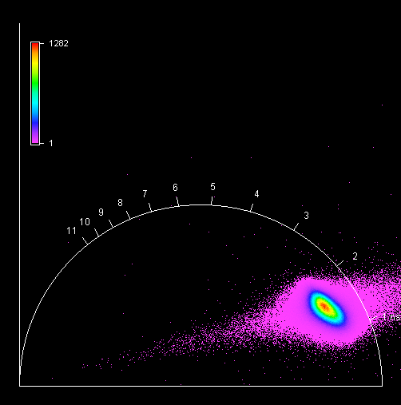

**Unknown, S032, F1, M3, AIII** 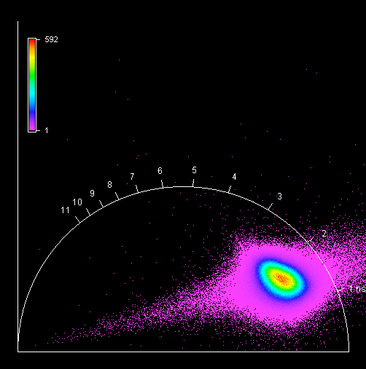

**Unknown, S032, F1, M4, AIII** 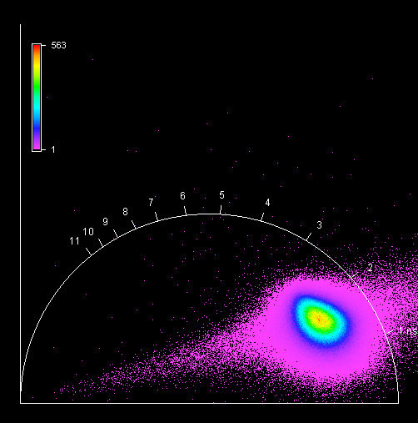

**Unknown, S033, F1, M1, AIII**

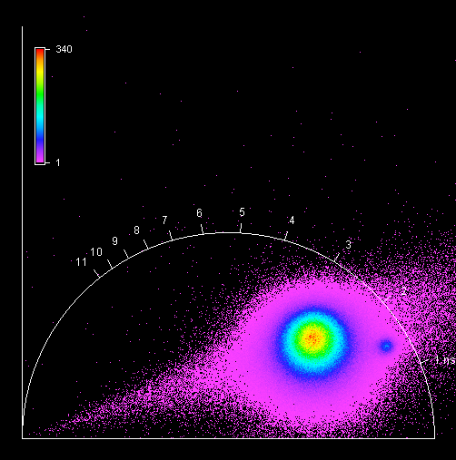

**Unknown, S033, F1, M2, AIII** 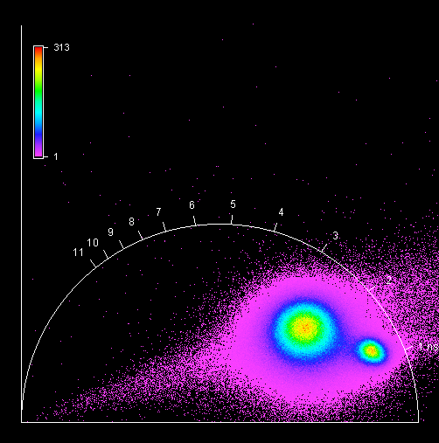

**Unknown, S033, F1, M3, AIII** 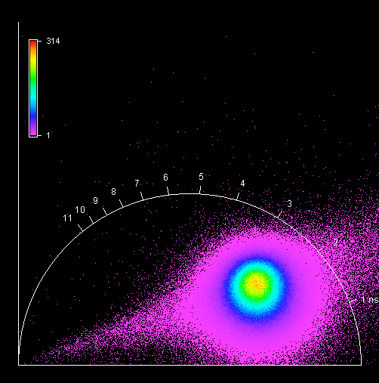

**Unknown, S033, F1, M4, AIII** 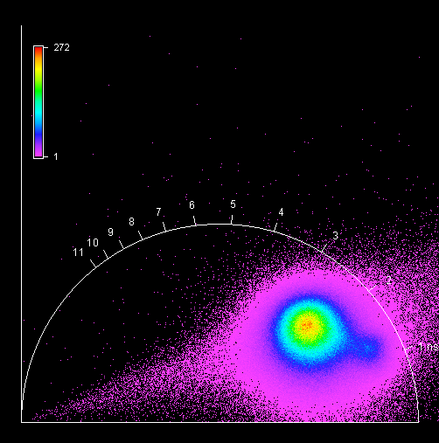

**Unknown, S034, F1, M1, AIV** 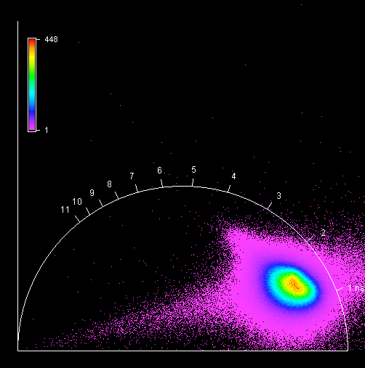

**Unknown, S034, F1, M2, AIV**

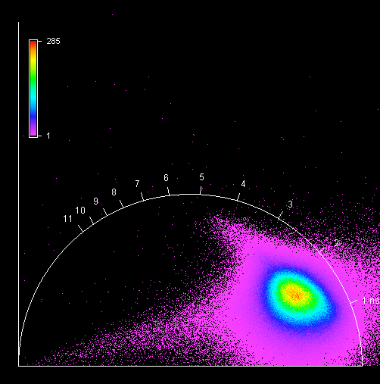

**Unknown, S034, F1, M3, AIV** 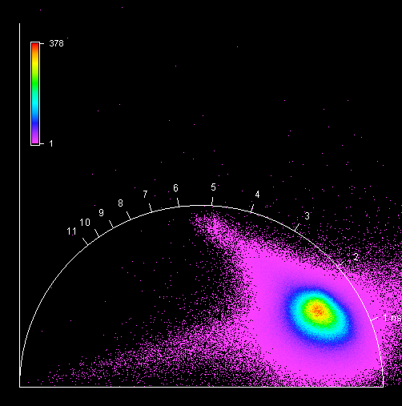

**Unknown, S034, F1, M4, AIV** 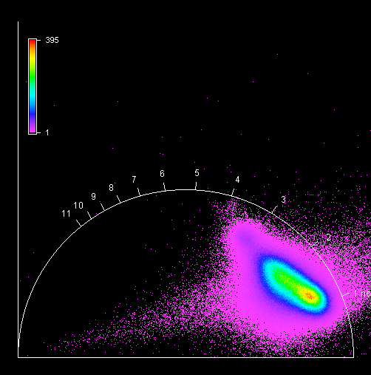

**Unknown, S035, F1, M1, AIV**

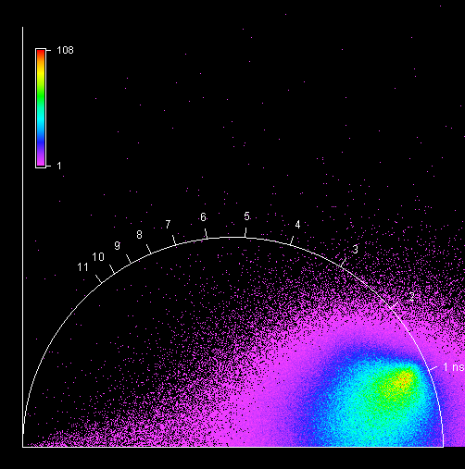

**Unknown, S035, F1, M2, AIV** 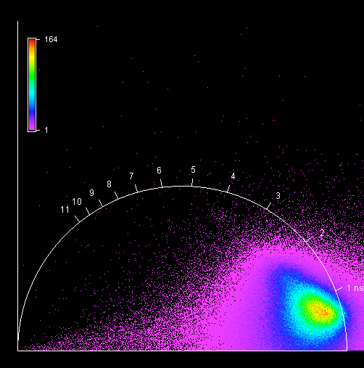

**Unknown, S035, F1, M3, AIV** 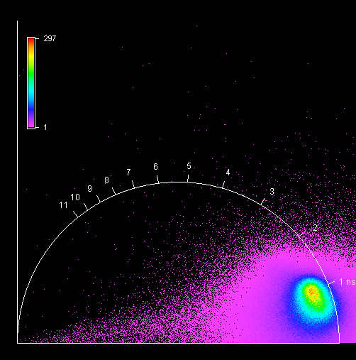

**Unknown, S035, F1, M4, AIV** 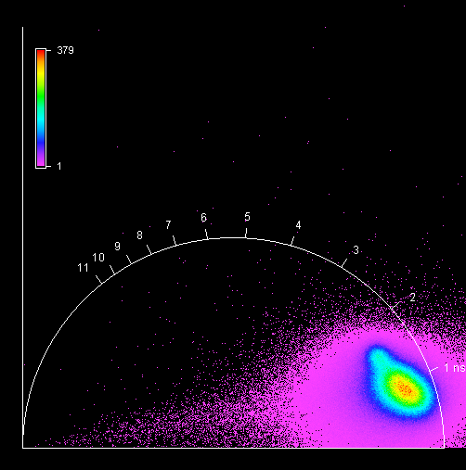

**Unknown, S036, F1, M1, AIII** 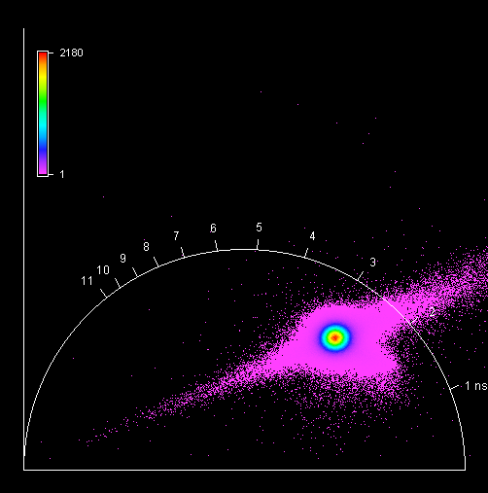

**Unknown, S036, F1, M2, AIII** 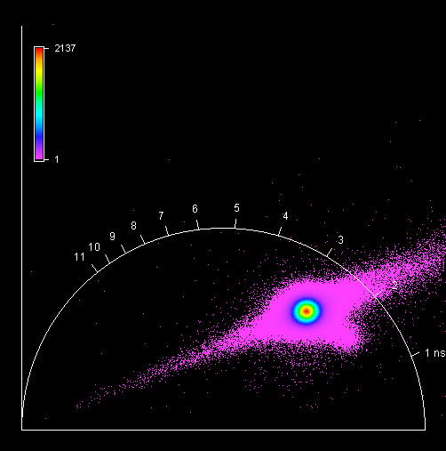

**Unknown, S036, F1, M3, AIII** 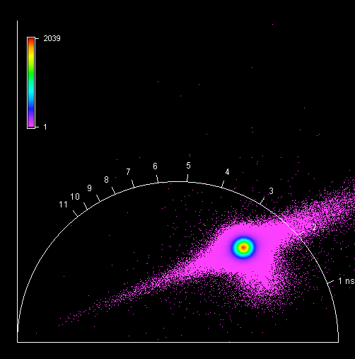

**Unknown, S036, F1, M4, AIII** 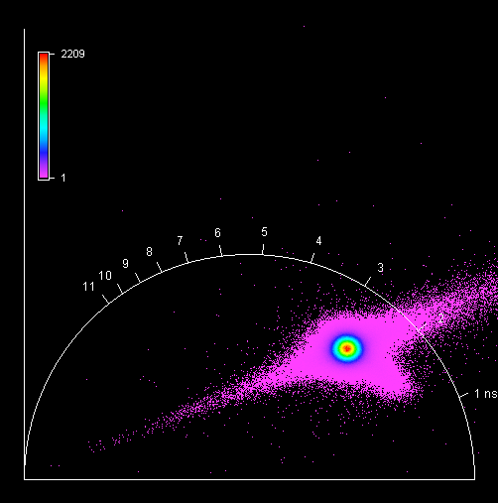

**Unknown, S037, F1, M1, AI** 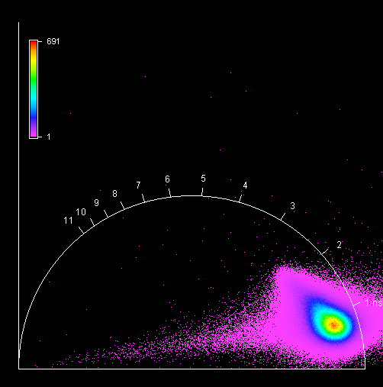

**Unknown, S037, F1, M2, AI** 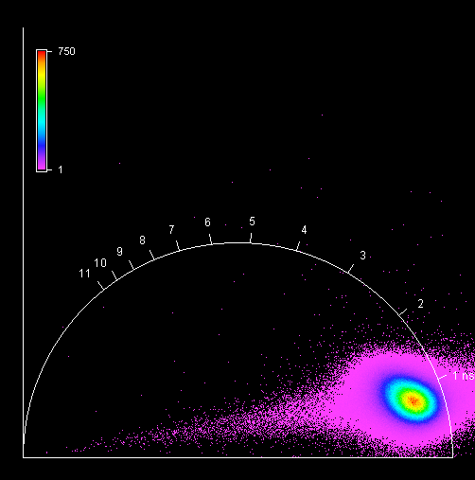

**Unknown, S037, F1, M3, AI** 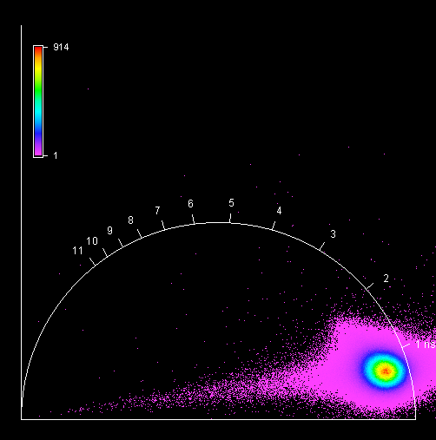

**Unknown, S037, F1, M4, AI** 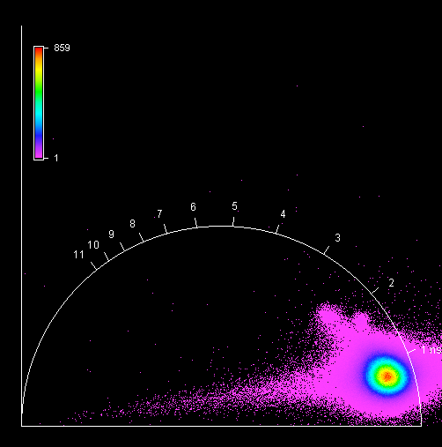

**Unknown, S038, F1, M1, AIII** 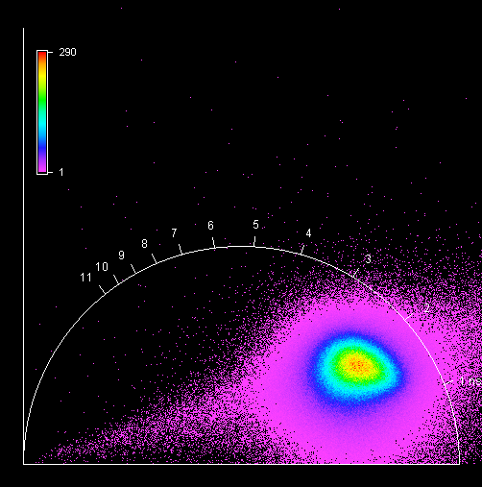

**Unknown, S038, F1, M2, AIII** 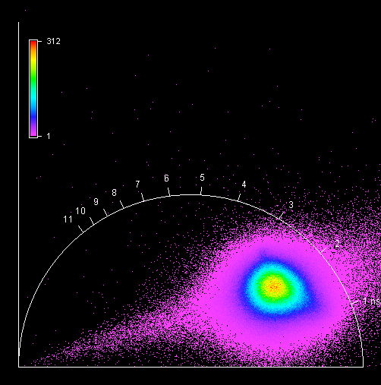

**Unknown, S038, F1, M3, AIII** 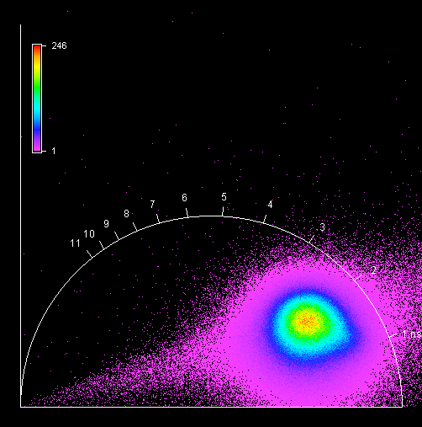

**Unknown, S038, F1, M4, AIII** 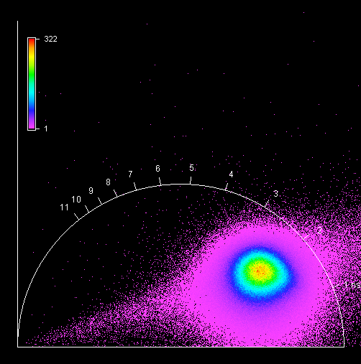

**Unknown, S039, F1, M1, AIII** 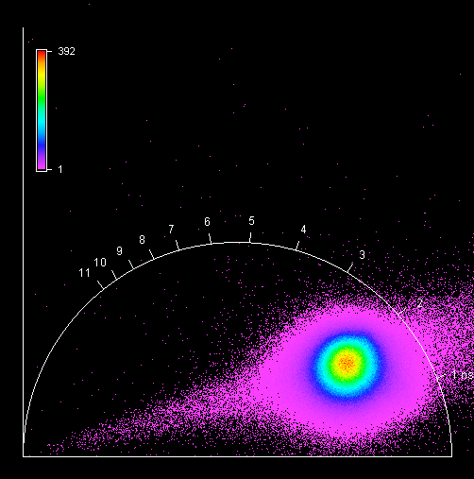

**Unknown, S039, F1, M2, AIII** 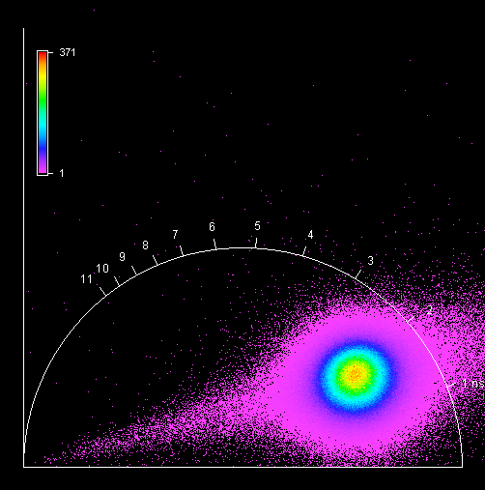

**Unknown, S039, F1, M3, AIII** 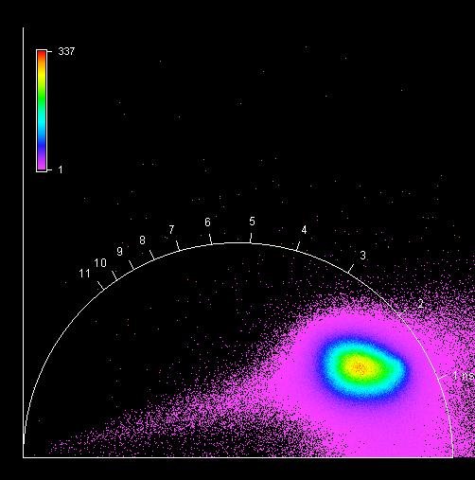

**Unknown, S039, F1, M4, AIII** 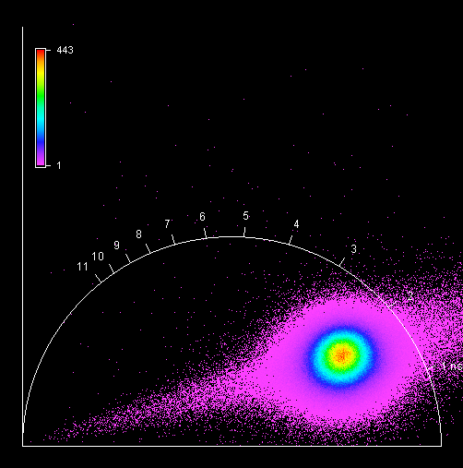

**Unknown, S040, F1, M1, AIII**

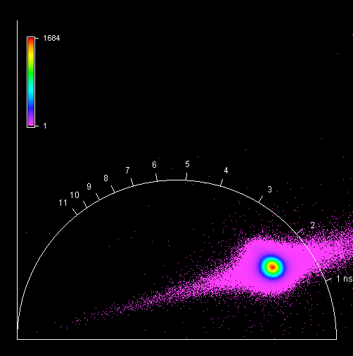

**Unknown, S040, F1, M2, AIII** 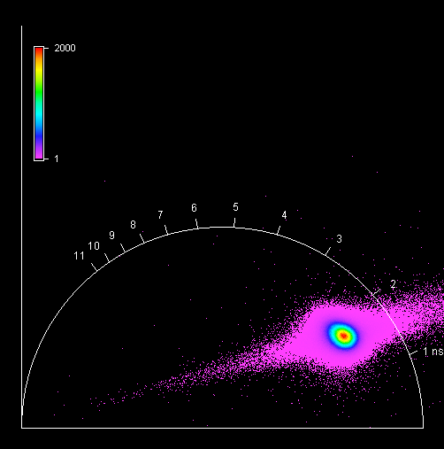

**Unknown, S040, F1, M3, AIII** 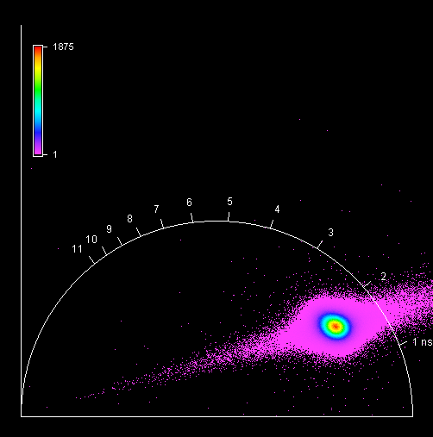

**Unknown, S040, F1, M4, AIII** 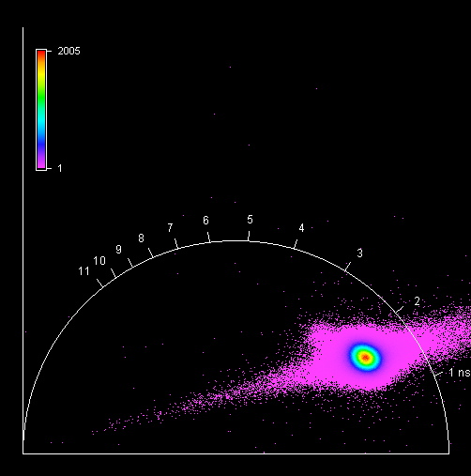

**Unknown, S041, F1, M1, AIV** 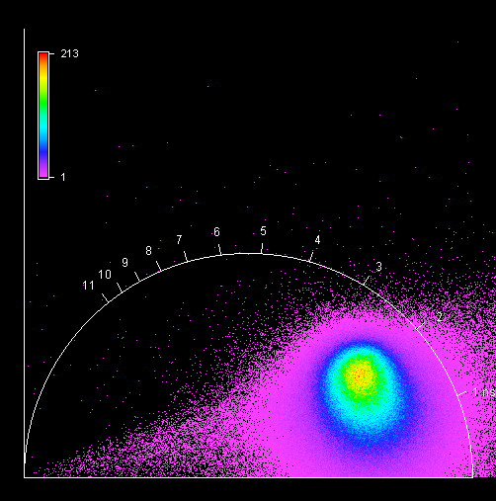

**Unknown, S041, F1, M2, AIV** 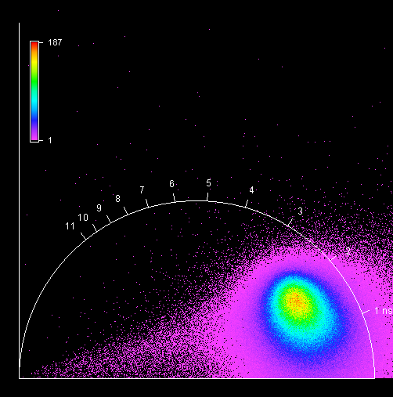

**Unknown, S041, F1, M3, AIV** 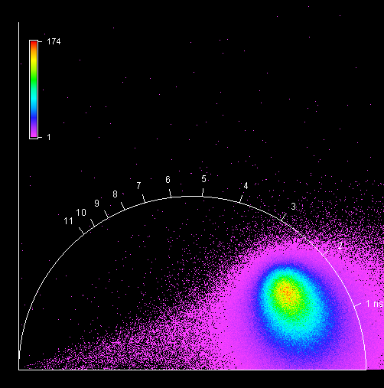

**Unknown, S041, F1, M4, AIV** 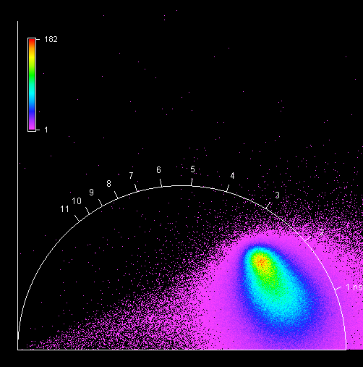

**Unknown, S042, F1, M1, AIII** 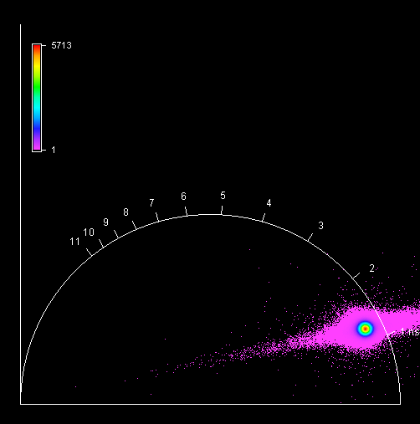

**Unknown, S042, F1, M2, AIII** 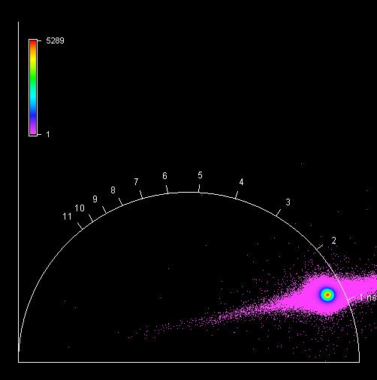

**Unknown, S042, F1, M3, AIII** 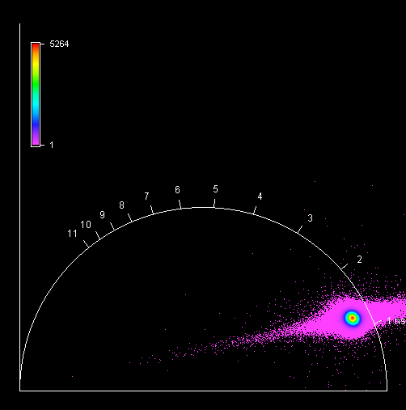

**Unknown, S042, F1, M4, AIII** 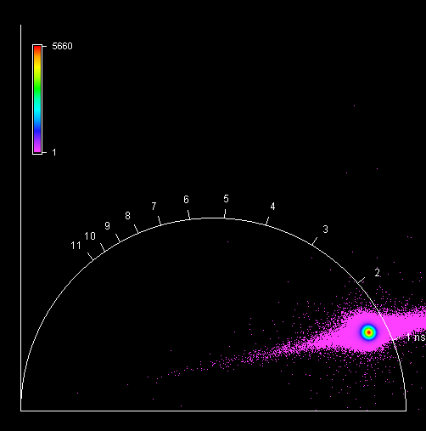

**Unknown, S043, F1, M1, AIII** 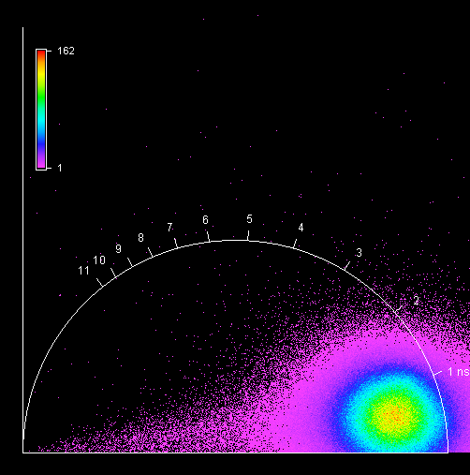

**Unknown, S043, F1, M2, AIII** 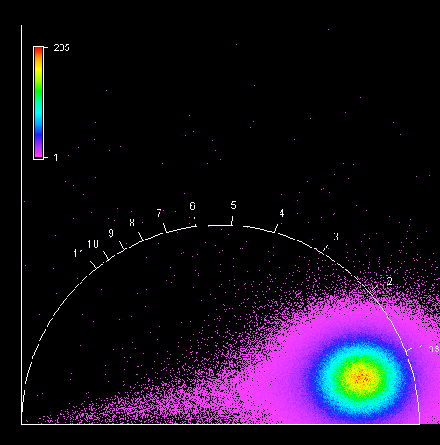

**Unknown, S043, F1, M3, AIII** 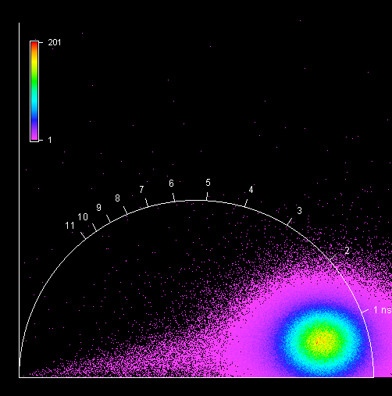

**Unknown, S043, F1, M4, AIII** 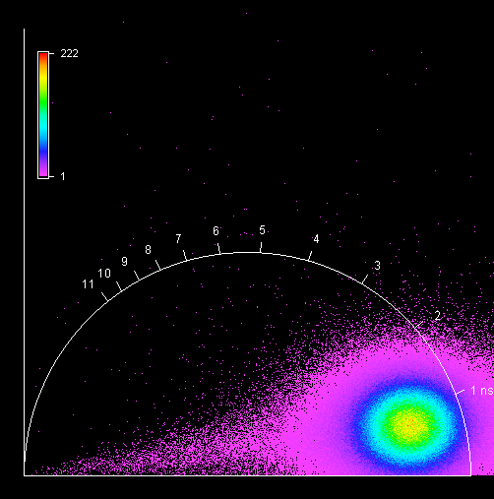

**Unknown, S044, F1, M1, AII** 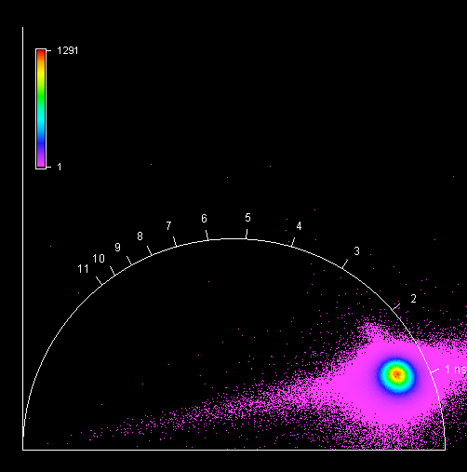

**Unknown, S044, F1, M2, AII** 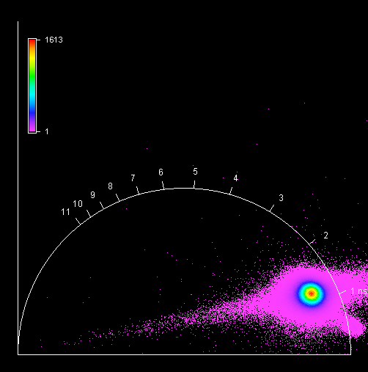

**Unknown, S044, F1, M3, AII** 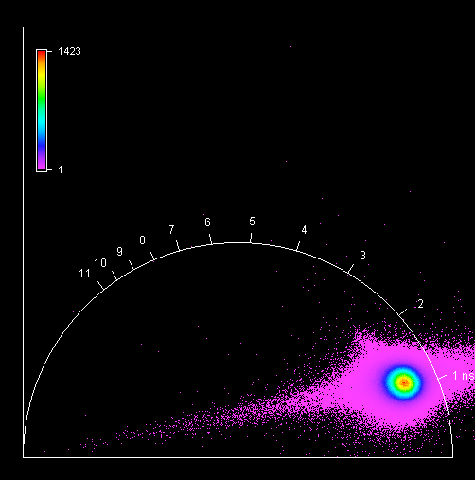

**Unknown, S044, F1, M4, AII** 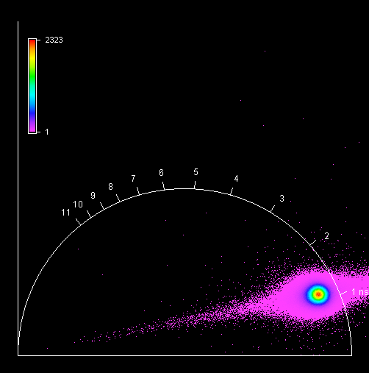

**Unknown, S045, F1, M1, AII** 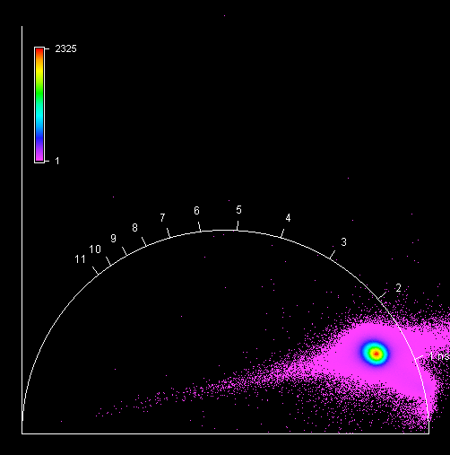

**Unknown, S045, F1, M2, AII** 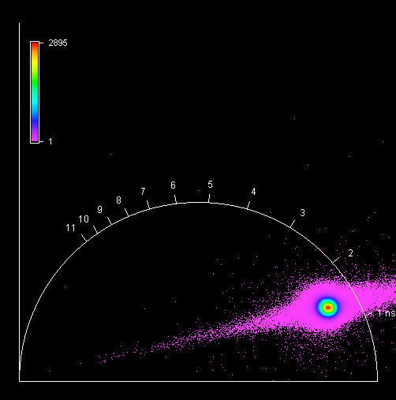

**Unknown, S045, F1, M3, AII** 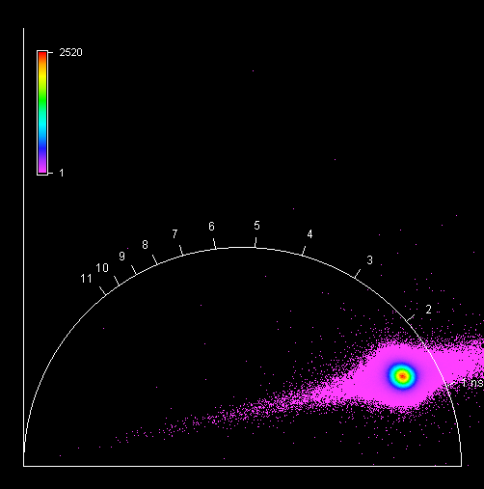

**Unknown, S045, F1, M4, AII** 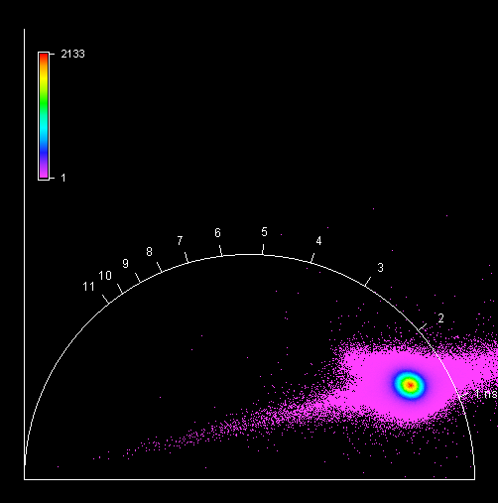

**Unknown, S046, F1, M1, AI** 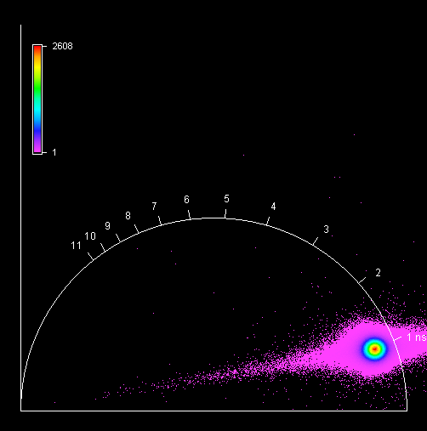

**Unknown, S046, F1, M2, AI** 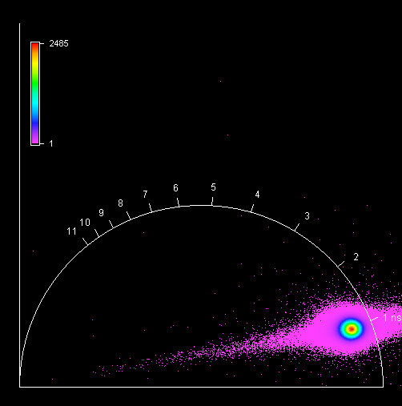

**Unknown, S046, F1, M3, AI** 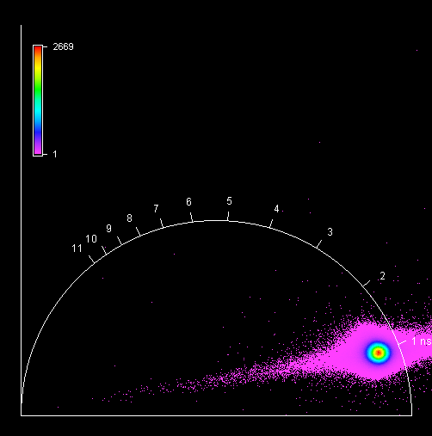

**Unknown, S046, F1, M4, AI** 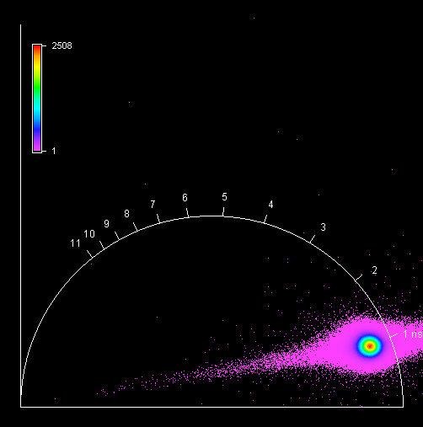

**Unknown, S047, F1, M1, AI** 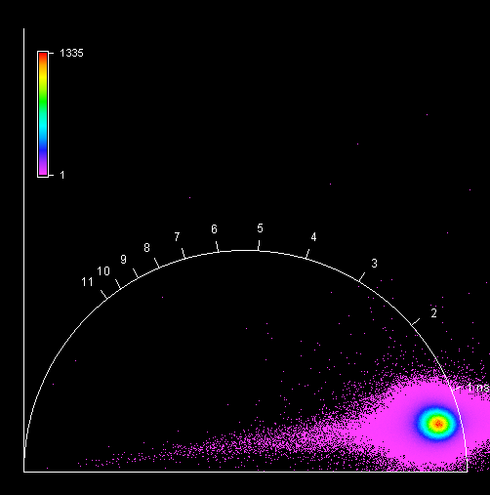

**Unknown, S047, F1, M2, AI** 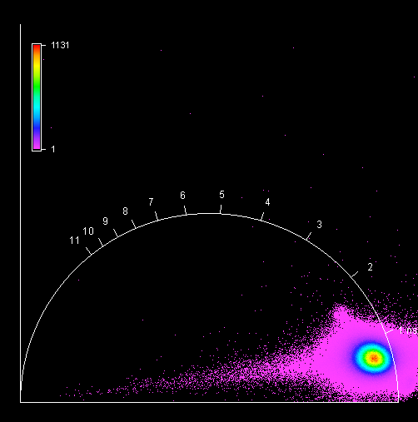

**Unknown, S047, F1, M3, AI** 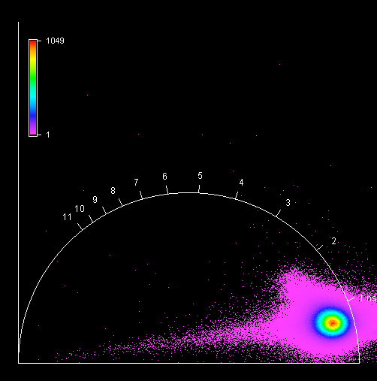

**Unknown, S047, F1, M4, AI** 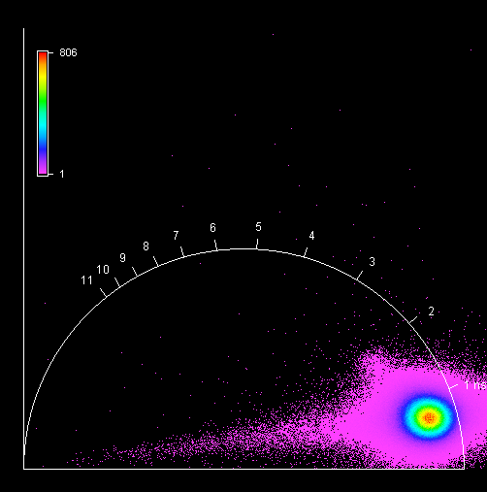

**Unknown, S048, F1, M1, AI** 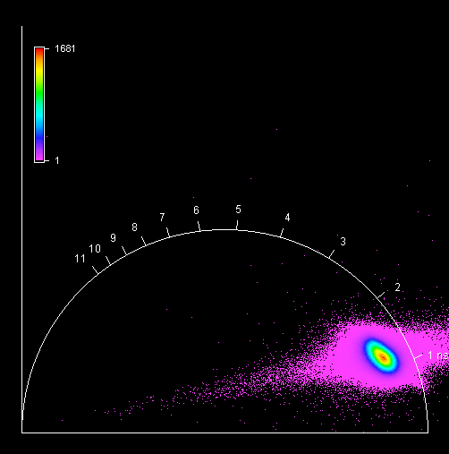

**Unknown, S048, F1, M2, AI** 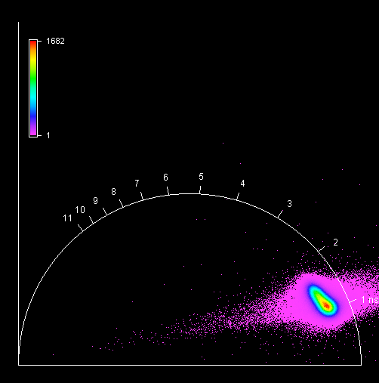

**Unknown, S048, F1, M3, AI** 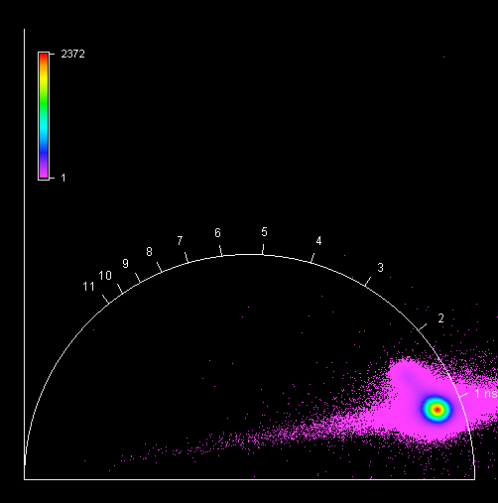

**Unknown, S048, F1, M4, AI** 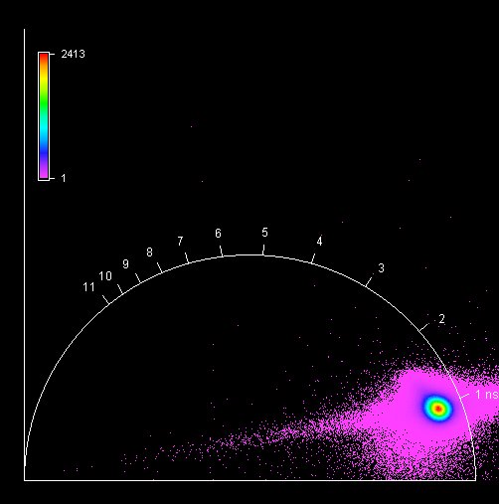

**Unknown, S049, F1, M1, AI** 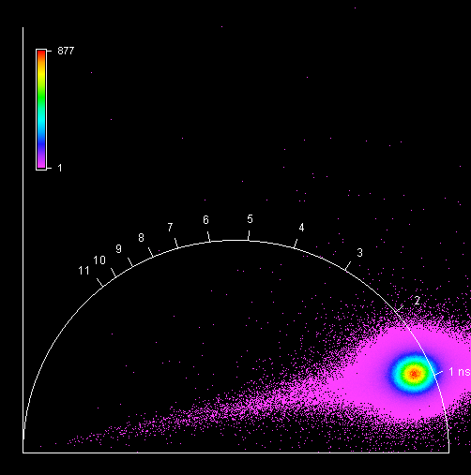

**Unknown, S049, F1, M2, AI** 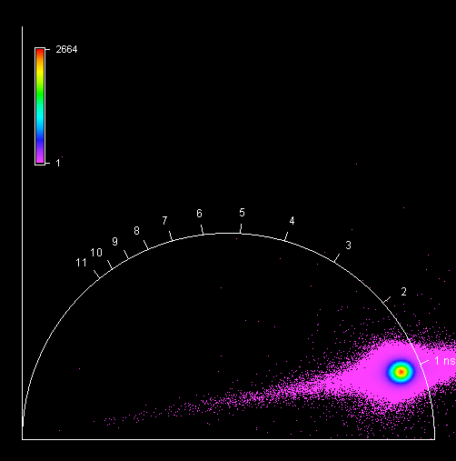

**Unknown, S049, F1, M3, AI** 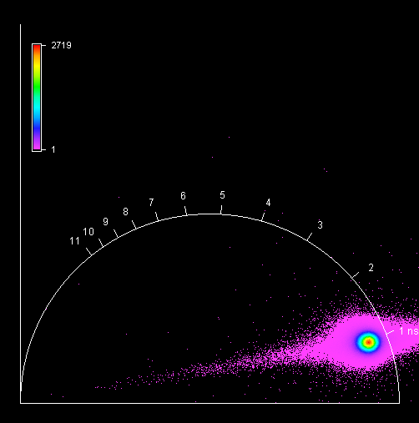

**Unknown, S049, F1, M4, AI** 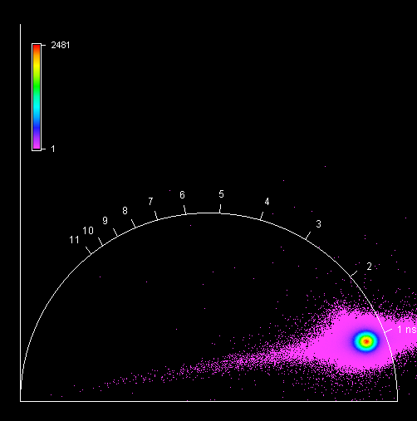

**Unknown, S050, F1, M1, AI** 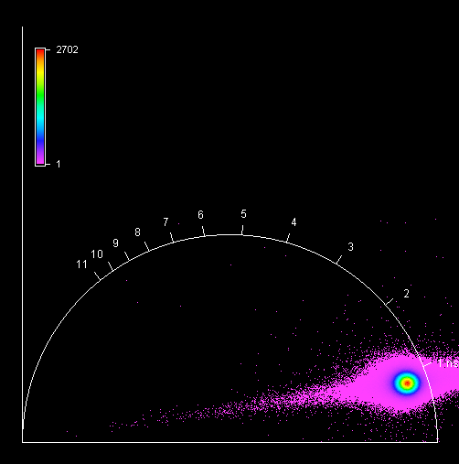

**Unknown, S050, F1, M2, AI** 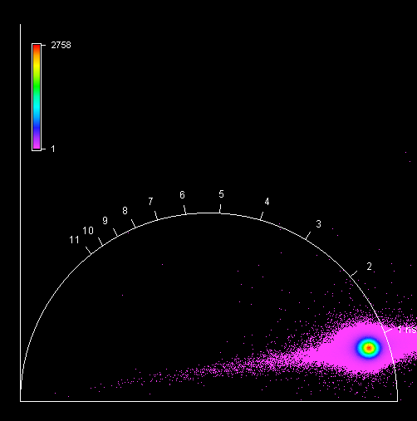

**Unknown, S050, F1, M3, AI** 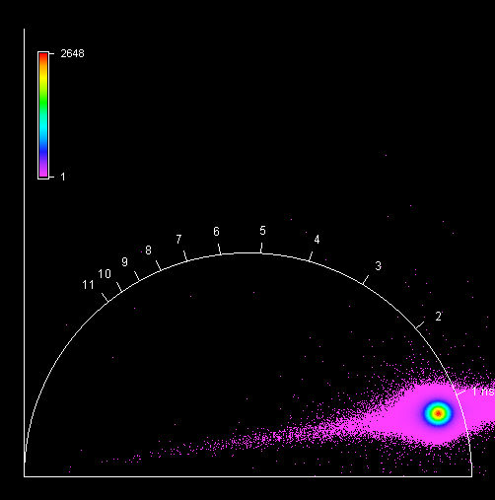

**Unknown, S050, F1, M4, AI** 