**Unknown, S051, F1, M1, AIV** 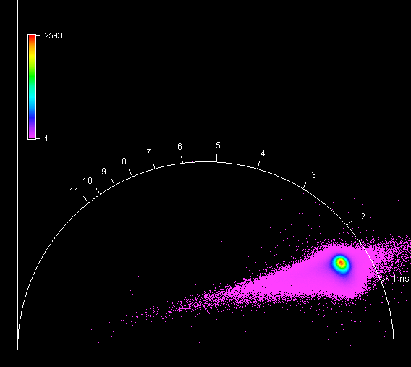

**Unknown, S051, F1, M2, AIV** 

**Unknown, S051, F1, M3, AIV** 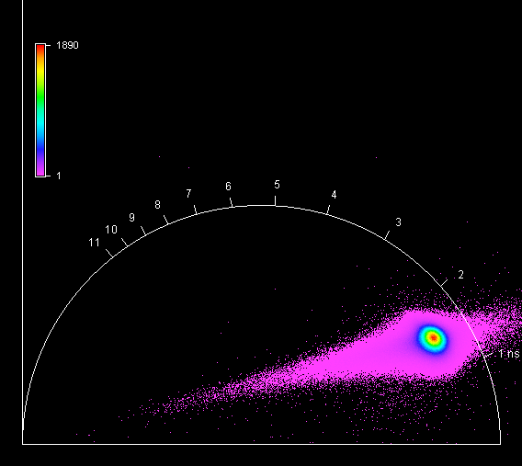

**Unknown, S051, F1, M4, AIV** 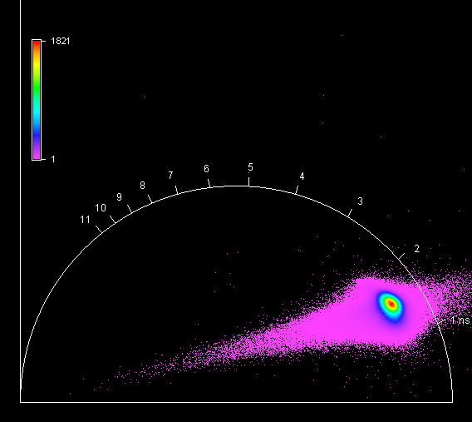

**Unknown, S052, F1, M1, AII** 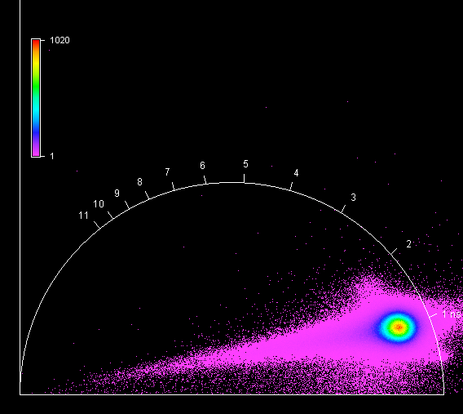

**Unknown, S052, F1, M2, AII** 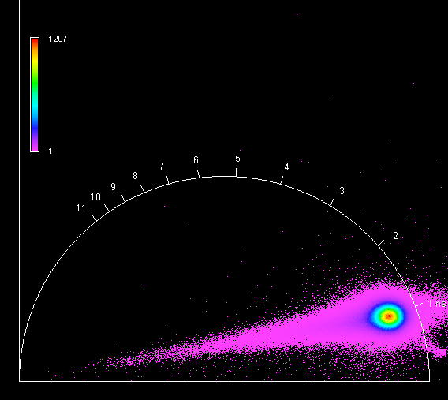

**Unknown, S052, F1, M3, AII** 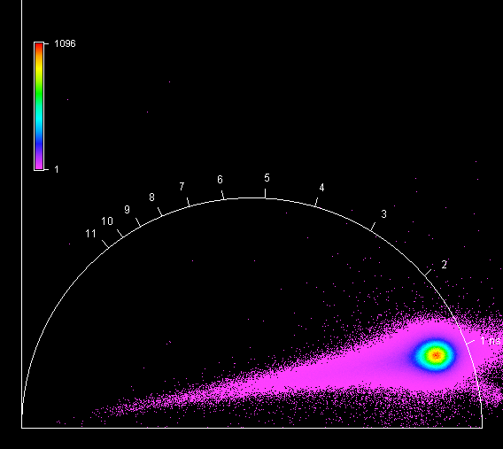

**Unknown, S052, F1, M4, AII** 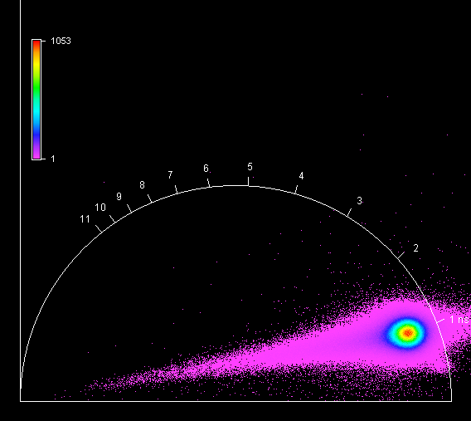

**Unknown, S053, F1, M1, AI** 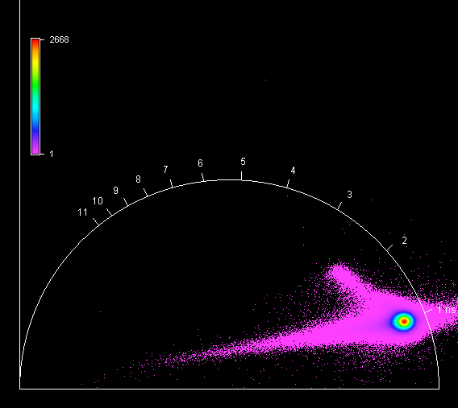

**Unknown, S053, F1, M2, AI** 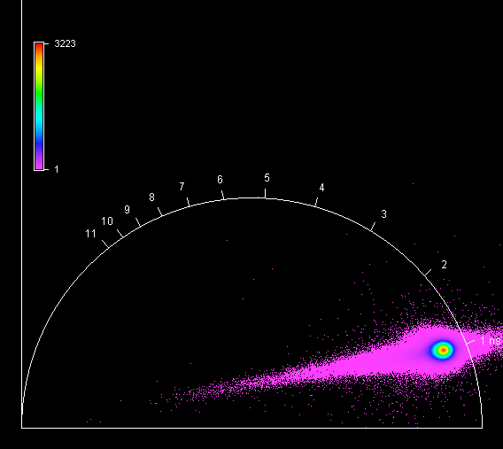

**Unknown, S053, F1, M3, AI** 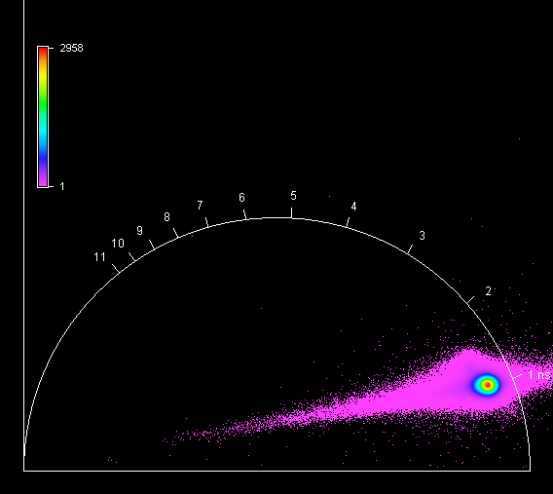

**Unknown, S053, F1, M4, AI** 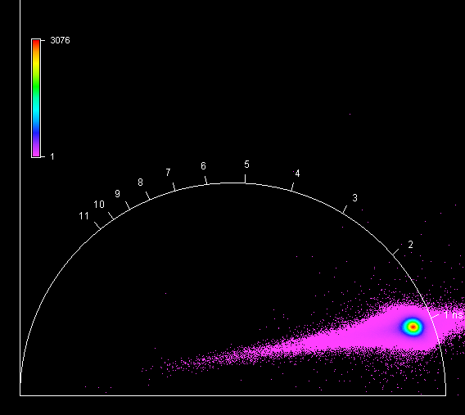

**Unknown, S054, F1, M1, AII** 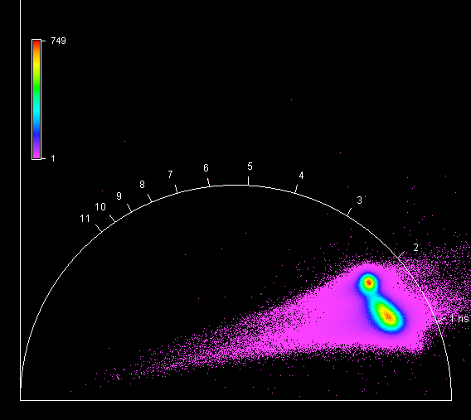

**Unknown, S054, F1, M2, AII** 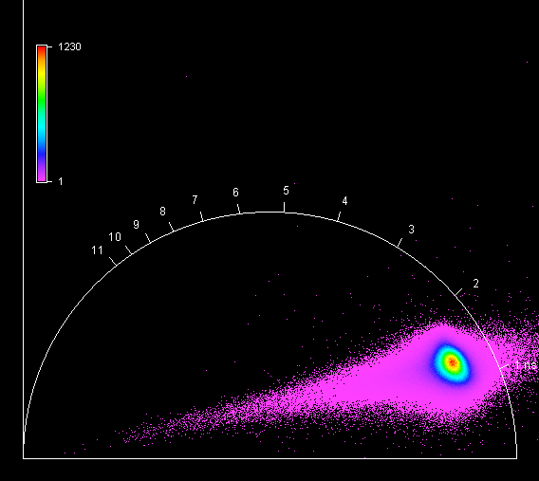

**Unknown, S054, F1, M3, AII** 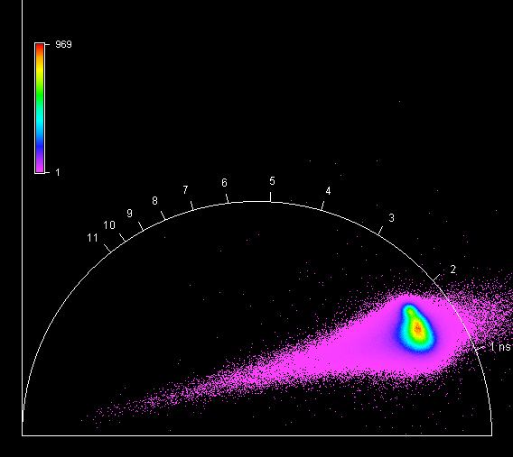

**Unknown, S054, F1, M4, AII** 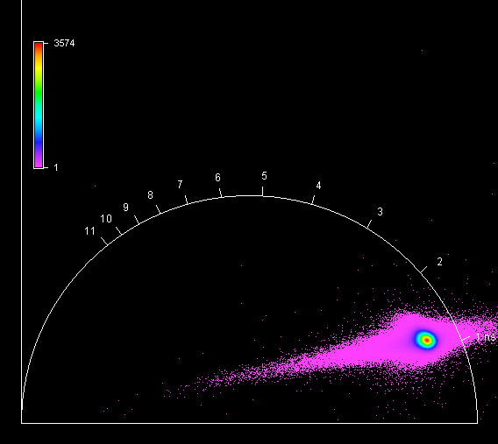

**Unknown, S055, F1, M1, AI** 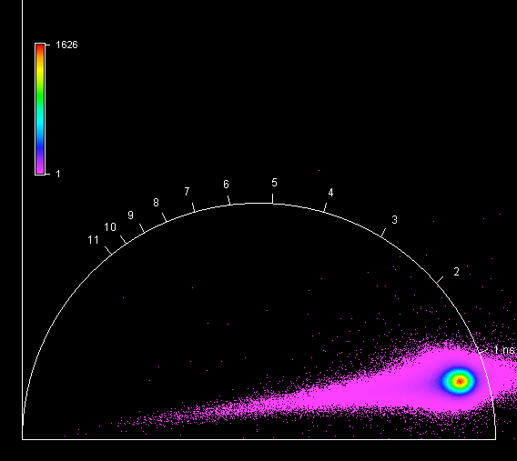

**Unknown, S055, F1, M2, AI** 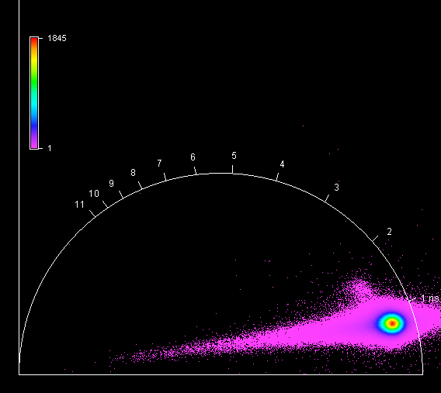

**Unknown, S055, F1, M3, AI** 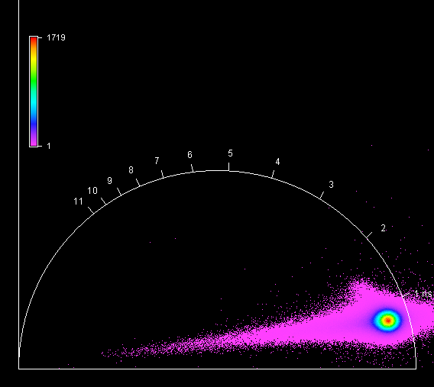

**Unknown, S055, F1, M4, AI** 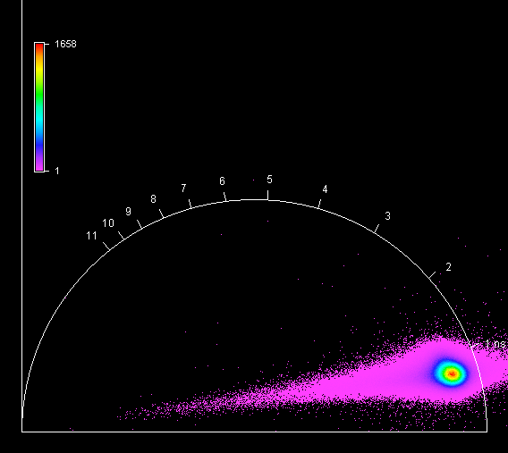

**Unknown, S056, F1, M1, AIV** 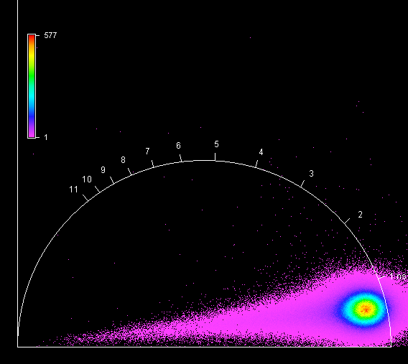

**Unknown, S056, F1, M2, AIV** 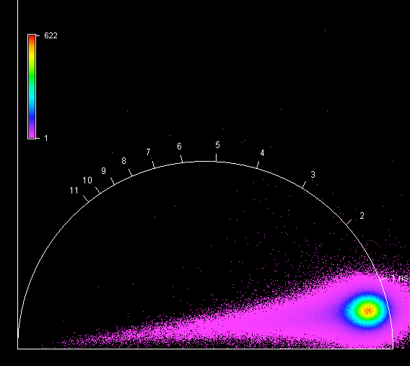

**Unknown, S056, F1, M3, AIV** 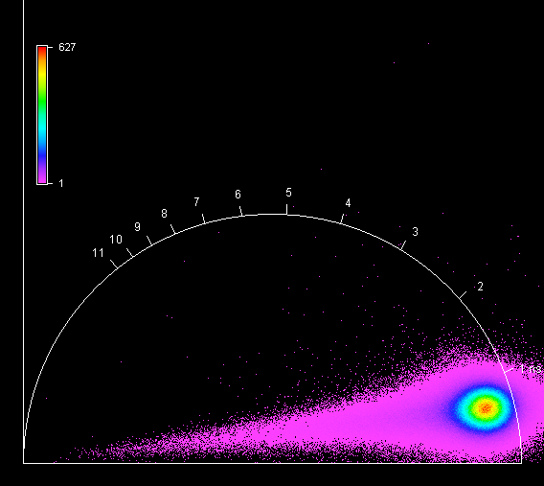

**Unknown, S056, F1, M4, AIV** 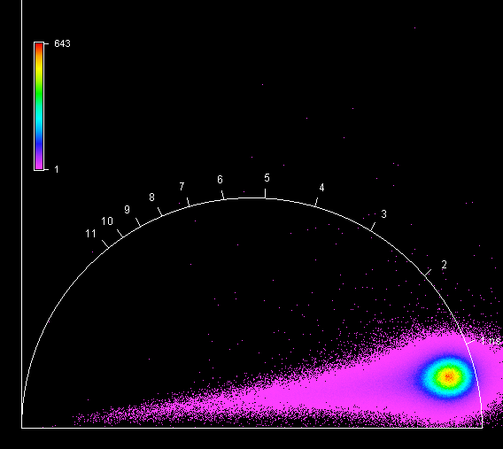

**Unknown, S057, F1, M1, AIII** 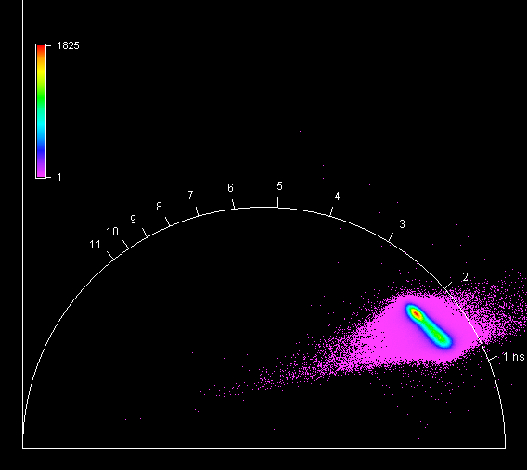

**Unknown, S057, F1, M2, AIII** 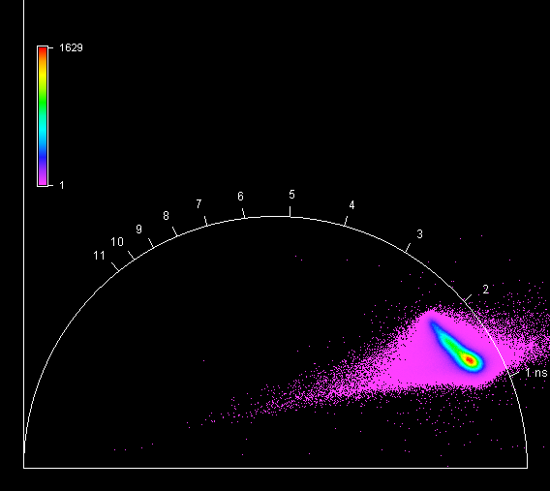

**Unknown, S057, F1, M3, AIII** 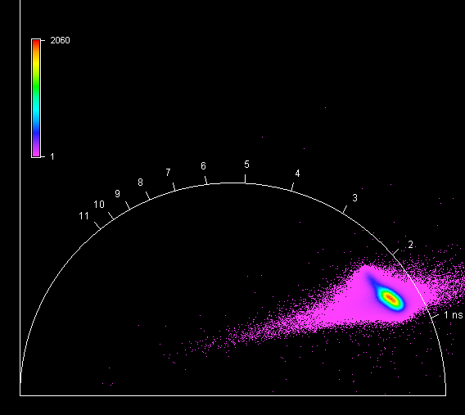

**Unknown, S057, F1, M4, AIII** 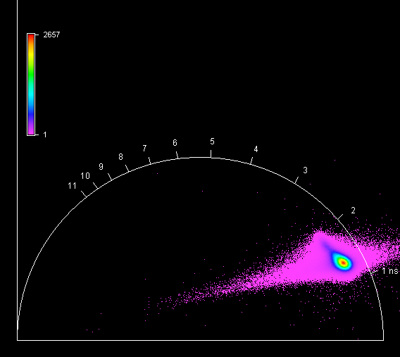

**Unknown, S058, F1, M1, AI** 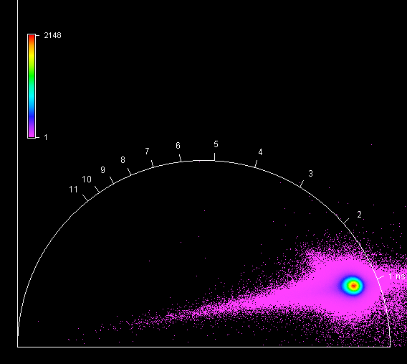

**Unknown, S058, F1, M2, AI** 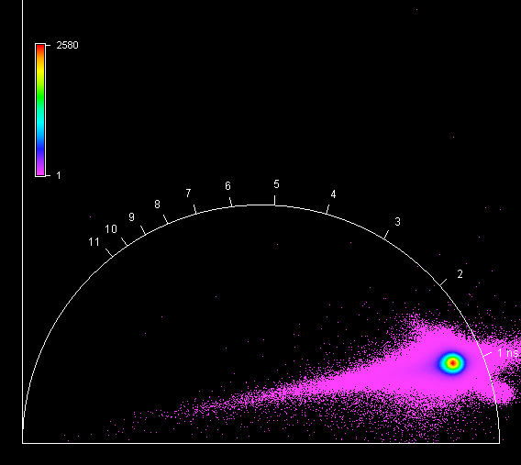

**Unknown, S058, F1, M3, AI** 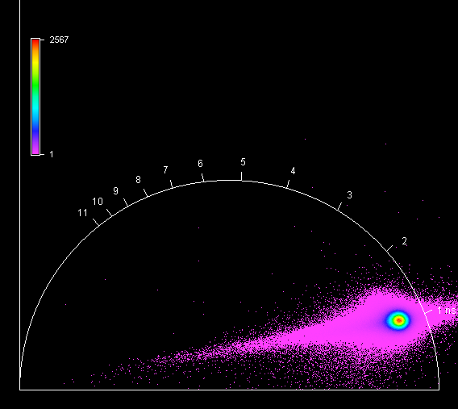

**Unknown, S058, F1, M4, AI** 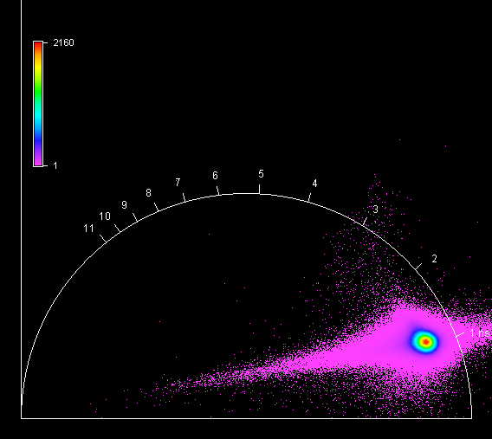

**Unknown, S059, F1, M1, AIII** 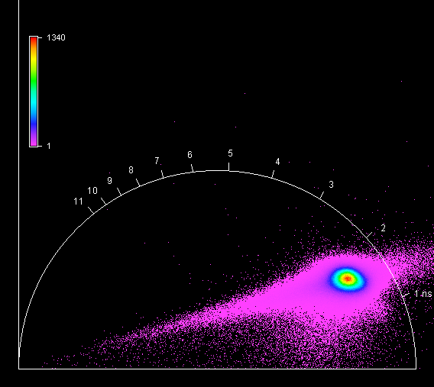

**Unknown, S059, F1, M2, AIII** 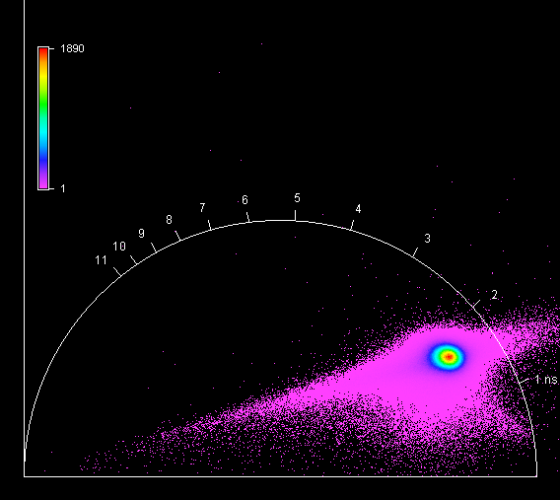

**Unknown, S059, F1, M3, AIII** 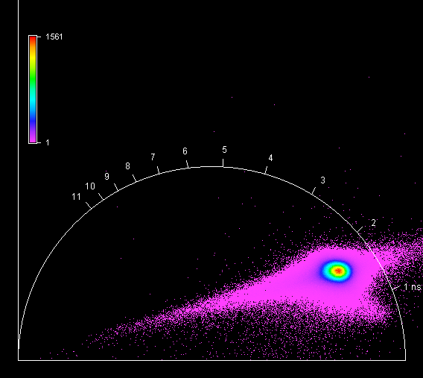

**Unknown, S059, F1, M4, AIII** 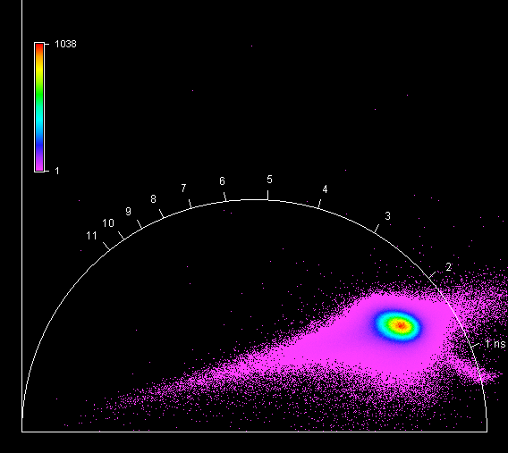

**Unknown, S060, F1, M1, AI** 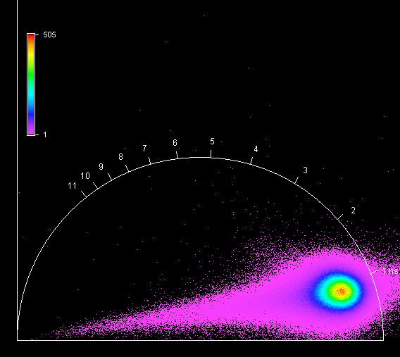

**Unknown, S060, F1, M2, AI** 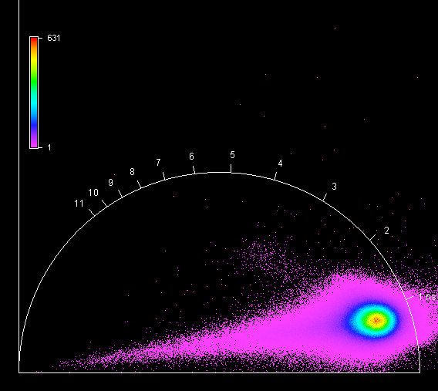

**Unknown, S060, F1, M3, AI** 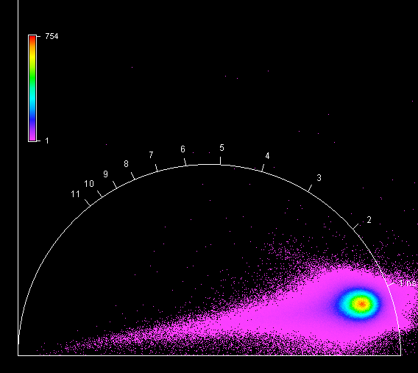

**Unknown, S060, F1, M4, AI** 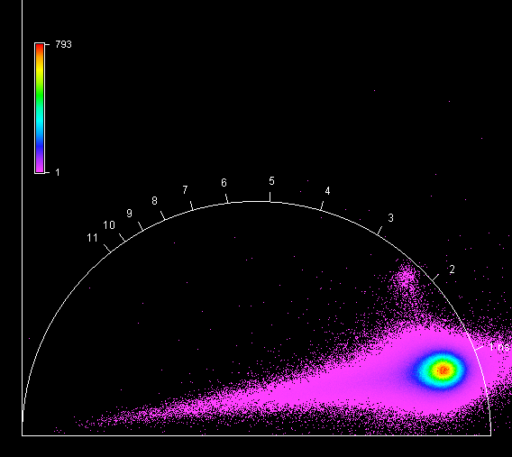

**Unknown, S061, F1, M1, AIV** 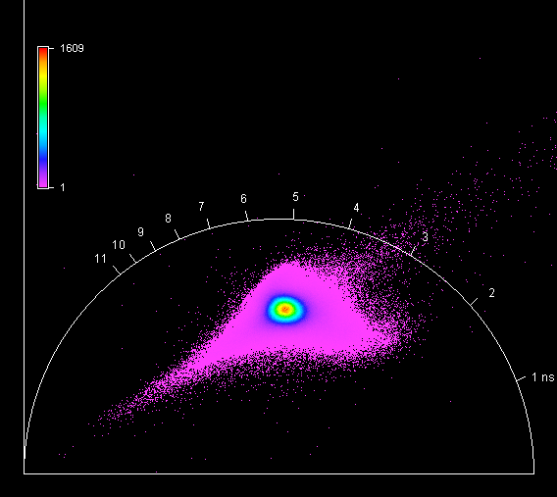

**Unknown, S061, F1, M2, AIV** 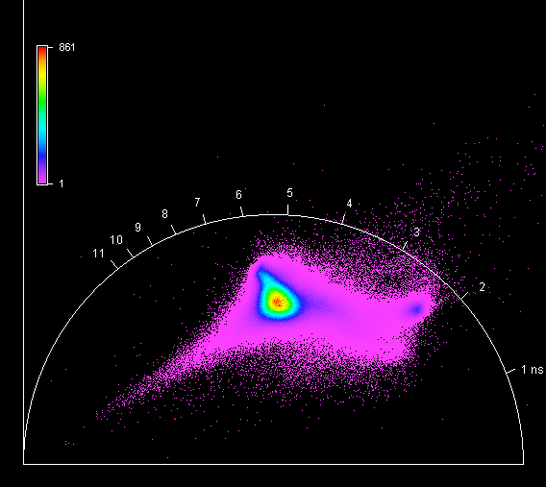

**Unknown, S061, F1, M3, AIV** 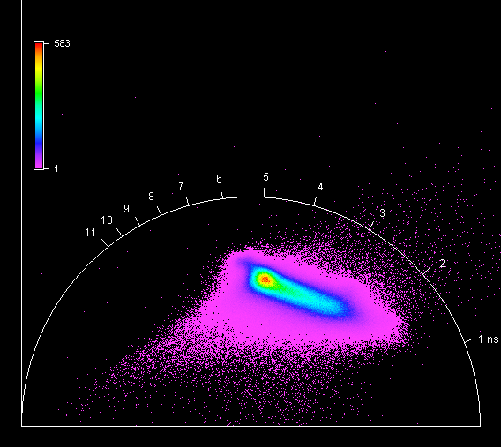

**Unknown, S061, F1, M4, AIV** 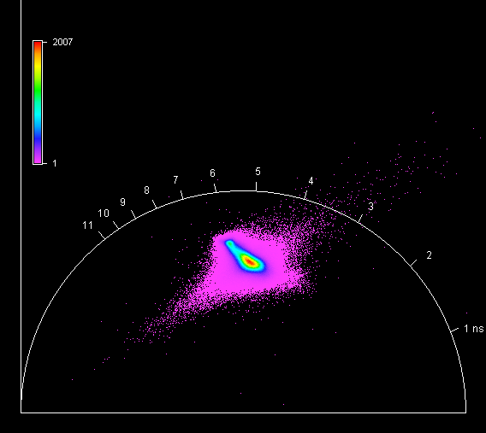

**Unknown, S062, F1, M1, AII** 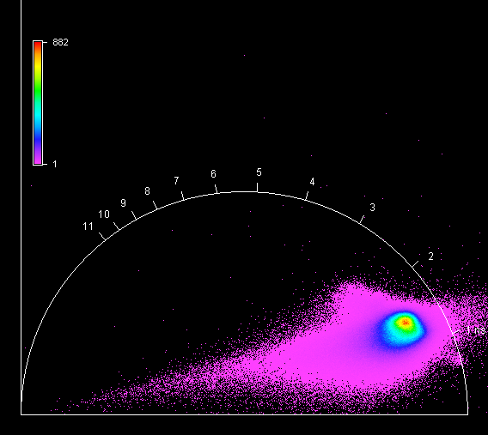

**Unknown, S062, F1, M2, AII** 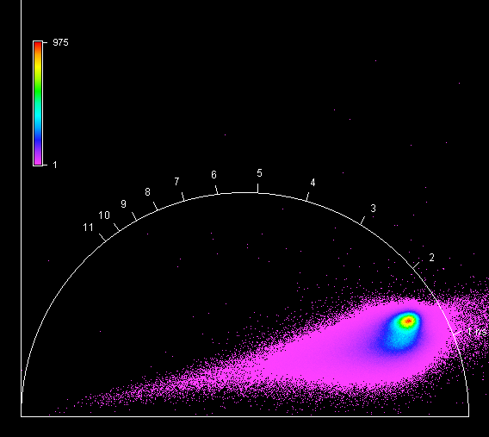

**Unknown, S062, F1, M3, AII** 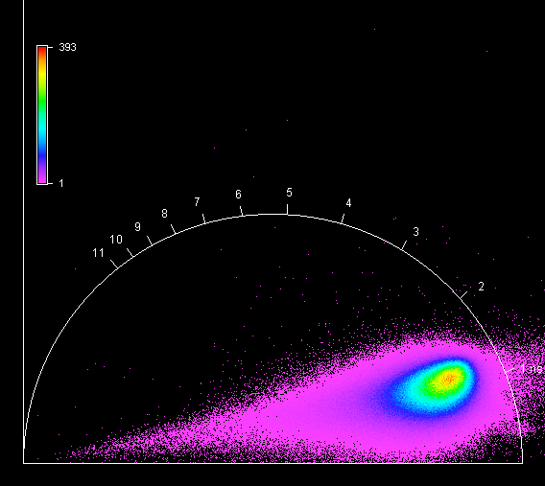

**Unknown, S062, F1, M4, AII** 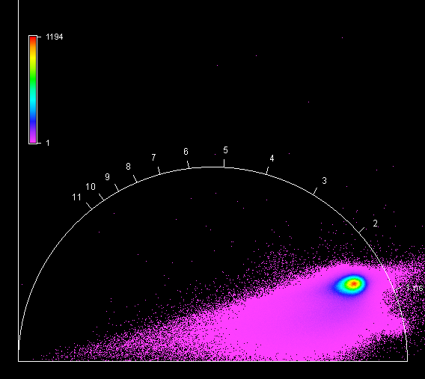

**Unknown, S063, F1, M1, AII** 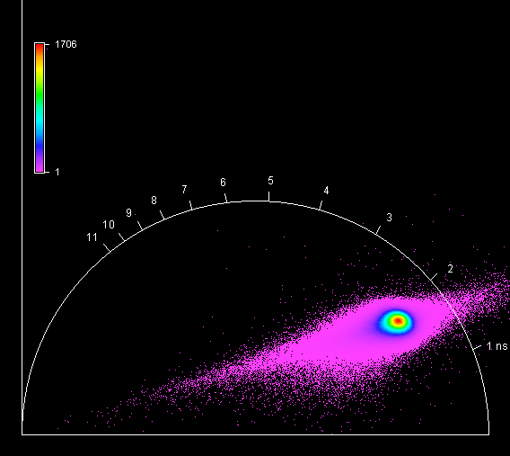

**Unknown, S063, F1, M2, AII** 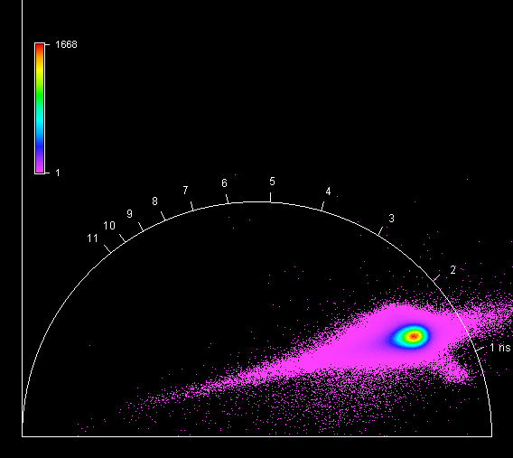

**Unknown, S063, F1, M3, AII** 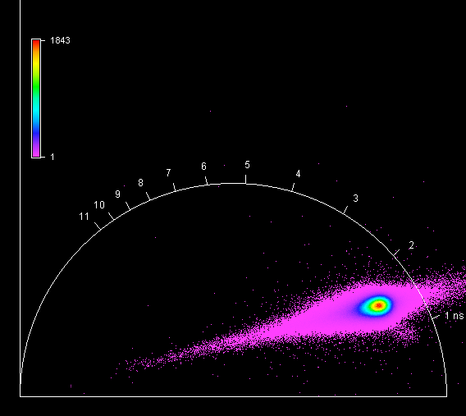

**Unknown, S063, F1, M4, AII** 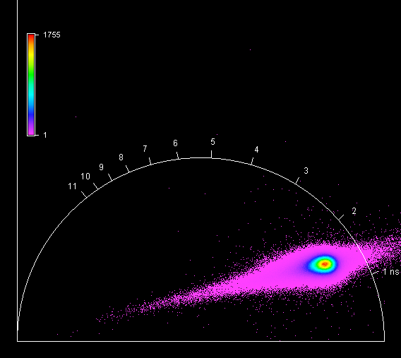

**Unknown, S064, F1, M1, AIII** 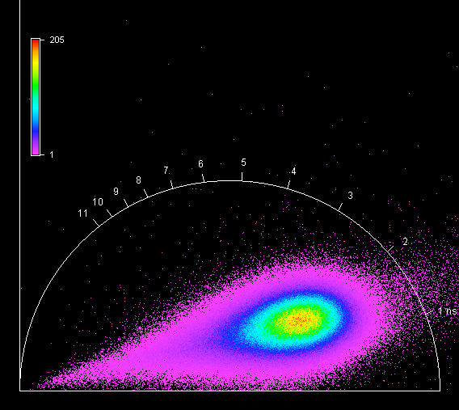

**Unknown, S064, F1, M2, AIII** 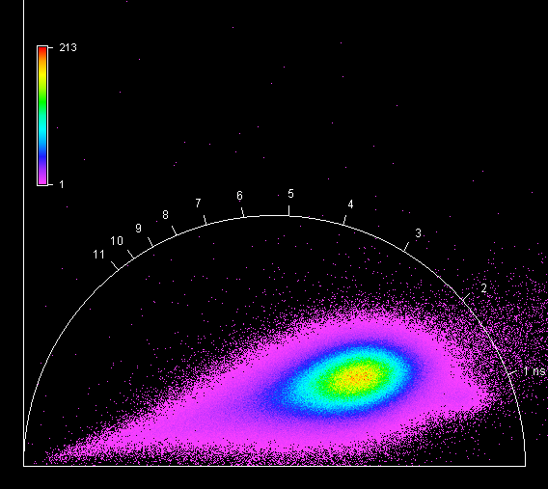

**Unknown, S064, F1, M3, AIII** 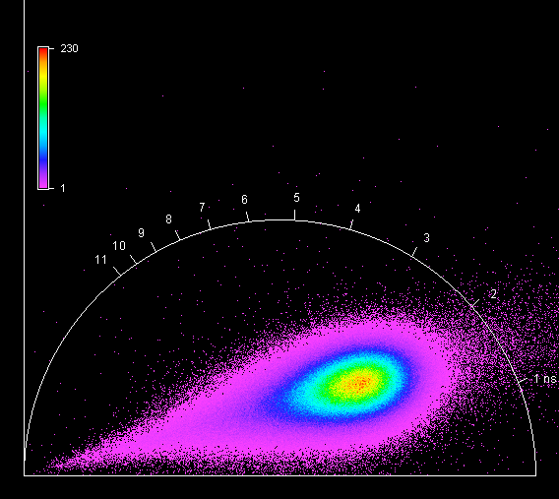

**Unknown, S064, F1, M4, AIII** 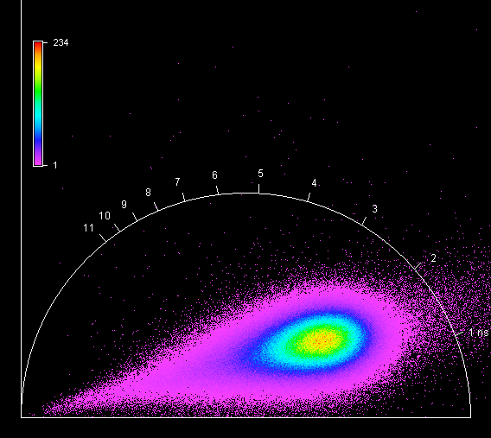

**Unknown, S065, F1, M1, AI** 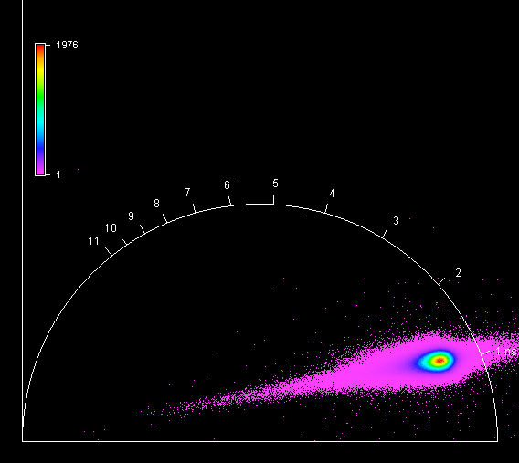

**Unknown, S065, F1, M2, AI** 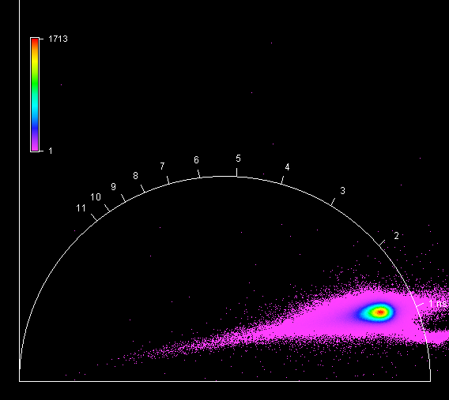

**Unknown, S065, F1, M3, AI** 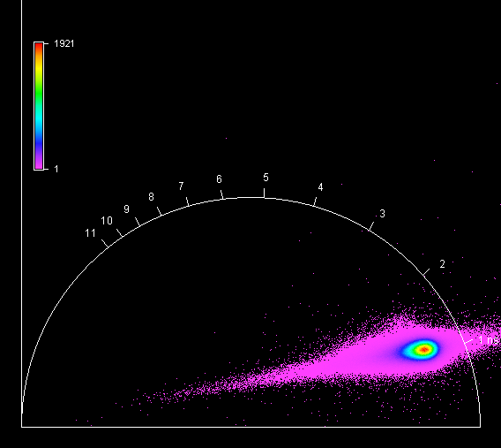

**Unknown, S065, F1, M4, AI** 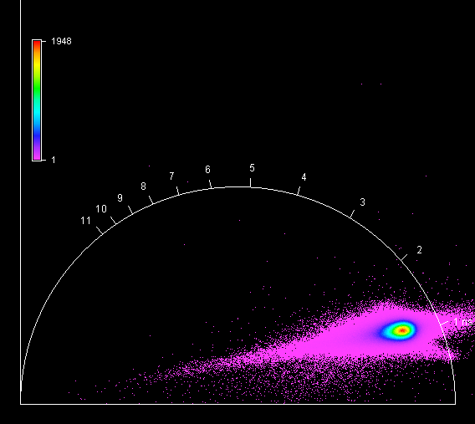

**Unknown, S066, F1, M1, AII** 

**Unknown, S066, F1, M2, AII** 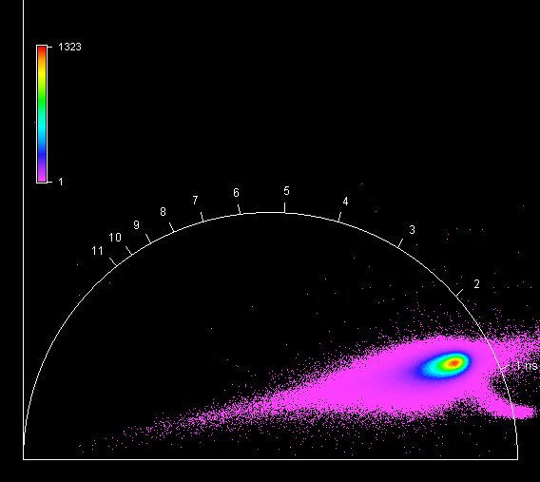

**Unknown, S066, F1, M3, AII** 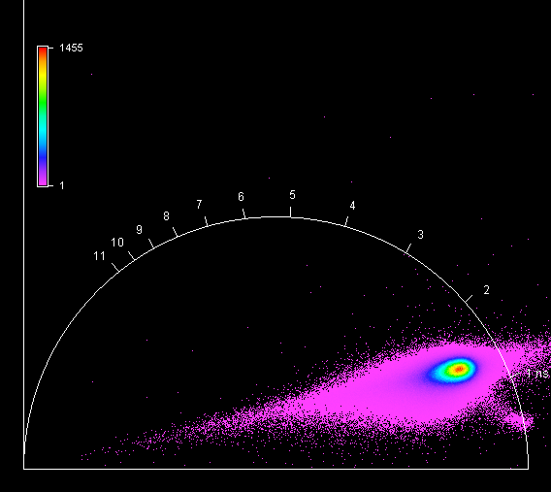

**Unknown, S066, F1, M4, AII** 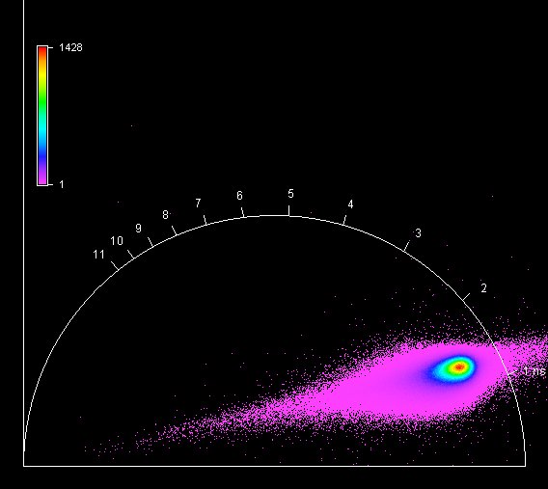

**Unknown, S067, F1, M1, AI** 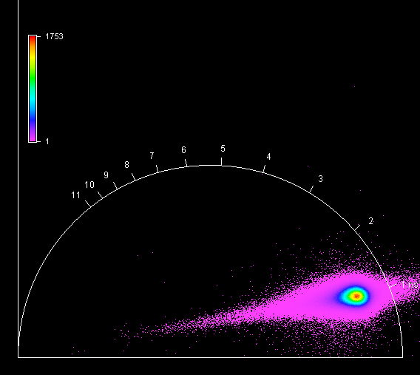

**Unknown, S067, F1, M2, AI** 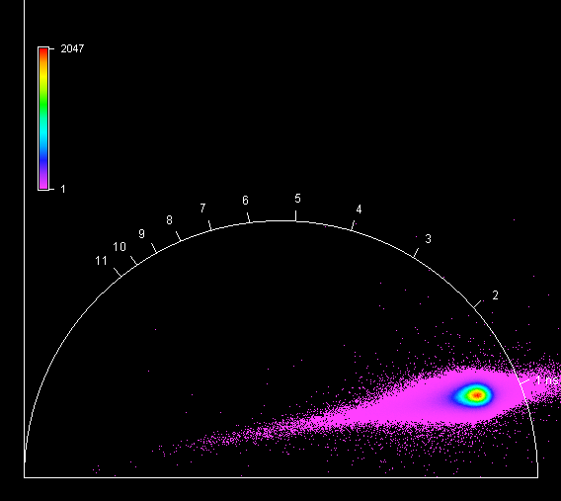

**Unknown, S067, F1, M3, AI** 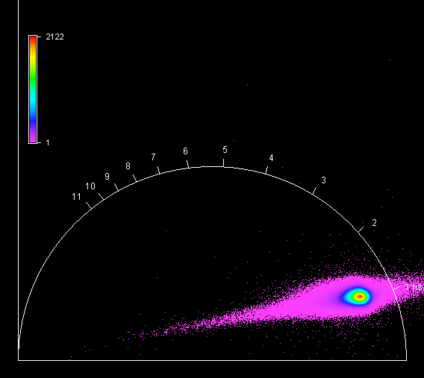

**Unknown, S067, F1, M4, AI** 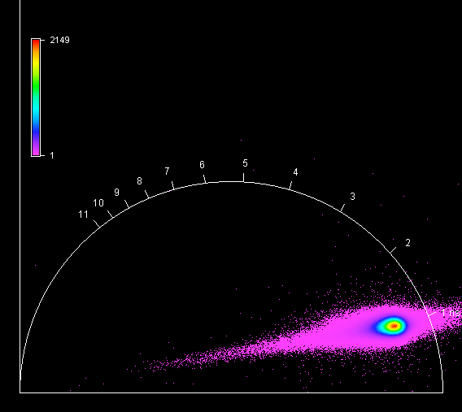

**Unknown, S068, F1, M1, AI** 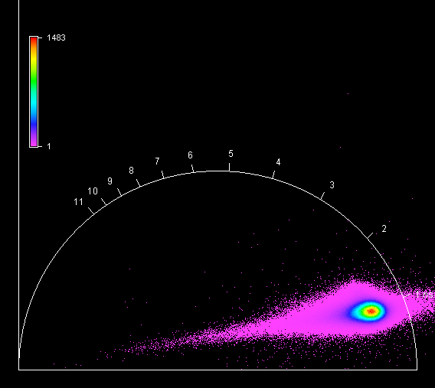

**Unknown, S068, F1, M2, AI** 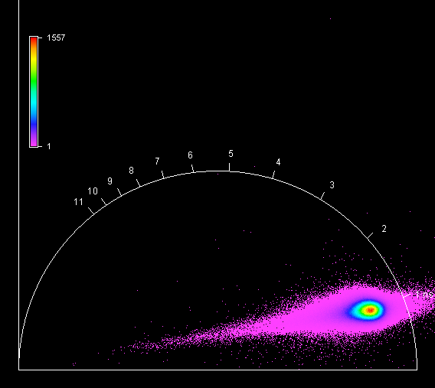

**Unknown, S068, F1, M3, AI** 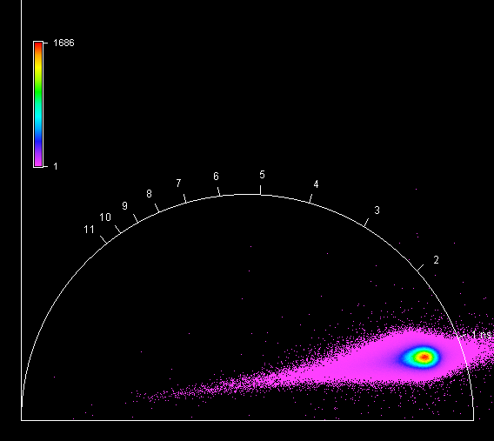

**Unknown, S068, F1, M4, AI** 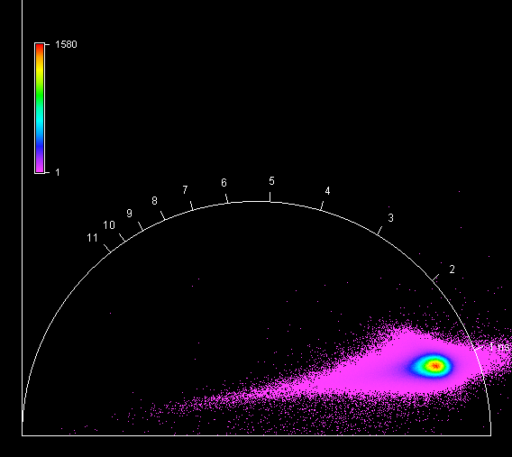

**Unknown, S069, F1, M1, AI** 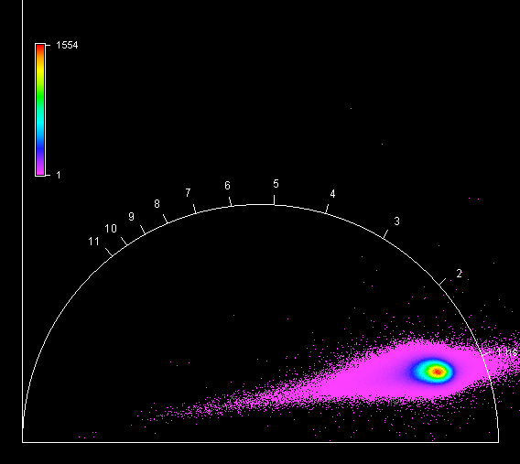

**Unknown, S069, F1, M2, AI** 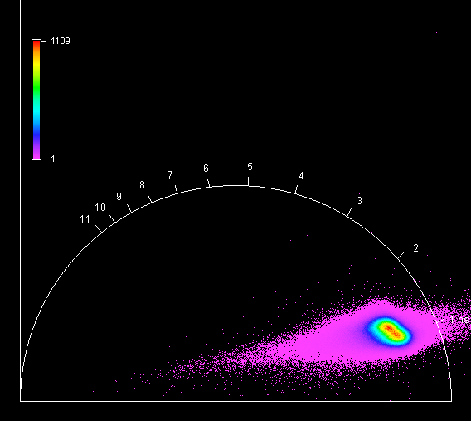

**Unknown, S069, F1, M3, AI** 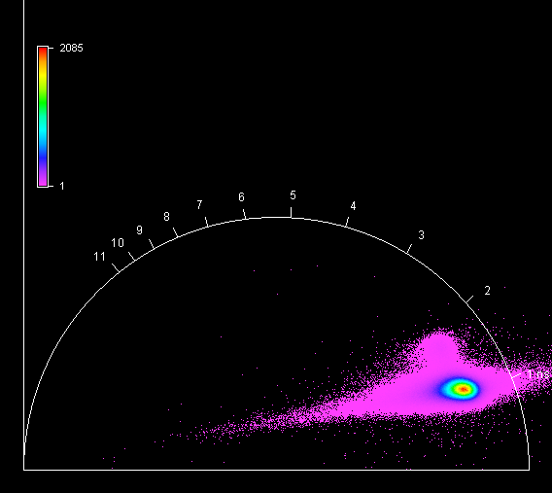

**Unknown, S069, F1, M4, AI** 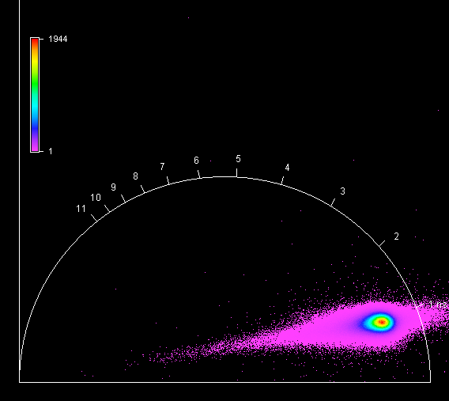

**Unknown, S070, F1, M1, AI** 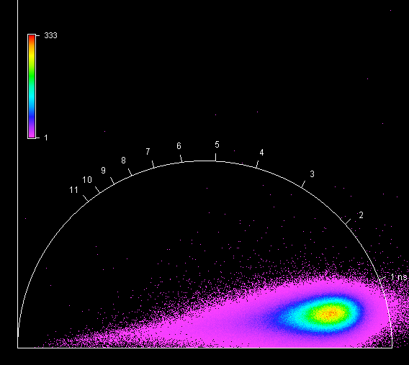

**Unknown, S070, F1, M2, AI** 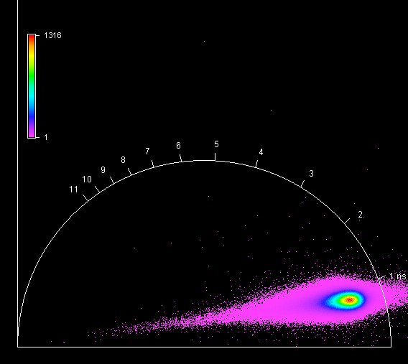

**Unknown, S070, F1, M3, AI** 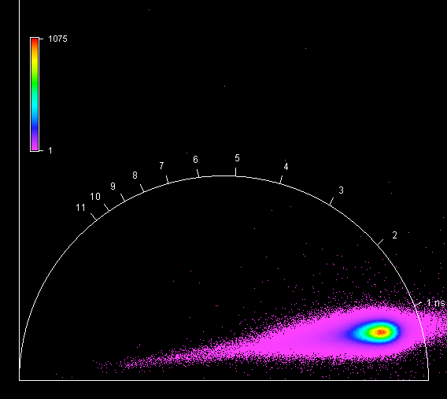

**Unknown, S070, F1, M4, AI** 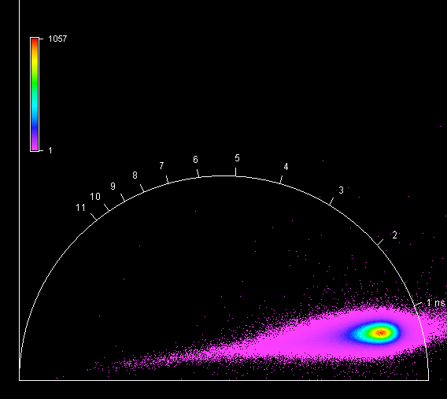

**Unknown, S071, F1, M1, AI** 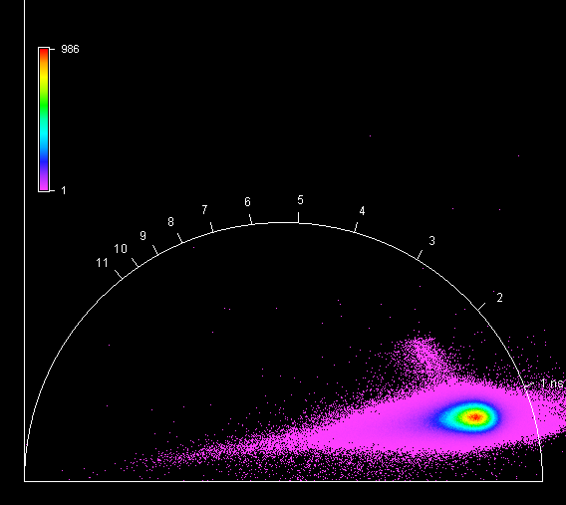

**Unknown, S071, F1, M2, AI** 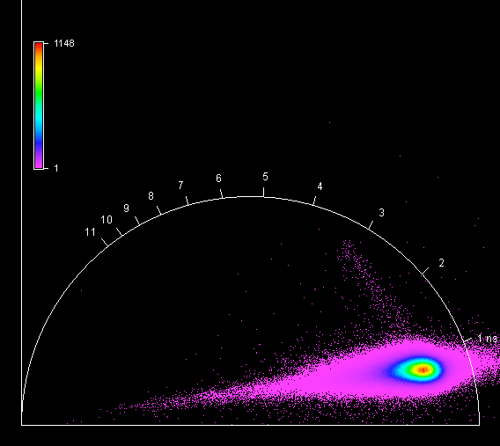

**Unknown, S071, F1, M3, AI** 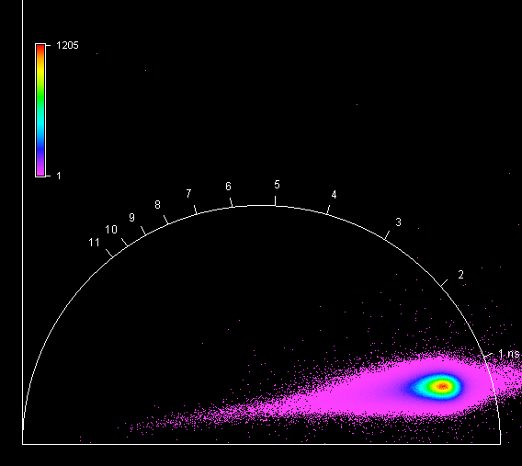

**Unknown, S071, F1, M4, AI** 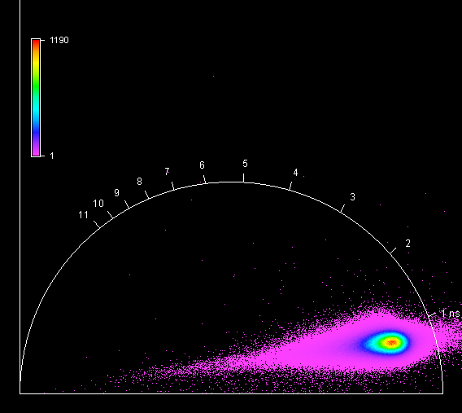

**Unknown, S072, F1, M1, AI** 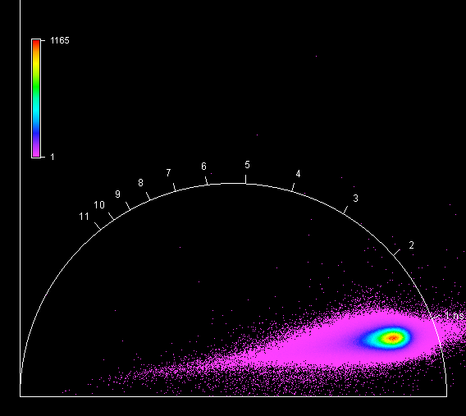

**Unknown, S072, F1, M2, AI** 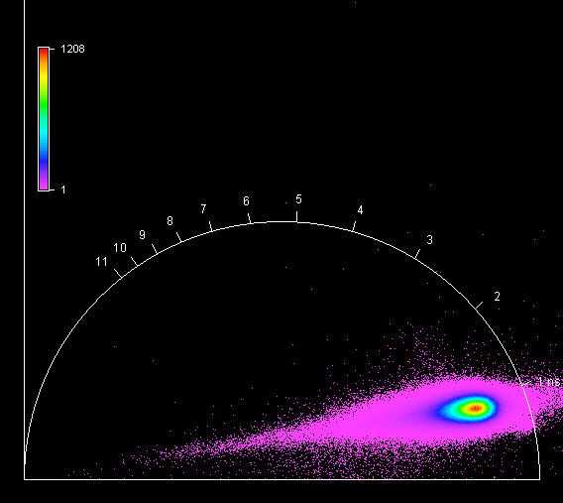

**Unknown, S072, F1, M3, AI** 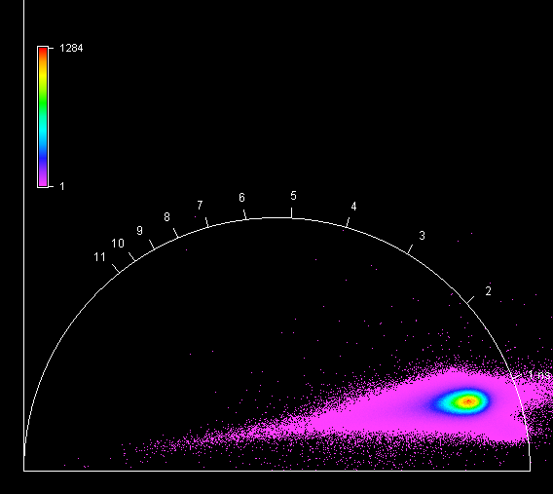

**Unknown, S072, F1, M4, AI** 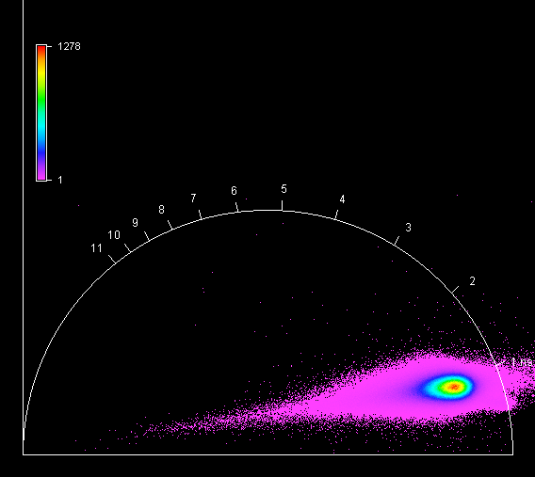

**Unknown, S073, F1, M1, AI** 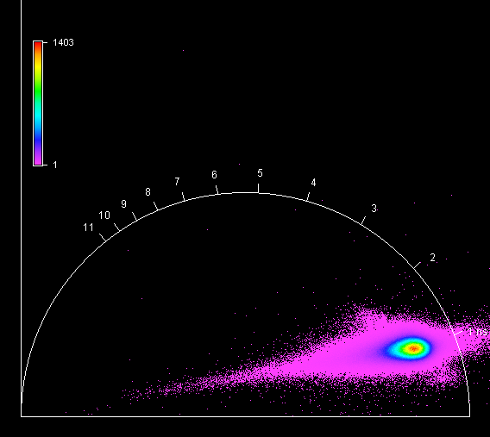

**Unknown, S073, F1, M2, AI** 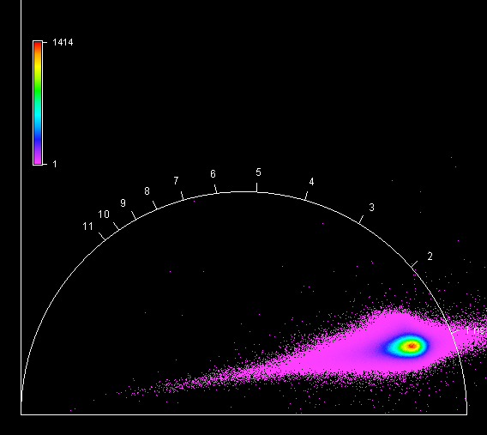

**Unknown, S073, F1, M3, AI** 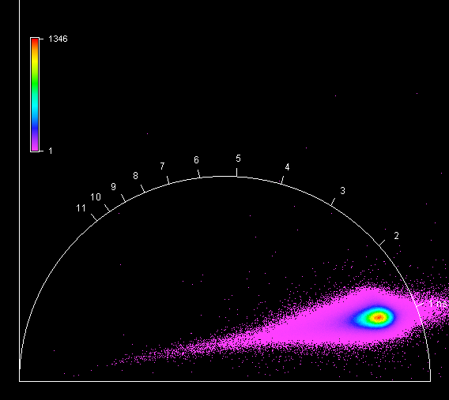

**Unknown, S073, F1, M4, AI** 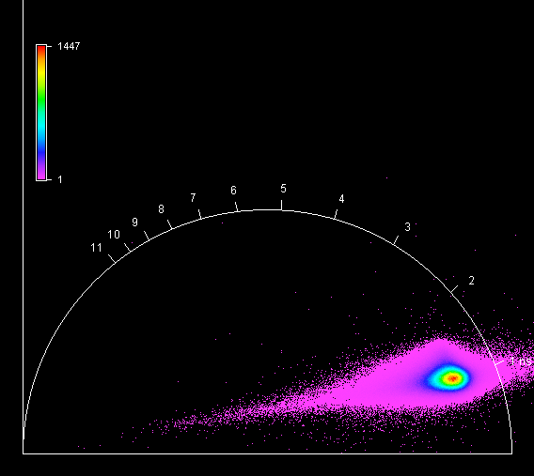

**Unknown, S074, F1, M1, AI** 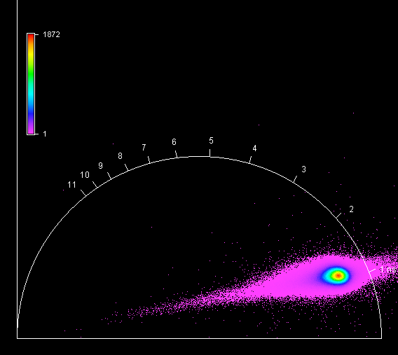

**Unknown, S074, F1, M2, AI** 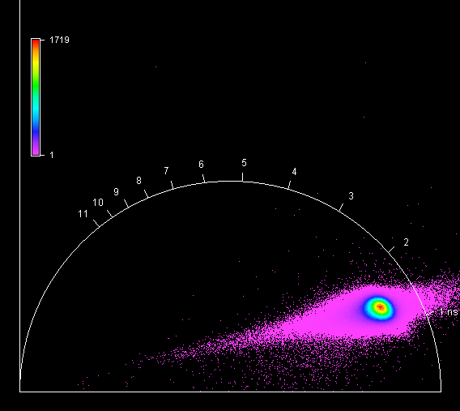

**Unknown, S074, F1, M3, AI** 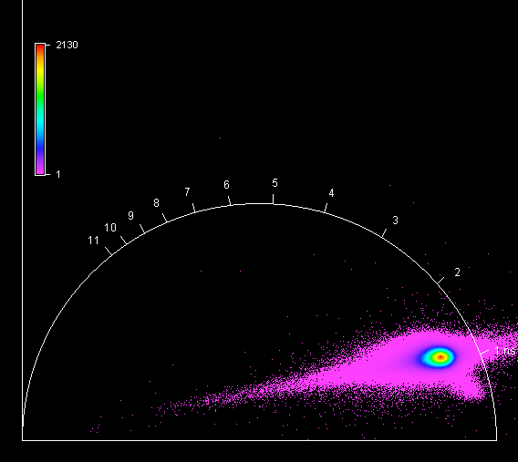

**Unknown, S074, F1, M4, AI** 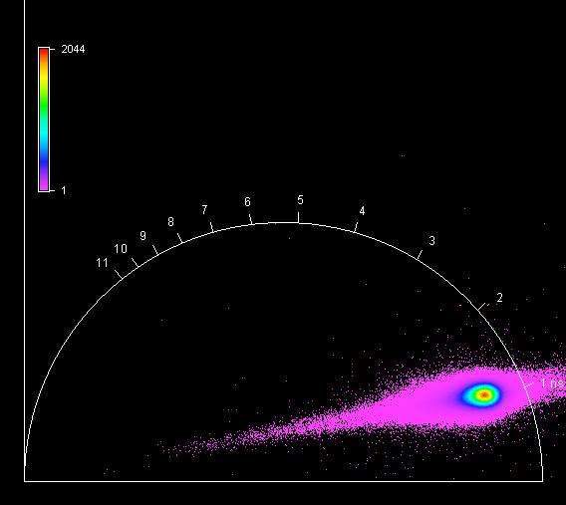

**Unknown, S075, F1, M1, AI** 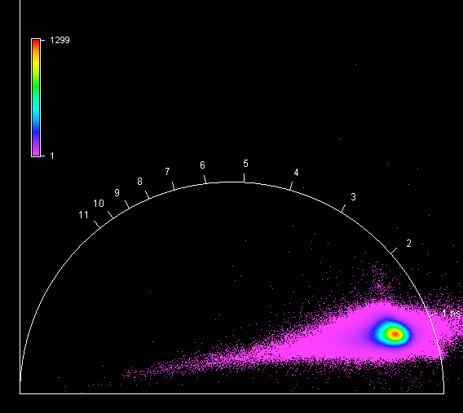

**Unknown, S075, F1, M2, AI** 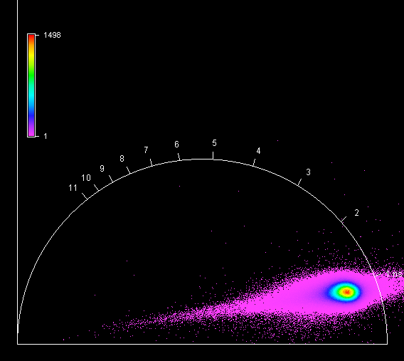

**Unknown, S075, F1, M3, AI** 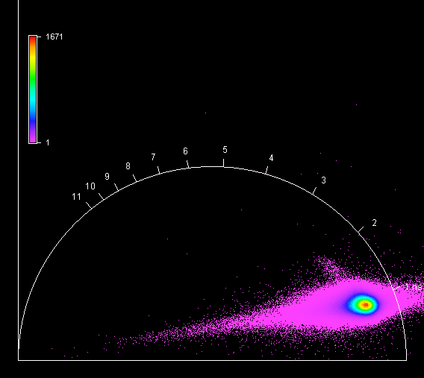

**Unknown, S075, F1, M4, AI** 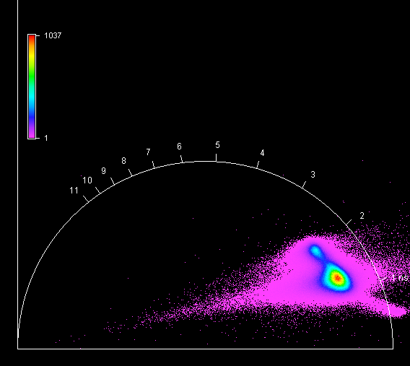

**Unknown, S076, F1, M1, AI** 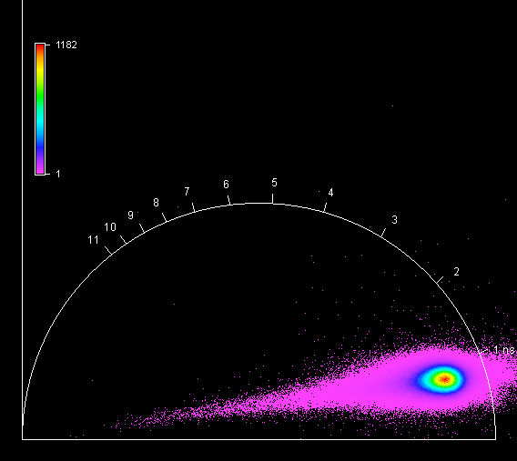

**Unknown, S076, F1, M2, AI** 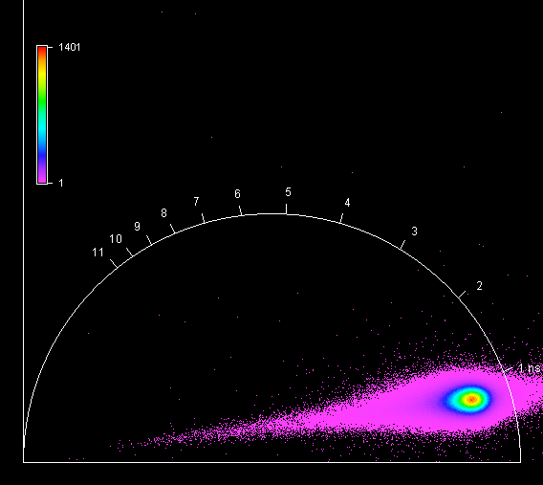

**Unknown, S076, F1, M3, AI** 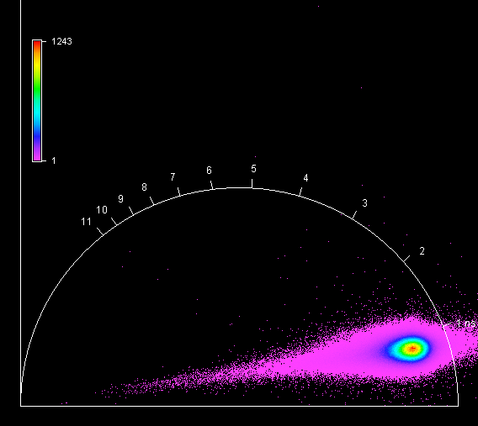

**Unknown, S076, F1, M4, AI** 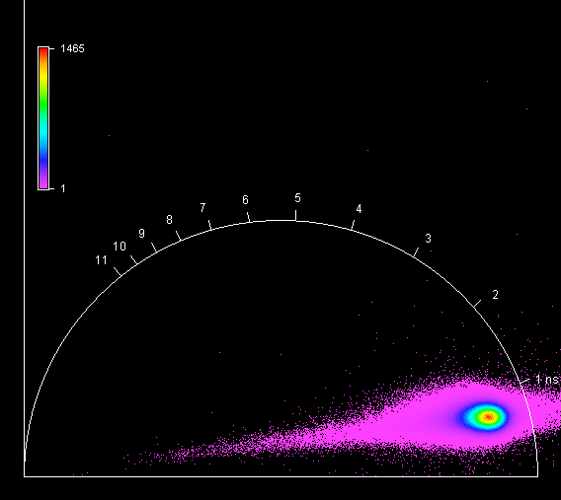

**Unknown, S077, F1, M1, AI** 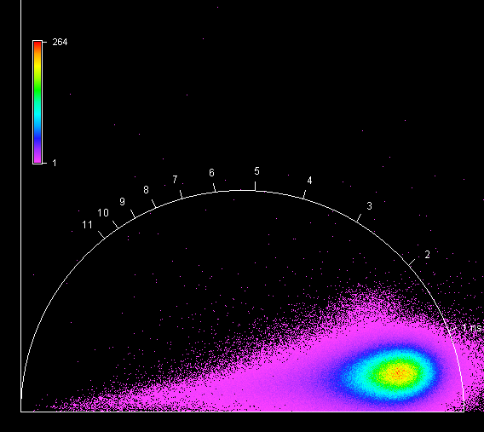

**Unknown, S077, F1, M2, AI** 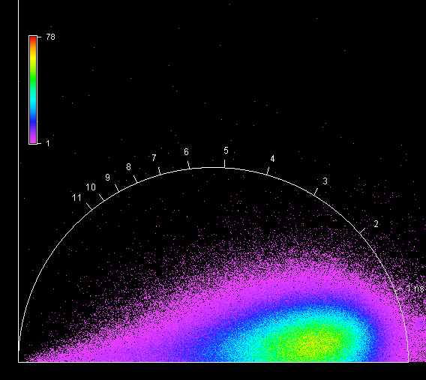

**Unknown, S077, F1, M3, AI** 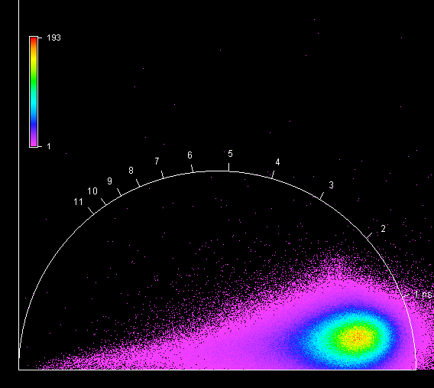

**Unknown, S077, F1, M4, AI** 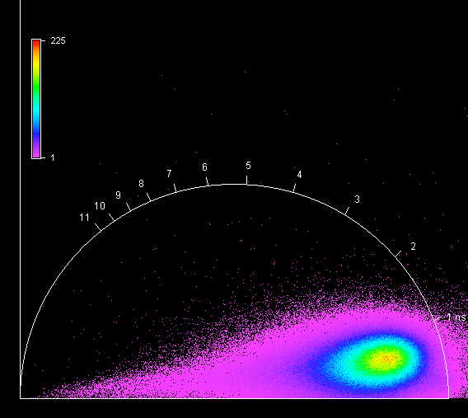

**Unknown, S078, F1, M1, AI** 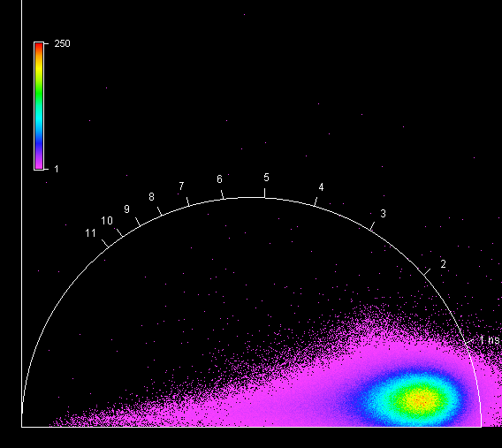

**Unknown, S078, F1, M2, AI** 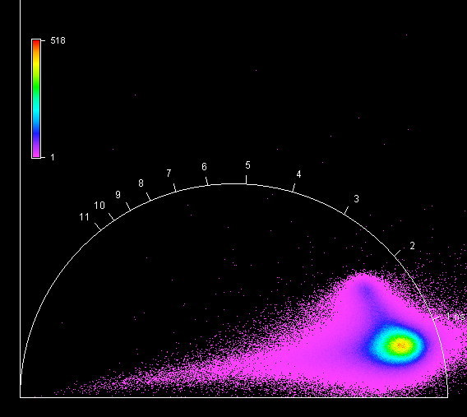

**Unknown, S078, F1, M3, AI** 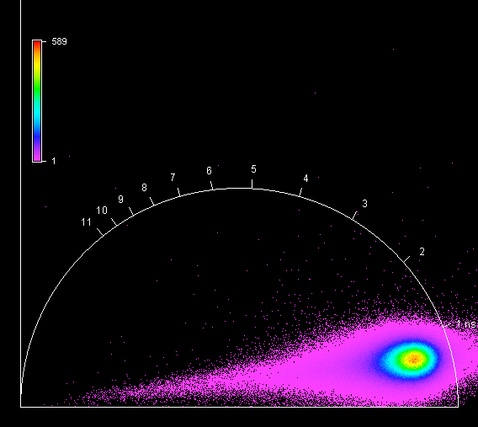

**Unknown, S078, F1, M4, AI** 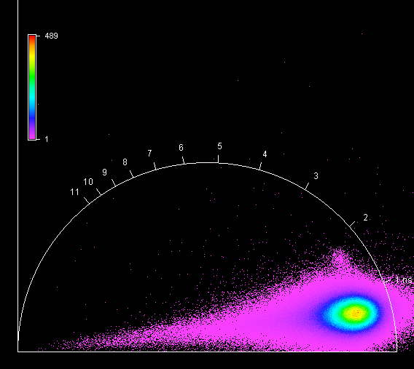

**Unknown, S079, F1, M1, AII** 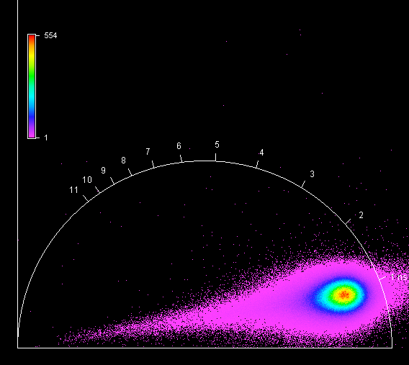

**Unknown, S079, F1, M2, AII** 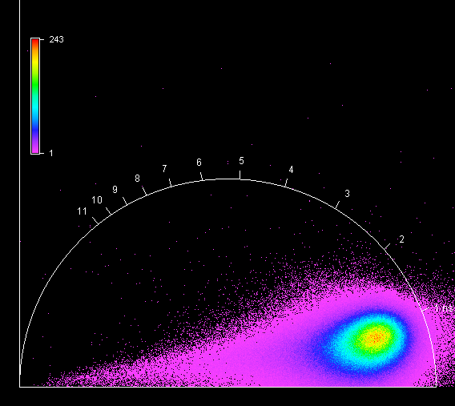

**Unknown, S079, F1, M3, AII** 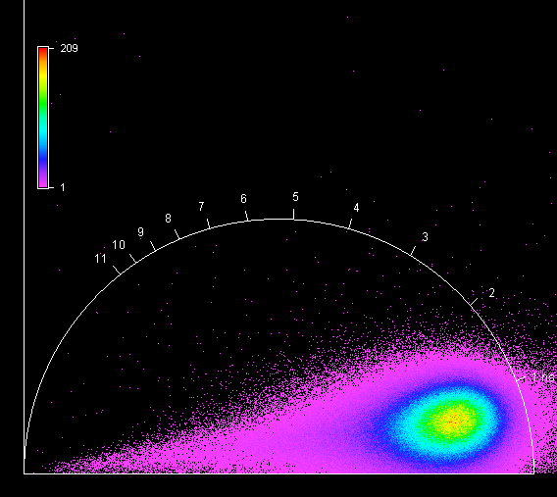

**Unknown, S079, F1, M4, AII** 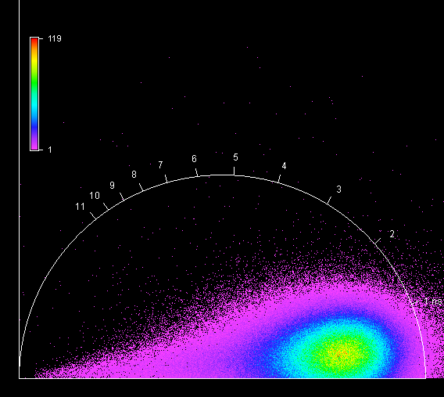

**Unknown, S080, F1, M1, AI** 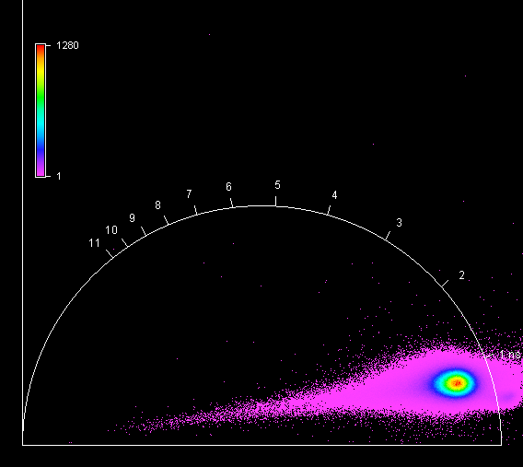

**Unknown, S080, F1, M2, AI** 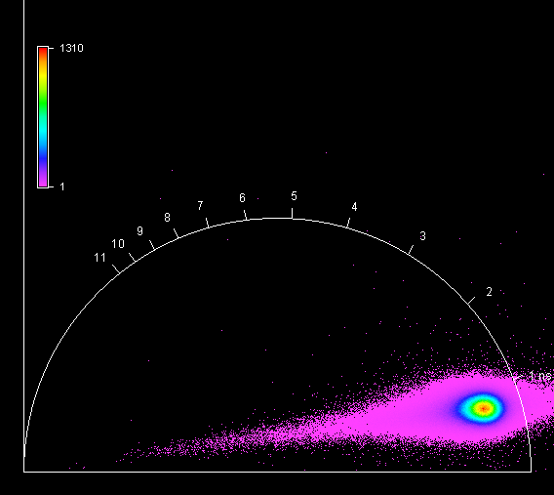

**Unknown, S080, F1, M3, AI** 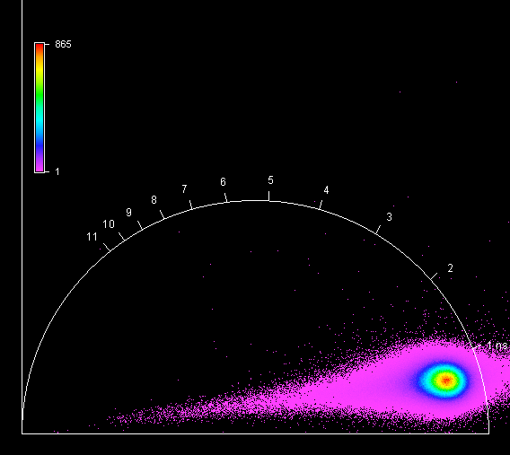

**Unknown, S080, F1, M4, AI** 