**Unknown, S081, F1, M1, AI** 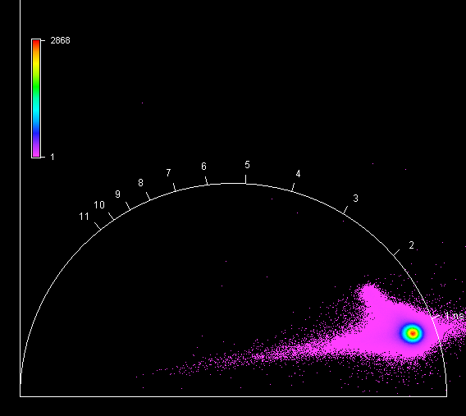

**Unknown, S081, F1, M2, AI** 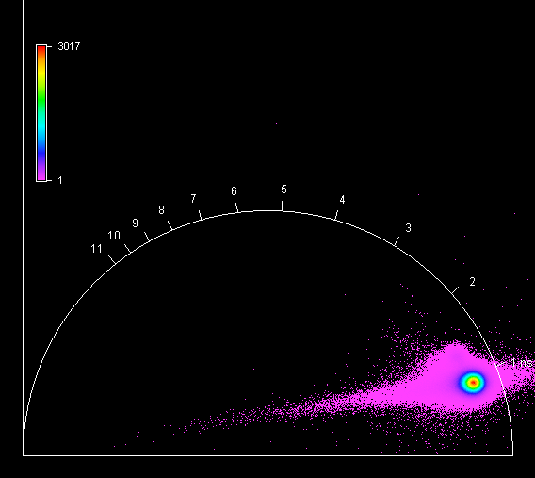

**Unknown, S081, F1, M3, AI** 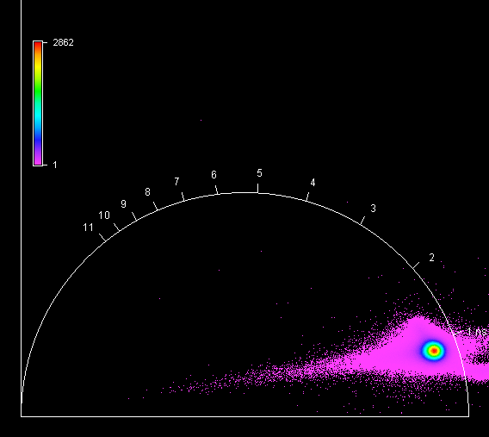

**Unknown, S081, F1, M4, AI** 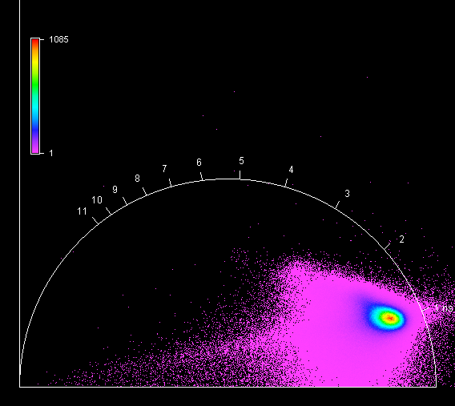

**Unknown, S082, F1, M1, AIV** 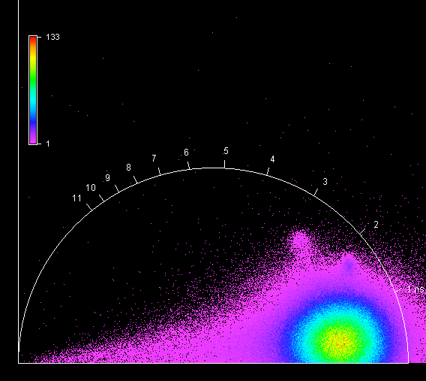

**Unknown, S082, F1, M2, AIV** 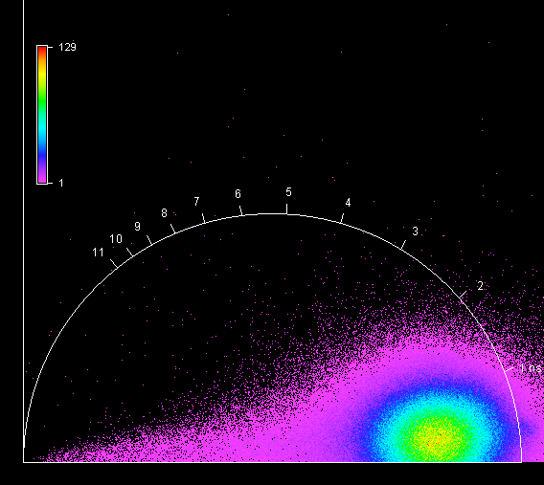

**Unknown, S082, F1, M3, AIV** 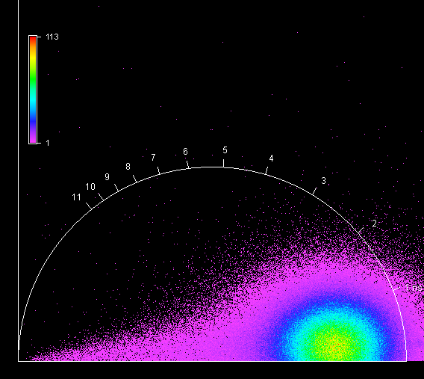

**Unknown, S082, F1, M4, AIV** 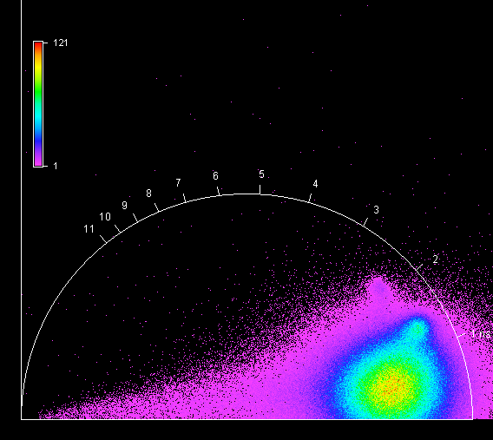

**Unknown, S083, F1, M1, AI** 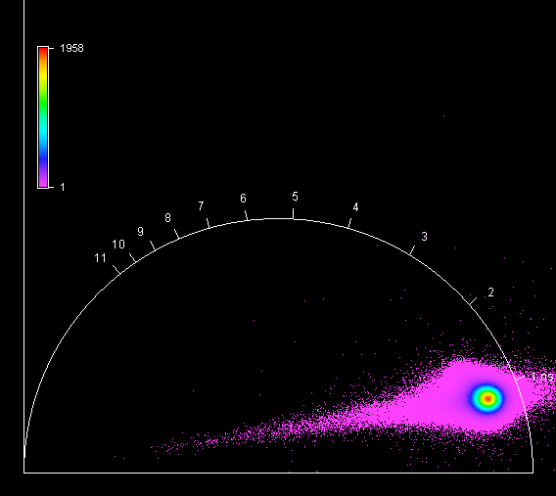

**Unknown, S083, F1, M2, AI** 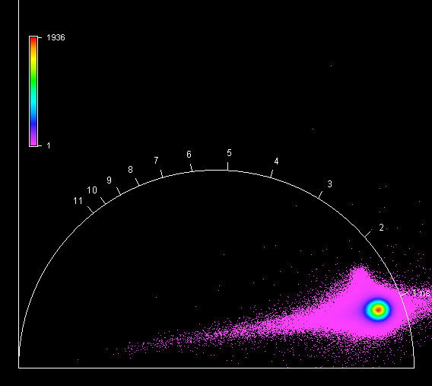

**Unknown, S083, F1, M1, AI** 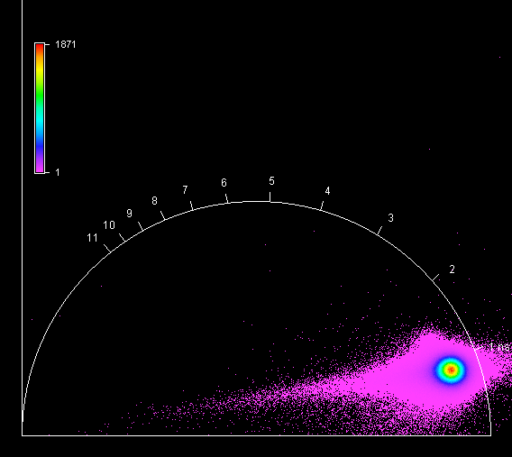

**Unknown, S083, F1, M1, AI** 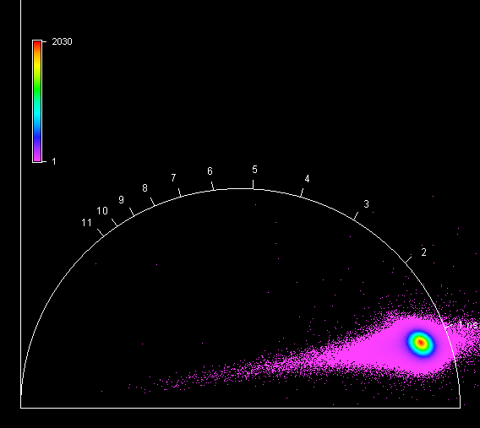

**Unknown, S084, F1, M1, AI** 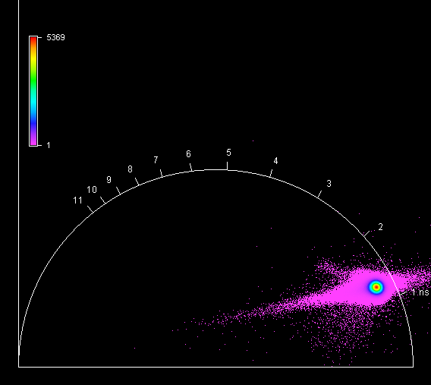

**Unknown, S084, F1, M2, AI** 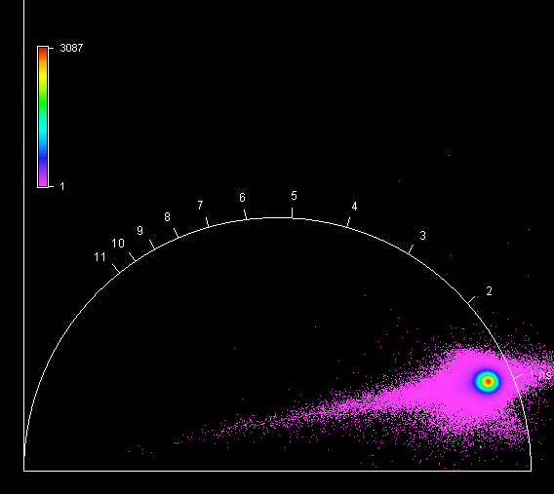

**Unknown, S084, F1, M3, AI** 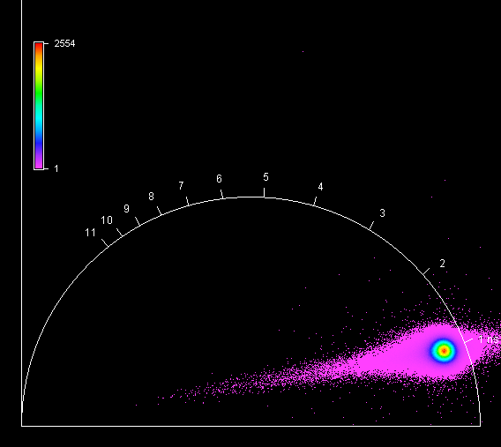

**Unknown, S084, F1, M4, AI** 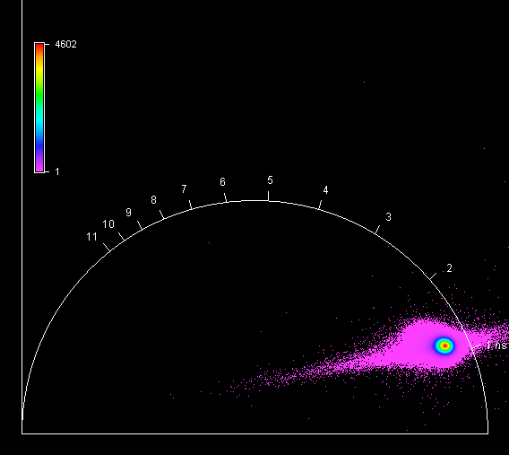

**Unknown, S085, F1, M1, AII** 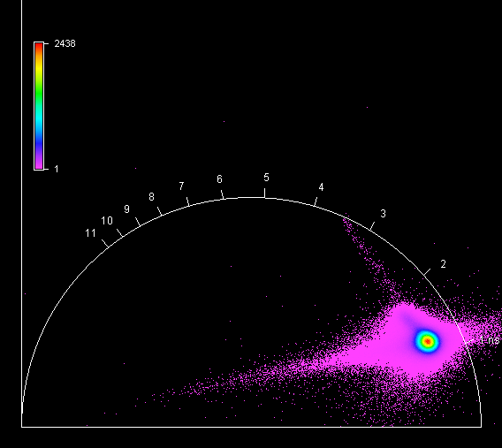

**Unknown, S085, F1, M2, AII** 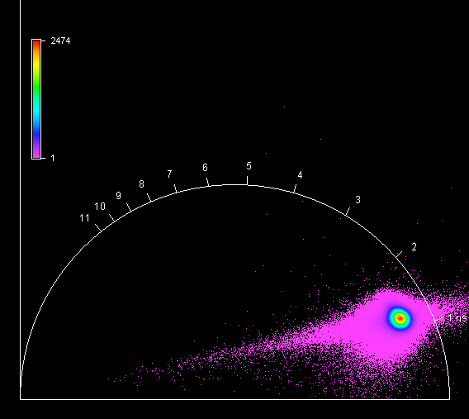

**Unknown, S085, F1, M3, AII** 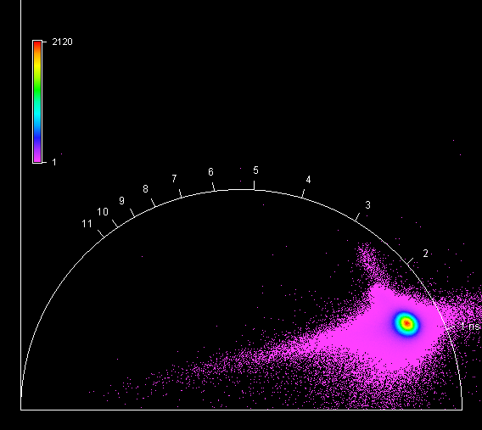

**Unknown, S085, F1, M4, AII** 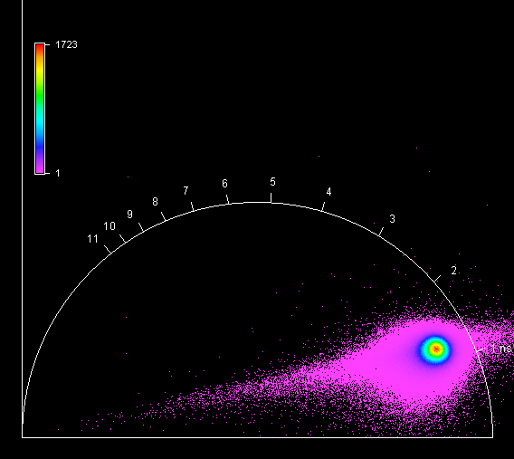

**Unknown, S086, F1, M1, AI** 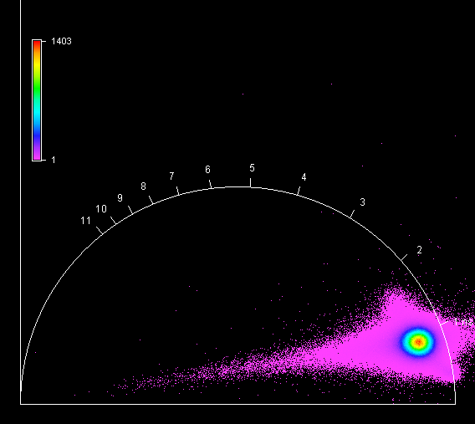

**Unknown, S086, F1, M2, AI** 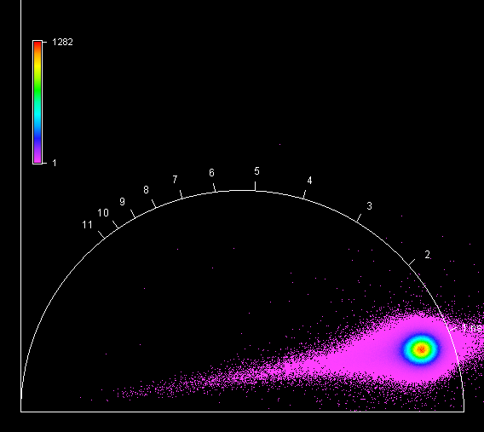

**Unknown, S086, F1, M3, AI** 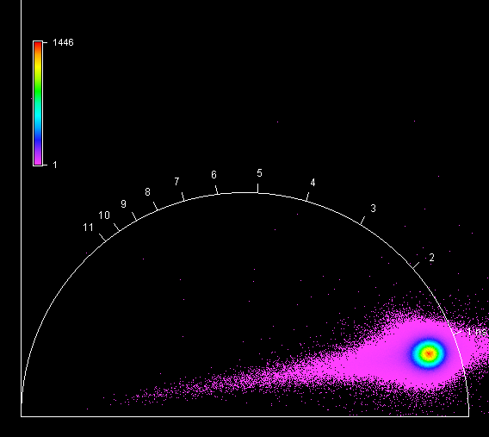

**Unknown, S086, F1, M4, AI** 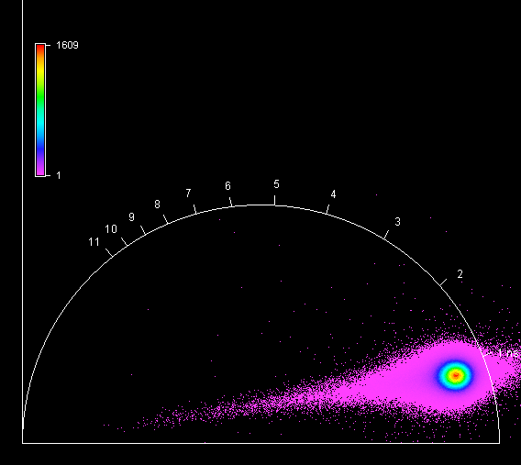

**Unknown, S087, F1, M1, AII** 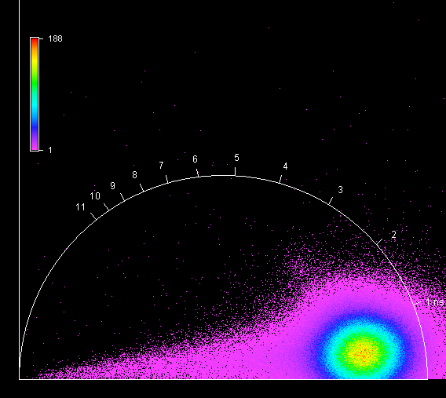

**Unknown, S087, F1, M2, AII** 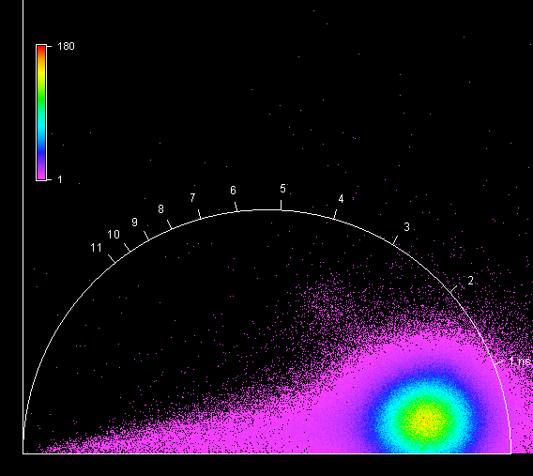

**Unknown, S087, F1, M3, AII** 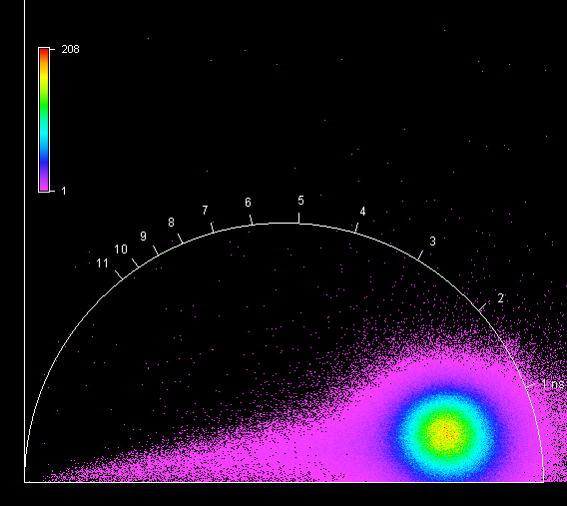

**Unknown, S087, F1, M4, AII** 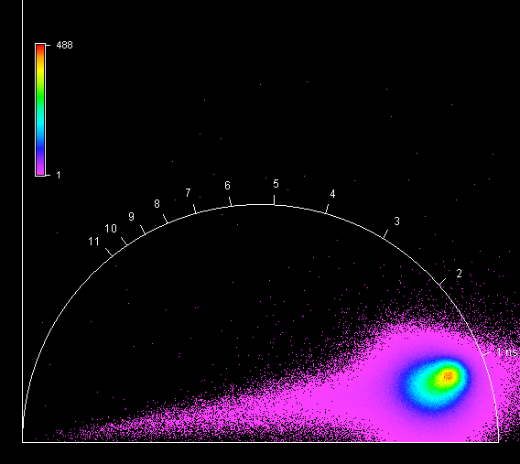

**Unknown, S088, F1, M1, AI** 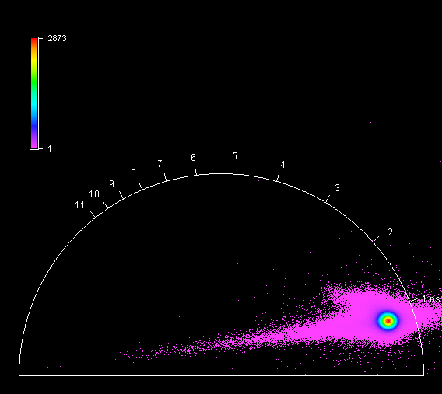

**Unknown, S088, F1, M2, AI** 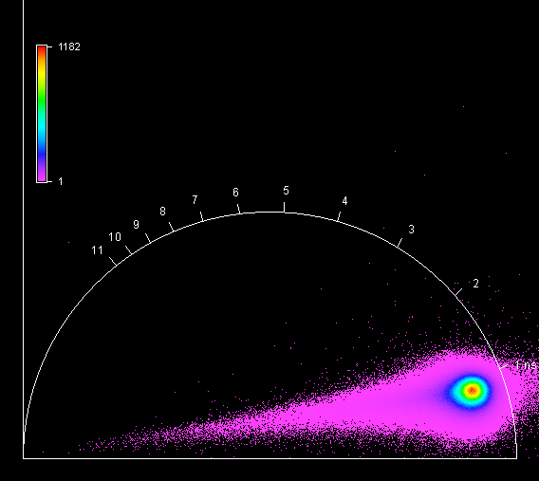

**Unknown, S088, F1, M3, AI** 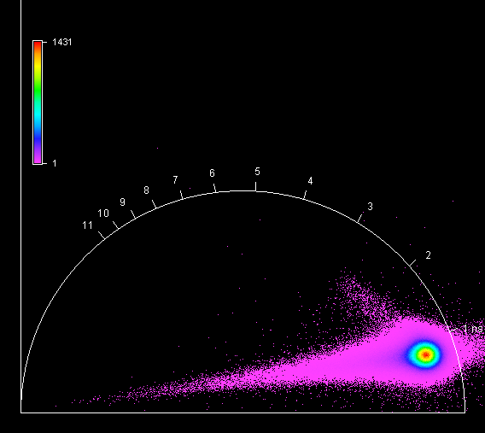

**Unknown, S088, F1, M4, AI** 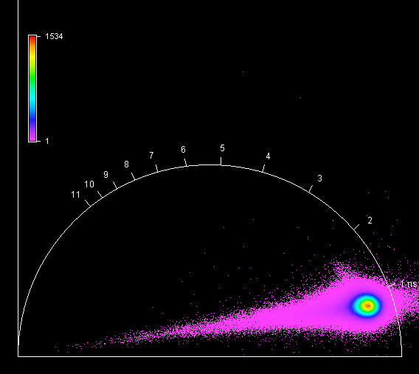

**Unknown, S089, F1, M1, AI** 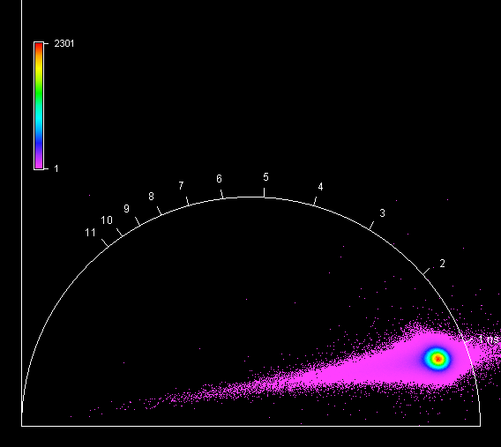

**Unknown, S089, F1, M2, AI** 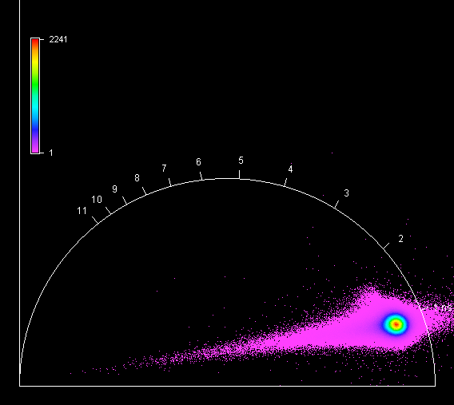

**Unknown, S089, F1, M3, AI** 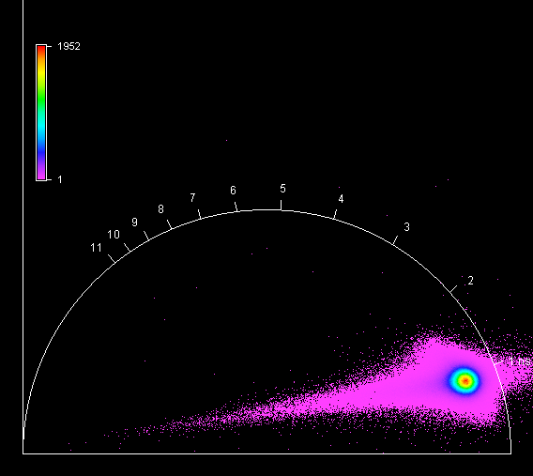

**Unknown, S089, F1, M4, AI** 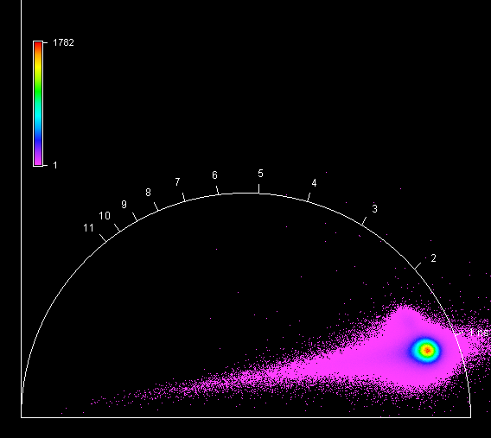

**Unknown, S090, F1, M1, AI** 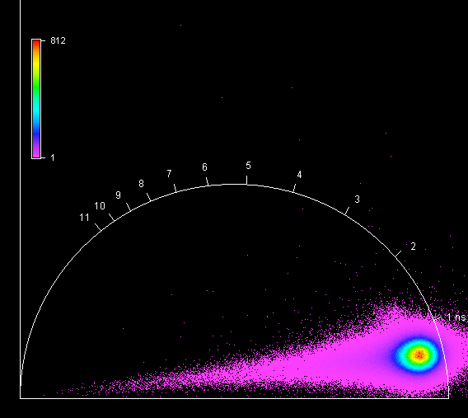

**Unknown, S090, F1, M2, AI** 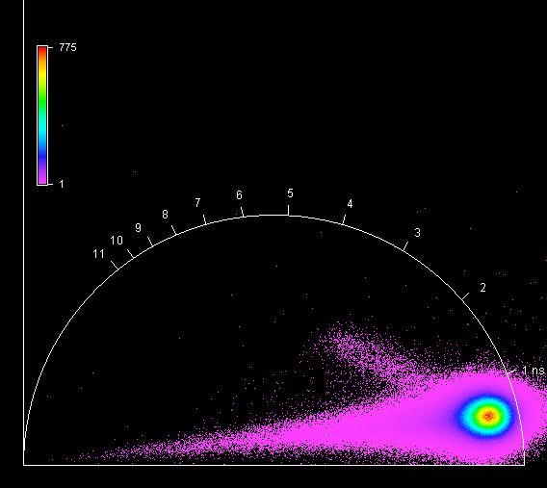

**Unknown, S090, F1, M3, AI** 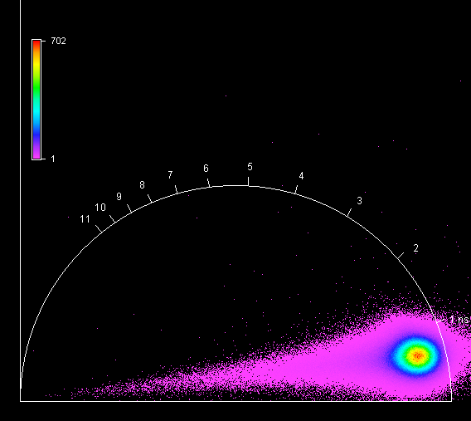

**Unknown, S090, F1, M4, AI** 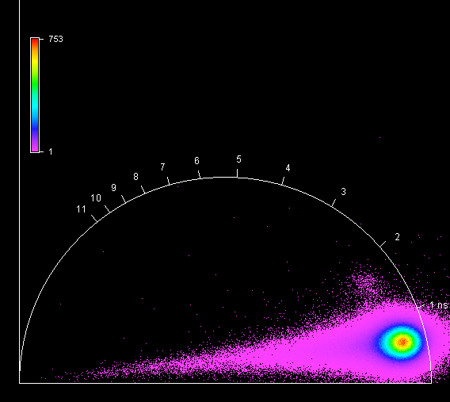

**Unknown, S091, F1, M1, AII** 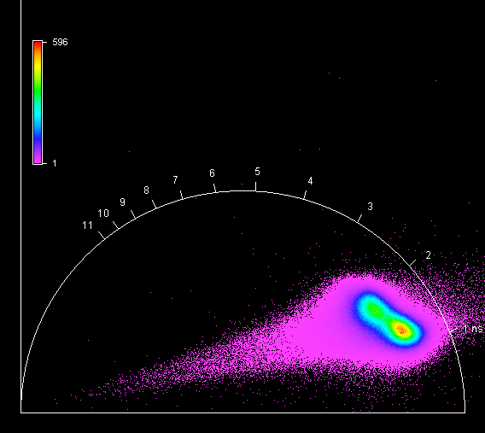

**Unknown, S091, F1, M2, AII** 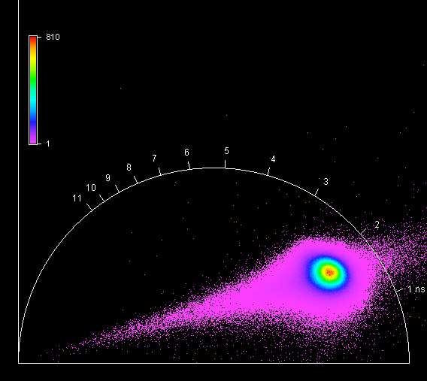

**Unknown, S091, F1, M3, AII** 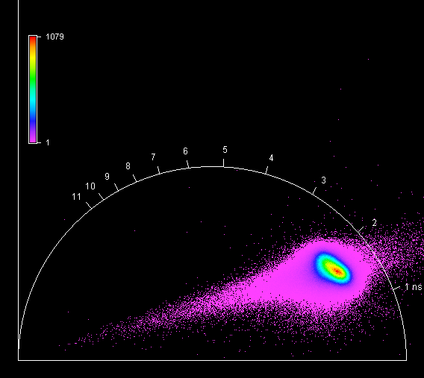

**Unknown, S091, F1, M4, AII** 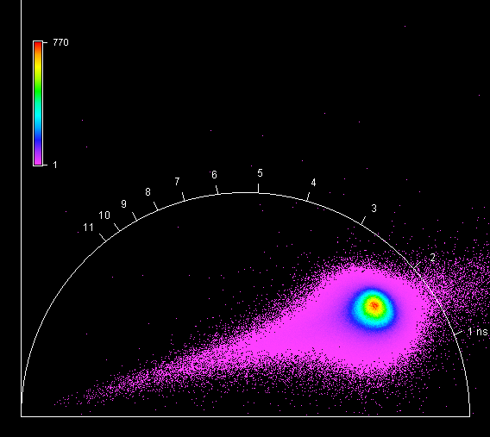

**Unknown, S092, F1, M1, AI** 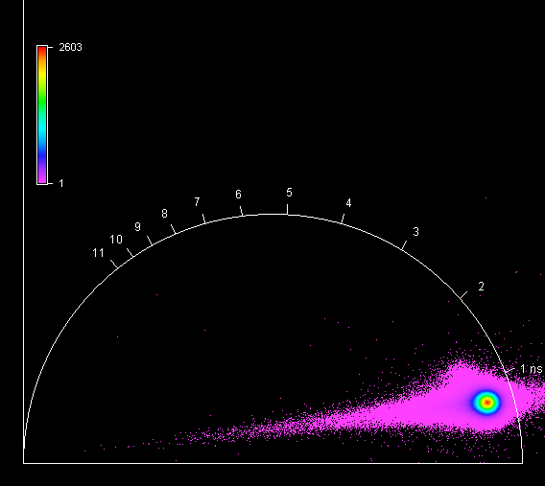

**Unknown, S092, F1, M2, AI** 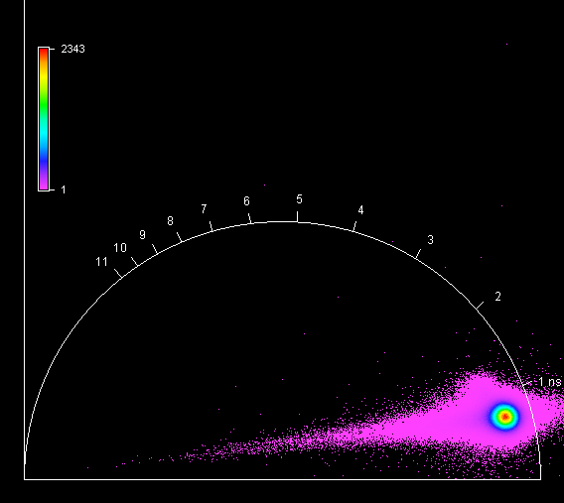

**Unknown, S092, F1, M3, AI** 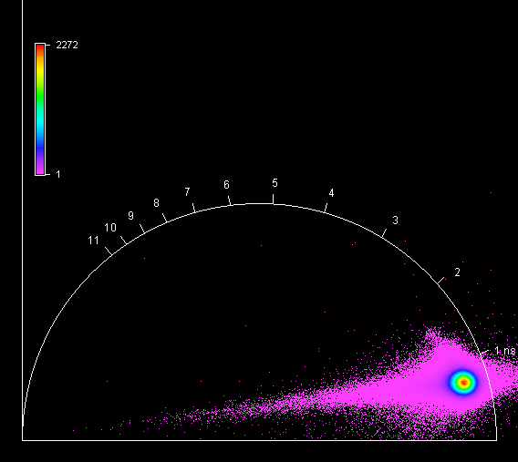

**Unknown, S092, F1, M4, AI** 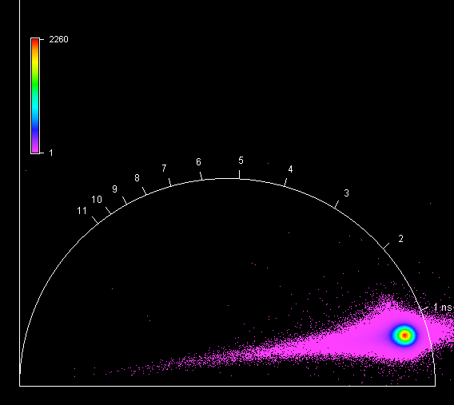

**Unknown, S093, F1, M1, AI** 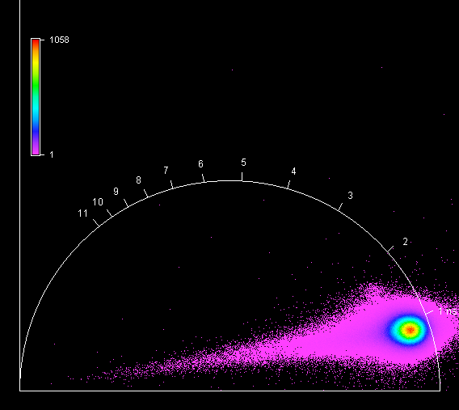

**Unknown, S093, F1, M2, AI** 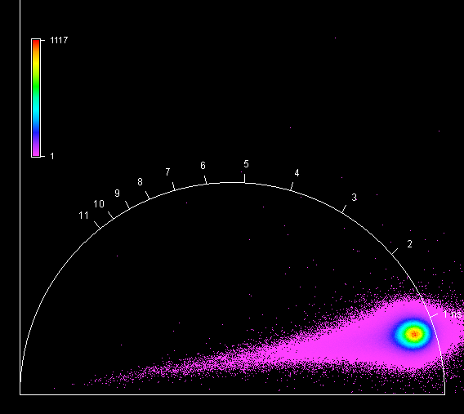

**Unknown, S093, F1, M3, AI** 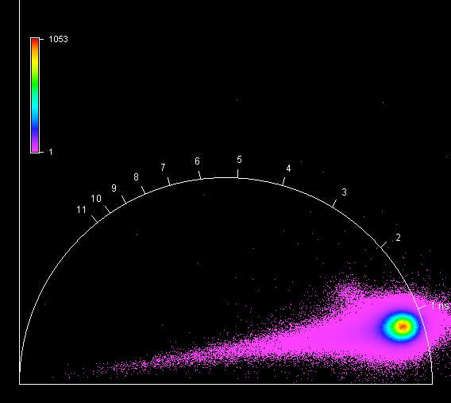

**Unknown, S093, F1, M4, AI** 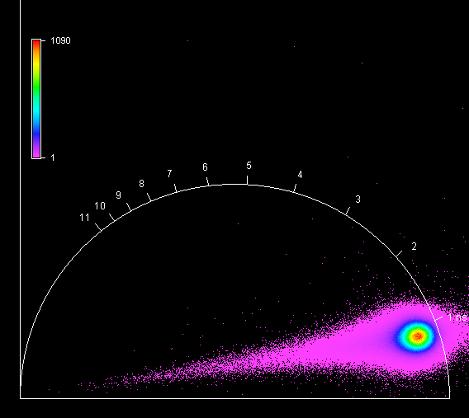

**Unknown, S094, F1, M1, AII** 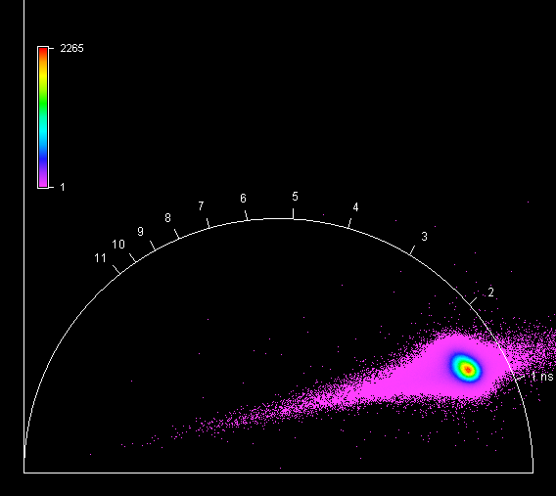

**Unknown, S094, F1, M2, AII** 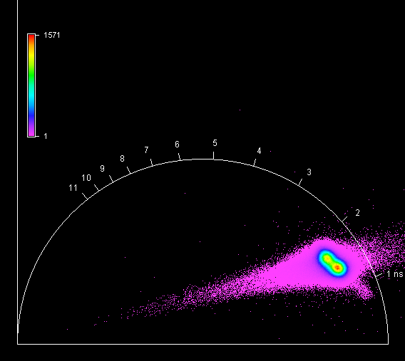

**Unknown, S094, F1, M3, AII** 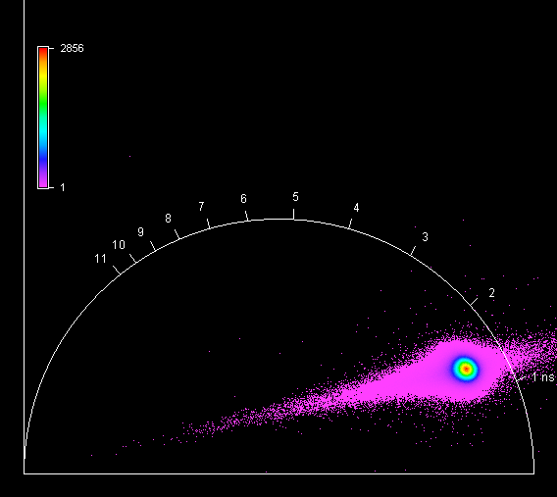

**Unknown, S094, F1, M4, AII** 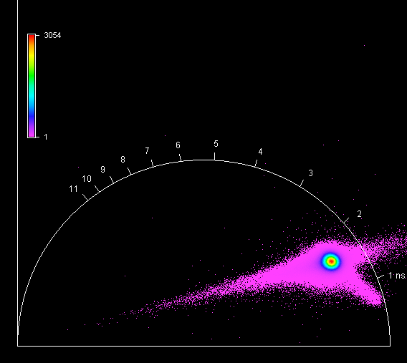

**Unknown, S095, F1, M1, AI** 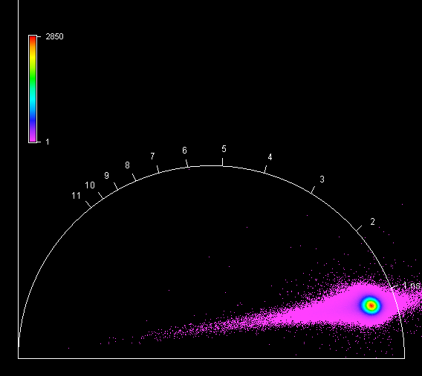

**Unknown, S095, F1, M2, AI** 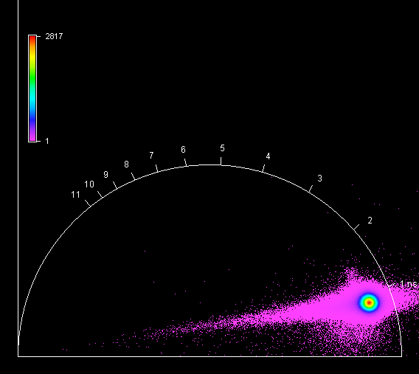

**Unknown, S095, F1, M3, AI** 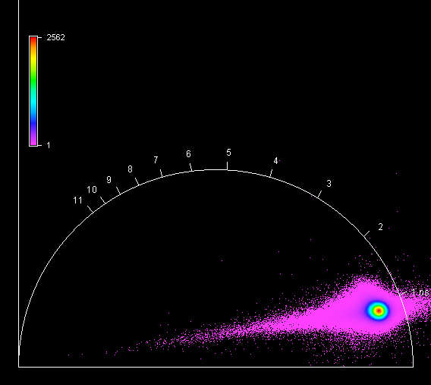

**Unknown, S095, F1, M4, AI** 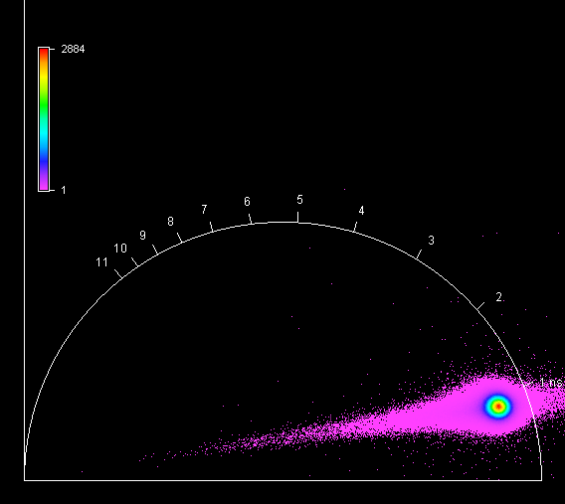

**Unknown, S096, F1, M1, AI** 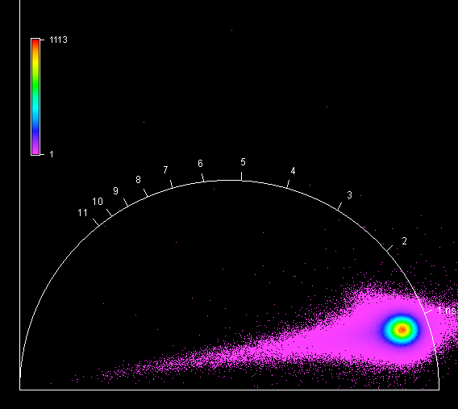

**Unknown, S096, F1, M2, AI** 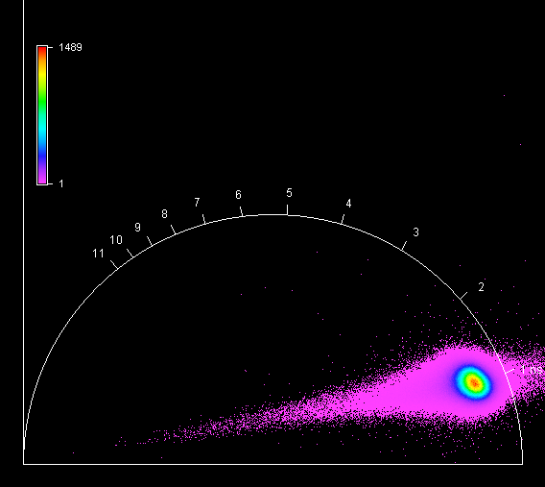

**Unknown, S096, F1, M3, AI** 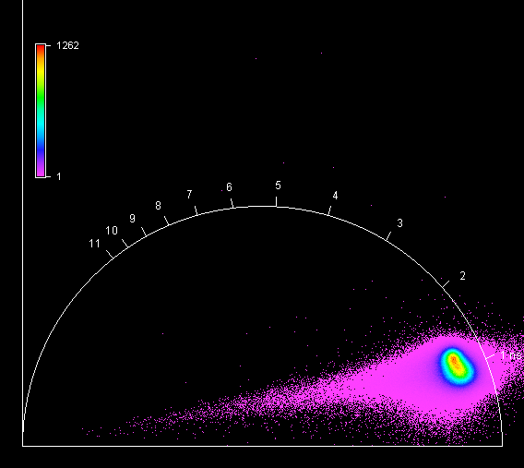

**Unknown, S096, F1, M4, AI** 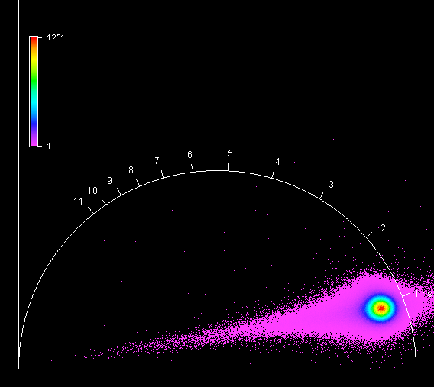

**Unknown, S097, F1, M1, AI** 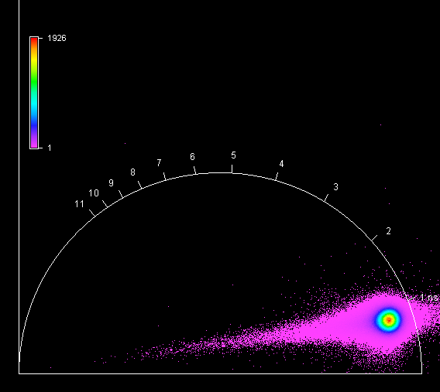

**Unknown, S097, F1, M2, AI** 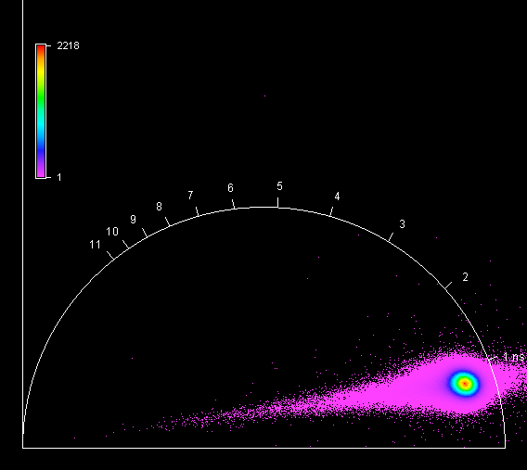

**Unknown, S097, F1, M3, AI** 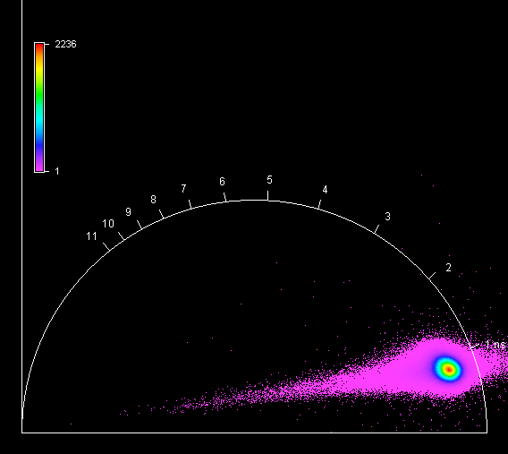

**Unknown, S097, F1, M4, AI** 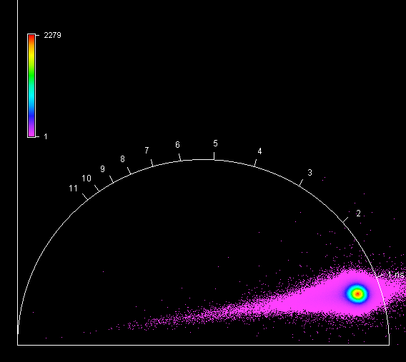

**Unknown, S098, F1, M1, AI** 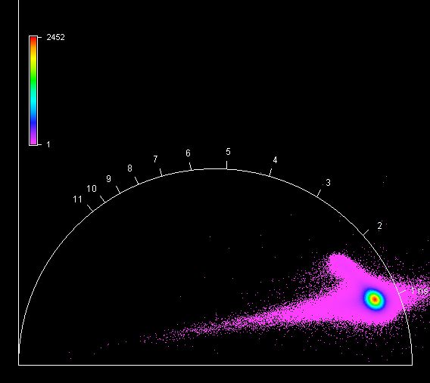

**Unknown, S098, F1, M2, AI** 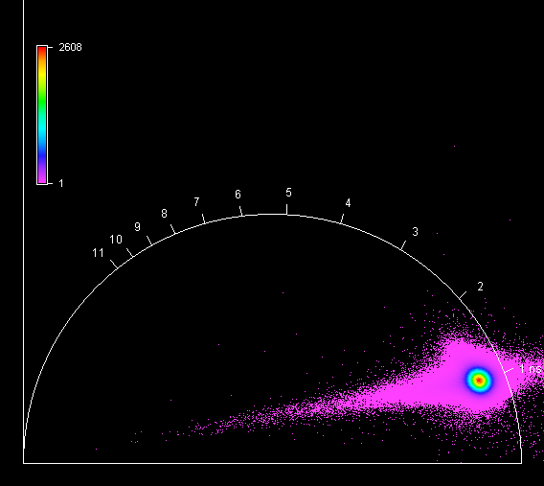

**Unknown, S098, F1, M3, AI**

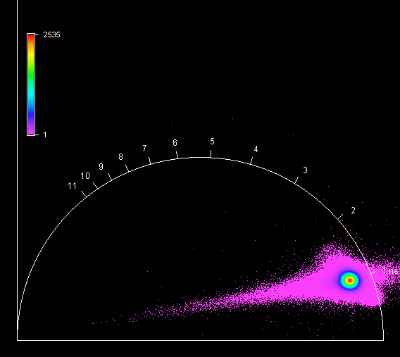

**Unknown, S098, F1, M4, AI**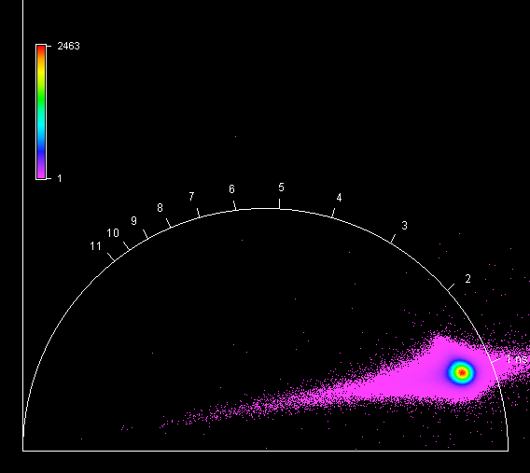

**Unknown, S099, F1, M1, AI**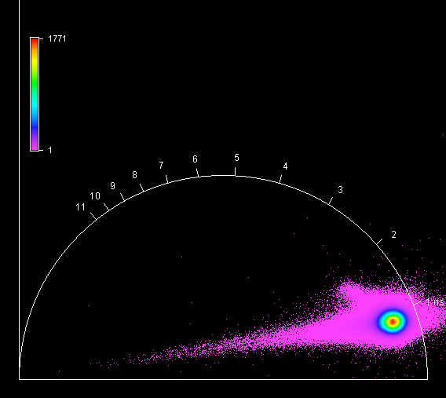

**Unknown, S099, F1, M2, AI**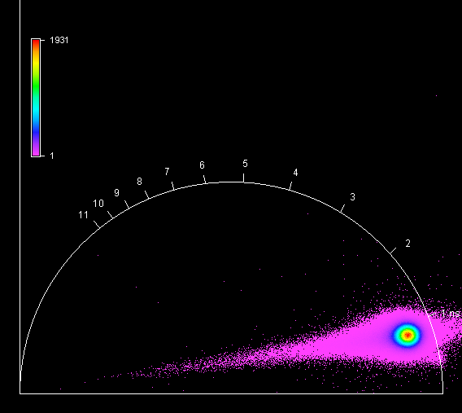

**Unknown, S099, F1, M3, AI**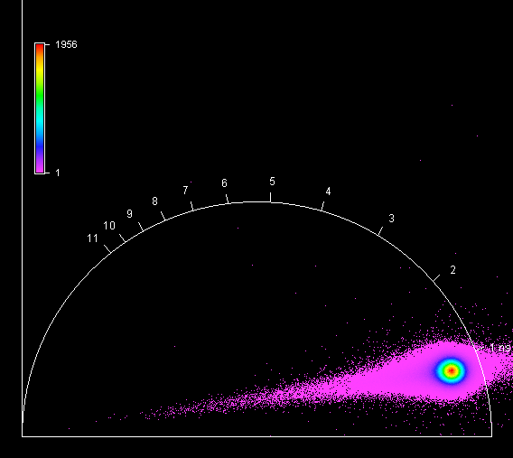

**Unknown, S099, F1, M4, AI**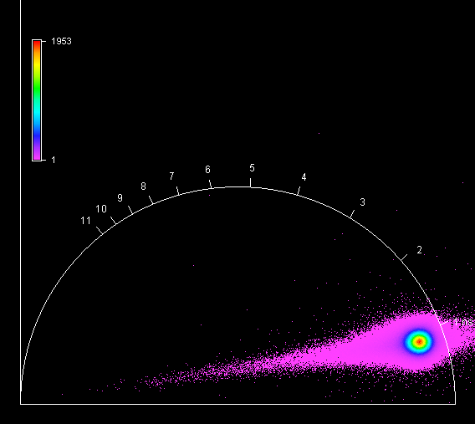

**Unknown, S100, F1, M1, AII**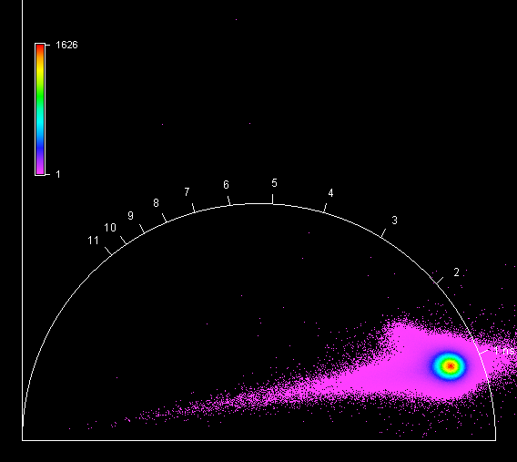

**Unknown, S100, F1, M2, AII**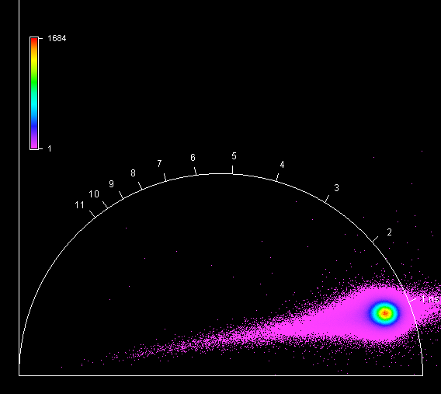

**Unknown, S100, F1, M3, AII**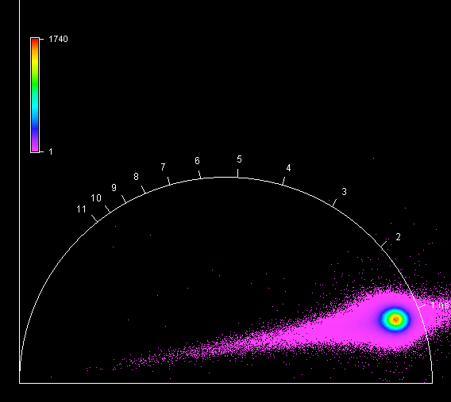

**Unknown, S100, F1, M4, AII**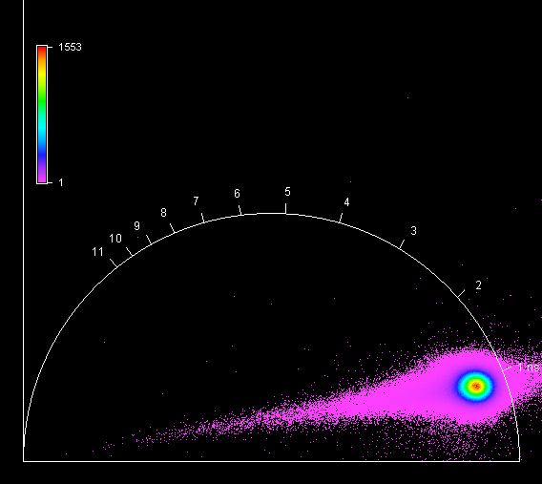

**Unknown, S101, F1, M1, AII** 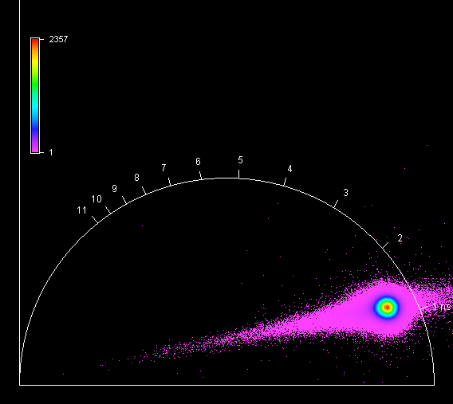

**Unknown, S101, F1, M2, AII** 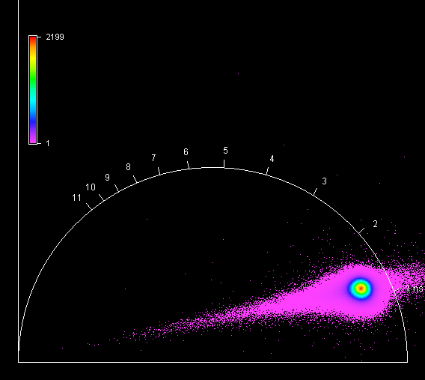

**Unknown, S101, F1, M3, AII** 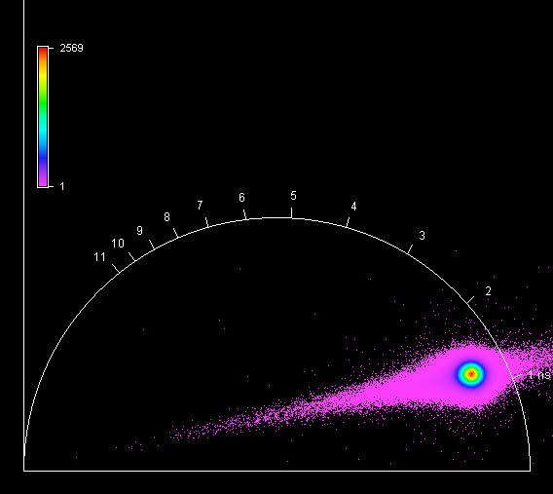

**Unknown, S101, F1, M4, AII** 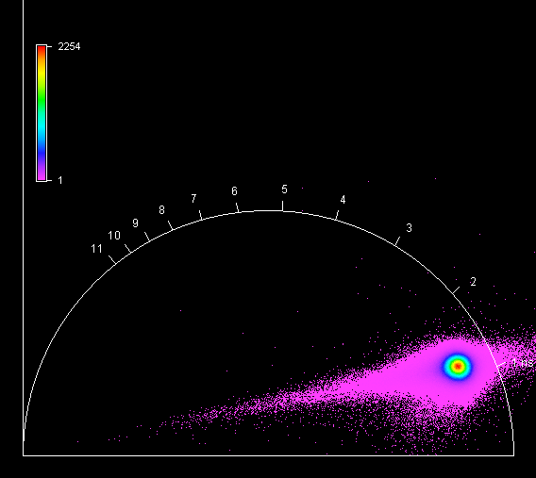

**Unknown, S102, F1, M1, AII** 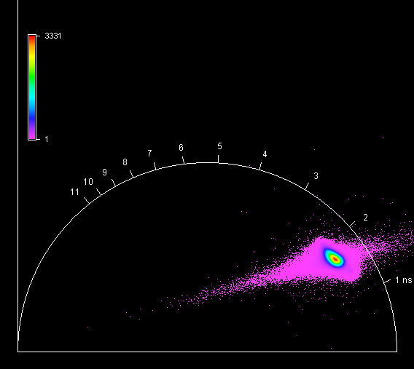

**Unknown, S102, F1, M2, AII** 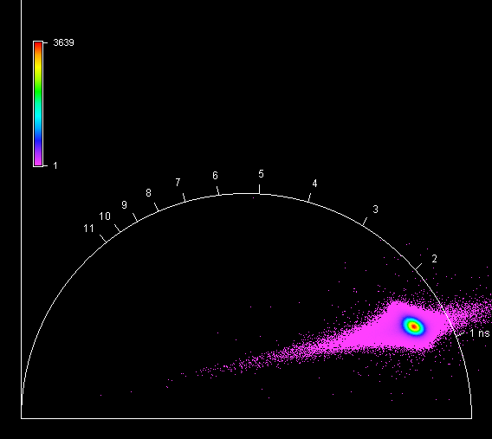

**Unknown, S102, F1, M3, AII** 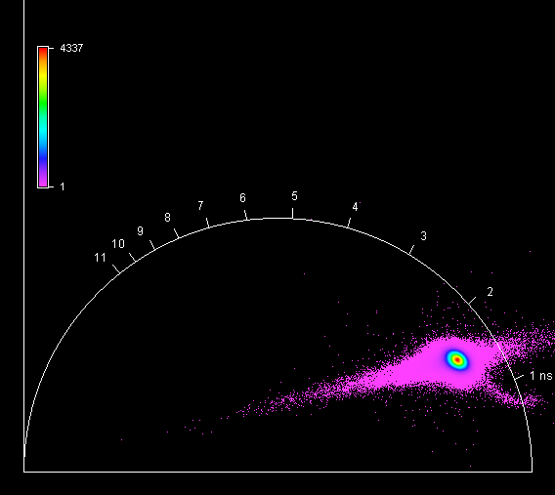

**Unknown, S102, F1, M4, AII** 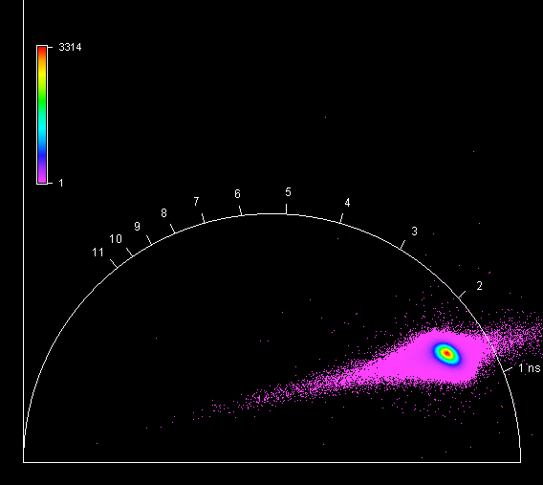

**Unknown, S103, F1, M1, AII** 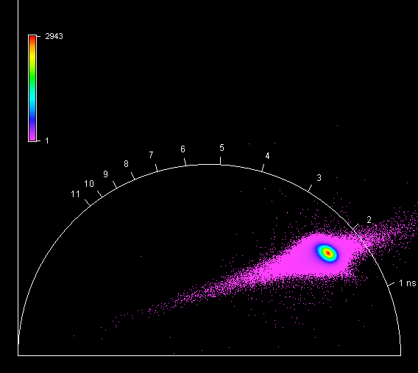

**Unknown, S103, F1, M2, AII** 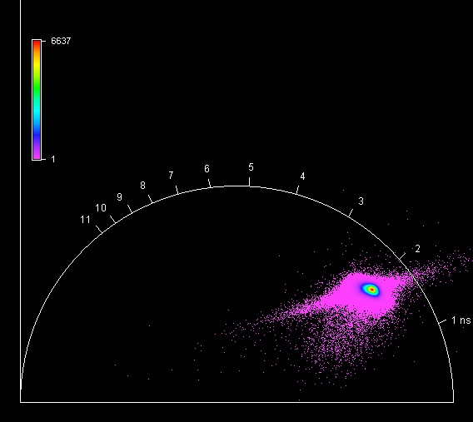

**Unknown, S103, F1, M3, AII** 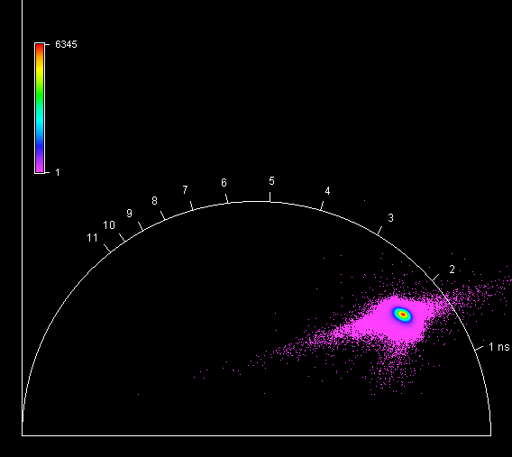

**Unknown, S103, F1, M4, AII** 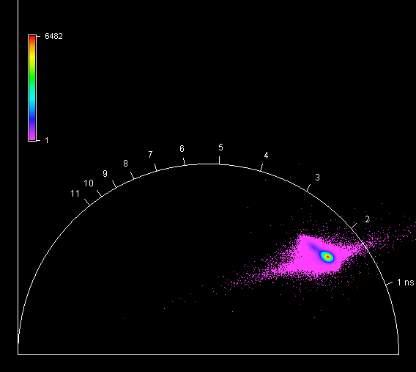

**Unknown, S104, F1, M1, AIII** 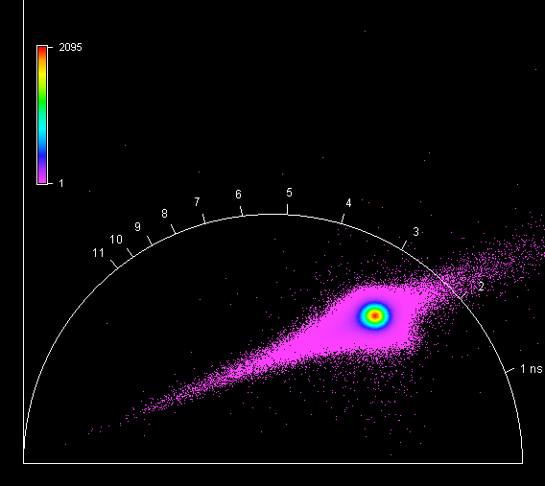

**Unknown, S104, F1, M2, AIII** 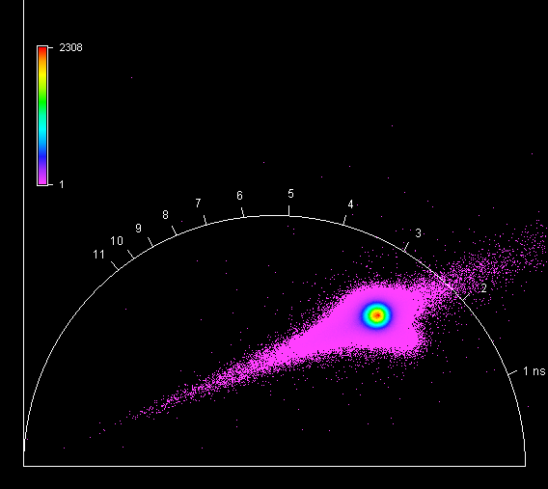

**Unknown, S104, F1, M3, AIII** 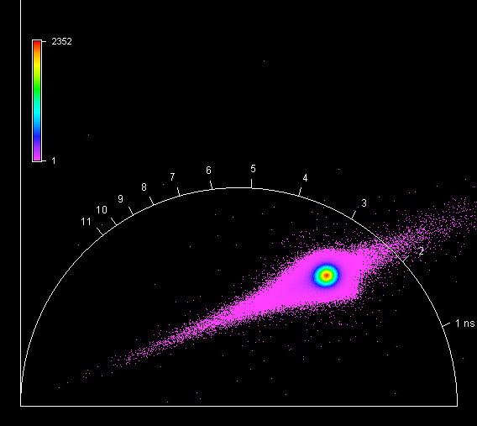

**Unknown, S104, F1, M4, AIII** 