**Unknown, S105, F1, M1, AII** 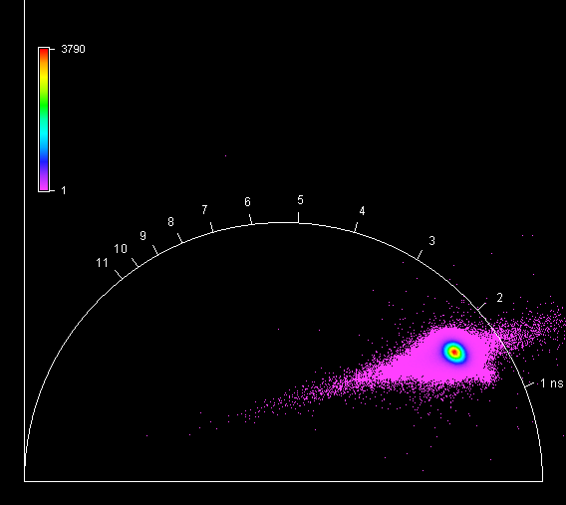

**Unknown, S105, F1, M2, AII** 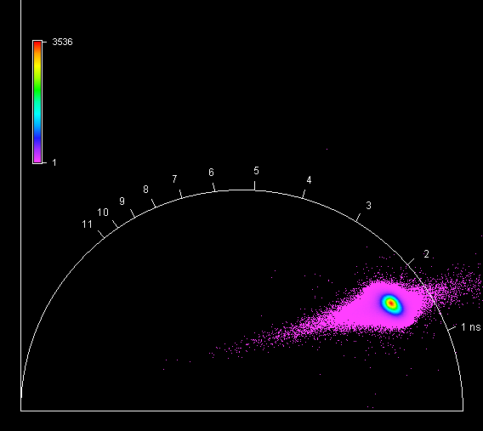

**Unknown, S105, F1, M3, AII** 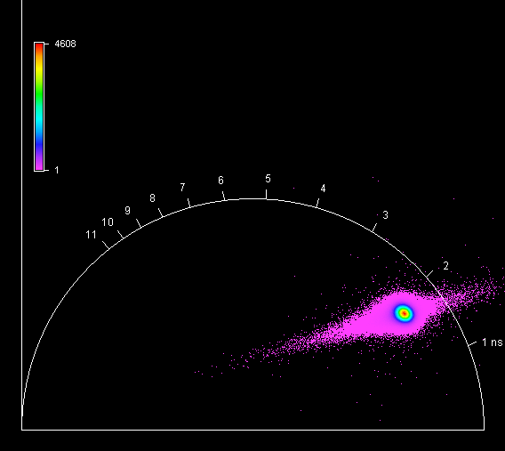

**Unknown, S105, F1, M4, AII** 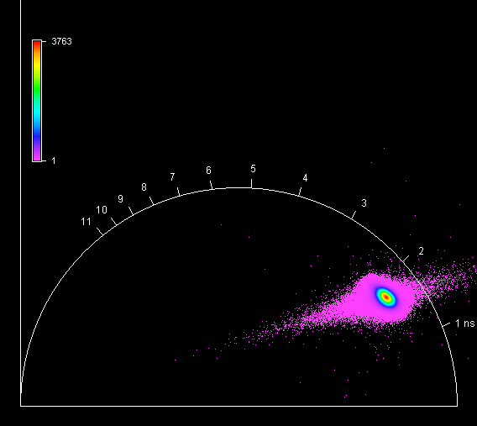

**Unknown, S106, F1, M1, AII** 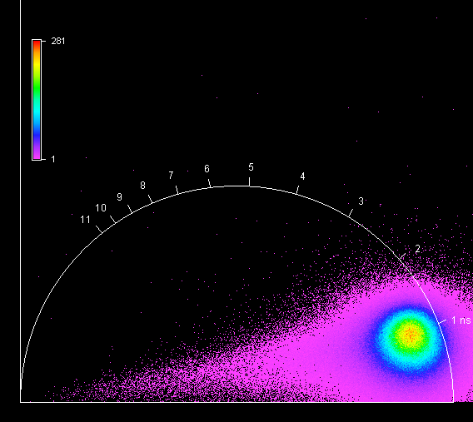

**Unknown, S106, F1, M2, AII** 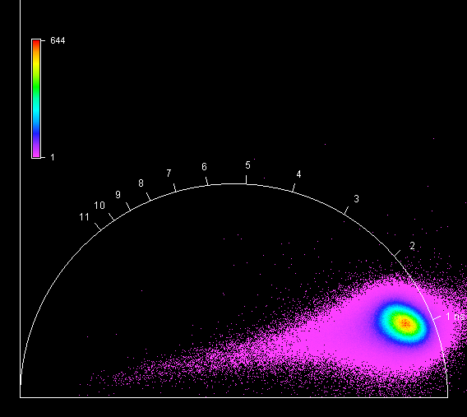

**Unknown, S106, F1, M3, AII** 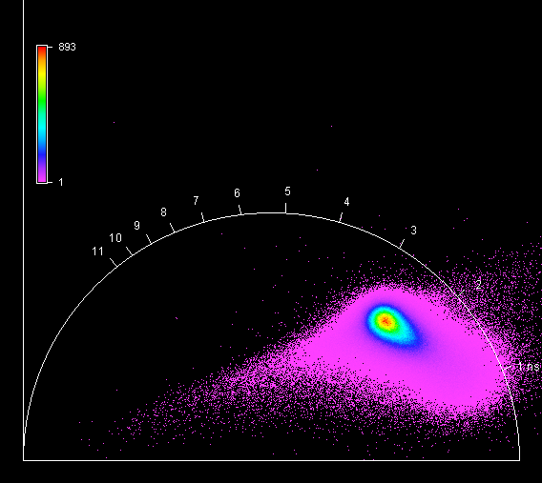

**Unknown, S106, F1, M4, AII** 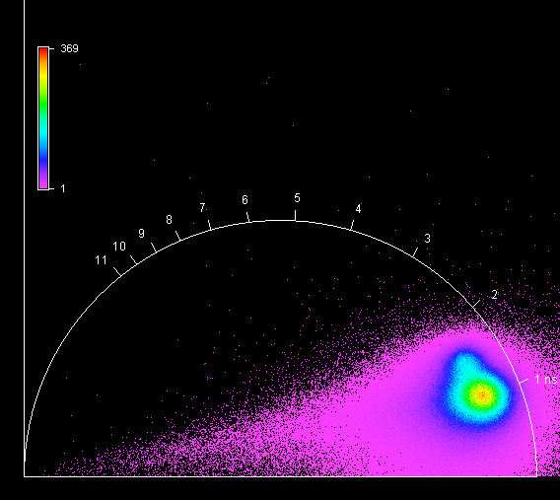

**Unknown, S107, F1, M1, AII** 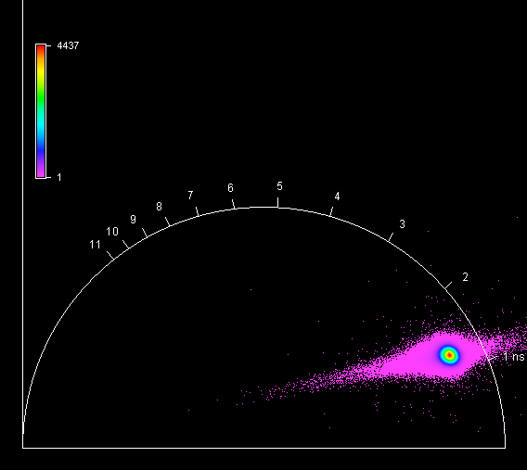

**Unknown, S107, F1, M2, AII** 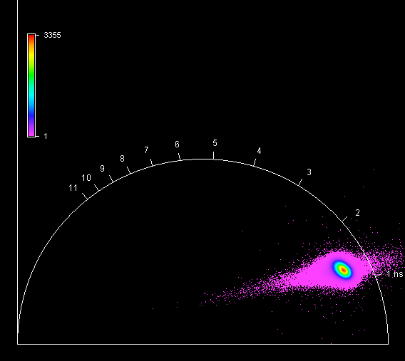

**Unknown, S107, F1, M3, AII** 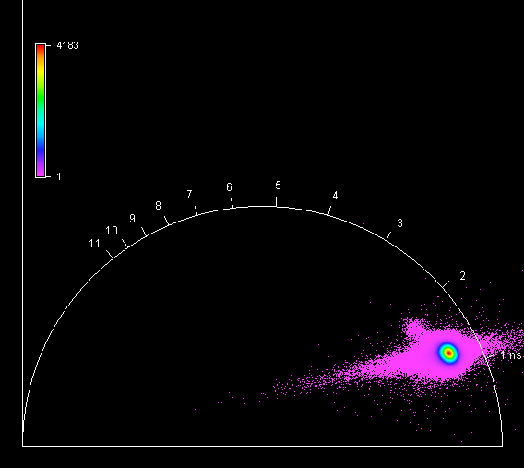

**Unknown, S107, F1, M4, AII** 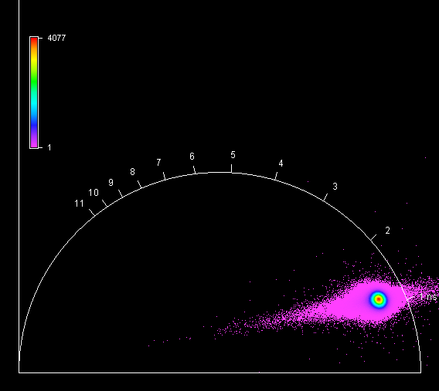

**Unknown, S108, F1, M1, AIII** 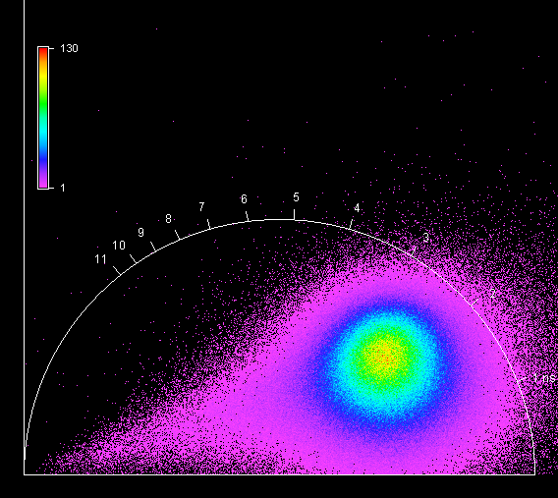

**Unknown, S108, F1, M2, AIII** 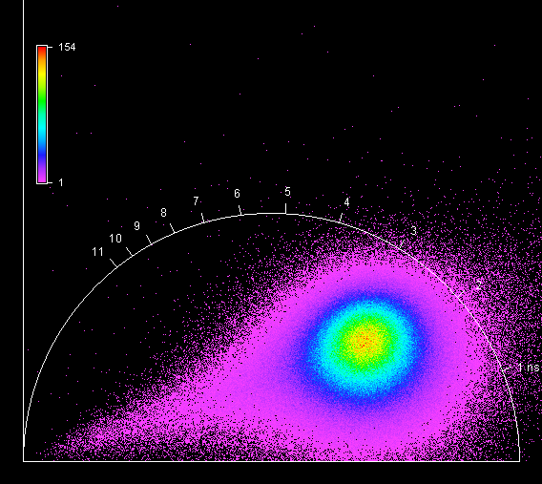

**Unknown, S108, F1, M3, AIII** 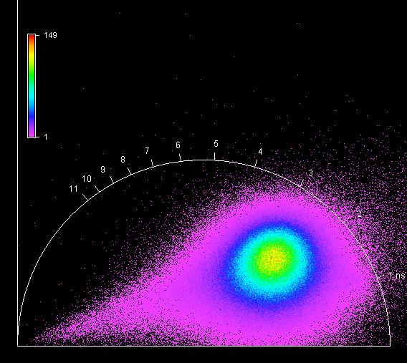

**Unknown, S108, F1, M4, AIII** 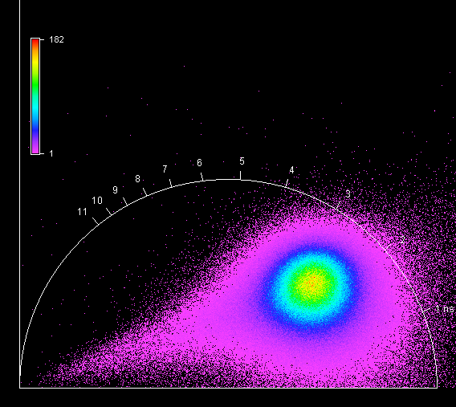

**Unknown, S109, F1, M1, AIV** 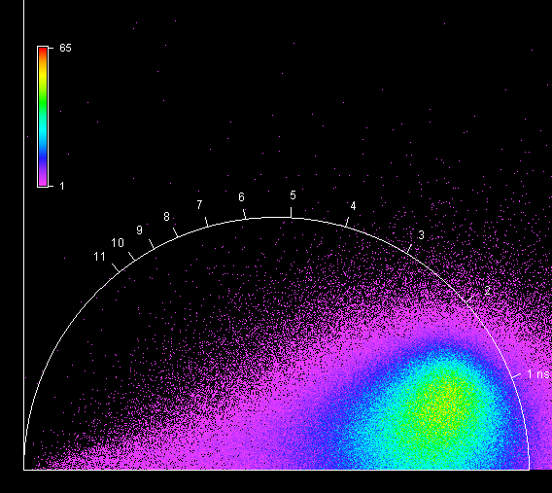

**Unknown, S109, F1, M2, AIV** 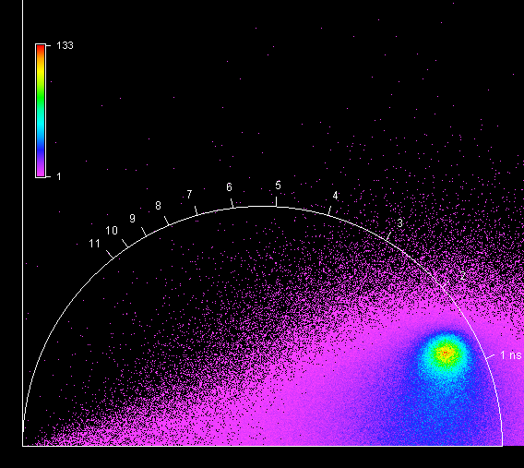

**Unknown, S109, F1, M3, AIV** 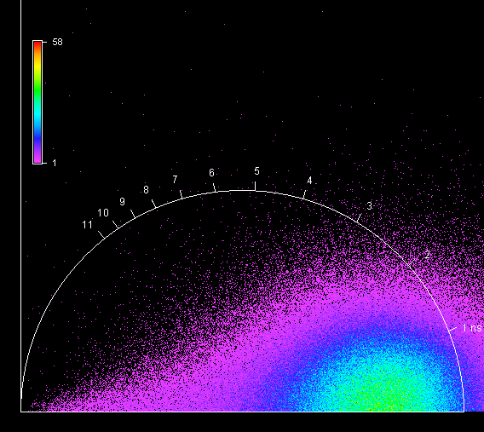

**Unknown, S109, F1, M4, AIV** 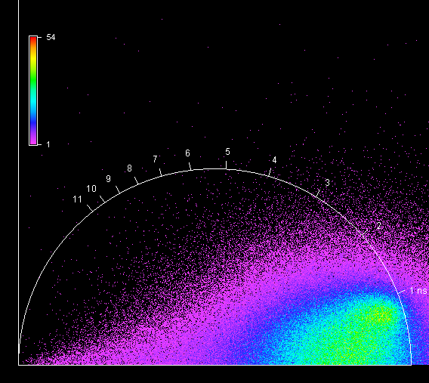

**Unknown, S110, F1, M1, AII** 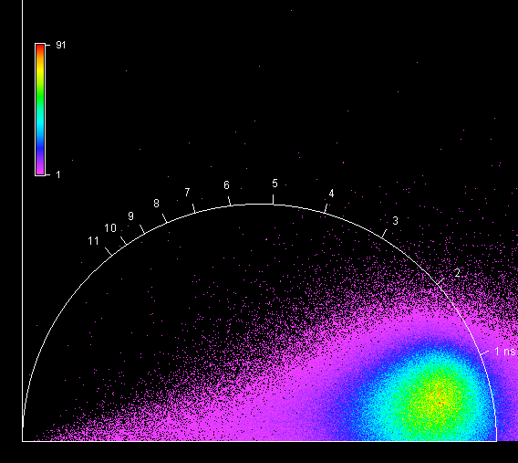

**Unknown, S110, F1, M2, AII** 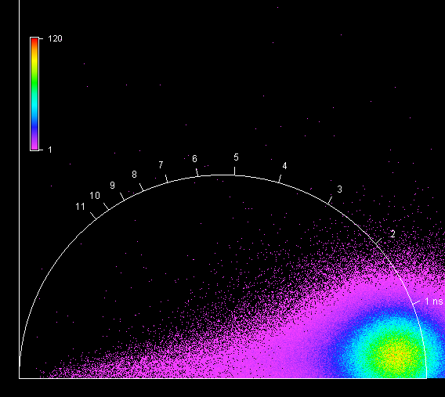

**Unknown, S110, F1, M3, AII** 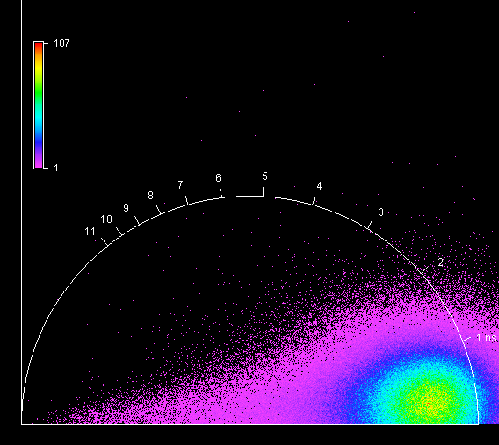

**Unknown, S110, F1, M4, AII** 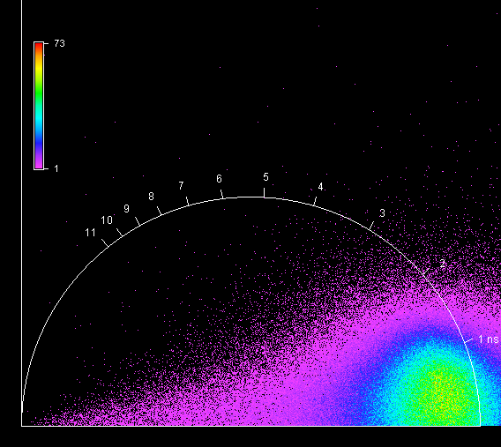

**Unknown, S111, F1, M1, AIII** 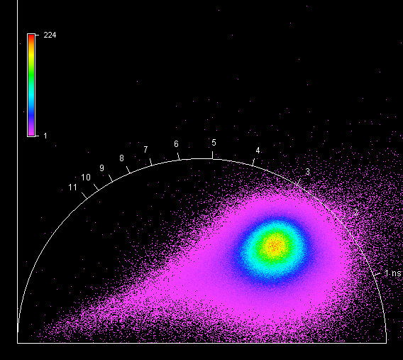

**Unknown, S111, F1, M2, AIII** 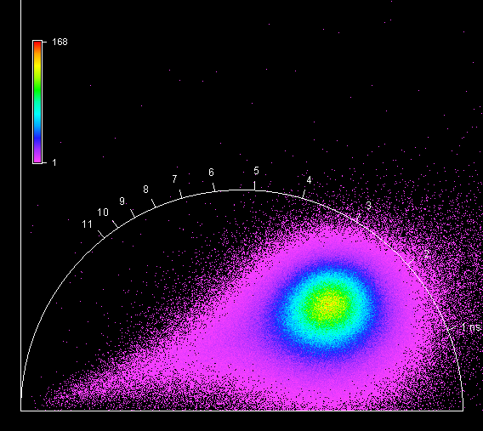

**Unknown, S111, F1, M3, AIII** 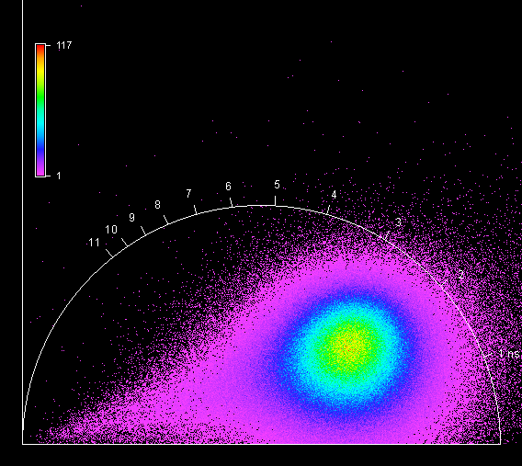

**Unknown, S111, F1, M4, AIII** 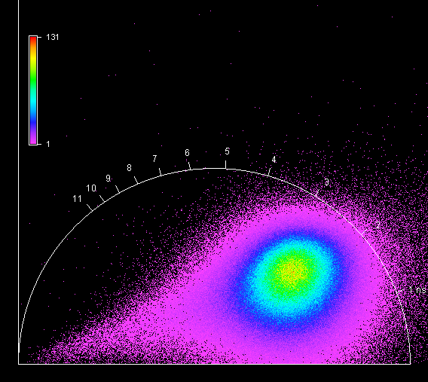

**Unknown, S112, F1, M1, AII** 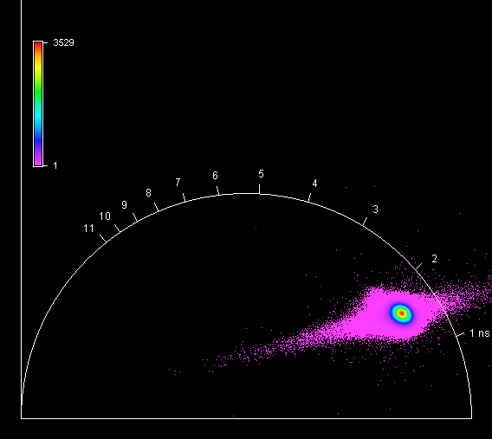

**Unknown, S112, F1, M2, AII** 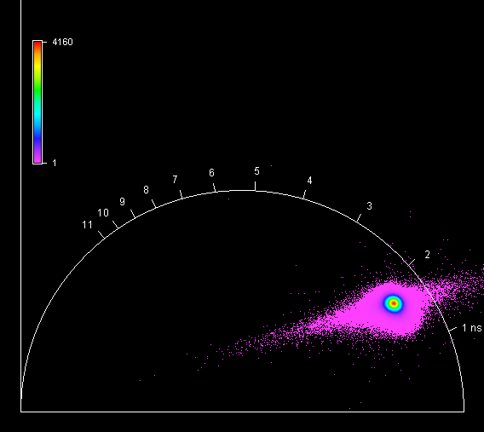

**Unknown, S112, F1, M3, AII** 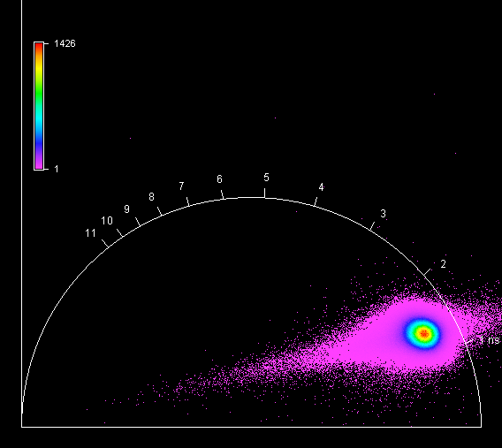

**Unknown, S112, F1, M4, AII** 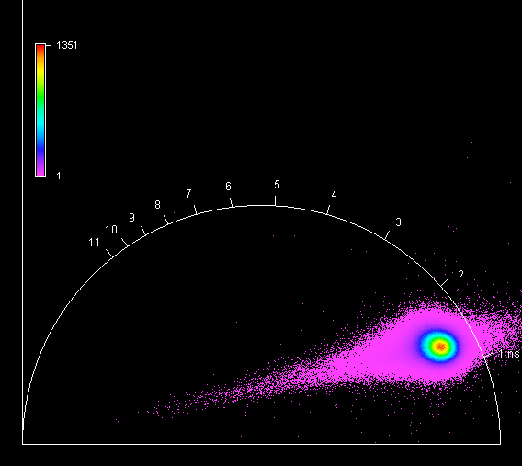

**Unknown, S113, F1, M1, AII** 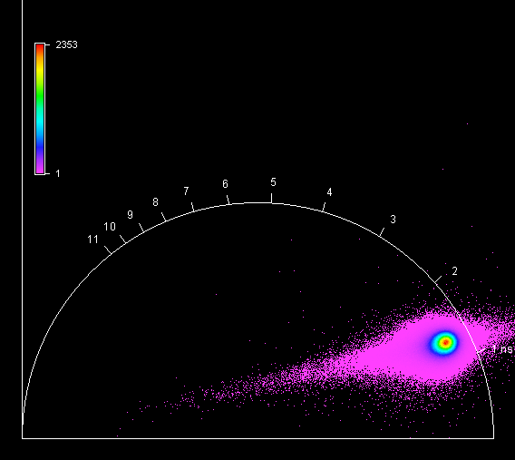

**Unknown, S113, F1, M2, AII** 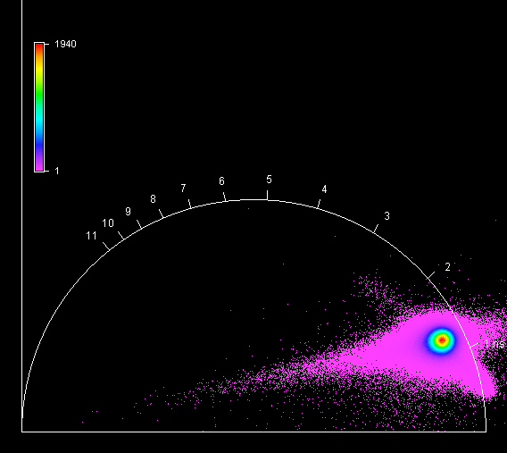

**Unknown, S113, F1, M3, AII** 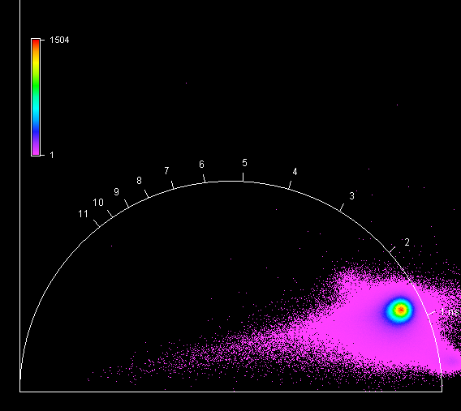

**Unknown, S113, F1, M4, AII** 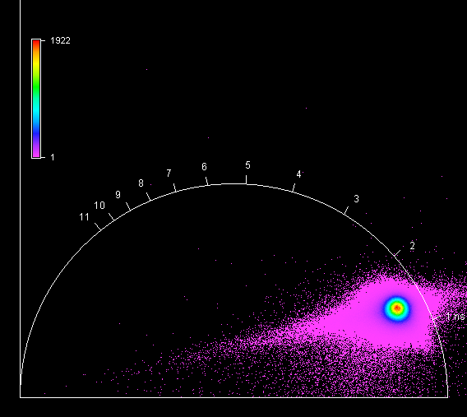

**Unknown, S114, F1, M1, AII** 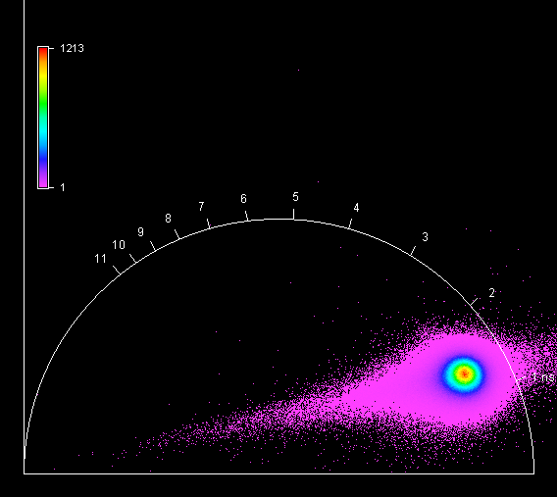

**Unknown, S114, F1, M2, AII** 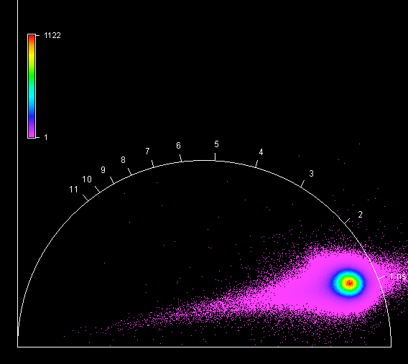

**Unknown, S114, F1, M3, AII** 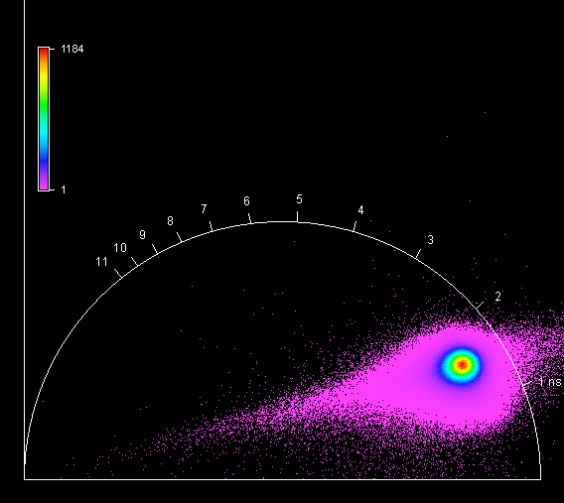

**Unknown, S114, F1, M4, AII** 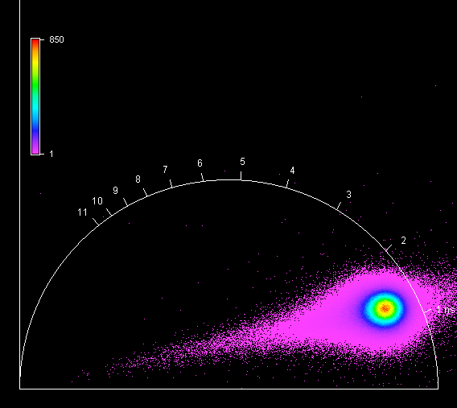

**Unknown, S115, F1, M1, AII** 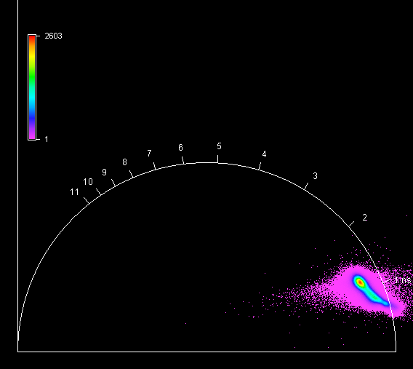

**Unknown, S115, F1, M2, AII** 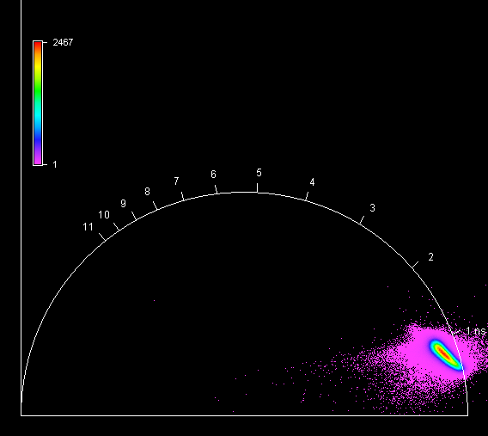

**Unknown, S115, F1, M3, AII** 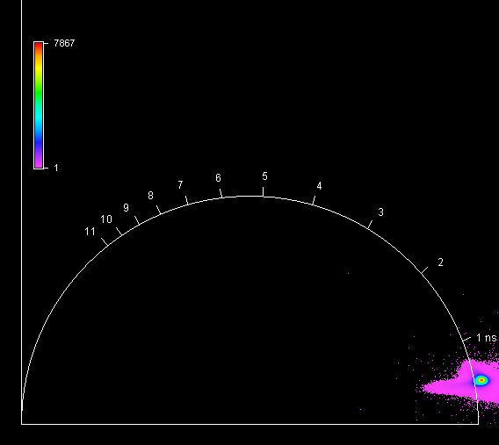

**Unknown, S115, F1, M4, AII** 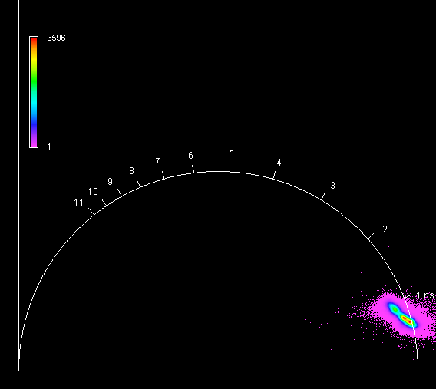

**Unknown, S116, F1, M1, AI** 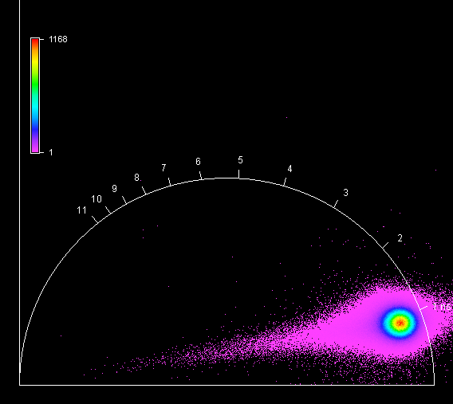

**Unknown, S116, F1, M2, AI** 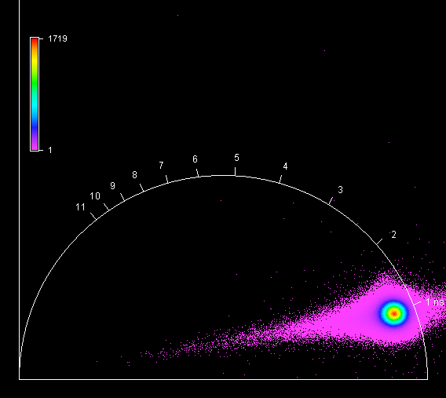

**Unknown, S116, F1, M3, AI** 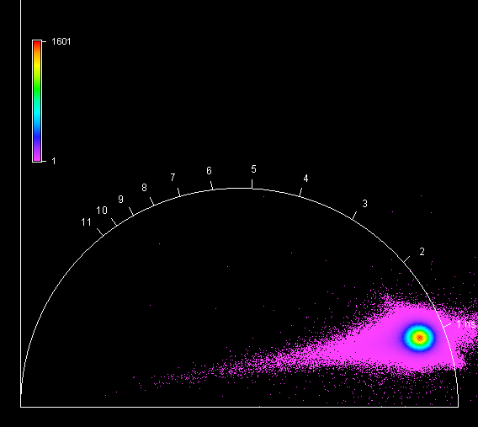

**Unknown, S116, F1, M4, AI** 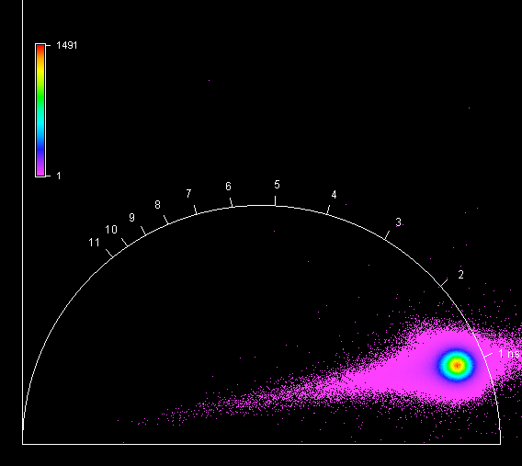

**Unknown, S117, F1, M1, AII** 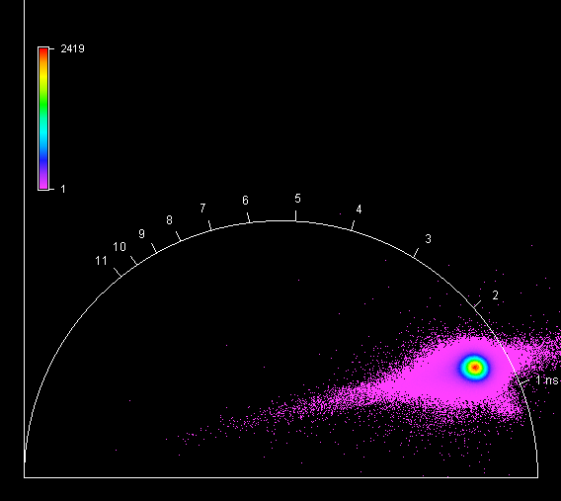

**Unknown, S117, F1, M2, AII** 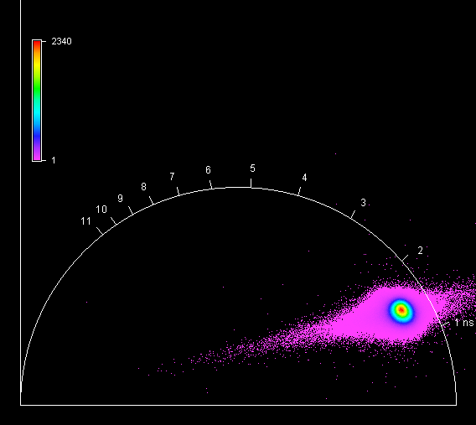

**Unknown, S117, F1, M3, AII** 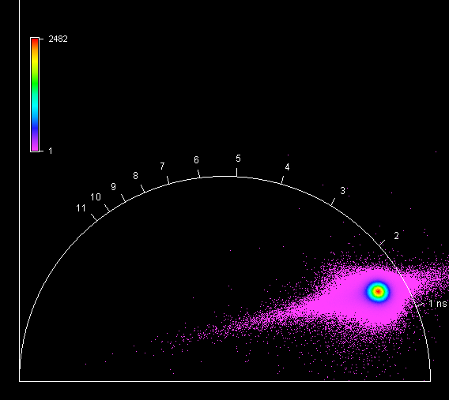

**Unknown, S117, F1, M4, AII** 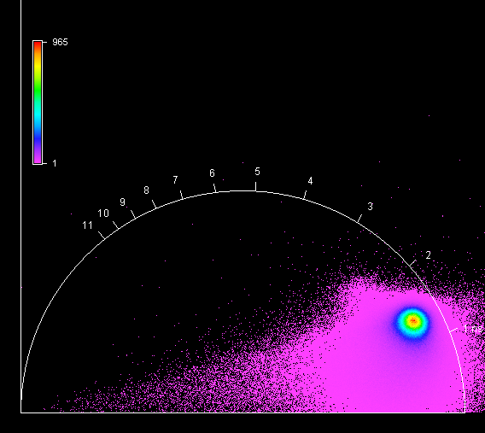

**Unknown, S118, F1, M1, AI** 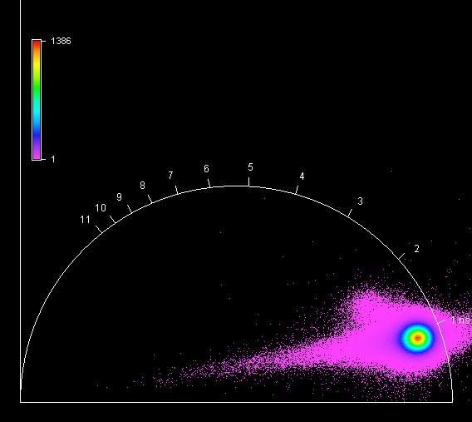

**Unknown, S118, F1, M2, AI** 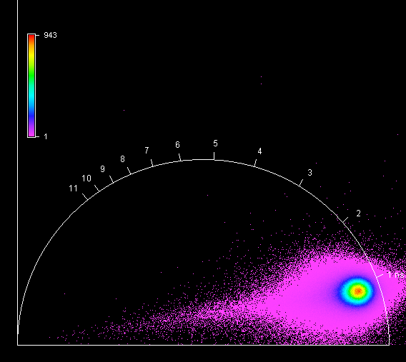

**Unknown, S118, F1, M3, AI** 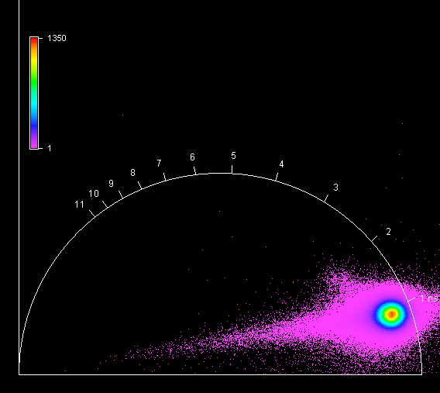

**Unknown, S118, F1, M4, AI** 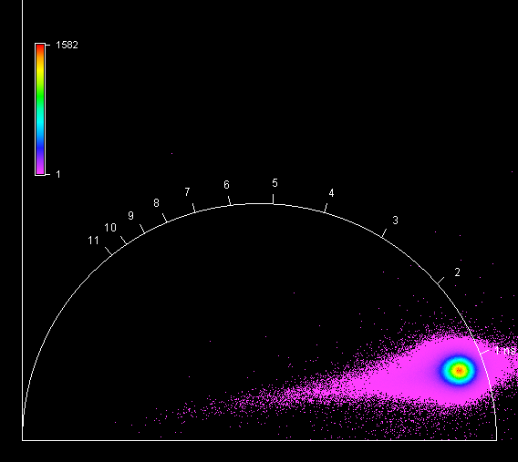

**Unknown, S119, F1, M1, AIV** 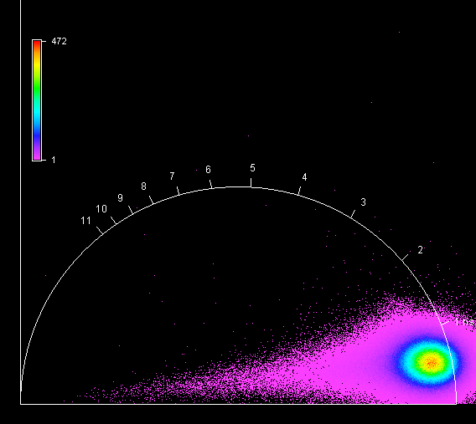

**Unknown, S119, F1, M2, AIV** 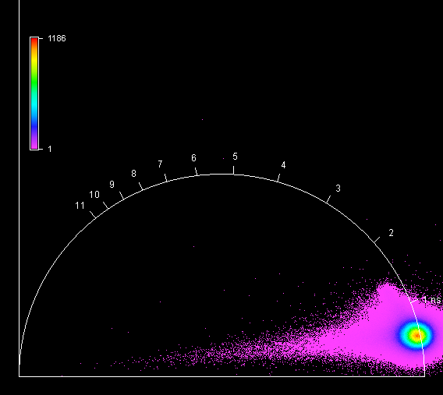

**Unknown, S119, F1, M3, AIV** 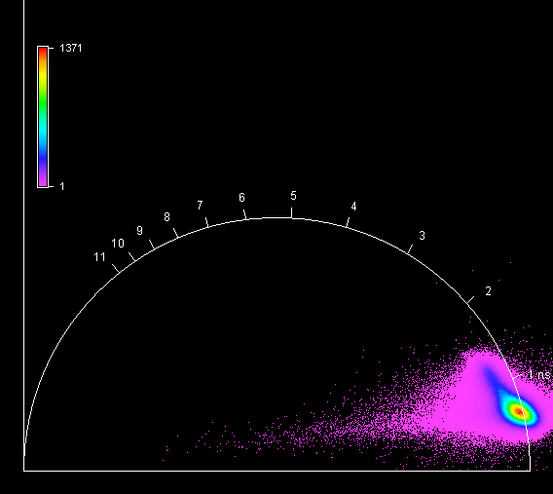

**Unknown, S119, F1, M4, AIV** 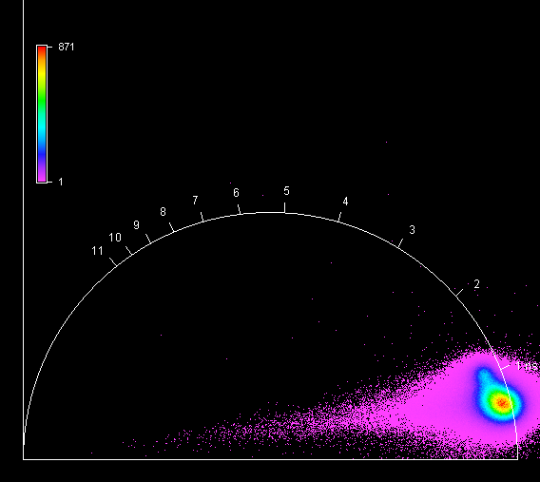

**Unknown, S120, F1, M1, AI** 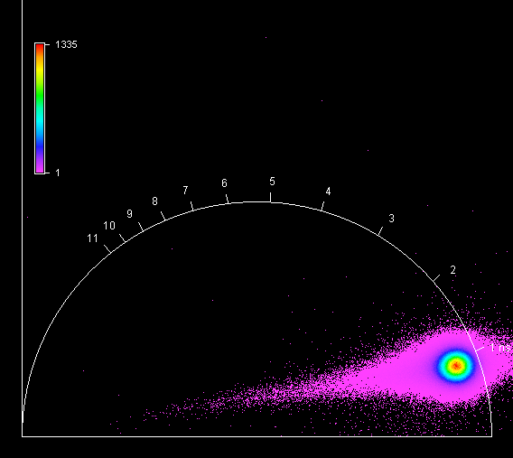

**Unknown, S120, F1, M2, AI** 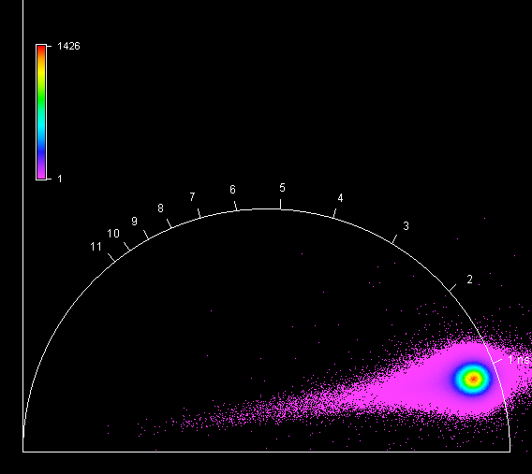

**Unknown, S120, F1, M3, AI** 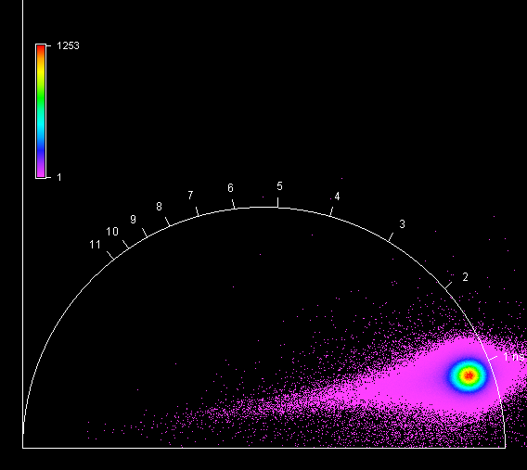

**Unknown, S120, F1, M4, AI** 