**Unknown, S121, F1, M1, AII** 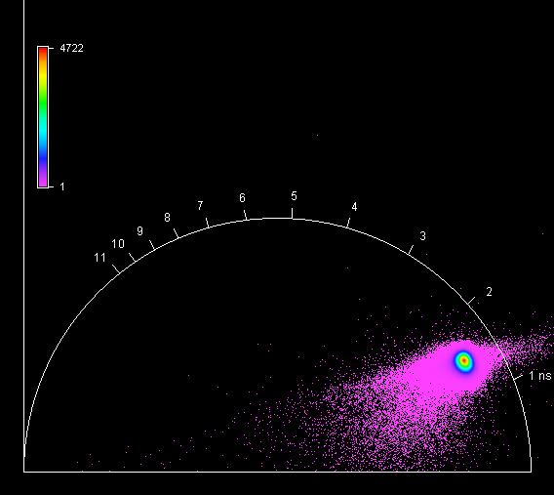

**Unknown, S121, F1, M2, AII** 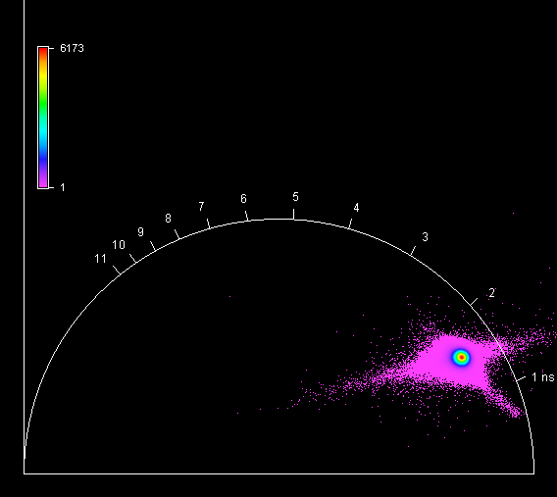

**Unknown, S121, F1, M3, AII** 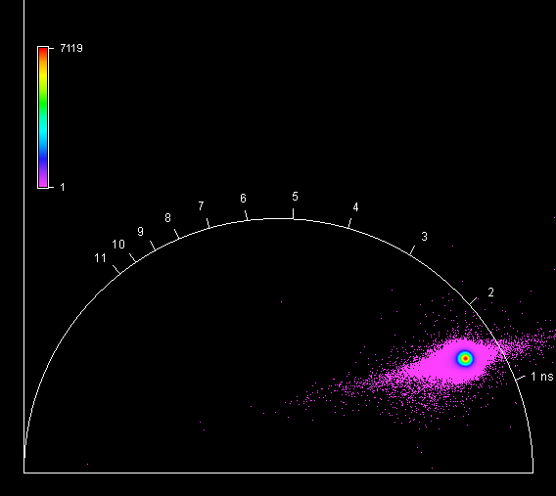

**Unknown, S121, F1, M4, AII** 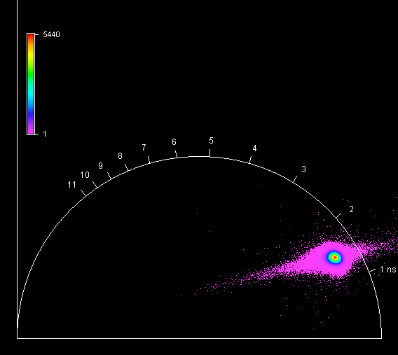

**Unknown, S122, F1, M1, AIII** 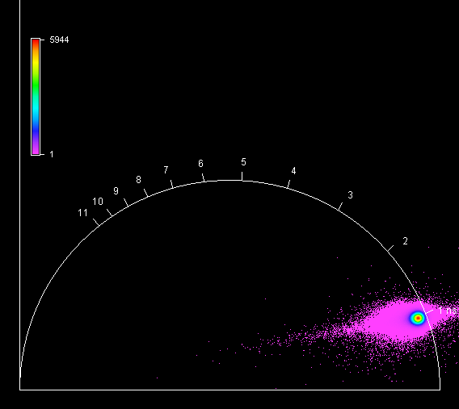

**Unknown, S122, F1, M2, AIII** 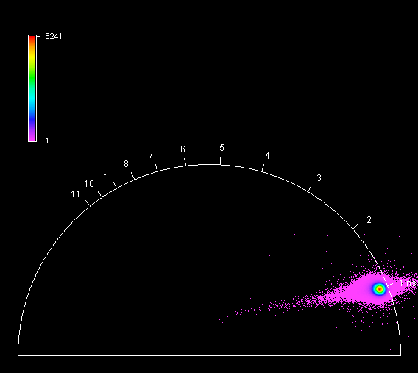

**Unknown, S122, F1, M3, AIII** 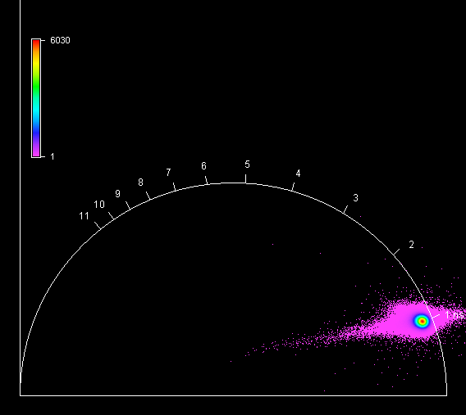

**Unknown, S122, F1, M4, AIII** 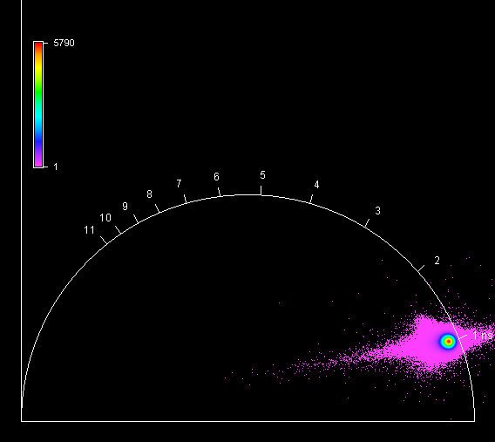

**Unknown, S123, F1, M1, AII** 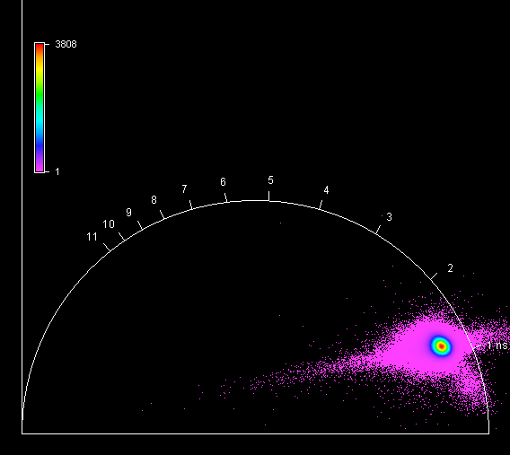

**Unknown, S123, F1, M2, AII** 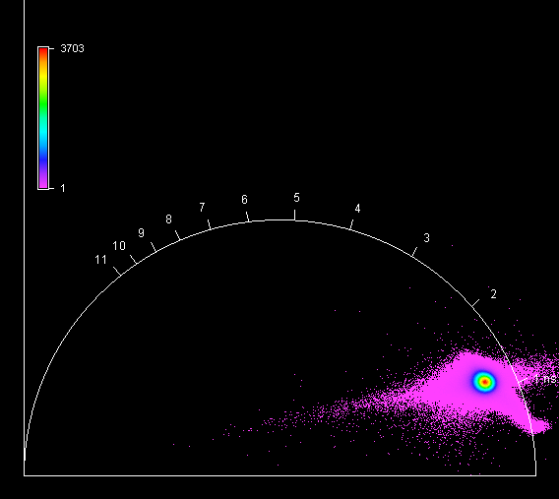

**Unknown, S123, F1, M3, AII** 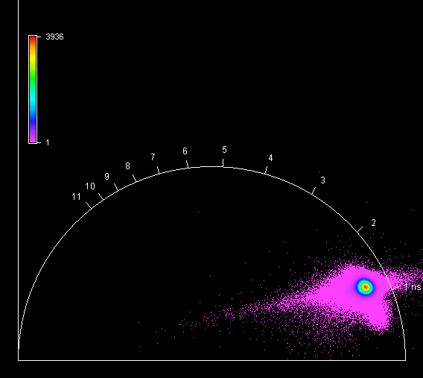

**Unknown, S123, F1, M4, AII** 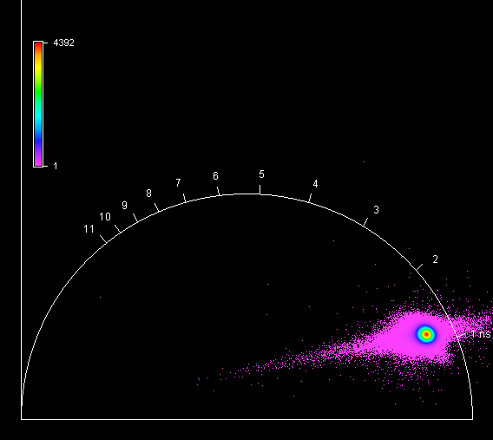

**Unknown, S124, F1, M1, AIII** 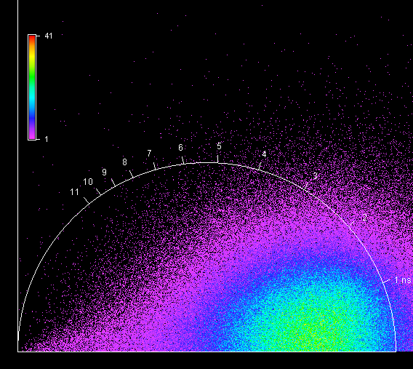

**Unknown, S124, F1, M2, AIII** 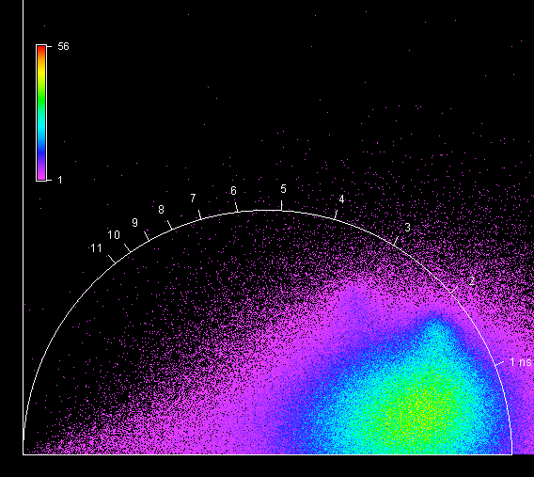

**Unknown, S124, F1, M3, AIII** 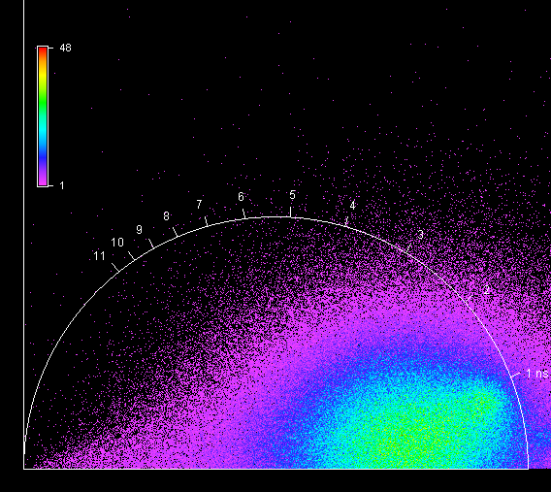

**Unknown, S124, F1, M4, AIII** 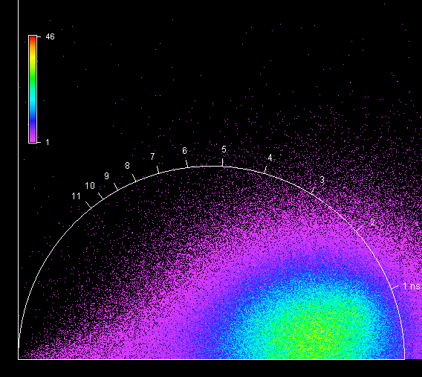

**Unknown, S125, F1, M1, AI** 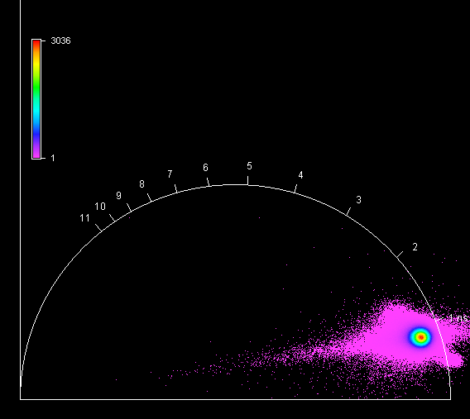

**Unknown, S125, F1, M2, AI** 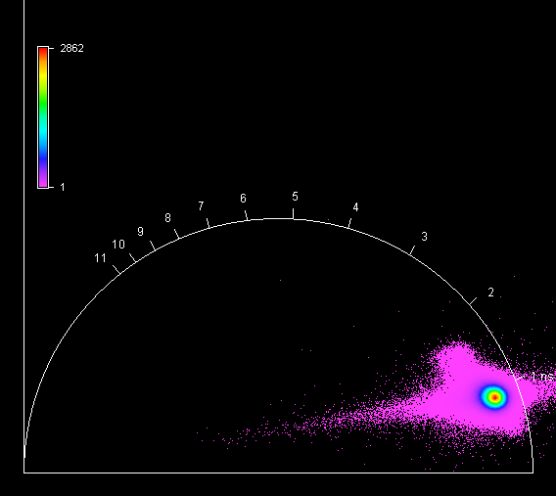

**Unknown, S125, F1, M3, AI** 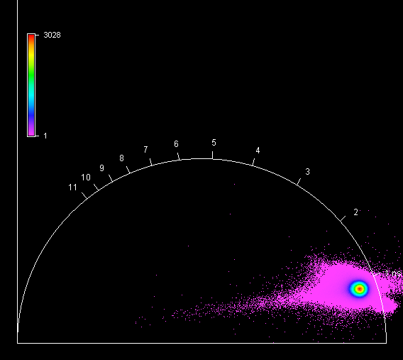

**Unknown, S125, F1, M4, AI** 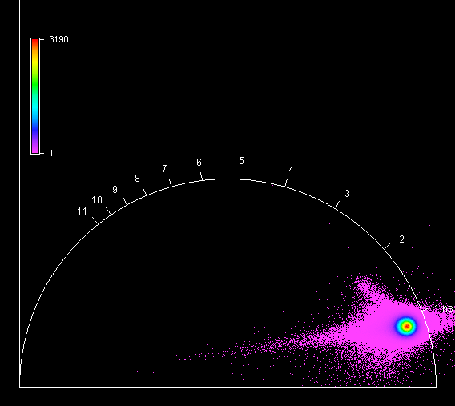

**Unknown, S126, F1, M1, AI** 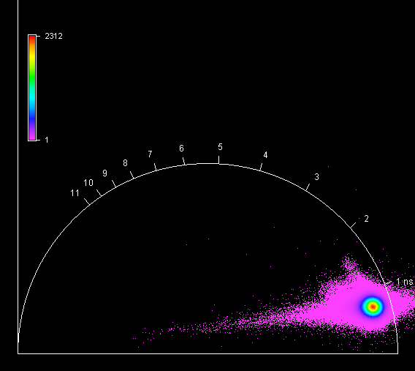

**Unknown, S126, F1, M2, AI** 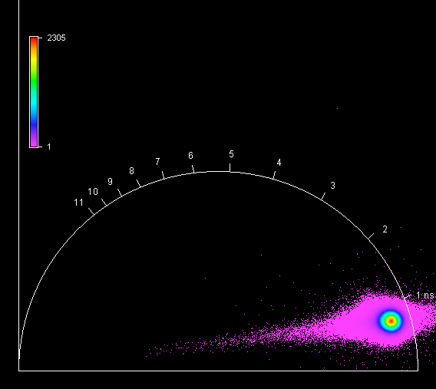

**Unknown, S126, F1, M3, AI** 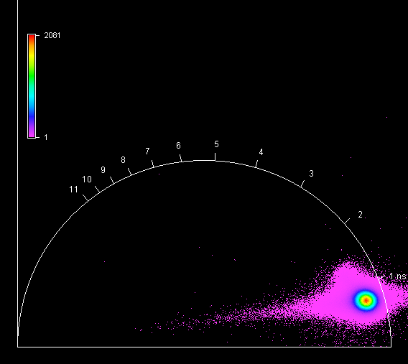

**Unknown, S126, F1, M4, AI** 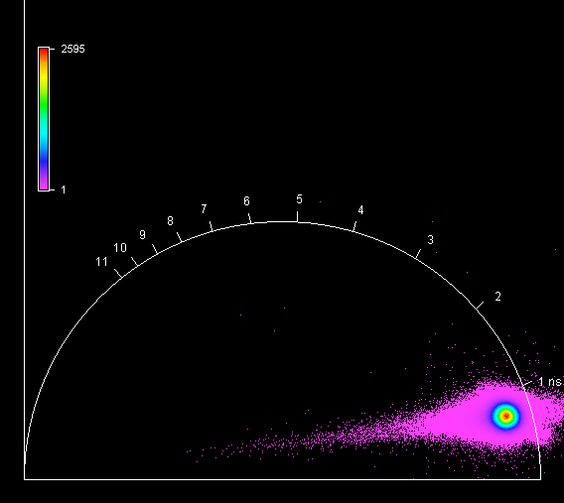

**Unknown, S127, F1, M1, AIII** 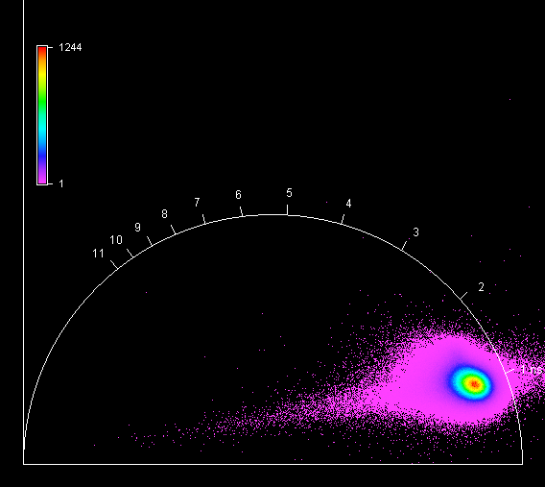

**Unknown, S127, F1, M2, AIII** 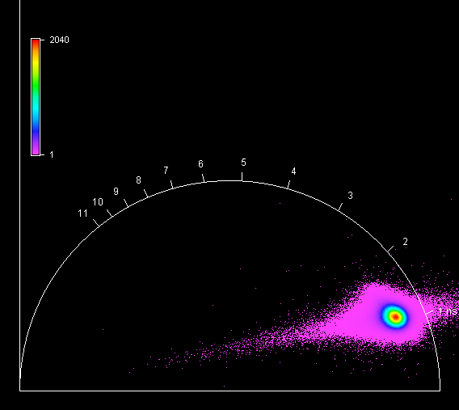

**Unknown, S127, F1, M3, AIII** 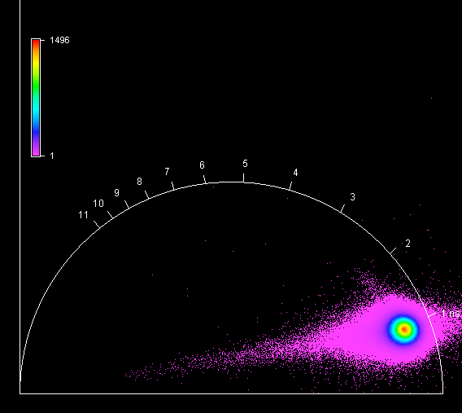

**Unknown, S127, F1, M4, AIII** 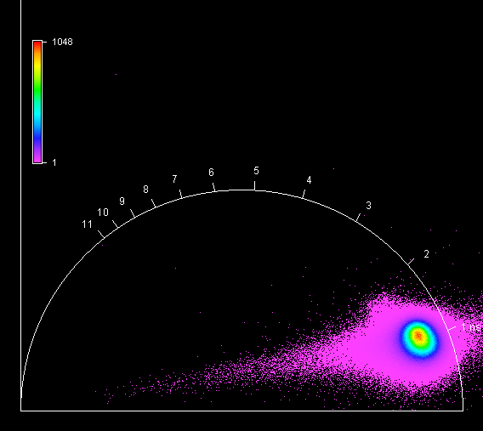

**Unknown, S128, F1, M1, AIII** 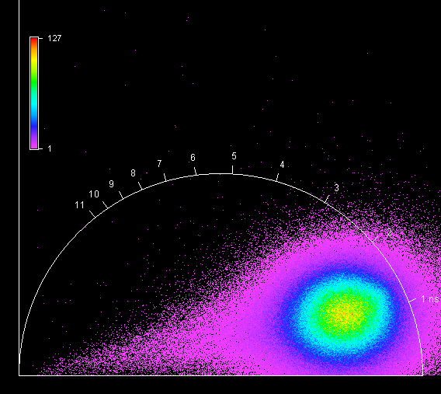

**Unknown, S128, F1, M1, AIII** 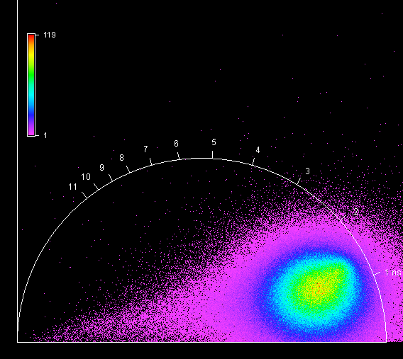

**Unknown, S128, F1, M1, AIII** 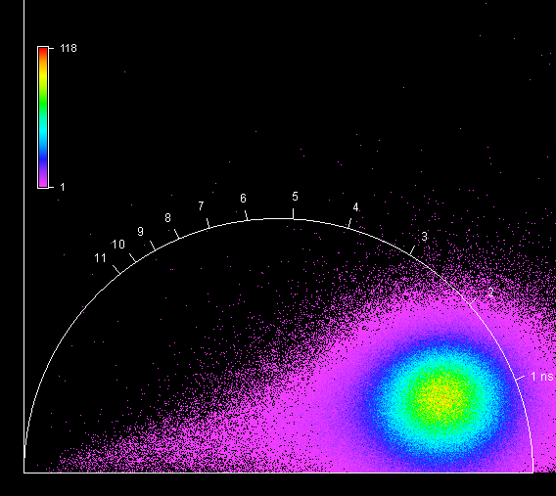

**Unknown, S128, F1, M1, AIII** 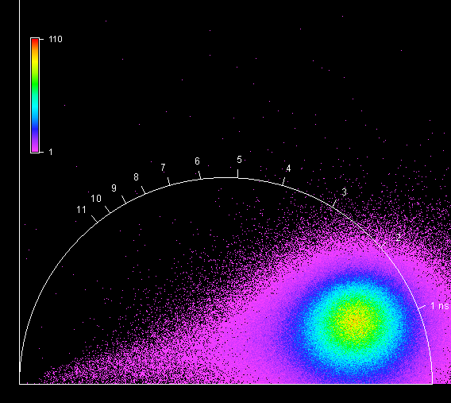

**Unknown, S129, F1, M1, AII** 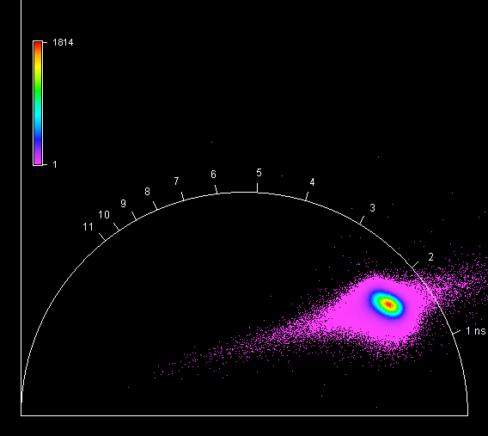

**Unknown, S129, F1, M2, AII** 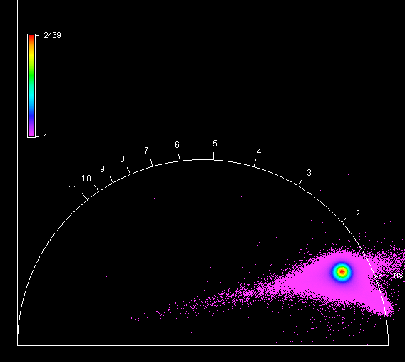

**Unknown, S129, F1, M3, AII** 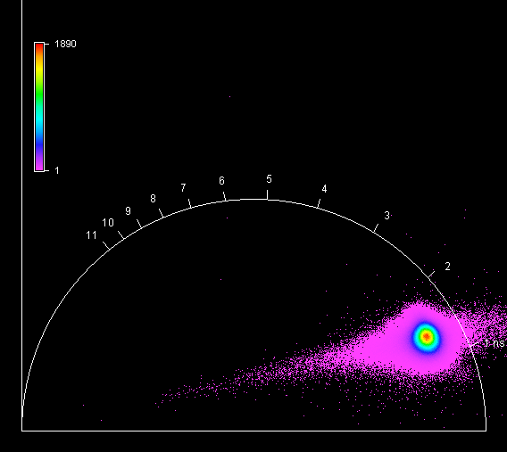

**Unknown, S129, F1, M4, AII** 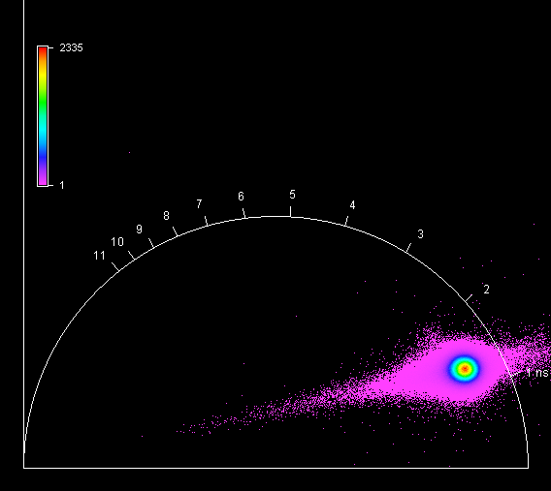

**Unknown, S130, F1, M1, AI** 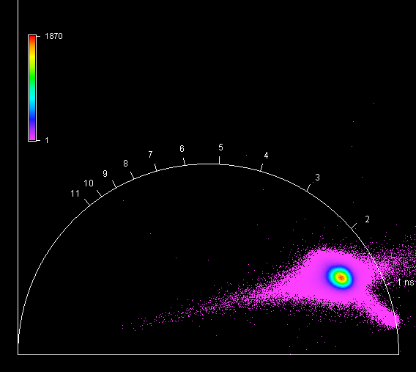

**Unknown, S130, F1, M2, AI** 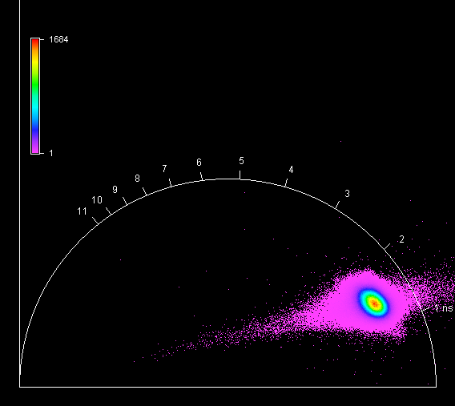

**Unknown, S130, F1, M3, AI** 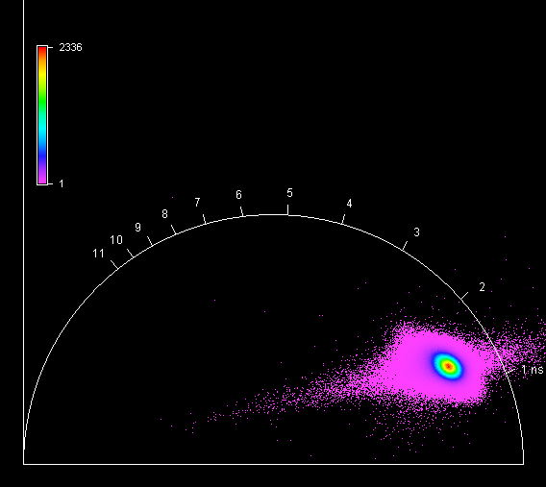

**Unknown, S130, F1, M4, AI** 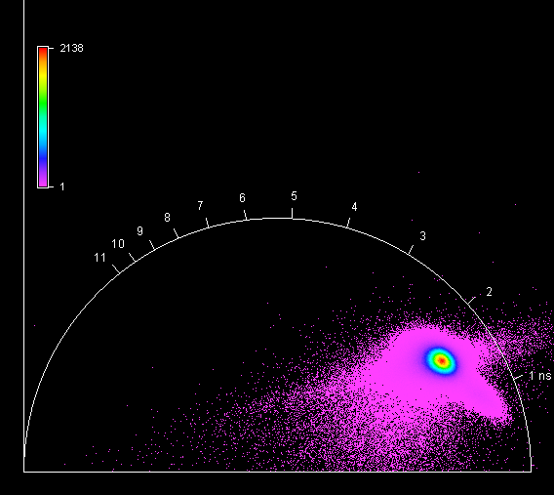

**Unknown, S131, F1, M1, AI** 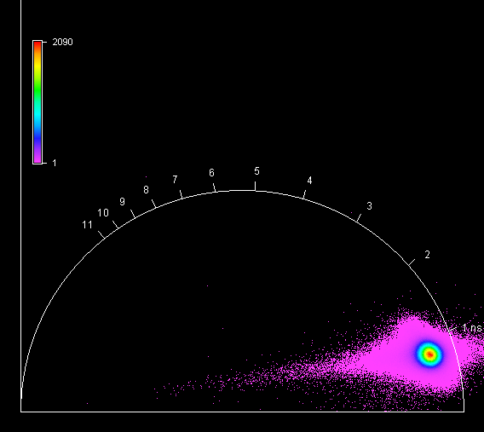

**Unknown, S131, F1, M2, AI** 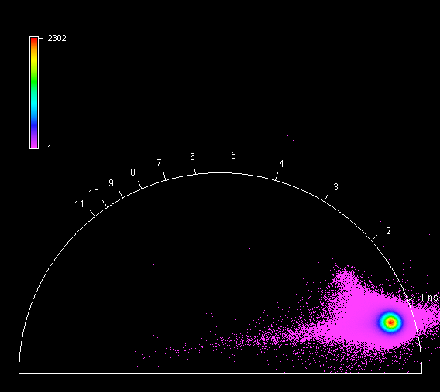

**Unknown, S131, F1, M3, AI** 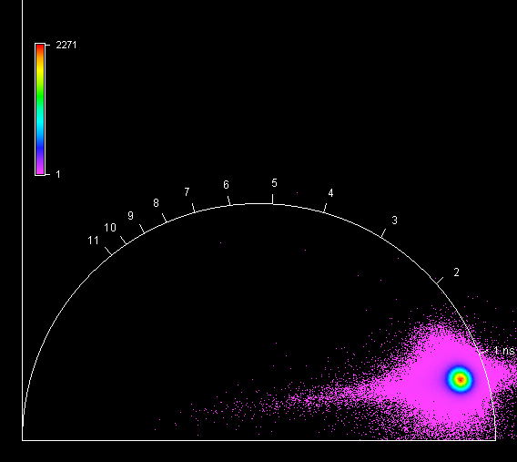

**Unknown, S131, F1, M4, AI** 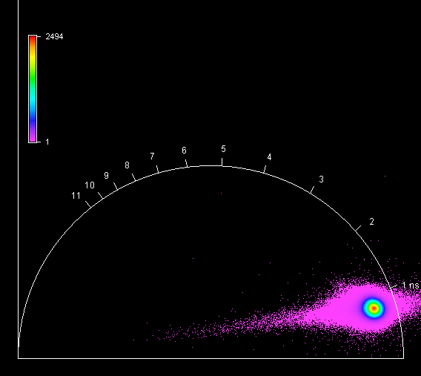

**Unknown, S132, F1, M1, AI** 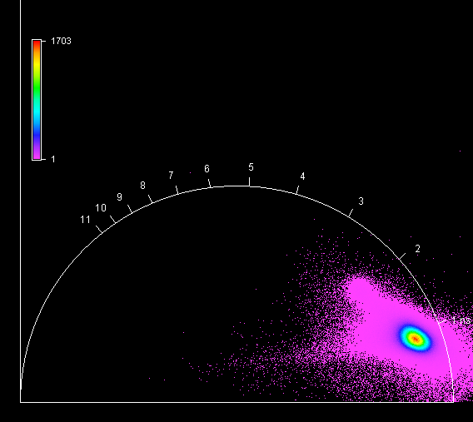

**Unknown, S132, F1, M2, AI** 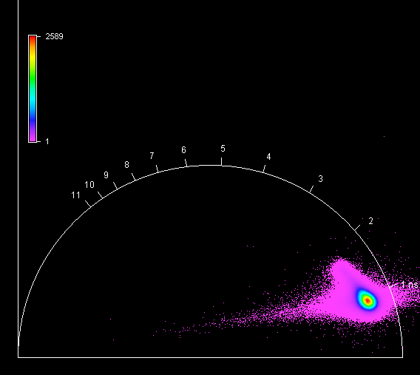

**Unknown, S132, F1, M3, AI** 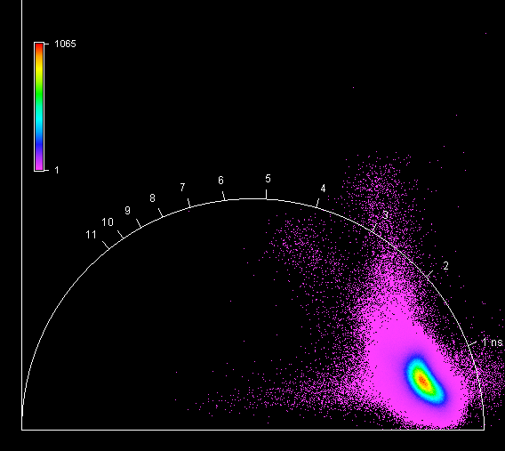

**Unknown, S132, F1, M4, AI** 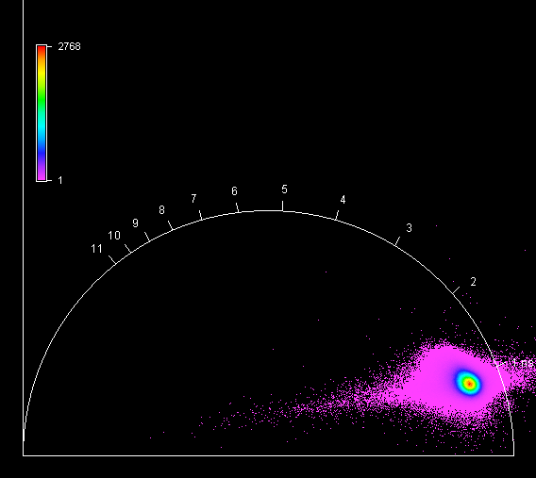

**Unknown, S133, F1, M1, AI** 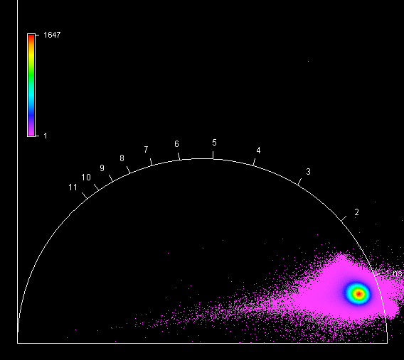

**Unknown, S133, F1, M2, AI** 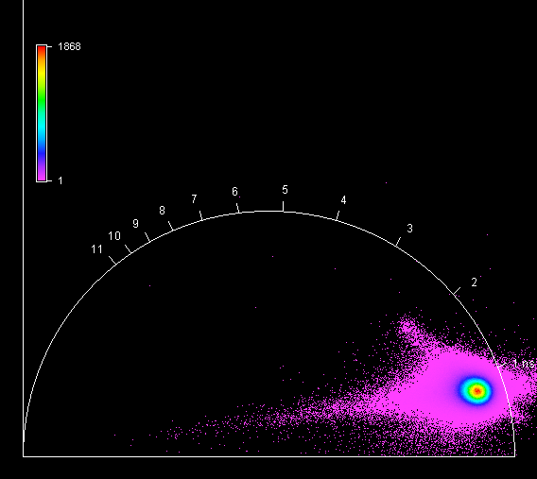

**Unknown, S133, F1, M3, AI** 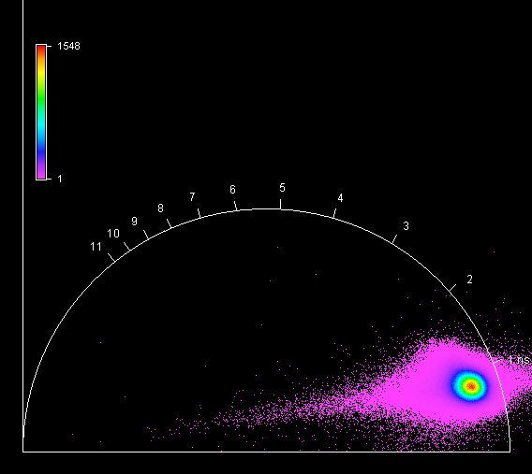

**Unknown, S133, F1, M4, AI** 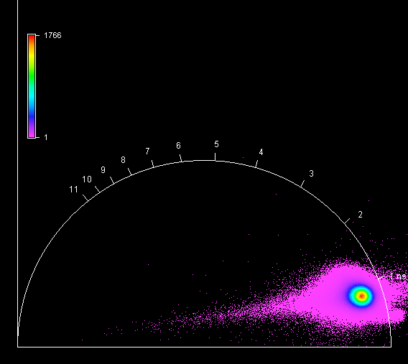

**Unknown, S134, F1, M1, AI** 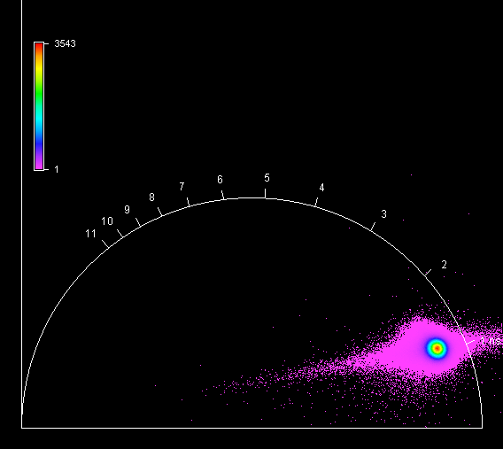

**Unknown, S134, F1, M2, AI** 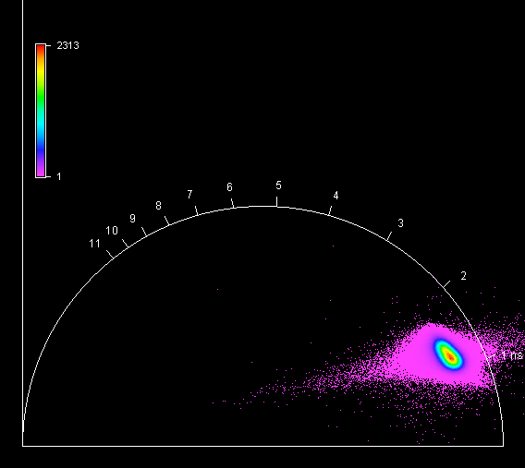

**Unknown, S134, F1, M3, AI** 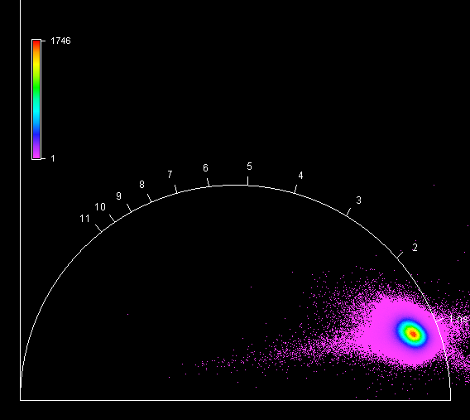

**Unknown, S134, F1, M4, AI** 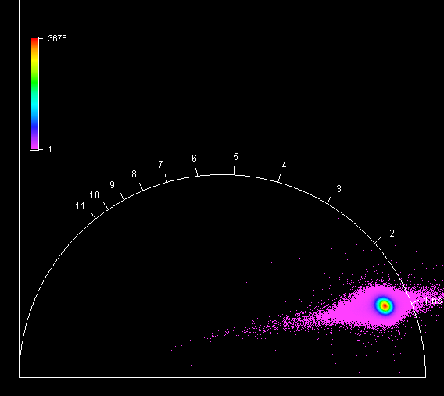

**Unknown, S135, F1, M1, AI** 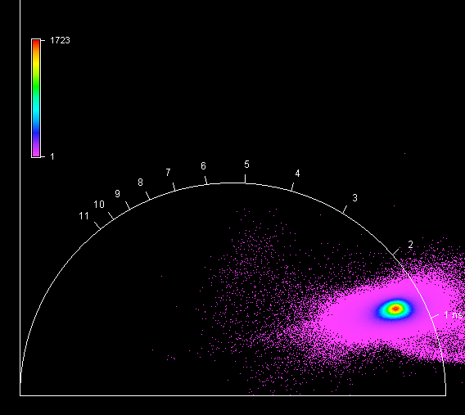

**Unknown, S135, F1, M2, AI** 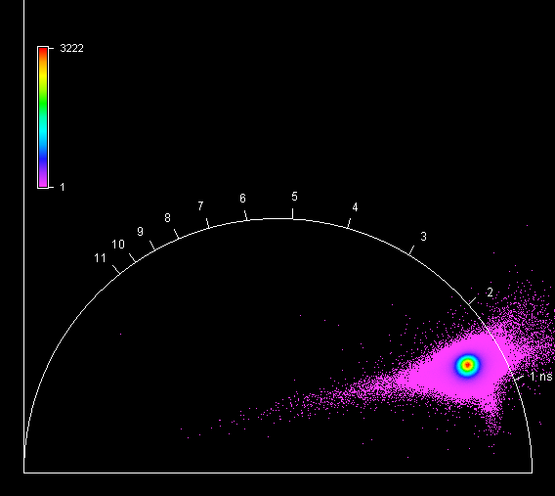

**Unknown, S135, F1, M3, AI** 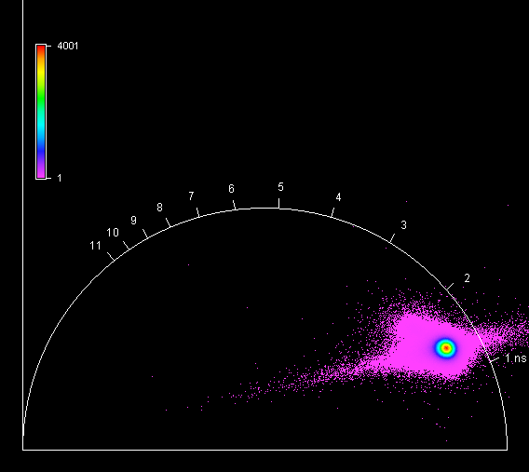

**Unknown, S135, F1, M4, AI** 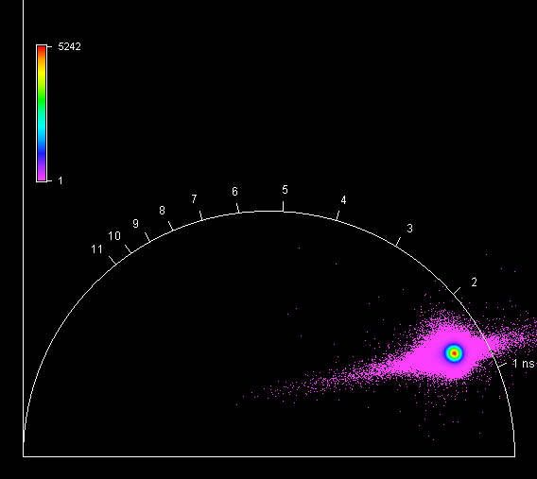

**Unknown, S136, F1, M1, AII** 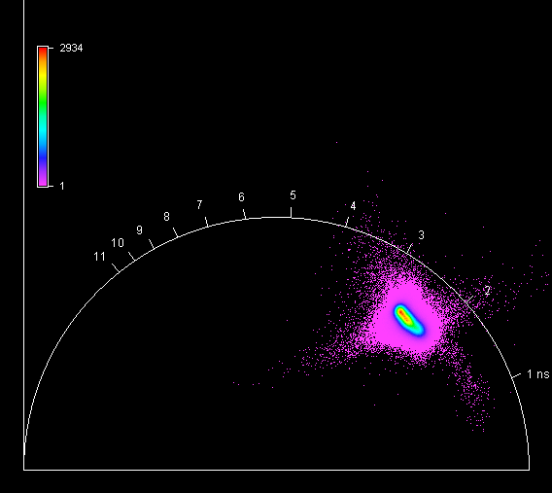

**Unknown, S136, F1, M2, AII** 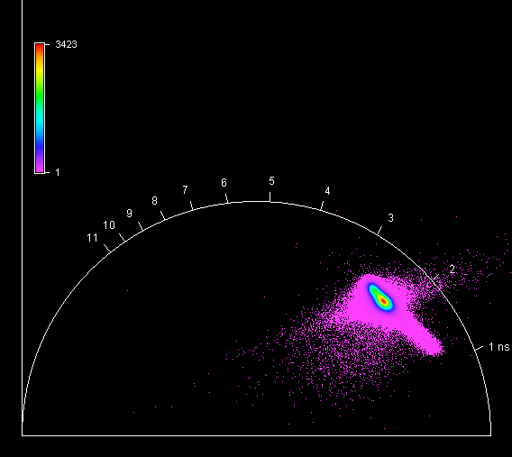

**Unknown, S136, F1, M3, AII** 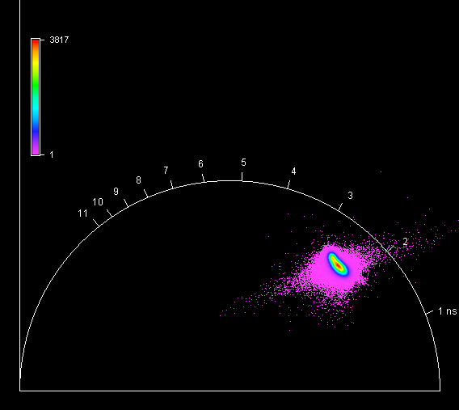

**Unknown, S136, F1, M4, AII** 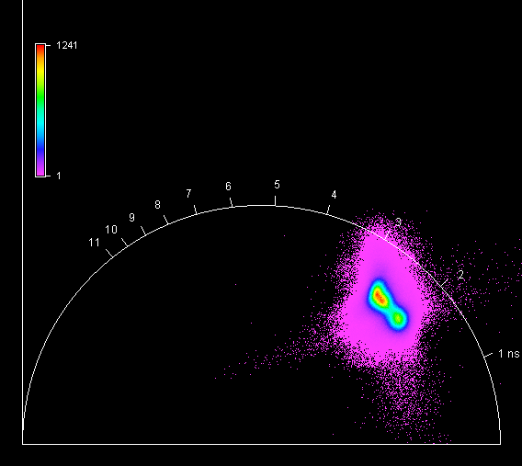

**Unknown, S137, F1, M1, AII** 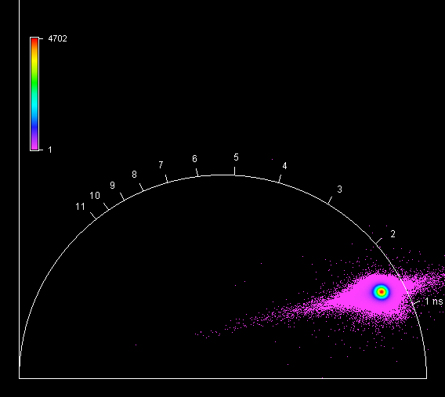

**Unknown, S137, F1, M2, AII** 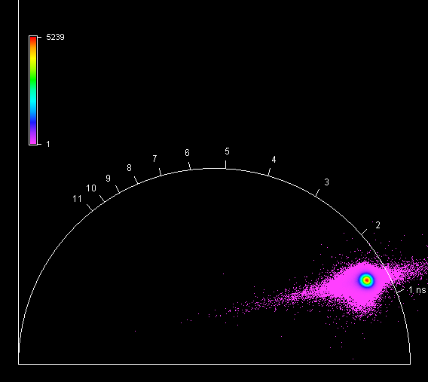

**Unknown, S137, F1, M3, AII** 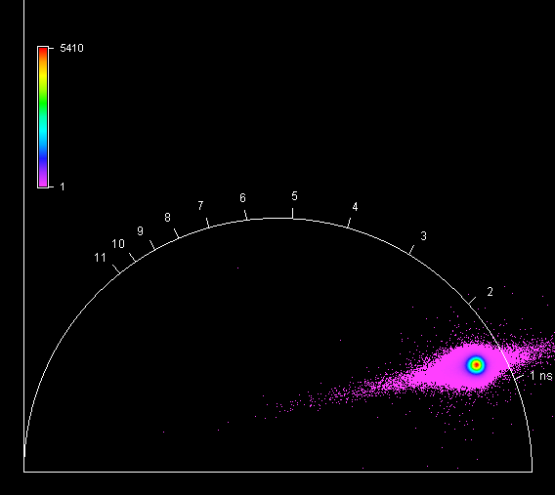

**Unknown, S137, F1, M4, AII** 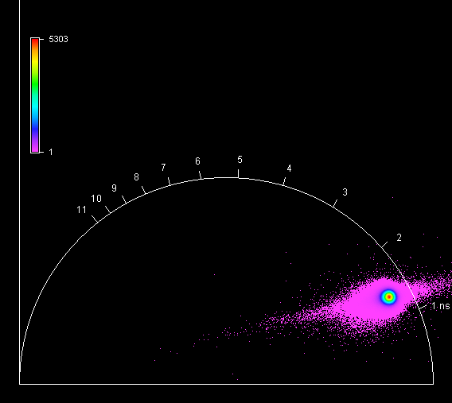

**Unknown, S138, F1, M1, AI** 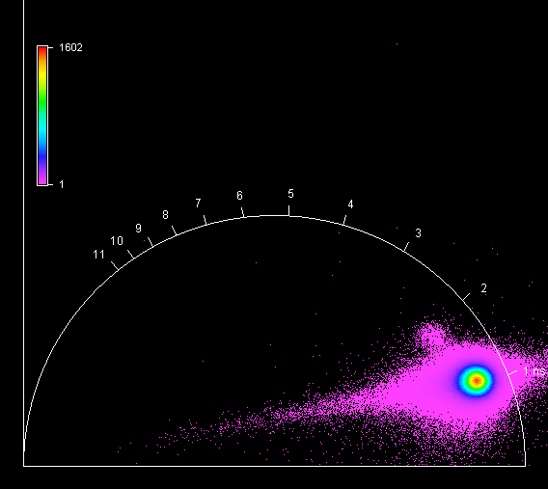

**Unknown, S138, F1, M2, AI** 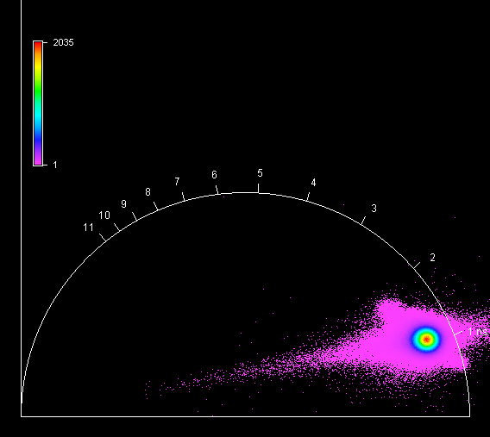

**Unknown, S138, F1, M3, AI** 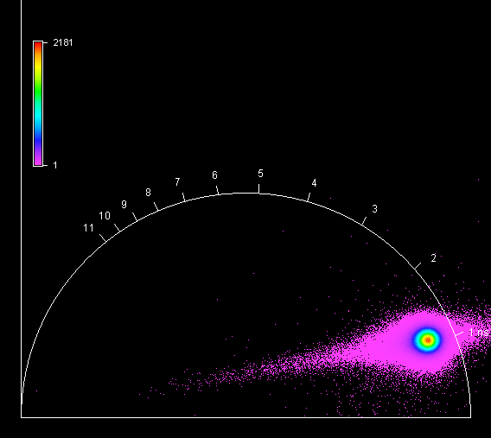

**Unknown, S138, F1, M4, AI** 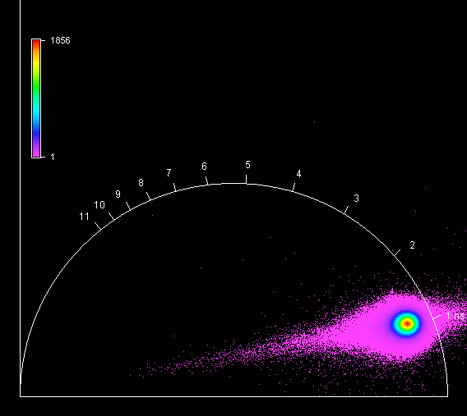

**Unknown, S139, F1, M1, AI** 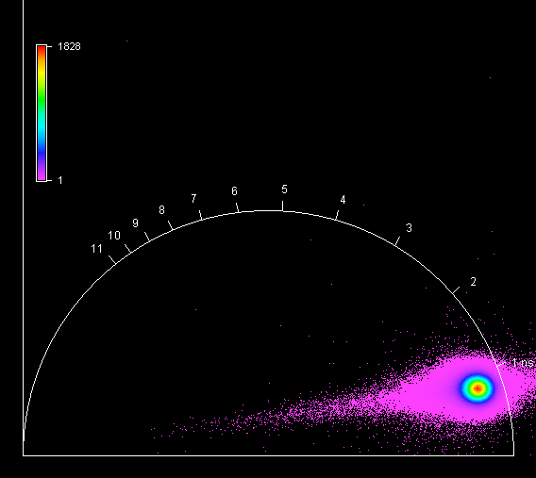

**Unknown, S139, F1, M2, AI** 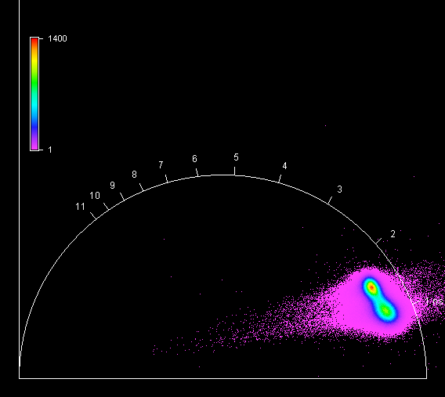

**Unknown, S139, F1, M3, AI** 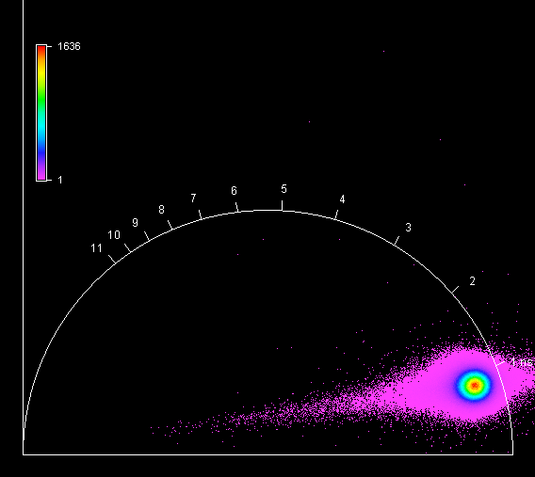

**Unknown, S139, F1, M4, AI** 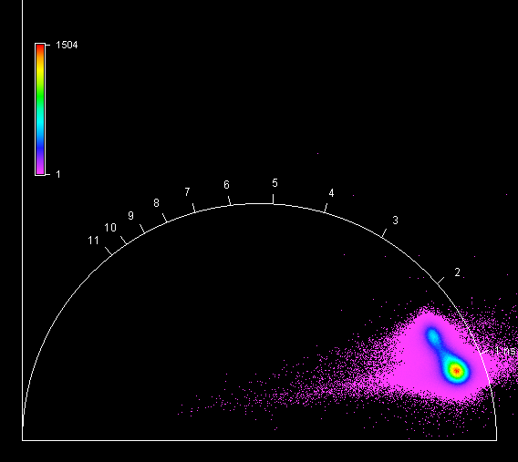

**Unknown, S140, F1, M1, AI** 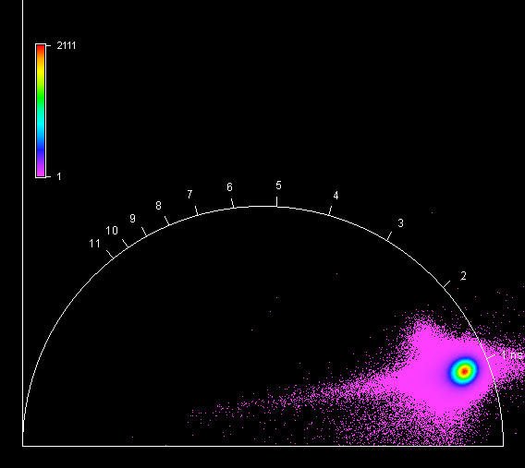

**Unknown, S140, F1, M2, AI** 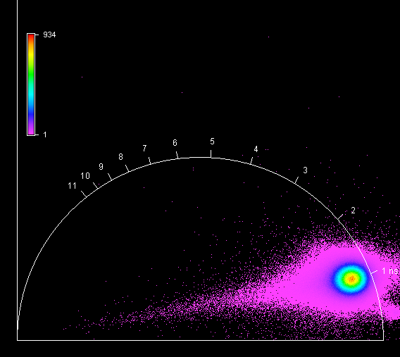

**Unknown, S140, F1, M3, AI** 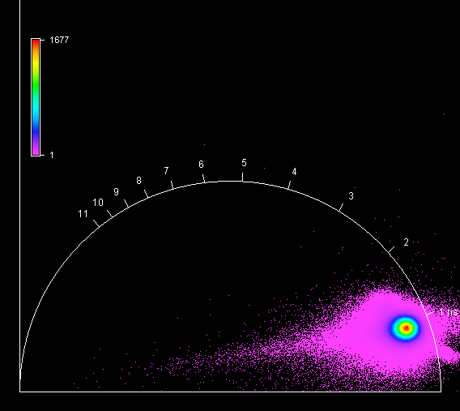

**Unknown, S140, F1, M4, AI** 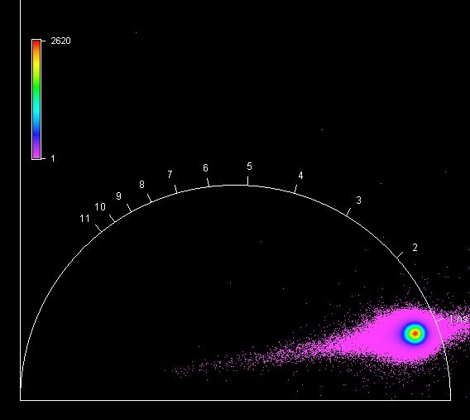

**Unknown, S141, F1, M1, AIV** 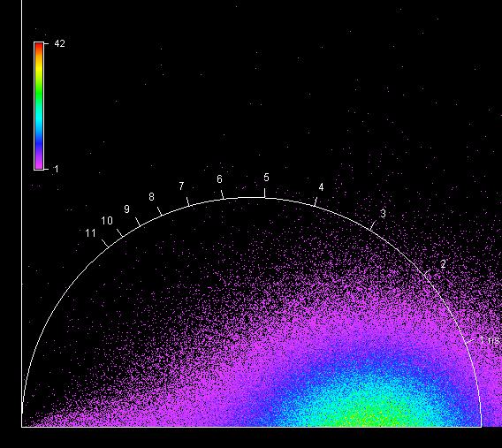

**Unknown, S141, F1, M2, AIV** 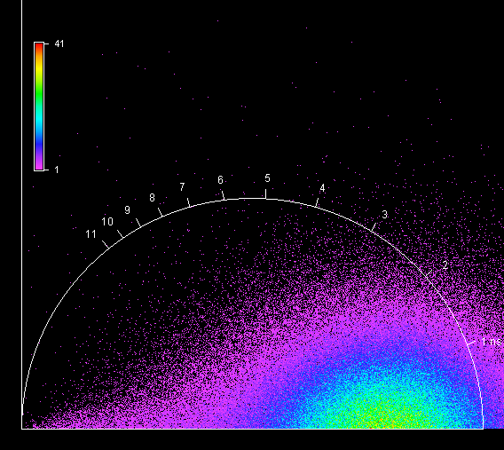

**Unknown, S141, F1, M3, AIV** 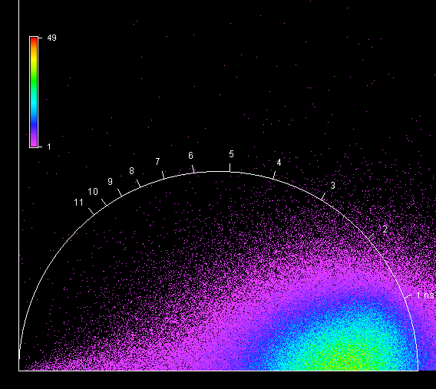

**Unknown, S141, F1, M4, AIV** 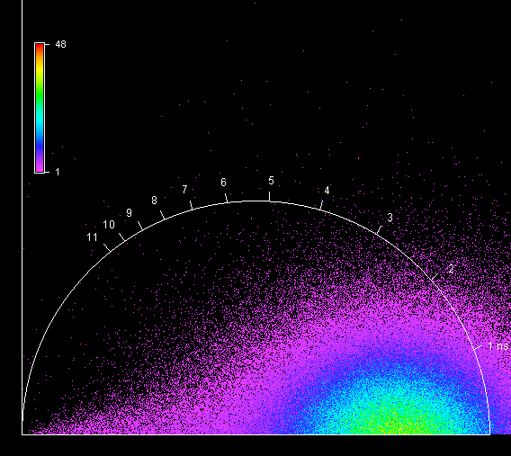

**Unknown, S142, F1, M1, AI** 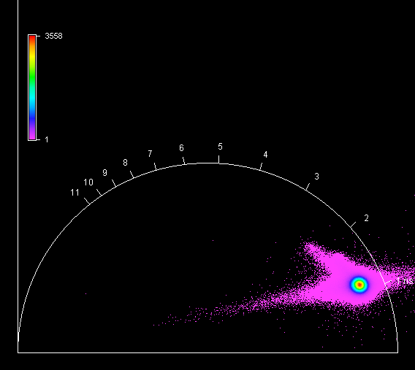

**Unknown, S142, F1, M2, AI** 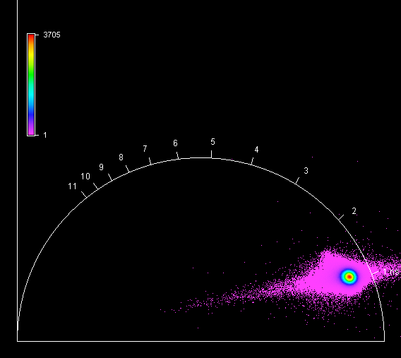

**Unknown, S142, F1, M3, AI** 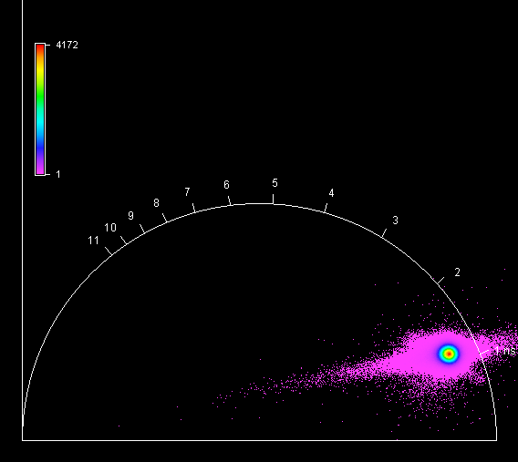

**Unknown, S142, F1, M4, AI** 