7/9 Discovery Drive, North Lakes, Queensland 4509, Australia
https://onetime.sport

Product & Services Update
16th July 2025

Overview
ONETIME is a provider of products and services that are used for the professional timing of endurance sports events. ONETIME offers a comprehensive solution, from timing readers, mats, and tags/bibs. ONETIME’s products have been engineered to minimize labor at events, reduce risks associated with data loss and timing errors, and to simplify logistics and lower labour costs. Our cloud-connected readers provide real-time access to timing data, as required for modern race management.

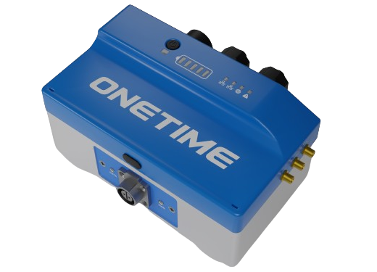
Hardware - our hardware products have been updated for 2025.
Readers - Our light-weight small form-factor readers still have our proprietary one-touch operation, mil-spec durability, and IP-68 rating. Network communications have been updated for global coverage wherever you are, they are mesh capable & include LoRaWAN. The replaceable and rechargeable batteries now have 2x extended life. Our

readers now receive online firmware updates & configuration over the air, minimizing service requirements.
Our readers now come in both active (HF) and passive (UHF) formats (they look identical).
Our readers include free real-time, secure data ingestion in our datacloud. When you configure our device, our API's automatically point your data at your Timing Software. ONETIME currently supports the BlackBox Timing message format, Itemhound, LLRP, Rufus, and IPICO/Trident formats. Other formats are being added all the time. Yours can be added by request.
We have a browser-based “responsive web” app for the configuration and monitoring of your readers, which also provides over-the-air (OTA) firmware updates.
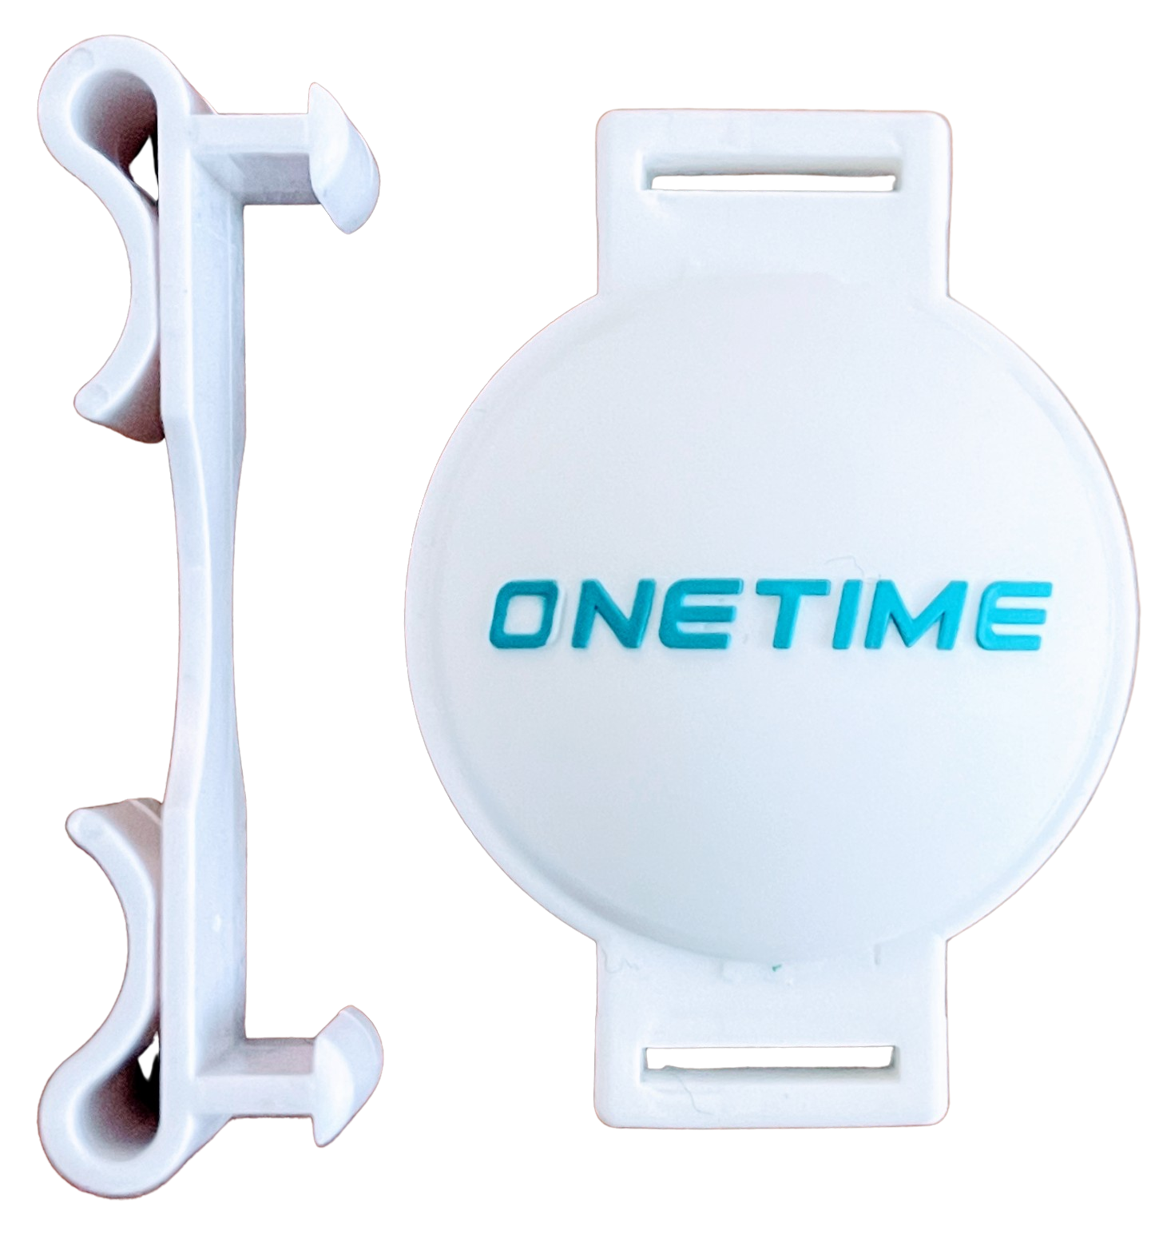
For full specifications please see the schedule to this document. All prices are quoted ex-works from Brisbane, Australia in US$. We can quote for transport & logistics, and in your preferred currency, on a case-by-case basis.
RFID Tags - We provide reusable active HF shoe-tag transponders, which now have a 10 year battery life. In addition we have multi-sport active (MTS) HF tags.
We also sell standard UHF bib tags, or you can use your own.
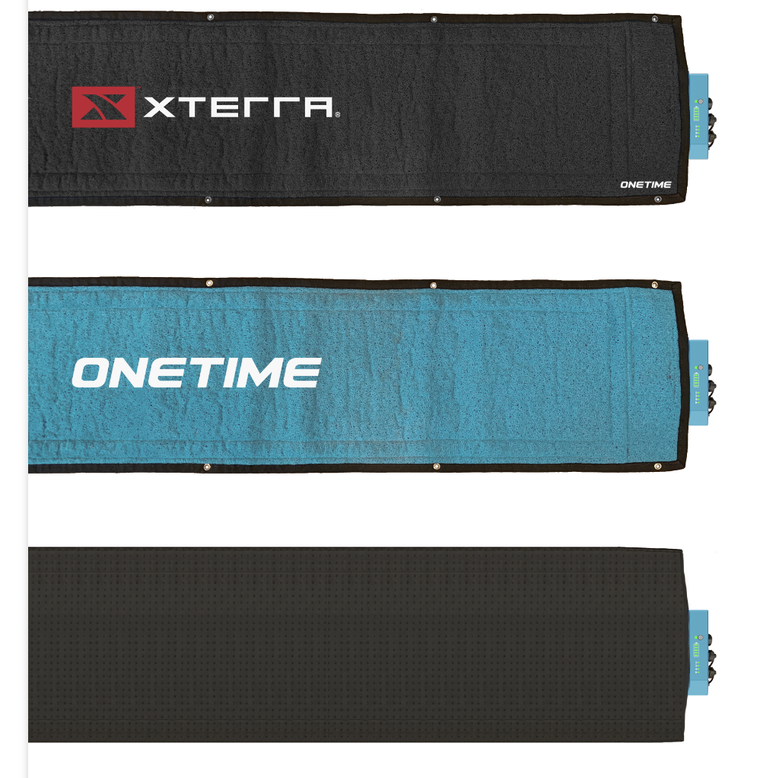
Our HF tags are required for use with our HF readers. Our UHF systems work with just about all UHF tags.
Mats - We sell a variety of mats suitable for use with both our HF and UHF systems. Our rollable and lightweight HF mats are required for use with our HF readers. We recommend that you use our UHF readers with our UHF mats, but the readers are also compatible with some other UHF mats.
Our foldable UHF mats can be deployed exactly where you need in less than a minute, reducing the stress of event day set up. The optional trolley allows you to pull your timing point around like a suitcase. When used with our UHF reader the package delivers industry-leading read rates allowing you to produce higher quality results. To increase the width of your UHF split timing point, blank segments can be used to expand the width of the mat line.

List Prices (June 2024)
Active HF Decoders (Reader) | US$2,535.00 | each
Active HF Mats | US$65.00 | per m
Active HF Shoe Tags | US$6.89 | each
Active HF Multisport Tags | US$14.63 | each
UHF Decoders (Reader) | US$2,535.00 | each
8m UHF Mats | US$1,300.00 | each
UHF Tags | US$0.26 | each

HF or UHF? You don’t have to choose, we have both!
The decision between HF and UHF has always been a decision based on a compromise between performance and tag prices. HF requires a battery in the tag, and is a superior technology in that it will deliver higher read rates giving less missed chip times that will provide more accurate results as it can more reliably detect when an athlete crosses a timing point. UHF is a cheaper tag technology allowing them to be disposable. The table below summarizes the HF versus UHF features.

 | Active (powered) HF Tag | UHF Tag
Wavelength | Has a longer wavelength allowing it to pass through objects, such as people, mud and water. | Has a shorter wavelength - only suitable for use in bibs.
Read Rate | Better read rates. | Human body interference can impact read rates.
Specificity & Sensitivity | Better specificity and sensitivity. | Line of sight between tag and mat/antenna is required.Human interference (arms, other athletes, etc) can be an issue.
Accuracy & Precision | Reads closer to the timing point leading to greater accuracy and precision. | Less accurate and more prone to errors due to read reflections.
Suited Events | Premium events, environmentally friendly events, clubs, cycling, swimming, triathlons, muddy and wet events, or where tags can be recovered or are kept by participants. | Low cost timing.
Tag Costs | Cost per tag is higher. | Cost per tag is lower.

Data Communications and Ingestion Service
Our readers are designed with in-built communications to the cloud. Each reader has a built-in Hologram SIM. You simply sign up for a Hologram account and add your SIM, and then pay for data communications on a per-use basis. Hologram has the best available global coverage. In addition to 5G we have ethernet, bluetooth, WiFi and LORAWAN built into the readers - allowing for up to 10km local networks for remote events.
We provide a completely free data ingestion service, hosted by AWS, for our readers, which provides our customers the gold standard in real-time data storage and security. Alternatively you can use your own or a preferred third party data ingestion services.
The benefits of cloud data ingestion include data security, real time race scoring using every reader at an event no matter where they are on the course, fewer hassles at site on race day, and the potential for less or even no labour on site with associated lower costs.
We currently support the following ingestion services - LLRP, Blackbox, IPICO/Trident, Rufus, Itemhound, Timeline, and others - access to these services can be purchased from the vendor and we have tested each with our system and they work perfectly. Or you can build your own.

Our app
Our browser-based “responsive web” app for the configuration and monitoring of your readers, also provides over-the-air (OTA) firmware updates. Inclusions include monitoring of timing-data and status-data ingestion, SIM/network charges, secure data storage, live data forwarding and data replay, and the decoder management dashboard.
When you first use our devices you simply configure the devices as follows using the web dashboard:
- Choose data ingestion host (Onetime AWS, Trident RFID, etc)
- Choose Status Data (telemetry data) - (Onetime AWS, Trident, etc)
- Choose data destination endpoint address - URL (e.g. BBtiming, Racetec, Rufus, etc)
A flashing greenlight on the reader tells you that your configuration choices are being checked. A solid greenlight on the reader informs you that all your configuration choices are working properly, and you are good to go.
Optionally we can also provide a Service Level Agreement which provides you with expert technical assistance before and during a race to ensure that your data is safely ingested into your chosen cloud storage system.

Key Specifications

UHF Decoder/Reader v2.0
Device & Operations
Environmental | IP68 with ports sealed and mat attached  IP54 with ports open and mat attached
Regulatory | FCC, RoHS
Relative Humidity - Max Operating Range | 95% per IP64
Operating Temperature | -20°C ~ +65°C
Storage Temperature | -40°C ~ +85°C
Weight | TBC
Dimensions | 185mm x 105mm x 95mm
Power Input | DC, 3-5V
Input Wattage (Sustain) | 2W min, 3W preferred
Input Wattage (Charge) | 5W min, 24W preferred (12V@2A), 60W max
Typical Current Draw | TBC
Battery Capacity | 12,000 mAh @ 8V (91.2 Wh) Replaceable
Battery Type | Li-NMC
Battery Flight Safety | UN3481 (2s2p 91.2 Wh)
Charging Time (typical) | 4 hours @ 24W
Battery Life | Up to 60 hours
Ports & Features
GNSS Receiver | GPS(L1), GLONASS(L1), QZSS(L1), Galileo(E1)
Real-time Clock (RTC) External | <86 ms per day lost time  Resynced during each GNSS lock.
Real-time Clock (RTC) Internal | <864 ms per day lost time.  Resynced frequently with External RTC.
LAN | Dual 10/100BaseT, auto crossover, internal switch
POE | Passive POE, supplied from DC port and internal batteries
WiFi | 802.11 b/g/n - WiFi4
DC Charging Port | 2.1 / 5.1 mm DC port
Buzzer | Frequency: 2.8 kHz  Min Volume: 85 dB
UHF Module
Antenna Ports | 8 x BNCs, each with LED status light
Air Interface Protocol | EPC Global UHF Class 1 Gen 2 / ISO 18000-6C
Spectrum Range | 902 MHz - 928 MHz, 865 Mhz - 868 MHz
Supported Regions | US, Canada & other regions following US FCC  Europe & other regions following ETSI EN 302 208.  China, Korea & Malaysia
Output Power | 0 - 33 dBm
Heat Dissipation | Integrated passive radiator
Receive Sensitivity | < -88 dBm
Peak Read Speed | >900 tags/second
Features | Tag RSSI, Antenna Detector
Working Mode | Single/DRM
Internet Features
HTTP | Posting to external servers for data transferring. Automatic downloading of firmware updates.
MQTT | Posting to external servers for data transferring. Automatic downloading of firmware updates.  Command/Control/Configuration
Raw TCP Sockets | Real-time status output  Real-time data timing output  Command/Control/Configuration
Web Interface | Uploading of firmware updates  Real-time status, console etc  Command/Control/Configuration
FTP | Interact with the local file system, retrieve logs
Cellular
Protocols | 4G LTE CAT1
LTE bands | B1, 2, 3, 4, 5, 7, 8, 12, 13, 18, 19, 20, 25, 26, 28, 66
LoRa
Protocols | LoRa, LoRaWAN
Data Rate | Max 25kBits/s
Internal Antenna | Internal 1x, Antenova SR41052
External Antenna | Optional 1x, SMA attached
Memory
Capacity | 32MB
Type | Flash (persistent)
Max IDs (without recycling memory) | 699,048
Max participants in single event (without recycling memory) | 209,016
Persistent memory is retained after the unit is powered off, and will be sent at the next available opportunity.
Timing Performance
Timing Resolution | 1/1,000,000th of a second (10uS)
Real timing performance specs are related to the performance of the tags.

HF Decoder/Reader v2.0
Device & Operations
Environmental | IP68 with ports sealed and mat attached  IP54 with ports open and mat attached
Regulatory | FCC, RoHS
Relative Humidity - Max Operating Range | 95% per IP64
Operating Temperature | -20°C ~ +65°C
Storage Temperature | -40°C ~ +85°C
Weight | TBC
Dimensions | 185mm x 105mm x 95mm
Power Input | DC, 3-5V
Input Wattage (Sustain) | 2W min, 3W preferred
Input Wattage (Charge) | 5W min, 24W preferred (12V@2A), 60W max
Typical Current Draw | TBC
Battery Capacity | 12,000 mAh @ 8V (91.2 Wh) Replaceable
Battery Type | Li-NMC
Battery Flight Safety | UN3481 (2s2p 91.2 Wh)
Charging Time (typical) | 4 hours @ 24W
Battery Life | Up to 60 hours
Ports & Features
GNSS Receiver | GPS(L1), GLONASS(L1), QZSS(L1), Galileo(E1)
Real-time Clock (RTC) External | <86 ms per day lost time  Resynced during each GNSS lock.
Real-time Clock (RTC) Internal | <864 ms per day lost time.  Resynced frequently with External RTC.
LAN | Dual 10/100BaseT, auto crossover, internal switch
POE | Passive POE, supplied from DC port and internal batteries
WiFi | 802.11 b/g/n - WiFi4
DC Charging Port | 2.1 / 5.1 mm DC port
Buzzer | Frequency: 2.8 kHz  Min Volume: 85 dB
HF Module
Antenna Ports | 8 x BNCs, each with LED status light
Air Interface Protocol | EPC Global UHF Class 1 Gen 2 / ISO 18000-6C
Spectrum Range | 902 MHz - 928 MHz, 865 Mhz - 868 MHz
Supported Regions | US, Canada & other regions following US FCC  Europe & other regions following ETSI EN 302 208.  China, Korea & Malaysia
Output Power | 0 - 33 dBm
Heat Dissipation | Integrated passive radiator
Receive Sensitivity | < -88 dBm
Peak Read Speed | >900 tags/second
Features | Tag RSSI, Antenna Detector
Working Mode | Single/DRM
Internet Features
HTTP | Posting to external servers for data transferring. Automatic downloading of firmware updates.
MQTT | Posting to external servers for data transferring. Automatic downloading of firmware updates.  Command/Control/Configuration
Raw TCP Sockets | Real-time status output  Real-time data timing output  Command/Control/Configuration
Web Interface | Uploading of firmware updates  Real-time status, console etc  Command/Control/Configuration
FTP | Interact with the local file system, retrieve logs
Cellular
Protocols | 4G LTE CAT1
LTE bands | B1, 2, 3, 4, 5, 7, 8, 12, 13, 18, 19, 20, 25, 26, 28, 66
LoRa
Protocols | LoRa, LoRaWAN
Data Rate | Max 25kBits/s
Internal Antenna | Internal 1x, Antenova SR41052
External Antenna | Optional 1x, SMA attached
Memory
Capacity | 32MB
Type | Flash (persistent)
Max IDs (without recycling memory) | 699,048
Max participants in single event (without recycling memory) | 209,016
Persistent memory is retained after the unit is powered off, and will be sent at the next available opportunity.
Timing Performance
Timing Resolution | 1/1,000,000th of a second (10uS)
Real timing performance specs are related to the performance of the tags.

Active HF Tags - Shoe-Tags & Multisport (MTS) Tags
Timing Specifications | Shoe Tag | MTS
IDs per second | 16 | 64
Max. density per mat | 208 | 833
Realistic density per mat | 77 | 307
Max. guaranteed read speed (3 reads per met, 3R) | 5.33 m/s  19.2 km/h | 21.3 m/s  76.8 km/h
Timing precision @ max guaranteed read speed | 187 ms  3R | 47 ms  3R
Timing Precision (#.##R indicates number of reads across a mat)
Walking (1.6 m/s) | 56 ms  9.98R | 3.5 ms  39.94R
5hr Marathon (2.3 m/s) | 81 ms  6.95R | 5 ms  27.78R
3hr Marathon (4 m/s) | 140 ms  3.99R | 8.8 ms  15.98R
15m 5km (5.5 m/s) | 193 ms  2.9R | 12 ms  11.62R
Cycling (8.3 m/s) | 291ms  1.29R | 18 ms  7.7R
Usain Bolt (10.44 m/s) | 367 ms  1.53R | 23 ms  6.12R
Peloton (13 m/s) | 457 ms  1.23R | 29 ms  4.92R
Mark Cavendish (16.6 m/s) | 483 ms  0.96R | 36 ms  3.85R
Lifespan after Activation | 2 years | 6 months
Frequency Specifications | Shoe Tag | MTS
Center | 13.33 MHz ± 200 kHz
Bandwidth | 1 MHz
Physical Specifications | Shoe Tage | MTS
Weight | 19 grams | 16.6 grams
IP rating | IP69 | IP69

Mats | UHF mats | HF Mats
Manufacturer | Blackbox, Feiboit & Rufus | ONETIME
Verified with our Readers & Tags | Yes | Yes
Lengths available | Up to 6.2m | Up to 5m
Widths available | 370mm | 410 - 450mm
Mass | 5.4 kg/m | 1.2 - 1.4 kg/m
Setup time (typical) | 1 minute (unfold) | 1 minute (unroll)
Adapt to uneven terrain | Yes | Yes
Polarization | Horizontal Preferred | NA
Customization | Print your logo or your sponsor’s logo on a custom coloured mat | Print your logo or your sponsor’s logo on a custom coloured mat
Other features | - Super slim with a non-slip top surface.  - Pegs holes. | - Super slim with a non-slip top surface.  - Peg holes.

Contact Details

Headoffice (Australia)
Phil Almond at
philip@onetime.sport
+61 (0) 422 813 869

