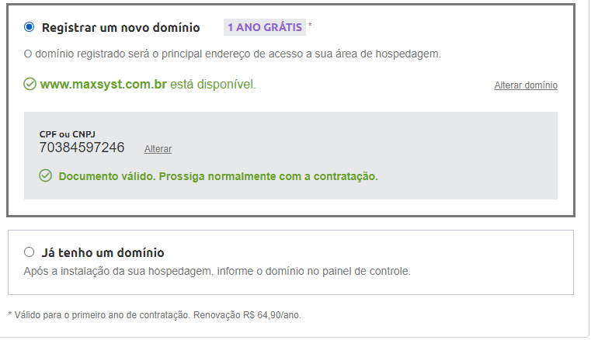

https://cpanel.epizy.com/panel/index.php

maxsyst.epizy.com

Your account has been created with

username epiz_32595073

pwd s34mcn0p

! Here are some things you need to know:

* It will take a few minutes for your account to be set up, but you can login to the control panel already.
* It can take up to 72 hours for the new domain to be visible everywhere due to DNS caching.
* Please login to the control panel once to enable all features.
* Not sure what to do next? Please see [this guide](https://forum.infinityfree.net/docs?topic=49312) for some ideas on how to get started.