Ministerul Educației al Republicii Moldova

Universitatea Tehnică a Moldovei

RAPORT

la Programarea aplicațiilor incorporate și independente de platformă

Lucrare de laborator Nr.3

Tema:”Transformarea signalului Analog in Digital.Conectarea unui sensor de temperatura.”

A efectuat st. gr. FAF-141: Nicu Maxian

A verificat lect. univ.: Andrei Bragarenco

Chişinău 2016

Topic

Converting Analog to Digital signal. Connecting temperature sensor to MCU and display temperature to display.

Scope

* ADC of the AVR
* Analog to Digital Conversion
* Connecting Temperature Sensor to MCU

Task

Write driver for ADC and LM20 Temperature sensor. ADC will transform Analog to Digital data. LM20 driver will use data from ADC to transform to temperature regarding to this sensor parameters. Also use push button to switch between metrics Celsius, Fahrenheit and Kelvin.

Domain

## Analog to Digital Conversion

[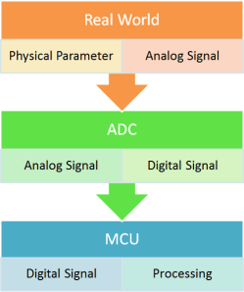](http://i1.wp.com/maxembedded.files.wordpress.com/2011/06/signal-acquisition-process.png)Most real world data is analog. Whether it be temperature, pressure, voltage, etc, their variation is always analog in nature. For example, the temperature inside a boiler is around 800°C. During its light-up, the temperature never approaches directly to 800°C. If the ambient temperature is 400°C, it will start increasing gradually to 450°C, 500°C and thus reaches 800°C over a period of time. This is an analog data.\

Now, we must process the data that we have received. But analog signal processing is quite inefficient in terms of accuracy, speed and desired output. Hence, we convert them to digital form using an Analog to Digital Converter (ADC).

### Signal Acquisition Process

In general, the signal (or data) acquisition process has 3 steps.

In the Real World, a [sensor](http://maxembedded.wordpress.com/2011/06/18/sensor-fundamentals/) senses any physical parameter and converts into an equivalent analog electrical signal.

For efficient and ease of signal processing, this analog signal is converted into a digital signal using an **Analog to Digital Converter (ADC).**

This digital signal is then fed to the **Microcontroller (MCU)** and is processed accordingly.

[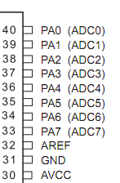](http://i0.wp.com/maxembedded.files.wordpress.com/2011/06/adc-pins-atmega16-32.png)

### Interfacing Sensors

In general, sensors provide with analog output, but a MCU is a digital one. Hence we need to use ADC. For simple circuits, comparator op-amps can be used. But even this won’t be required if we use a MCU. We can straightaway use the inbuilt ADC of the MCU. In ATMEGA16/32, PORTA contains the ADC pins.

## The ADC of the AVR

The AVR features inbuilt ADC in almost all its MCU. In ATMEGA16/32, PORTA contains the ADC pins. Some other features of the ADC are as follows:

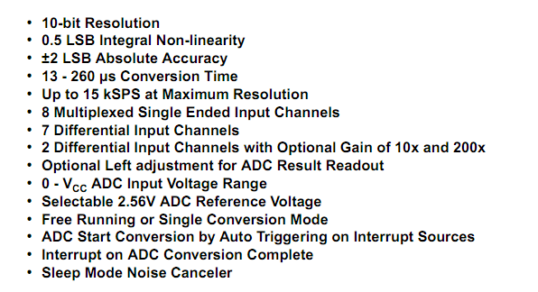

Right now, we are concerned about the **8 channel 10 bit resolution**feature.

**8 channel** implies that there are 8 ADC pins are multiplexed together. You can easily see that these pins are located across PORTA (PA0…PA7).

**10 bit resolution** implies that there are 2^10 = 1024 steps (as described below).

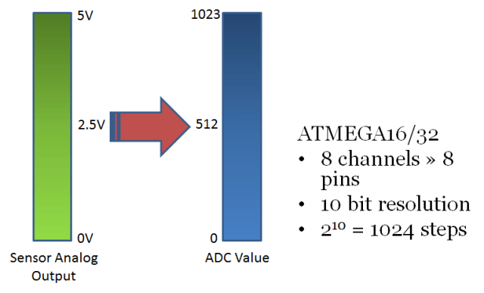

Suppose we use a 5V reference. In this case, any analog value in between 0 and 5V is converted into its equivalent ADC value as shown above. The 0-5V range is divided into 2^10 = 1024 steps. Thus, a 0V input will give an ADC output of 0, 5V input will give an ADC output of 1023, whereas a 2.5V input will give an ADC output of around 512. This is the basic concept of ADC.

To those whom it might concern, the type of ADC implemented inside the AVR MCU is of [Successive Approximation](http://en.wikipedia.org/wiki/Successive_approximation_ADC) type.

Apart from this, the other things that we need to know about the AVR ADC are:

ADC Prescaler

ADC Registers – ADMUX, ADCSRA, ADCH, ADCL and SFIOR

## ADC Prescaler

The ADC of the AVR converts analog signal into digital signal at some regular interval. This interval is determined by the clock frequency. In general, the ADC operates within a frequency range of 50kHz to 200kHz. But the CPU clock frequency is much higher (in the order of MHz). So to achieve it, frequency division must take place. The prescaler acts as this division factor. It produces desired frequency from the external higher frequency. There are some predefined division factors – 2, 4, 8, 16, 32, 64, and 128. For example, a prescaler of 64 implies F_ADC = F_CPU/64. For F_CPU = 16MHz, F_ADC = 16M/64 = 250kHz.

Now, the major question is… which frequency to select? Out of the 50kHz-200kHz range of frequencies, which one do we need? Well, the answer lies in your need. **There is a trade-off between frequency and accuracy**. Greater the frequency, lesser the accuracy and vice-versa. So, if your application is not sophisticated and doesn’t require much accuracy, you could go for higher frequencies.

## ADC Registers

### ADMUX – ADC Multiplexer Selection Register

The ADMUX register is as follows.

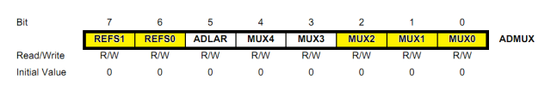

The bits that are highlighted are of interest to us. In any case, we will discuss all the bits one by one.

* **Bits 7:6 – REFS1:0 – Reference Selection Bits** – These bits are used to choose the reference voltage. The following combinations are used.

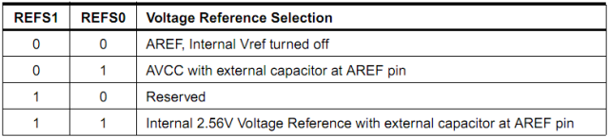

The ADC needs a reference voltage to work upon. For this we have a three pins AREF, AVCC and GND. We can supply our own reference voltage across AREF and GND. For this, choose the first option. Apart from this case, you can either connect a capacitor across AREF pin and ground it to prevent from noise, or you may choose to leave it unconnected. If you want to use the VCC (+5V), choose the second option. Or else, choose the last option for internal Vref.

Let’s choose the second option for Vcc = 5V.

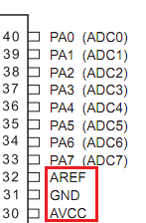

* **Bit 5 – ADLAR – ADC Left Adjust Result** – Make it ‘1’ to Left Adjust the ADC Result. We will discuss about this a bit later.
* **Bits 4:0 – MUX4:0 – Analog Channel and Gain Selection Bits** – There are 8 ADC channels (PA0…PA7). Which one do we choose? Choose any one! It doesn’t matter. How to choose? You can choose it by setting these bits. Since there are 5 bits, it consists of 2^5 = 32 different conditions as follows. However, we are concerned only with the first 8 conditions. Initially, all the bits are set to zero.

### ADCSRA – ADC Control and Status Register A

The ADCSRA register is as follows.

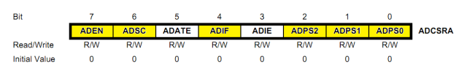

The bits that are highlighted are of interest to us. In any case, we will discuss all the bits one by one.

* **Bit 7 – ADEN – ADC Enable** – As the name says, it enables the ADC feature. Unless this is enabled, ADC operations cannot take place across PORTA i.e. PORTA will behave as GPIO pins.
* **Bit 6 – ADSC – ADC Start Conversion** – Write this to ‘1’ before starting any conversion. This 1 is written as long as the conversion is in progress, after which it returns to zero. Normally it takes 13 ADC clock pulses for this operation. But when you call it for the first time, it takes 25 as it performs the initialization together with it.
* **Bit 5 – ADATE – ADC Auto Trigger Enable** – Setting it to ‘1’ enables auto-triggering of ADC. ADC is triggered automatically at every rising edge of clock pulse. View the SFIOR register for more details.
* **Bit 4 – ADIF – ADC Interrupt** Flag – Whenever a conversion is finished and the registers are updated, this bit is set to ‘1’ automatically. Thus, this is used to check whether the conversion is complete or not.
* **Bit 3 – ADIE – ADC Interrupt Enable** – When this bit is set to ‘1’, the ADC interrupt is enabled. This is used in the case of interrupt-driven ADC.
* **Bits 2:0 – ADPS2:0 – ADC Prescaler Select Bits** – The prescaler (division factor between XTAL frequency and the ADC clock frequency) is determined by selecting the proper combination from the following.

### ADCL and ADCH – ADC Data Registers

The result of the ADC conversion is stored here. Since the ADC has a resolution of 10 bits, it requires 10 bits to store the result. Hence one single 8 bit register is not sufficient. We need two registers – ADCL and ADCH (ADC Low byte and ADC High byte) as follows. The two can be called together as ADC.

Used Resources

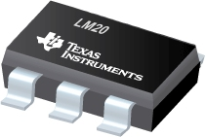

LM20 –Temperature Sensor

### Characteristics

* Rated for −55°C to 130°C Range
* Suitable for Remote Applications
* Accuracy at 30°C ±1.5 to ±4°C (Maximum)
* Accuracy at 130°C and −55°C ±2.5 to ±5°C
* Power Supply Voltage Range 2.4 V to 5.5 V
* Current Drain 10 μA (Maximum)
* Output Impedance 160 Ω (Maximum)

## Applications

* Cellular Phones
* Computers
* Power Supply Modules
* Battery Management
* FAX Machines
* Printers
* HVAC
* Disk Drives
* Appliances

Solution

**Project Structure** looks in this way

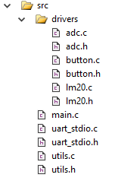

## adc.h / adc.c

Contains declaration and implementation of ADC Driver. It has 3 methods:

1. void ADC_Init();
2. int ADC_GetData();
3. float ADC_GetVoltage();

1 ) Initializes driver

2) Get data from initialized ADC. It’s a 10 bit value, which can give us value from range 0..1023

3) Get Voltage from ADC but converts it to range 0 to 5 Volts.

## lm20.h /lm20.c

Contains declaration and implementation of LM20 Driver. It depends on ADC driver. It has 2 methods:

1. void LM20_Init();
2. int LM20_GetTemperature();

1 ) Initializes driver. Initialization is done in ADC also.

2) Uses ADC driver to get digital value and converts to Celsius temperature.

## lm20.h /lm20.c

Contains useful methods used in entire project.

float ConvertValueFromToRange(float val,float minFromRange,float maxFromRange,float minToRange,float maxToRange);

This method is used by ADC and LM20 drivers in order to transform value from [0..1023] to [0..5V] and for converting [0.3..2.4V] to Celsius [-55..130].This method uses Euqation of a line, for conversion form one line to another.

### Main Program

Main Program is responsible for :

* Initialization of 2 buttons , which switch from Celsius to Fahrenheit and Kelvin
* Initialization of UART , for displaying temperature
* Initialization of LM20 Sensor
* Every 1 second program Receives temperature from Sensor and converts it to needed conversion, which is decided by button push

After code implementation, we should now **Build Hex** which will be written to MCU ROM.



### Schematics

For our laboratory work we need only simple ATMega32 MCU,2 Push Buttons, LM20 sensor and peripheral UART device, which in our case is virtual terminal.

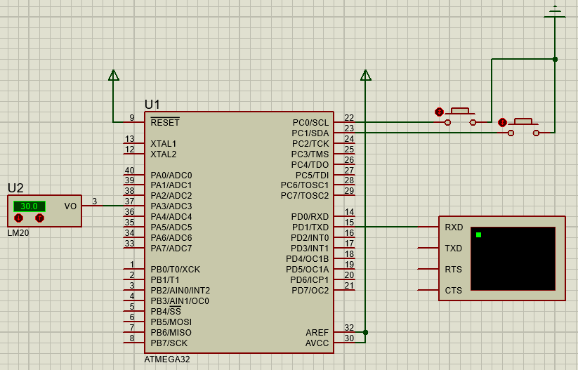

We need to make sure that our MCU is connected to Virtual Terminal. Because we use only data transmission on one direction (OUTPUT) we need to make sure that our MC **Tx** is connected to Peripheral **Rx**.

MCU is transmitter and peripheral is receiver. No vice versa connection because we don’t need it in our laboratory work.

Our LM20 Sensor was connected to ADC3 and Push Buttons to port C , pin 0 and 1.

### Simulation Result

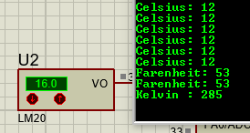

We can see that our temperature is close to original. Error rate appears because we used proportional distribution for transformation to temperature. There is a formula on LM20 Datasheet for precise transformation.

Conclusion

This laboratory work gave us a basic concepts about ADC. We connected sensor to our MCU and have written Drivers for ADC and LM20 which actually prepares hardware and get’s Analog data from sensor then converts it to Digital Data.

Most difficult part of this laboratory work was ADC driver. Actually initialization was one of hardest thing. Rest of application is quite easy for whose who have basic C knowledge. Also I used linear conversion for getting Temperature from device, but it could be better to use formula from LM20 datasheet. This improvement will make our temperature more precise.

Appendix

### Main.c

#include <avr/io.h>

#include <avr/delay.h>

#include "uart_stdio.h"

#include "drivers/button.h"

#include "drivers/lm20.h"

#define DELAY_TIME_MS 1000

int CelsiusToKelvin(int celsius){

return celsius+273;

}

int CelsiusToFarenheit(int celsius){

return celsius*18/10 + 32;

}

void main() {

struct ButtonDevice button1;

struct ButtonDevice button2;

button1.ddr = &DDRC;

button1.pin = &PINC;

button1.pinIndex = 0;

button2.ddr = &DDRC;

button2.pin = &PINC;

button2.pinIndex = 1;

// Initialization

uart_stdio_Init();

LM20_Init();

ButtonInit(&button1);

ButtonInit(&button2);

int temperature;

while(1){

temperature = LM20_GetTemperature();

if(ButtonPressed(&button1)){

temperature = CelsiusToKelvin(temperature);

printf("Kelvin : %d\n",temperature);

} else {

if (ButtonPressed(&button2))

{

temperature = CelsiusToFarenheit(temperature);

printf("Farenheit: %d \n",temperature);

} else {

printf("Celsius: %d\n",temperature);

}

}

_delay_ms(DELAY_TIME_MS);

}

}

### adc.h

/*

* adc.h

*

* Created: 10/5/2016 6:54:38 AM

* Author: Maxian Nicu

*/

#ifndef ADC_H_

#define ADC_H_

#include <avr/io.h>

void ADC_Init();

int ADC_GetData();

float ADC_GetVoltage();

#endif /* ADC_H_ */

### adc.c

#include "adc.h"

#include "../utils.h"

void ADC_Init(){

ADCSRA = (1 << ADEN)

|(1 << ADSC)

|(0 << ADATE)

|(0 << ADIF)

|(0 << ADIE)

|(1 << ADPS2)

|(1 << ADPS1)

|(0 << ADPS0);

ADMUX = 0x03;

}

int ADC_GetData(){

ADCSRA |= (1 << ADSC);

while(ADCSRA && ADIF == 0);

return ADC;

}

float ADC_GetVoltage(){

return ConvertValueFromToRange(ADC_GetData(),0,1023,0,5);

}

### Lm20.h

#ifndef LM20_H_

#define LM20_H_

#include "adc.h"

void LM20_Init();

int LM20_GetTemperature();

#endif /* LM20_H_ */

### Lm20.c

#include "lm20.h"

#include "../utils.h"

void LM20_Init(){

ADC_Init();

}

int LM20_GetTemperature(){

return ConvertValueFromToRange(ADC_GetVoltage(),0.3,2.48,130,-55);

}

### FlowChart

